# DAFTAR PUSTAKA

Agustiani, S., Ramdhan, B., & Suhendar. (2022). BIODIK: Jurnal Ilmiah Pendidikan Biologi Analisis Minat Wirausaha Dan Kreativitas Dalam Pembelajaran Menggunakan Model Project Based Learning Berorientasi Bioentrepreneurship. *BIODIK : Jurnal Ilmiah Pendidikan Biologi*, *08*(04), 19–

29. https://online-journal.unja.ac.id/biodik Alma, B. (2021). *Kewirausahaan*. ALFABETA, cv.

Anugrah Mustofa, A. (2023). Pengaruh Pembelajaran Kewirausahaan dan Praktik Kewirausahaan Terhadap Minat Berwirausaha. *Journal of Management : Small and Medium Enterprises (SMEs)*, *16*(1), 185–196. https://doi.org/10.35508/jom.v16i1.9710

Arikunto, S. (2020). *Prosedur Penelitian: Suatu Pendekatan Praktik*. PT RINEKA CIPTA.

Dewi, K., Yaspita, H., & Yulianda, A. (2020). *Manajemen Kewirausahaan*.

Deepublish.

Dinar, M., Ahmad, M. I. S., & Hasan, M. (2020). *Kewirausahaan*. Cv. Media Sains Indonesia.

Erdalina, E., Azhari, A., Negeri, S. M. K., & Aceh, T. (2023). Pengaruh Motivasi , Kreativitas dan Inovasi terhadap Minat Berwirausaha Siswa ( Studi pada SMK Negeri 1 Bandar Dua Kabupaten Pidie Jaya ). *Management, Business and Entreprenuership*, *2*(3), 25–35.

Farhad Effendi, R., Wiradendi Wolor, C., & Marsofiyati. (2023). *Pengaruh Pendidikan Kewirausahaan Dan Praktik Kewirausahaan Pada Business Center Terhadap Minat Berwirausaha Siswa Smkn 14 Jakarta*. *1*(5), 182–197.

Fauziah, K. (2021). Kajian Teori Dan Kerangka Pemikiran Aves.

[*Http://Repository.Unpas.Ac.Id/50123/7/BAB%20II.Pdf*,](http://Repository.Unpas.Ac.Id/50123/7/BAB%20II.Pdf) 1–23.

Habibi, B., Kaptiasih, R., & Dan, T. (2023). Penguatan Profil Pelajar Pancasila melalui Pembelajaran Berbasis Proyek. *Journal of Education Research*, *4*(3), 1488–1494.

Hafni, N., Diana, N., & Mawardi, M. C. (2022). Pengaruh Pendidikan Kewirausahaan, Praktik Kewirausahaan, Motivasi, Dan Lingungan Keluarga Terhadap Minat Mahasiswa Untuk Berwirausaha Di Masa Pandemi Covid-19 (Studi Kasus Pada Mahasiswa Angkatan 2018 Jurusan Akuntansi Fakultas Ekonomi dan Bisnis Univer. *E-Jra*, *11*(09), 84–92.

Khosmas, F. (2021). Pengaruh Pembelajaran Produk Kreatif Dan Kewirausahaan Terhadap Minat Berwirausaha Siswa Kelas Xii Kompetensi Keahlian Teknik Kendaraan Ringan Otomotif Di Smk Negeri 1 Mandor. *Sosial Khatulistiwa: Jurnal Pendidikan IPS*, *1*(1), 29. https://doi.org/10.26418/skjpi.v1i1.48864

Khuzaemah, R. (2019). *Produk Kreatif dan Kewirausahaan_Kompetensi Keahlian Bisnis daring dan Pemasaran, Akuntansi Keuangan Lembaga, Otomatisasi dan Tata Kelola Perkantoran* (T. Rianto (ed.)). PT Bumi Aksara.

Lestari, D. A., Hafid, R., Hasiru, R., Hinelo, R., & Maruwae, A. (2023). *Pengaruh Pembelajran Produk Kreatif dan Kewirausahaan ( PKK ) terhadap Perilaku Wirausaha Siswa Kelas XI di SMK N 1 Boalemo*. *6*, 8105–8110.

Malawat, M. S. (2019). *Kewirausahaan Pendidikan*. Deepublish.

Marilin, W. C., Asriati, N., & S, B. G. (2019). Pengaruh Praktik Kewirausahaan Terhadap Motivasi Berwirausaha Siswa Kelas XII Pemasaran Di SMKN 1 Pontianak. *Pendidikan Dan Pembelajaran Khatulistiwa*, *8*(1), 1–10.

Nurmahmudah, E. (2021). *Covid Bukan Penghalang Jadi Entrepreneur*. Kota Tasikmalaya, Jawa Barat.

Nurmalasari, R., Sutadji, E., Yoto, & Marsono. (2020). *Urgensi Sinergi Lembaga Pendidikan Kejuruan dan Industri di Era Merdeka Belajar*. Media Nusa Creative (MNC Publishing).

Putu, Y., Bagus, A., & Ketut, S. I. (2022). Penerapan Hybrid Learning Dalam Proses Pembelajaran Produk Kreatif Dan Kewirausahaan Di Smk Negeri 1 Denpasar: Application of Hybrid Learning in Product …. *Prospek*, *Prospek I*, 39–45.

https://ojs.mahadewa.ac.id/index.php/prospek/article/view/1720%0Ahttps://o js.mahadewa.ac.id/index.php/prospek/article/download/1720/1265

Ramadhania. (2018). Pengaruh Pengetahuan Kewirausahaan dan Praktek Kewirausahaan dalam Menumbuhkembangkan Perilaku Kewirausahaan Mahasiswa. *Manajemen Dan Kewirausahaan*, *9*(2), 64.

https://doi.org/10.31317/jmk.9.2.64-76.2018

Rini Rindrayani, S. (2017). Pengaruh Praktik Kewirausahaan, Lingkungan Keluarga Dan Sikap Kewirausahaan Terhadap Minat Berwirausaha Pada Mahasiswa Program Studi Pendidikan Ekonomi Stkip Pgri Tulungagung. *Jurnal Pendidikan Ekonomi*, 37–53. <http://jurnal.stkippgritulungagung.ac.id/index.php/jupeko/article/view/362>

Sari, A. P., Anggraini, D. D., Happy, M., Sari, N., Gandasari, D., Siagian, V., Septarini, R. S., Tjiptadi, D. D., Sulaiman, O. K., Munsarif, M., Siregar, P. A., Nugraha, N. A., Simarmata, J., Yayasan, P., & Menulis, K. (2020). *Kewirausahaan Bisnis Online*.

Silvana, N. (2023). *Pengaruh Mata Pelajaran Produk Kreatif dan Kewirausahaan (PKK) Terhadap Minat Berwirausaha Pada Siswa Kelas XII di SMK Baramuli Pinrang*. *5*, 24–32.

Sudirman, N. R., Niswaty, R., & Darwis, M. (2019). Pengaruh Pembelajaran Produk Kreatif Dan Kewirausahaan Terhadap Minat Berwirausaha Siswa Kelas XI Kompetensi Keahlian Otomatisasi Tata Kelola Perkantoran Di SMK Negeri 1 Sinjai. *Jurnal Nurul Reski Sudirman*, *1*(1), 8.

<http://eprints.unm.ac.id/id/eprint/15067>

Sugiyono. (2019). *Metode Penelitian Kuantitatif, Kualitatif, dan R&D*. ALFABETA, cv.

Sugiyono. (2022). *Metode Penelitian Kiantitatif, Kualitatif, dan R&D*. ALFABETA, cv.

Syahrudin, H., & Kuswanti, H. (2023). *Pengaruh Praktik Kewirausahaan Terhadap Minat Berwirausaha Peserta Didik Kelas XII Pemasaran SMK N 8 Pontianak*. *12*, 2715–2723. https://doi.org/10.26418/jppk.v12i9.69565

Venny, S., Asriati, N., & Syamsuri, S. (2023). Pengaruh Pembelajaran Produk Kreatif Kewirausahaan dan 21 st-Century Digital Skills terhadap Minat Berwirausaha Pada Peserta Didik SMK. *Jurnal Ilmiah Dikdaya*, *13*(2), 627. https://doi.org/10.33087/dikdaya.v13i2.533

LAMPIRAN

101

*Lampiran 1*

**DAFTAR SISWA KELAS XII AKUNTANSI DAN KEUANGAN LEMBAGA SMK NEGERI 2 SONGGOM**

**KELAS XII AKL 1**

|  |  |  |
| --- | --- | --- |
| **No** | **NIS** | **Nama** |
| 1 | 1418 | AFTIA MASPIYATUL AMALIA |
| 2 | 1419 | AHDA SABILLA |
| 3 | 1420 | ANGGI AULIYANI SAFINAH |
| 4 | 1421 | ANIN NURUL INAYAH |
| 5 | 1422 | BUNAYA SALSABILA ARIFAH |
| 6 | 1423 | DAFFA AMAR FADILAH |
| 7 | 1424 | DEA MAULUDIANI |
| 8 | 1425 | DEIMA AMELIYA PUTRI |
| 9 | 1426 | DIYANA |
| 10 | 1427 | DWI RISKIYAH |
| 11 | 1428 | ERNA WULANDARI |
| 12 | 1429 | INDAH OKTAFIOLA RAMADHANI |
| 13 | 1430 | IRMA RAHMAWATI |
| 14 | 1431 | KAYLLA NOVITA ANASTASYA |
| 15 | 1432 | KHAERUL UMAM |
| 16 | 1433 | KHIRANIA ZAHWA AULIA |
| 17 | 1434 | KIKI MUNIFAH |
| 18 | 1435 | LUTFI AZHAR AGUSTINA |
| 19 | 1436 | MOH. GUNTUR ALI WAHYUDI |
| 20 | 1437 | MURNI SETIA ASIH |
| 21 | 1438 | NINDA DESTIANI |
| 22 | 1439 | PURQOTUN NAZIAH |
| 23 | 1440 | RAFI NOFERMA |
| 24 | 1442 | RIRIN KHAERUNNISA |
| 25 | 1443 | SANDI SOKO ANGGIT ASMORO SUHARYADI PUTRO |
| 26 | 1444 | SIFA NESFITA |
| 27 | 1445 | SITI KHODIJAH |
| 28 | 1446 | SITI NADIYAH |
| 29 | 1447 | SITI NUR FATIMAH |
| 30 | 1448 | SYIFA AULIA |
| 31 | 1449 | ULFATUN KHASANAH |
| 32 | 1450 | VERA LIZA LESTARI |
| 33 | 1451 | WINDI DESTIANI LESPITASARI |
| 34 | 1452 | WINDRA TATA SAPUTRA |
| 35 | 1453 | YULIANI |

**DAFTAR SISWA KELAS XII AKUNTANSI DAN KEUANGAN LEMBAGA SMK NEGERI 2 SONGGOM**

**KELAS XII AKL 2**

|  |  |  |
| --- | --- | --- |
| **No** | **NIS** | **Nama** |
| 1 | 1454 | ARYANTI |
| 2 | 1455 | AUREL ADELIA PRATAMA SYARIF |
| 3 | 1456 | CAHAYA AENI AMINATI |
| 4 | 1457 | DAFFA FEBRIAN PRASETYO |
| 5 | 1458 | DEA SOLEKHATUN AMALIA |
| 6 | 1459 | DESIKA ELSIANA PUTRI |
| 7 | 1460 | FIRDA KHALIFAH PUTRI |
| 8 | 1461 | GINA SOPIYANTI |
| 9 | 1462 | HANNY NURFADZILLAH |
| 10 | 1463 | IBTISAN THUPAELAH |
| 11 | 1464 | ILHAM ADE SAPUTRA |
| 12 | 1465 | INDAH APRILIANI |
| 13 | 1466 | INTAN FITRIYANI |
| 14 | 1467 | IVINIA ZAHRA |
| 15 | 1468 | JULIA TRIANA |
| 16 | 1469 | KEISYA FAIRUS JELILA |
| 17 | 1470 | LILA SALSABILA KUSNADI |
| 18 | 1471 | M. HAFIDZ AL FARIZI |
| 19 | 1472 | MAILUN NURUL NISA AL HIDAYAH |
| 20 | 1473 | MARATUL HASANAH |
| 21 | 1474 | MOH. SIFA'UL UMAM |
| 22 | 1475 | NAJWA NAZULFANY |
| 23 | 1476 | NIA FAIZAH |
| 24 | 1477 | NOPITA WAHYUNINGSIH |
| 25 | 1478 | RIRIN DWI RIANTI |
| 26 | 1479 | SALKHA INDAH SARI |
| 27 | 1480 | SELIN SEPTIANA |
| 28 | 1481 | SITI MEY KHARINA |
| 29 | 1482 | SITI SELPI |
| 30 | 1483 | ULUL AZMI ARUM |
| 31 | 1484 | USWATUN KHASANAH |
| 32 | 1485 | VIQI FERDIANSYAH |
| 33 | 1486 | WINANTI |
| 34 | 1487 | WINDA DESTIANA LESPITA SARI |
| 35 | 1488 | YAZID AHSANUL RIZQI |
| 36 | 1489 | YULIANTI ZAHROTUNNISA |

**DAFTAR SISWA KELAS XII AKUNTANSI DAN KEUANGAN LEMBAGA SMK NEGERI 2 SONGGOM**

**KELAS XII AKL 3**

|  |  |  |
| --- | --- | --- |
| **No** | **NIS** | **Nama** |
| 1 | 1490 | ALYA FARAH SALMA |
| 2 | 1491 | ANGGI TIA NINGSIH |
| 3 | 1492 | ANIKA ANDIYANI ASMUI |
| 4 | 1493 | DAVINA RAHMADANI |
| 5 | 1494 | DEVI RAHMALIA LESTARI |
| 6 | 1495 | DWI ROHMATUN NAZILAH |
| 7 | 1496 | EVA FEBRIANTI |
| 8 | 1497 | FIRA RAHMAYANTI |
| 9 | 1498 | HIKA AYU AMELLIA |
| 10 | 1499 | INEZ SINTIA |
| 11 | 1500 | IRA DWI RAHAYU |
| 12 | 1501 | KARTINI |
| 13 | 1502 | KHAERUN NISA |
| 14 | 1503 | MARIPAH |
| 15 | 1504 | MARSYA DWI AGUSTIN |
| 16 | 1505 | MAULIDA BERLIAN NURHIDAYATI |
| 17 | 1506 | MELPI OLIVIA |
| 18 | 1507 | NADZIFA FIANTIKA |
| 19 | 1508 | NAJWA |
| 20 | 1509 | NELI PUSPITASARI |
| 21 | 1510 | NESSI RATHNA FAULIYA |
| 22 | 1511 | NIDAH SAFAROTIN NAZILA |
| 23 | 1512 | NOVI YANTI |
| 24 | 1513 | NUR LAELY RAMADANI |
| 25 | 1514 | NURJANAH |
| 26 | 1515 | RAHAYU PUSPITA SARI |
| 27 | 1516 | ROSSA BINTANG MUSTIKA SARI |
| 28 | 1517 | SAGIVA AMANAH DIATI |
| 29 | 1518 | SITI KHAROMAH ILAH |
| 30 | 1519 | SUCI LIDIAWATI |
| 31 | 1520 | SYIFAANNA RINDU |
| 32 | 1521 | TITI RINDIYARTI |
| 33 | 1522 | VERA NUR HIDAYANI |
| 34 | 1523 | WIWIN INDRIYANI |
| 35 | 1524 | YULITA SRI AYUNI |
| 36 | 1525 | ZAHROTUSSYITA |

**DAFTAR SISWA KELAS XII AKUNTANSI DAN KEUANGAN LEMBAGA SMK NEGERI 2 SONGGOM**

**KELAS XII AKL 4**

|  |  |  |
| --- | --- | --- |
| **No** | **NIS** | **Nama** |
| 1 | 1526 | ALYA ZAHRANIA |
| 2 | 1527 | ANA ULFATUNNISA |
| 3 | 1528 | ANISSA AMELIA MAYSURRA |
| 4 | 1529 | CHACA INDIRAWATI |
| 5 | 1530 | DEVI MARISKA |
| 6 | 1531 | DILA ARYANTI |
| 7 | 1532 | DITA NUR AZIZAH |
| 8 | 1533 | FINNA SEPTI HARYANTI |
| 9 | 1534 | FISKA RIZQI ANDINI |
| 10 | 1535 | HELLA SAPUTRI |
| 11 | 1536 | INDY SALWA ZAHRINA |
| 12 | 1537 | KHALDA NABILA ULFA |
| 13 | 1538 | KIKI ISTINAH |
| 14 | 1539 | LINGGAR AISYAHRILLA TUNGGA SESAR |
| 15 | 1540 | MEILAN INDAH PRATIWI |
| 16 | 1541 | MUTIA KHALIDA FASHA |
| 17 | 1542 | NAJAH AYU NITA |
| 18 | 1543 | NAJWA HAIFA SYAFA'ATI |
| 19 | 1544 | NOVA FENTY AULIA |
| 20 | 1545 | NURTIA NENGSIH |
| 21 | 1546 | PUTRI WIDIA SARI |
| 22 | 1547 | RAVENA TIARA SALSABILA |
| 23 | 1548 | RISKA KURNIA PUTRI |
| 24 | 1549 | SALMA INDRIYANI |
| 25 | 1550 | SALWA NUR AFIZAH |
| 26 | 1551 | SELVI AGUSTIN |
| 27 | 1552 | SESI LIA AGUSTIN |
| 28 | 1553 | SITI NUR FAIZAH |
| 29 | 1554 | SRI MULYANINGASIH |
| 30 | 1555 | TRI RESTI MULYANI |
| 31 | 1556 | USWATUN KHASANAH |
| 32 | 1557 | WINDA EKA SAPUTRI |
| 33 | 1558 | WINDI AMELIA PUTRI |
| 34 | 1559 | ZAHROTUL AULIA |
| 35 | 1560 | ZAHROTUN NISA ROMADHON |
| 36 | 1561 | ZULEKHA PUTRISARI |

106

*Lampiran 2*

# STRUKTUR ORGANISASI SMK NEGERI 2 SONGGOM TAHUN PELAJARAN 2023/2024

KOMITE

KEPALA SEKOLAH

WIGIT MARSETO ADJI.,S.Pd.,M.Si. NIP. 19691016 199702 1 003

MITRA DUNIA USAHA – DUNIA INDUSTRI

Plt. KASUBBAG TATA USAHA

TEGUH HARYANTO, S.Pd NIP. 19820128 201001 1 011

WAKA KURIKULUM

MOHAMAD NUROKIN,S.Pd. NIP. 19850104 202221 1 009

KOORDINATOR BIDANG PENGAJARAN ROSALIA MUZALFAH, S.Pd

NIP. 19950113 202221 2 014

WAKA KESISWAAN

KHAERUNISA, S.Pd

NIP. 19890317 202221 2 018

PEMBINA OSIS

ROSALIA MUZALFAH, S.Pd NIP. 19950113 202221 2 014

WAKA SARPRAS

WANTO HANDRIYONO, S.Pd. NIP. 19881029 202321 1 007

BIDANG INVENTARIS BARANG EKO SUHARSONO

WAKA HUMAS – HUB IN

TEGUH HARYANTO, S.Pd NIP. 19820128 201001 1 011

BIDANG PKL AKL EDI PURNOMO, S.Pd

NIP. 19841228 202221 1 014

BIDANG ADMINISTRASI KURIKULUM DIAH NAFISAH

KOORDINATOR BK HERU PRASETYO, S.Pd

BIDANG BKK TOLKHA MANSUR

BIDANG PERPUSTAKAAN

RIZKI WINDI KARTIKA, S.Pd

NIP. 19880827 202221 2 011

KETUA STP2K

EKO SUGENG RIYADI

KA.PROG. KEAHLIAN NKPI

KA.PROG KEAHKIAN AKL

EGI LUKIASA RAMASARI, S.Pi. NIP. 19880421 201902 2 010

SUBAGYO.,S.E.

NIP. 19801212 202221 1 008



GURU DAN WALI KELAS

*Lampiran 3*

# KUESIONER PENELITIAN

PENGARUH PEMBELAJARAN PRODUK KREATIF KEWIRAUSAHAAN, PRAKTIK KEWIRAUSAHAAN, DAN KREATIVITAS TERHADAP MINAT BERWIRAUSAHA SISWA SMK NEGERI 2 SONGGOM

1. **Pengantar**

Dengan hormat, dalam rangka menyelesaikan penyusunan skripsi mengenai “Pengaruh Pembelajaran Produk Kreatif Kewirausahaan, Praktik Kewirausahaan, dan Kreativitas Terhadap Minat Berwirausaha Siswa SMK Negeri 2 Songgom”, maka saya membutuhkan data terkait dengan judul skripsi tersebut.

Sehubungan dengan itu, saya meminta kesediaan Siswa Kelas XI Akuntansi dan Keuangan Lembaga SMK Negeri 2 Songgom untuk dapat mengisi kuesioner yang tersedia untuk menunjang penelitian saya. Jawaban kuesioner dijamin kerahasiaannya dan tidak mempengaruhi nilai sikap. Jadi anda diharapkan dapat memberikan jawaban yang sesuai dengan kondisi dan apa yang dirasakan sesungguhnya. Untuk perhatian dan dukungan yang anda berikan, saya ucapkan Terima Kasih.

1. **Identitas Anggota**

Nama :

No Absen :

Kelas :

1. **Petunjuk Pengisian**
   1. Bacalah pernyataan di bawah ini dengan baik dan seksama, kemudian berikan tanda (  ) pada salah satu alternatif jawaban yang sudah tersedia di samping kolom pernyataan.
   2. Pilihlah jawaban yang tersedia terdiri dari:

|  |  |
| --- | --- |
| **Kategori** | **Skor** |
| Sangat Setuju (SS) | 5 |
| Setuju (ST) | 4 |
| Cukup Setuju (CS) | 3 |
| Tidak Setuju (TS) | 2 |
| Sangat Tidak Setuju (STS) | 1 |

* 1. Pastikan seluruh pernyataan sudah terjawab semua di setiap variabelnya.

1. **Variabel Pembelajaran Produk Kreatif Kewirausahaan (X1)**

|  |  |  |  |  |  |  |
| --- | --- | --- | --- | --- | --- | --- |
| **No** | **Pernyataan** | **Pilihan Jawaban** | | | | |
| **SS** | **ST** | **CS** | **TS** | **STS** |
| **A** | **Sikap dan Perilaku Kewirausahaan** | | | | | |
| 1 | Saya kreatif dalam mengembangkan ide-ide baru |  |  |  |  |  |
| 2 | Saya berani mengambil risiko dalam memulai usaha  baru |  |  |  |  |  |
| 3 | Saya mampu bekerja sama dalam tim |  |  |  |  |  |
| 4 | Saya mampu berkomunikasi dengan baik dalam  lingkungan bisnis |  |  |  |  |  |
| 5 | Saya mampu bertanggung jawab atas keputusan  yang diambil dan hasil yang diperoleh |  |  |  |  |  |
| **B** | **Peluang Usaha dan Produk Barang/Jasa** | | | | | |
| 1 | Saya dapat mengidentifikasi peluang usaha di  lingkungan sekitar |  |  |  |  |  |
| 2 | Saya mampu mengembangkan ide menjadi produk  barang atau jasa |  |  |  |  |  |
| 3 | Saya dapat menyusun rencana bisnis |  |  |  |  |  |
| 4 | Saya mampu merancang produk barang/jasa yang  sesuai dengan kebutuhan pasar |  |  |  |  |  |
| **C** | **Siklus dalam Desain/Prototipe Produk Barang/Jasa** | | | | | |
| 1 | Saya dapat menjelaskan setiap tahapan dalam  pembuatan produk |  |  |  |  |  |
| 2 | Saya mampu menciptakan model awal produk |  |  |  |  |  |
| 3 | Saya mampu membuat desain dan pengembangan  produk |  |  |  |  |  |

|  |  |  |  |  |  |  |
| --- | --- | --- | --- | --- | --- | --- |
| 4 | Saya dapat melakukan penyempurnaan terhadap  produk yang dibuat |  |  |  |  |  |
| **D** | **Menganalisis Kebutuhan Sumber Daya Usaha** | | | | | |
| 1 | Saya dapat melihat peluang usaha yang ada  disekeliling |  |  |  |  |  |
| 2 | Saya mampu memanfaatkan sumber daya usaha  yang ada |  |  |  |  |  |
| 3 | Saya dapat menganalisis kebutuhan dalam  membangun usaha |  |  |  |  |  |

1. **Variabel Praktik Kewirausahaan (X2)**

|  |  |  |  |  |  |  |
| --- | --- | --- | --- | --- | --- | --- |
| **No** | **Pernyataan** | **Pilihan Jawaban** | | | | |
| **SS** | **ST** | **CS** | **TS** | **STS** |
| **A** | **Peluang untuk Berperan Bagi Masyarakat** | | | | | |
| 1 | Saya mampu merumuskan solusi inovatif dalam  membuat produk |  |  |  |  |  |
| 2 | Saya mampu menghadapi dan menyelesaikan  masalah di dalam masyarakat |  |  |  |  |  |
| 3 | Saya dapat beradaptasi dengan kelompok  masyarakat |  |  |  |  |  |
| 4 | Saya bertanggung jawab dalam usaha yang saya  jalankan |  |  |  |  |  |
| **B** | **Kebebasan Mengaktualisasikan Potensi yang Dimiliki** | | | | | |
| 1 | Saya memiliki semangat kewirausahaan yang tinggi |  |  |  |  |  |
| 2 | Saya memiliki keterampilan dan pengetahuan yang  diperlukan untuk menjalankan usaha |  |  |  |  |  |
| 3 | Saya mampu menciptakan produk atau jasa yang  bernilai jual |  |  |  |  |  |
| 4 | Saya dapat memanfaatkan sumber daya yang ada  secara optimal |  |  |  |  |  |
| 5 | Saya mampu menunjukkan keterampilan dan  kemampuan yang dimiliki |  |  |  |  |  |
| **C** | **Menjadi Motivasi Tersendiri untuk Berwirausaha** | | | | | |
| 1 | Saya berminat untuk berwirausaha melalui kegiatan  kewirausahaan |  |  |  |  |  |
| 2 | Saya memiliki motivasi yang kuat untuk mengejar  karier sebagai wirausahawan |  |  |  |  |  |
| 3 | Saya bersemangat dalam menjalani proses bisnis |  |  |  |  |  |

|  |  |  |  |  |  |  |
| --- | --- | --- | --- | --- | --- | --- |
| 4 | Saya berkomitmen untuk belajar & mengembangkan  keterampilan |  |  |  |  |  |
| **D** | **Membuat Perencanaan Kebutuhan Sumber Daya Usaha** | | | | | |
| 1 | Saya mampu mengolah sumber daya usaha dengan  baik |  |  |  |  |  |
| 2 | Saya dapat membuat perencanaan kebutuhan  sumber daya usaha |  |  |  |  |  |
| 3 | Saya mampu merancang kebutuhan sumber daya  dalam membangun sebuah usaha |  |  |  |  |  |

1. **Variabel Kreativitas (X3)**

|  |  |  |  |  |  |  |
| --- | --- | --- | --- | --- | --- | --- |
| **No** | **Pernyataan** | **Pilihan Jawaban** | | | | |
| **SS** | **ST** | **CS** | **TS** | **STS** |
| **A** | **Rasa Ingin Tahu yang Kuat** | | | | | |
| 1 | Saya mempunyai keinginan untuk mencoba sesuatu  hal yang baru |  |  |  |  |  |
| 2 | Saya aktif mencari informasi dan pengetahuan baru  dengan penuh semangat |  |  |  |  |  |
| 3 | Saya sering mengajukan pertanyaan dan  memperdalam pemahaman |  |  |  |  |  |
| **B** | **Memiliki Motivasi dan Kemampuan untuk Memecahkan Suatu Masalah** | | | | | |
| 1 | Saya mampu mencari solusi terhadap masalah yang  dihadapi |  |  |  |  |  |
| 2 | Saya kreatif dan inovatif untuk menemukan solusi  dari setiap permasalahan |  |  |  |  |  |
| 3 | Saya mampu menghadapi masalah |  |  |  |  |  |
| 4 | Saya sabar dalam menyelesaikan tantangan |  |  |  |  |  |
| **C** | **Mampu Menyatakan Ide Secara Jelas** | | | | | |
| 1 | Saya mampu menciptakan ide dan gagasan dengan  cara yang unik |  |  |  |  |  |
| 2 | Saya mampu menyampaikan ide kreatif |  |  |  |  |  |
| 3 | Saya mampu menciptakan keunikan dan keaslian  dalam karya yang dihasilkan |  |  |  |  |  |
| **D** | **Berani Tampil Beda** | | | | | |
| 1 | Saya dapat menciptkana hal baru |  |  |  |  |  |
| 2 | Saya berani mengajukan ide-ide yang berbeda  dalam diskusi |  |  |  |  |  |
| 3 | Saya percaya diri dalam mengekspresikan karya  yang berbeda |  |  |  |  |  |

|  |  |  |  |  |  |  |
| --- | --- | --- | --- | --- | --- | --- |
| 4 | Saya mampu memberikan umpan balik dan kritik  yang membangun |  |  |  |  |  |
| **E** | **Fleksibilitas** | | | | | |
| 1 | Saya mampu beradaptasi dengan situasi baru di  lingkungan sekitar |  |  |  |  |  |
| 2 | Saya mampu menunjukkan ketenangan dalam  menanggapi situasi yang tidak terduga |  |  |  |  |  |
| 3 | Saya memberikan perubahan berdasarkan kritik dan  saran yang diterima |  |  |  |  |  |
| 4 | Saya mampu menciptakan solusi inovatif |  |  |  |  |  |

1. **Variabel Minat Berwirausaha (Y)**

|  |  |  |  |  |  |  |
| --- | --- | --- | --- | --- | --- | --- |
| **No** | **Pernyataan** | **Pilihan Jawaban** | | | | |
| **SS** | **ST** | **CS** | **TS** | **STS** |
| **A** | **Percaya Diri** | | | | | |
| 1 | Saya percaya diri tentang ide bisnis |  |  |  |  |  |
| 2 | Saya percaya diri dalam komunikasi dalam  masyarakat |  |  |  |  |  |
| 3 | Saya memiliki kemampuan untuk mencapai tujuan  kewirausahaan |  |  |  |  |  |
| **B** | **Berani mengambil Risiko** |  |  |  |  |  |
| 1 | Saya berani membuat keputusan dalam situasi yang  tidak pasti |  |  |  |  |  |
| 2 | Saya mampu belajar dari kegagalan dan berusaha  maksimal |  |  |  |  |  |
| 3 | Saya berani keluar dari zona nyaman dan mencoba  hal-hal baru |  |  |  |  |  |
| **C** | **Kreatif dan Inovatif** | | | | | |
| 1 | Saya dapat menghasilkan ide-ide baru untuk produk  bisnis |  |  |  |  |  |
| 2 | Saya selalu mencari cara untuk memperbaiki produk  bisnis yang ada |  |  |  |  |  |
| 3 | Saya selalu berusaha menemukan solusi yang  kreatif & inovatif |  |  |  |  |  |
| **D** | **Berorientasi pada Masa Depan** | | | | | |
| 1 | Saya memiliki rencana yang jelas dalam berbisnis |  |  |  |  |  |
| 2 | Saya mempersiapkan diri untuk mengikuti tren  masa depan dalam industri usaha |  |  |  |  |  |
| 3 | Saya mampu beradaptasi sesuai dengan visi |  |  |  |  |  |

|  |  |  |  |  |  |  |
| --- | --- | --- | --- | --- | --- | --- |
| **E** | **Memiliki Rasa Ingin Tahu** | | | | | |
| 1 | Saya mampu menunjukkan minat dan  perkembangan terbaru dalam dunia bisnis |  |  |  |  |  |
| 2 | Saya selalu mencari ide baru yang menarik |  |  |  |  |  |
| 3 | Saya mampu berusaha memahami berbagai strategi  kewirausahaan |  |  |  |  |  |
| **F** | **Kemauan Berwirausaha** | | | | | |
| 1 | Saya berkomitmen untuk memulai dan  mengembangkan usaha |  |  |  |  |  |
| 2 | Saya berinisiatif dalam mencari peluang bisnis |  |  |  |  |  |
| 3 | Saya mampu mencari cara untuk mengembangkan  bisnis |  |  |  |  |  |
| 4 | Saya sering memiliki ide-ide baru dan melihat  peluang |  |  |  |  |  |

*Lampiran 4*

# DAFTAR NAMA RESPONDEN UJI COBA 30 DATA UJI COBA 30 RESPONDEN PENELITIAN

|  |  |  |  |
| --- | --- | --- | --- |
| **No** | **NIS** | **Nama** | **Kelas** |
| 1 | 1420 | ANGGI AULIYANI SAFINAH | XII AKL 1 |
| 2 | 1421 | ANIN NURUL INAYAH | XII AKL 1 |
| 3 | 1429 | INDAH OKTAFIOLA RAMADHANI | XII AKL 1 |
| 4 | 1433 | KHIRANIA ZAHWA AULIA | XII AKL 1 |
| 5 | 1439 | PURQOTUN NAZIAH | XII AKL 1 |
| 6 | 1447 | SITI NUR FATIMAH | XII AKL 1 |
| 7 | 1451 | WINDI DESTIANI LESPITASARI | XII AKL 1 |
| 8 | 1455 | AUREL ADELIA PRATAMA SYARIF | XII AKL 2 |
| 9 | 1459 | DESIKA ELSIANA PUTRI | XII AKL 2 |
| 10 | 1461 | GINA SOPIYANTI | XII AKL 2 |
| 11 | 1470 | LILA SALSABILA KUSNADI | XII AKL 2 |
| 12 | 1473 | MARATUL HASANAH | XII AKL 2 |
| 13 | 1481 | SITI MEY KHARINA | XII AKL 2 |
| 14 | 1487 | WINDA DESTIANA LESPITA SARI | XII AKL 2 |
| 15 | 1490 | ALYA FARAH SALMA | XII AKL 3 |
| 16 | 1494 | DEVI RAHMALIA LESTARI | XII AKL 3 |
| 17 | 1498 | HIKA AYU AMELLIA | XII AKL 3 |
| 18 | 1499 | INEZ SINTIA | XII AKL 3 |
| 19 | 1501 | KARTINI | XII AKL 3 |
| 20 | 1508 | NAJWA | XII AKL 3 |
| 21 | 1517 | SAGIVA AMANAH DIATI | XII AKL 3 |
| 22 | 1518 | SITI KHAROMAH ILAH | XII AKL 3 |
| 23 | 1529 | CHACA INDIRAWATI | XII AKL 4 |
| 24 | 1530 | DEVI MARISKA | XII AKL 4 |
| 25 | 1535 | HELLA SAPUTRI | XII AKL 4 |
| 26 | 1536 | INDY SALWA ZAHRINA | XII AKL 4 |
| 27 | 1541 | MUTIA KHALIDA FASHA | XII AKL 4 |
| 28 | 1544 | NOVA FENTY AULIA | XII AKL 4 |
| 29 | 1549 | SALMA INDRIYANI | XII AKL 4 |
| 30 | 1557 | WINDA EKA SAPUTRI | XII AKL 4 |

*Lampiraan 5*

**TABULASI DATA UJI COBA 30 RESPONDEN VARIABEL PEMBELAJARAN PRODUK KREATIF KEWIRAUSAHAAN (X1)**

|  |  |  |  |  |  |  |  |  |  |  |  |  |  |  |  |  |  |
| --- | --- | --- | --- | --- | --- | --- | --- | --- | --- | --- | --- | --- | --- | --- | --- | --- | --- |
| Nomor  Responden | Pertanyaan | | | | | | | | | | | | | | | | Total |
| P1 | P2 | P3 | P4 | P5 | P6 | P7 | P8 | P9 | P10 | P11 | P12 | P13 | P14 | P15 | P16 |
| 1 | 4 | 5 | 4 | 5 | 5 | 4 | 5 | 4 | 5 | 5 | 5 | 4 | 4 | 3 | 5 | 5 | 72 |
| 2 | 4 | 5 | 4 | 5 | 4 | 5 | 5 | 4 | 5 | 4 | 5 | 4 | 4 | 5 | 5 | 5 | 73 |
| 3 | 5 | 4 | 5 | 4 | 5 | 5 | 5 | 5 | 5 | 5 | 5 | 5 | 5 | 4 | 4 | 4 | 75 |
| 4 | 5 | 4 | 4 | 4 | 5 | 4 | 5 | 5 | 5 | 5 | 5 | 5 | 5 | 4 | 5 | 4 | 74 |
| 5 | 4 | 4 | 5 | 4 | 4 | 3 | 4 | 3 | 5 | 5 | 4 | 5 | 5 | 4 | 5 | 4 | 68 |
| 6 | 5 | 4 | 4 | 4 | 5 | 4 | 4 | 5 | 4 | 5 | 5 | 5 | 5 | 5 | 5 | 4 | 73 |
| 7 | 3 | 4 | 5 | 4 | 5 | 4 | 4 | 5 | 4 | 4 | 4 | 3 | 4 | 4 | 4 | 4 | 65 |
| 8 | 5 | 4 | 5 | 5 | 5 | 4 | 5 | 4 | 5 | 5 | 5 | 5 | 5 | 4 | 5 | 5 | 76 |
| 9 | 5 | 4 | 5 | 5 | 4 | 5 | 4 | 5 | 4 | 5 | 5 | 5 | 5 | 4 | 5 | 4 | 74 |
| 10 | 4 | 4 | 5 | 5 | 5 | 5 | 5 | 5 | 4 | 4 | 5 | 5 | 4 | 3 | 5 | 4 | 72 |
| 11 | 5 | 4 | 4 | 4 | 5 | 4 | 4 | 4 | 4 | 3 | 5 | 4 | 4 | 3 | 4 | 3 | 64 |
| 12 | 5 | 4 | 5 | 5 | 4 | 4 | 5 | 4 | 4 | 4 | 4 | 5 | 4 | 5 | 5 | 5 | 72 |
| 13 | 5 | 4 | 3 | 4 | 4 | 3 | 4 | 4 | 4 | 4 | 4 | 5 | 5 | 3 | 5 | 5 | 66 |
| 14 | 5 | 5 | 3 | 4 | 5 | 4 | 4 | 5 | 4 | 5 | 4 | 5 | 4 | 5 | 4 | 3 | 69 |
| 15 | 4 | 5 | 4 | 4 | 4 | 5 | 4 | 4 | 4 | 4 | 4 | 5 | 4 | 4 | 4 | 4 | 67 |
| 16 | 4 | 5 | 5 | 5 | 5 | 4 | 4 | 5 | 5 | 4 | 5 | 5 | 5 | 4 | 4 | 5 | 74 |
| 17 | 5 | 5 | 5 | 4 | 5 | 4 | 5 | 4 | 5 | 4 | 4 | 4 | 4 | 3 | 4 | 3 | 68 |
| 18 | 5 | 4 | 4 | 4 | 4 | 4 | 5 | 5 | 5 | 4 | 5 | 5 | 4 | 4 | 4 | 3 | 69 |
| 19 | 4 | 4 | 4 | 4 | 4 | 3 | 5 | 4 | 5 | 5 | 5 | 5 | 5 | 4 | 5 | 4 | 70 |

|  |  |  |  |  |  |  |  |  |  |  |  |  |  |  |  |  |  |
| --- | --- | --- | --- | --- | --- | --- | --- | --- | --- | --- | --- | --- | --- | --- | --- | --- | --- |
| 20 | 4 | 3 | 4 | 4 | 4 | 5 | 4 | 4 | 4 | 4 | 5 | 4 | 5 | 4 | 3 | 4 | 65 |
| 21 | 4 | 4 | 3 | 5 | 5 | 4 | 5 | 4 | 5 | 4 | 4 | 3 | 4 | 5 | 4 | 5 | 68 |
| 22 | 5 | 4 | 5 | 5 | 5 | 4 | 4 | 5 | 5 | 5 | 5 | 4 | 5 | 4 | 5 | 4 | 74 |
| 23 | 4 | 5 | 5 | 5 | 5 | 5 | 5 | 4 | 5 | 5 | 4 | 5 | 5 | 5 | 4 | 4 | 75 |
| 24 | 5 | 4 | 4 | 5 | 5 | 5 | 4 | 5 | 5 | 5 | 5 | 5 | 5 | 4 | 5 | 5 | 76 |
| 25 | 5 | 5 | 4 | 4 | 5 | 5 | 5 | 5 | 5 | 4 | 5 | 5 | 5 | 5 | 5 | 5 | 77 |
| 26 | 5 | 5 | 5 | 5 | 5 | 5 | 5 | 5 | 5 | 5 | 5 | 4 | 5 | 4 | 5 | 5 | 78 |
| 27 | 5 | 5 | 5 | 5 | 5 | 4 | 4 | 5 | 4 | 4 | 5 | 5 | 5 | 5 | 5 | 5 | 76 |
| 28 | 5 | 4 | 4 | 5 | 5 | 4 | 4 | 4 | 4 | 5 | 4 | 5 | 5 | 5 | 4 | 4 | 71 |
| 29 | 4 | 5 | 5 | 5 | 5 | 5 | 5 | 5 | 5 | 5 | 5 | 4 | 5 | 4 | 4 | 3 | 74 |
| 30 | 5 | 5 | 4 | 4 | 5 | 5 | 5 | 4 | 5 | 4 | 5 | 5 | 5 | 5 | 5 | 5 | 76 |

**TABULASI DATA UJI COBA 30 RESPONDEN VARIABEL PRAKTIK KEWIRAUSAHAAN (X2)**

|  |  |  |  |  |  |  |  |  |  |  |  |  |  |  |  |  |  |
| --- | --- | --- | --- | --- | --- | --- | --- | --- | --- | --- | --- | --- | --- | --- | --- | --- | --- |
| Nomor  Responden | Pertanyaan | | | | | | | | | | | | | | | | Total |
| P1 | P2 | P3 | P4 | P5 | P6 | P7 | P8 | P9 | P10 | P11 | P12 | P13 | P14 | P15 | P16 |
| 1 | 4 | 5 | 5 | 5 | 5 | 5 | 5 | 4 | 5 | 5 | 4 | 5 | 5 | 5 | 5 | 4 | 76 |
| 2 | 5 | 5 | 4 | 4 | 4 | 4 | 5 | 4 | 4 | 5 | 5 | 5 | 4 | 5 | 5 | 4 | 72 |
| 3 | 5 | 4 | 4 | 5 | 4 | 5 | 5 | 4 | 5 | 5 | 5 | 5 | 5 | 4 | 4 | 5 | 74 |
| 4 | 4 | 5 | 4 | 5 | 4 | 5 | 5 | 3 | 4 | 5 | 4 | 5 | 4 | 5 | 5 | 4 | 71 |
| 5 | 4 | 4 | 5 | 4 | 4 | 4 | 3 | 4 | 5 | 4 | 4 | 3 | 5 | 4 | 5 | 3 | 65 |
| 6 | 4 | 5 | 4 | 4 | 5 | 3 | 4 | 3 | 3 | 4 | 4 | 4 | 4 | 3 | 3 | 4 | 61 |
| 7 | 5 | 5 | 4 | 4 | 4 | 5 | 4 | 5 | 5 | 4 | 3 | 3 | 4 | 5 | 4 | 5 | 69 |
| 8 | 5 | 4 | 4 | 5 | 3 | 4 | 5 | 4 | 5 | 4 | 3 | 3 | 3 | 3 | 5 | 3 | 63 |
| 9 | 4 | 5 | 3 | 5 | 4 | 4 | 4 | 5 | 5 | 5 | 4 | 4 | 5 | 5 | 5 | 5 | 72 |
| 10 | 5 | 4 | 5 | 5 | 5 | 5 | 5 | 5 | 5 | 5 | 5 | 4 | 5 | 5 | 5 | 5 | 78 |
| 11 | 5 | 5 | 3 | 4 | 4 | 4 | 3 | 4 | 4 | 3 | 4 | 4 | 5 | 3 | 4 | 5 | 64 |
| 12 | 4 | 4 | 3 | 5 | 3 | 4 | 4 | 4 | 5 | 4 | 3 | 5 | 4 | 5 | 4 | 3 | 64 |
| 13 | 4 | 4 | 4 | 4 | 3 | 5 | 4 | 4 | 4 | 3 | 5 | 4 | 4 | 4 | 4 | 4 | 64 |
| 14 | 5 | 3 | 4 | 5 | 5 | 4 | 3 | 5 | 4 | 5 | 4 | 4 | 5 | 4 | 4 | 3 | 67 |
| 15 | 5 | 3 | 4 | 5 | 4 | 4 | 4 | 4 | 5 | 4 | 3 | 4 | 5 | 4 | 3 | 4 | 65 |
| 16 | 4 | 4 | 5 | 4 | 5 | 4 | 3 | 4 | 4 | 5 | 5 | 4 | 3 | 3 | 5 | 3 | 65 |
| 17 | 5 | 5 | 4 | 5 | 5 | 4 | 5 | 4 | 5 | 5 | 4 | 5 | 5 | 4 | 5 | 3 | 73 |
| 18 | 4 | 4 | 3 | 4 | 4 | 3 | 5 | 4 | 5 | 4 | 3 | 4 | 3 | 5 | 3 | 4 | 62 |
| 19 | 5 | 4 | 3 | 4 | 5 | 4 | 4 | 3 | 3 | 5 | 4 | 3 | 4 | 4 | 5 | 4 | 64 |
| 20 | 4 | 5 | 4 | 5 | 4 | 3 | 5 | 3 | 4 | 4 | 3 | 4 | 4 | 3 | 4 | 5 | 64 |
| 21 | 4 | 5 | 5 | 5 | 4 | 3 | 5 | 4 | 5 | 5 | 4 | 5 | 3 | 5 | 5 | 5 | 72 |

|  |  |  |  |  |  |  |  |  |  |  |  |  |  |  |  |  |  |
| --- | --- | --- | --- | --- | --- | --- | --- | --- | --- | --- | --- | --- | --- | --- | --- | --- | --- |
| 22 | 5 | 4 | 5 | 4 | 5 | 4 | 5 | 4 | 4 | 5 | 5 | 4 | 5 | 3 | 4 | 4 | 70 |
| 23 | 4 | 3 | 3 | 5 | 3 | 4 | 4 | 3 | 4 | 4 | 3 | 5 | 4 | 4 | 4 | 3 | 60 |
| 24 | 5 | 4 | 5 | 5 | 4 | 4 | 4 | 4 | 5 | 4 | 5 | 4 | 5 | 3 | 5 | 4 | 70 |
| 25 | 4 | 4 | 3 | 4 | 3 | 3 | 3 | 4 | 4 | 4 | 3 | 4 | 4 | 4 | 4 | 3 | 58 |
| 26 | 5 | 5 | 4 | 5 | 4 | 5 | 4 | 5 | 4 | 3 | 5 | 5 | 4 | 5 | 4 | 4 | 71 |
| 27 | 4 | 4 | 5 | 4 | 4 | 4 | 4 | 4 | 5 | 3 | 5 | 4 | 3 | 4 | 5 | 4 | 66 |
| 28 | 5 | 4 | 4 | 5 | 4 | 5 | 5 | 3 | 4 | 3 | 4 | 5 | 5 | 4 | 3 | 4 | 67 |
| 29 | 5 | 5 | 5 | 5 | 4 | 5 | 5 | 4 | 4 | 5 | 4 | 5 | 5 | 3 | 4 | 5 | 73 |
| 30 | 5 | 4 | 4 | 5 | 5 | 5 | 5 | 4 | 5 | 4 | 5 | 4 | 4 | 5 | 4 | 5 | 73 |

**TABULASI DATA UJI COBA 30 RESPONDEN VARIABEL KREATIVITAS (X3)**

|  |  |  |  |  |  |  |  |  |  |  |  |  |  |  |  |  |  |  |  |
| --- | --- | --- | --- | --- | --- | --- | --- | --- | --- | --- | --- | --- | --- | --- | --- | --- | --- | --- | --- |
| Nomor  Responden | Pertanyaan | | | | | | | | | | | | | | | | | | Total |
| P1 | P2 | P3 | P4 | P5 | P6 | P7 | P8 | P9 | P10 | P11 | P12 | P13 | P14 | P15 | P16 | P17 | P18 |
| 1 | 5 | 4 | 4 | 4 | 4 | 4 | 5 | 5 | 5 | 5 | 4 | 4 | 5 | 5 | 5 | 4 | 5 | 5 | 82 |
| 2 | 5 | 5 | 4 | 4 | 5 | 4 | 5 | 5 | 4 | 5 | 4 | 5 | 4 | 5 | 5 | 4 | 5 | 4 | 82 |
| 3 | 4 | 5 | 5 | 5 | 4 | 5 | 5 | 5 | 3 | 4 | 5 | 5 | 5 | 4 | 4 | 5 | 5 | 5 | 83 |
| 4 | 5 | 4 | 5 | 4 | 4 | 5 | 5 | 5 | 5 | 4 | 5 | 4 | 5 | 4 | 4 | 5 | 5 | 5 | 83 |
| 5 | 5 | 3 | 5 | 5 | 4 | 4 | 5 | 4 | 4 | 4 | 3 | 3 | 4 | 4 | 4 | 5 | 4 | 5 | 75 |
| 6 | 5 | 4 | 5 | 4 | 5 | 5 | 4 | 5 | 4 | 4 | 5 | 5 | 5 | 4 | 4 | 5 | 4 | 5 | 82 |
| 7 | 4 | 4 | 4 | 5 | 4 | 3 | 4 | 4 | 4 | 4 | 5 | 4 | 5 | 4 | 4 | 3 | 4 | 4 | 73 |
| 8 | 5 | 4 | 5 | 5 | 4 | 5 | 5 | 5 | 5 | 4 | 4 | 4 | 5 | 5 | 5 | 5 | 5 | 5 | 85 |
| 9 | 5 | 5 | 5 | 5 | 4 | 5 | 4 | 5 | 4 | 4 | 5 | 4 | 4 | 5 | 4 | 5 | 4 | 5 | 82 |
| 10 | 5 | 5 | 4 | 5 | 3 | 4 | 4 | 5 | 3 | 4 | 5 | 5 | 5 | 5 | 4 | 5 | 5 | 4 | 80 |
| 11 | 4 | 4 | 4 | 4 | 3 | 5 | 4 | 5 | 5 | 4 | 4 | 3 | 5 | 4 | 3 | 4 | 4 | 3 | 72 |
| 12 | 5 | 4 | 4 | 5 | 5 | 5 | 4 | 4 | 4 | 4 | 5 | 4 | 4 | 5 | 5 | 5 | 5 | 4 | 81 |
| 13 | 5 | 3 | 5 | 3 | 3 | 5 | 4 | 4 | 4 | 4 | 4 | 5 | 4 | 4 | 5 | 5 | 4 | 4 | 75 |
| 14 | 4 | 4 | 4 | 3 | 5 | 5 | 4 | 4 | 5 | 5 | 5 | 4 | 5 | 4 | 3 | 5 | 4 | 5 | 78 |
| 15 | 4 | 5 | 4 | 4 | 4 | 4 | 4 | 4 | 3 | 5 | 4 | 4 | 4 | 4 | 4 | 5 | 4 | 4 | 74 |
| 16 | 4 | 4 | 5 | 5 | 4 | 4 | 5 | 5 | 4 | 5 | 5 | 4 | 5 | 5 | 5 | 5 | 4 | 4 | 82 |
| 17 | 4 | 4 | 4 | 4 | 3 | 5 | 5 | 4 | 4 | 5 | 4 | 5 | 5 | 4 | 3 | 4 | 5 | 4 | 76 |
| 18 | 4 | 4 | 4 | 4 | 5 | 5 | 5 | 5 | 5 | 4 | 5 | 4 | 4 | 4 | 3 | 5 | 5 | 4 | 79 |
| 19 | 5 | 3 | 5 | 4 | 4 | 4 | 5 | 5 | 4 | 4 | 4 | 5 | 4 | 4 | 4 | 5 | 5 | 5 | 79 |
| 20 | 3 | 5 | 5 | 4 | 4 | 4 | 4 | 5 | 3 | 3 | 4 | 5 | 4 | 4 | 4 | 4 | 4 | 4 | 73 |
| 21 | 4 | 4 | 4 | 3 | 4 | 4 | 5 | 4 | 4 | 4 | 4 | 3 | 5 | 5 | 5 | 3 | 5 | 4 | 74 |

|  |  |  |  |  |  |  |  |  |  |  |  |  |  |  |  |  |  |  |  |
| --- | --- | --- | --- | --- | --- | --- | --- | --- | --- | --- | --- | --- | --- | --- | --- | --- | --- | --- | --- |
| 22 | 5 | 4 | 5 | 5 | 4 | 5 | 5 | 5 | 4 | 4 | 5 | 4 | 5 | 5 | 4 | 4 | 4 | 5 | 82 |
| 23 | 4 | 5 | 5 | 5 | 5 | 4 | 5 | 4 | 5 | 5 | 4 | 4 | 5 | 5 | 4 | 5 | 5 | 5 | 84 |
| 24 | 5 | 5 | 5 | 4 | 4 | 5 | 5 | 5 | 5 | 4 | 5 | 5 | 5 | 5 | 5 | 5 | 4 | 5 | 86 |
| 25 | 5 | 5 | 5 | 4 | 5 | 5 | 5 | 5 | 4 | 5 | 5 | 4 | 5 | 4 | 5 | 5 | 5 | 4 | 85 |
| 26 | 5 | 5 | 5 | 5 | 4 | 5 | 5 | 5 | 5 | 5 | 5 | 5 | 5 | 5 | 5 | 4 | 5 | 5 | 88 |
| 27 | 5 | 4 | 5 | 5 | 5 | 5 | 4 | 5 | 5 | 5 | 5 | 5 | 5 | 5 | 5 | 5 | 4 | 4 | 86 |
| 28 | 4 | 4 | 5 | 4 | 5 | 5 | 4 | 4 | 3 | 4 | 4 | 4 | 5 | 5 | 4 | 5 | 4 | 5 | 78 |
| 29 | 4 | 5 | 5 | 5 | 4 | 4 | 5 | 5 | 5 | 5 | 5 | 4 | 5 | 5 | 3 | 4 | 5 | 5 | 83 |
| 30 | 5 | 5 | 5 | 4 | 5 | 5 | 5 | 5 | 4 | 5 | 4 | 5 | 5 | 4 | 5 | 5 | 5 | 4 | 85 |

**TABULASI DATA UJI COBA 30 RESPONDEN VARIABEL MINAT BERWIRAUSAHA (Y)**

|  |  |  |  |  |  |  |  |  |  |  |  |  |  |  |  |  |  |  |  |  |
| --- | --- | --- | --- | --- | --- | --- | --- | --- | --- | --- | --- | --- | --- | --- | --- | --- | --- | --- | --- | --- |
| Nomor  Responden | Pertanyaan | | | | | | | | | | | | | | | | | |  | Total |
| P1 | P2 | P3 | P4 | P5 | P6 | P7 | P8 | P9 | P10 | P11 | P12 | P13 | P14 | P15 | P16 | P17 | P18 | P19 |
| 1 | 5 | 5 | 5 | 4 | 5 | 4 | 5 | 5 | 4 | 5 | 4 | 3 | 5 | 5 | 5 | 5 | 5 | 5 | 4 | 88 |
| 2 | 4 | 4 | 5 | 4 | 5 | 5 | 5 | 4 | 5 | 4 | 4 | 4 | 4 | 4 | 4 | 5 | 5 | 5 | 5 | 85 |
| 3 | 5 | 5 | 5 | 4 | 5 | 5 | 4 | 4 | 4 | 5 | 5 | 5 | 4 | 5 | 4 | 4 | 4 | 5 | 5 | 87 |
| 4 | 4 | 4 | 5 | 3 | 5 | 4 | 5 | 4 | 4 | 5 | 4 | 4 | 4 | 5 | 4 | 5 | 5 | 5 | 4 | 83 |
| 5 | 5 | 5 | 3 | 4 | 3 | 4 | 4 | 5 | 4 | 4 | 3 | 3 | 5 | 4 | 4 | 4 | 5 | 4 | 4 | 77 |
| 6 | 3 | 4 | 4 | 3 | 4 | 4 | 5 | 3 | 5 | 3 | 4 | 4 | 4 | 4 | 5 | 3 | 3 | 4 | 4 | 73 |
| 7 | 5 | 4 | 4 | 5 | 3 | 5 | 5 | 5 | 5 | 5 | 5 | 5 | 4 | 4 | 4 | 5 | 4 | 4 | 3 | 84 |
| 8 | 5 | 3 | 5 | 4 | 3 | 5 | 4 | 5 | 3 | 4 | 3 | 4 | 4 | 5 | 3 | 3 | 5 | 4 | 3 | 75 |
| 9 | 5 | 5 | 4 | 5 | 4 | 4 | 5 | 4 | 4 | 4 | 5 | 4 | 3 | 5 | 4 | 5 | 5 | 5 | 4 | 84 |
| 10 | 5 | 5 | 5 | 5 | 4 | 5 | 4 | 5 | 5 | 5 | 5 | 5 | 5 | 5 | 5 | 5 | 5 | 5 | 5 | 93 |
| 11 | 4 | 5 | 3 | 4 | 4 | 5 | 5 | 4 | 4 | 4 | 5 | 4 | 3 | 4 | 4 | 3 | 4 | 3 | 4 | 76 |
| 12 | 5 | 4 | 4 | 4 | 5 | 4 | 4 | 5 | 4 | 4 | 3 | 4 | 3 | 5 | 3 | 5 | 4 | 4 | 3 | 77 |
| 13 | 4 | 4 | 4 | 4 | 3 | 4 | 4 | 4 | 4 | 5 | 4 | 4 | 4 | 4 | 3 | 4 | 4 | 3 | 5 | 75 |
| 14 | 5 | 5 | 3 | 5 | 4 | 5 | 4 | 5 | 5 | 4 | 3 | 5 | 4 | 5 | 5 | 4 | 4 | 5 | 4 | 84 |
| 15 | 5 | 5 | 4 | 4 | 4 | 5 | 3 | 5 | 4 | 4 | 4 | 4 | 4 | 5 | 4 | 4 | 3 | 4 | 3 | 78 |
| 16 | 4 | 3 | 3 | 4 | 4 | 4 | 4 | 4 | 5 | 4 | 3 | 3 | 5 | 4 | 5 | 3 | 5 | 5 | 5 | 77 |
| 17 | 5 | 5 | 5 | 4 | 5 | 5 | 5 | 4 | 4 | 4 | 3 | 5 | 4 | 5 | 5 | 4 | 5 | 5 | 4 | 86 |
| 18 | 5 | 3 | 5 | 4 | 4 | 4 | 4 | 3 | 4 | 3 | 4 | 4 | 3 | 4 | 4 | 5 | 3 | 4 | 3 | 73 |
| 19 | 3 | 4 | 4 | 3 | 3 | 5 | 4 | 4 | 3 | 4 | 4 | 5 | 3 | 4 | 5 | 4 | 5 | 5 | 4 | 76 |
| 20 | 4 | 4 | 5 | 3 | 4 | 4 | 5 | 4 | 4 | 3 | 5 | 5 | 4 | 5 | 4 | 3 | 4 | 4 | 3 | 77 |
| 21 | 5 | 3 | 5 | 4 | 5 | 4 | 5 | 5 | 5 | 3 | 5 | 4 | 5 | 5 | 4 | 5 | 5 | 5 | 4 | 86 |

|  |  |  |  |  |  |  |  |  |  |  |  |  |  |  |  |  |  |  |  |  |
| --- | --- | --- | --- | --- | --- | --- | --- | --- | --- | --- | --- | --- | --- | --- | --- | --- | --- | --- | --- | --- |
| 22 | 4 | 5 | 5 | 4 | 4 | 5 | 4 | 5 | 5 | 4 | 4 | 4 | 5 | 4 | 5 | 3 | 4 | 5 | 5 | 84 |
| 23 | 4 | 4 | 4 | 3 | 5 | 4 | 3 | 4 | 5 | 4 | 3 | 3 | 3 | 5 | 3 | 4 | 4 | 4 | 3 | 72 |
| 24 | 5 | 5 | 4 | 4 | 4 | 5 | 5 | 4 | 4 | 4 | 4 | 4 | 5 | 5 | 4 | 3 | 5 | 4 | 5 | 83 |
| 25 | 4 | 4 | 3 | 4 | 4 | 4 | 4 | 5 | 3 | 3 | 3 | 4 | 3 | 4 | 3 | 4 | 4 | 4 | 3 | 70 |
| 26 | 4 | 4 | 4 | 5 | 5 | 5 | 5 | 5 | 4 | 5 | 4 | 5 | 4 | 5 | 4 | 5 | 4 | 3 | 5 | 85 |
| 27 | 5 | 3 | 4 | 4 | 4 | 4 | 4 | 4 | 4 | 4 | 4 | 5 | 5 | 4 | 4 | 4 | 5 | 3 | 5 | 79 |
| 28 | 4 | 5 | 5 | 3 | 5 | 5 | 4 | 4 | 5 | 5 | 4 | 4 | 4 | 5 | 4 | 4 | 5 | 3 | 4 | 82 |
| 29 | 4 | 5 | 5 | 4 | 5 | 5 | 5 | 5 | 4 | 5 | 5 | 5 | 5 | 5 | 4 | 3 | 4 | 5 | 4 | 87 |
| 30 | 5 | 4 | 5 | 4 | 4 | 5 | 4 | 5 | 5 | 5 | 5 | 5 | 4 | 5 | 5 | 5 | 4 | 4 | 5 | 88 |

*Lampiran 6*

# UJI COBA VALIDITAS 30 RESPONDEN VARIABEL PEMBELAJARAN PRODUK KREATIF KEWIRAUSAHAAN

**Correlations**

|  |  |  |  |  |  |  |  |  |  |  |  |  |  |  |  |  |  |  |
| --- | --- | --- | --- | --- | --- | --- | --- | --- | --- | --- | --- | --- | --- | --- | --- | --- | --- | --- |
| PPKK  _01 | | | PPKK  _02 | PPKK  _03 | PPKK  _04 | PPKK  _05 | PPKK  _06 | PPKK  _07 | PPKK  _08 | PPKK  _09 | PPKK  _10 | PPKK  _11 | PPKK  _12 | PPKK  _13 | PPKK  _14 | PPKK  _15 | PPKK  _16 | TOTAL |
| PPKK_01 | Pearson Correlation | 1 | -.025 | -.112 | -.060 | .143 | -.009 | -.008 | .219 | -.024 | .113 | .211 | .469** | .276 | .101 | .312 | .003 | .369* |
| Sig. (2-tailed) |  | .894 | .556 | .754 | .450 | .961 | .967 | .244 | .898 | .551 | .263 | .009 | .139 | .594 | .094 | .988 | .045 |
| N | 30 | 30 | 30 | 30 | 30 | 30 | 30 | 30 | 30 | 30 | 30 | 30 | 30 | 30 | 30 | 30 | 30 |
| PPKK_02 | Pearson Correlation | -.025 | 1 | .090 | .183 | .306 | .257 | .261 | .094 | .299 | -.014 | -.043 | .040 | -.122 | .192 | .123 | .122 | .396* |
| Sig. (2-tailed) | .894 |  | .638 | .333 | .100 | .170 | .164 | .621 | .109 | .939 | .821 | .834 | .520 | .309 | .517 | .520 | .031 |
| N | 30 | 30 | 30 | 30 | 30 | 30 | 30 | 30 | 30 | 30 | 30 | 30 | 30 | 30 | 30 | 30 | 30 |
| PPKK_03 | Pearson Correlation | -.112 | .090 | 1 | .355 | .144 | .214 | .115 | .168 | .145 | .168 | .179 | .033 | .214 | -.135 | .102 | -.040 | .381* |
| Sig. (2-tailed) | .556 | .638 |  | .054 | .448 | .257 | .544 | .373 | .445 | .373 | .343 | .862 | .256 | .476 | .591 | .833 | .038 |
| N | 30 | 30 | 30 | 30 | 30 | 30 | 30 | 30 | 30 | 30 | 30 | 30 | 30 | 30 | 30 | 30 | 30 |
| PPKK_04 | Pearson Correlation | -.060 | .183 | .355 | 1 | .218 | .260 | .134 | .119 | .136 | .237 | .141 | -.109 | .069 | .146 | .237 | .419* | .504** |
| Sig. (2-tailed) | .754 | .333 | .054 |  | .247 | .165 | .481 | .532 | .473 | .207 | .456 | .566 | .716 | .443 | .207 | .021 | .004 |
| N | 30 | 30 | 30 | 30 | 30 | 30 | 30 | 30 | 30 | 30 | 30 | 30 | 30 | 30 | 30 | 30 | 30 |
| PPKK_05 | Pearson Correlation | .143 | .306 | .144 | .218 | 1 | .193 | .117 | .414* | .208 | .155 | .154 | -.190 | .106 | .053 | -.026 | .010 | .397* |
| Sig. (2-tailed) | .450 | .100 | .448 | .247 |  | .307 | .539 | .023 | .270 | .412 | .416 | .313 | .578 | .781 | .892 | .957 | .030 |
| N | 30 | 30 | 30 | 30 | 30 | 30 | 30 | 30 | 30 | 30 | 30 | 30 | 30 | 30 | 30 | 30 | 30 |
| PPKK_06 | Pearson Correlation | -.009 | .257 | .214 | .260 | .193 | 1 | .230 | .352 | .064 | -.019 | .331 | -.034 | .032 | .189 | -.167 | .065 | .436* |
| Sig. (2-tailed) | .961 | .170 | .257 | .165 | .307 |  | .222 | .056 | .738 | .923 | .074 | .858 | .865 | .316 | .378 | .731 | .016 |

|  |  |  |  |  |  |  |  |  |  |  |  |  |  |  |  |  |  |  |
| --- | --- | --- | --- | --- | --- | --- | --- | --- | --- | --- | --- | --- | --- | --- | --- | --- | --- | --- |
| N | | 30 | 30 | 30 | 30 | 30 | 30 | 30 | 30 | 30 | 30 | 30 | 30 | 30 | 30 | 30 | 30 | 30 |
| PPKK_07 | Pearson Correlation | -.008 | .261 | .115 | .134 | .117 | .230 | 1 | -.056 | .600** | .063 | .189 | -.066 | -.157 | .032 | .174 | .118 | .373* |
| Sig. (2-tailed) | .967 | .164 | .544 | .481 | .539 | .222 |  | .771 | .000 | .739 | .317 | .730 | .407 | .865 | .357 | .534 | .042 |
| N | 30 | 30 | 30 | 30 | 30 | 30 | 30 | 30 | 30 | 30 | 30 | 30 | 30 | 30 | 30 | 30 | 30 |
| PPKK_08 | Pearson Correlation | .219 | .094 | .168 | .119 | .414* | .352 | -.056 | 1 | -.048 | .155 | .462* | .058 | .140 | .058 | .056 | -.105 | .429* |
| Sig. (2-tailed) | .244 | .621 | .373 | .532 | .023 | .056 | .771 |  | .799 | .414 | .010 | .760 | .462 | .763 | .767 | .581 | .018 |
| N | 30 | 30 | 30 | 30 | 30 | 30 | 30 | 30 | 30 | 30 | 30 | 30 | 30 | 30 | 30 | 30 | 30 |
| PPKK_09 | Pearson Correlation | -.024 | .299 | .145 | .136 | .208 | .064 | .600** | -.048 | 1 | .315 | .289 | -.089 | .226 | .000 | .170 | .171 | .461* |
| Sig. (2-tailed) | .898 | .109 | .445 | .473 | .270 | .738 | .000 | .799 |  | .090 | .122 | .640 | .230 | 1.000 | .370 | .366 | .010 |
| N | 30 | 30 | 30 | 30 | 30 | 30 | 30 | 30 | 30 | 30 | 30 | 30 | 30 | 30 | 30 | 30 | 30 |
| PPKK_10 | Pearson Correlation | .113 | -.014 | .168 | .237 | .155 | -.019 | .063 | .155 | .315 | 1 | .084 | .253 | .509** | .144 | .268 | -.022 | .475** |
| Sig. (2-tailed) | .551 | .939 | .373 | .207 | .412 | .923 | .739 | .414 | .090 |  | .659 | .178 | .004 | .448 | .153 | .908 | .008 |
| N | 30 | 30 | 30 | 30 | 30 | 30 | 30 | 30 | 30 | 30 | 30 | 30 | 30 | 30 | 30 | 30 | 30 |
| PPKK_11 | Pearson Correlation | .211 | -.043 | .179 | .141 | .154 | .331 | .189 | .462* | .289 | .084 | 1 | .116 | .342 | -.137 | .294 | .132 | .508** |
| Sig. (2-tailed) | .263 | .821 | .343 | .456 | .416 | .074 | .317 | .010 | .122 | .659 |  | .543 | .064 | .470 | .115 | .488 | .004 |
| N | 30 | 30 | 30 | 30 | 30 | 30 | 30 | 30 | 30 | 30 | 30 | 30 | 30 | 30 | 30 | 30 | 30 |
| PPKK_12 | Pearson Correlation | .469** | .040 | .033 | -.109 | -.190 | -.034 | -.066 | .058 | -.089 | .253 | .116 | 1 | .408* | .159 | .330 | .061 | .369* |
| Sig. (2-tailed) | .009 | .834 | .862 | .566 | .313 | .858 | .730 | .760 | .640 | .178 | .543 |  | .025 | .402 | .075 | .749 | .045 |
| N | 30 | 30 | 30 | 30 | 30 | 30 | 30 | 30 | 30 | 30 | 30 | 30 | 30 | 30 | 30 | 30 | 30 |
| PPKK_13 | Pearson Correlation | .276 | -.122 | .214 | .069 | .106 | .032 | -.157 | .140 | .226 | .509** | .342 | .408* | 1 | .185 | .230 | .248 | .527** |
| Sig. (2-tailed) | .139 | .520 | .256 | .716 | .578 | .865 | .407 | .462 | .230 | .004 | .064 | .025 |  | .329 | .222 | .186 | .003 |
| N | 30 | 30 | 30 | 30 | 30 | 30 | 30 | 30 | 30 | 30 | 30 | 30 | 30 | 30 | 30 | 30 | 30 |
| PPKK_14 Pearson Correlation | | .101 | .192 | -.135 | .146 | .053 | .189 | .032 | .058 | .000 | .144 | -.137 | .159 | .185 | 1 | .029 | .260 | .367* |

|  |  |  |  |  |  |  |  |  |  |  |  |  |  |  |  |  |  |  |
| --- | --- | --- | --- | --- | --- | --- | --- | --- | --- | --- | --- | --- | --- | --- | --- | --- | --- | --- |
|  | Sig. (2-tailed) | .594 | .309 | .476 | .443 | .781 | .316 | .865 | .763 | 1.000 | .448 | .470 | .402 | .329 |  | .880 | .166 | .046 |
| N | 30 | 30 | 30 | 30 | 30 | 30 | 30 | 30 | 30 | 30 | 30 | 30 | 30 | 30 | 30 | 30 | 30 |
| PPKK_15 | Pearson Correlation | .312 | .123 | .102 | .237 | -.026 | -.167 | .174 | .056 | .170 | .268 | .294 | .330 | .230 | .029 | 1 | .520** | .529** |
| Sig. (2-tailed) | .094 | .517 | .591 | .207 | .892 | .378 | .357 | .767 | .370 | .153 | .115 | .075 | .222 | .880 |  | .003 | .003 |
| N | 30 | 30 | 30 | 30 | 30 | 30 | 30 | 30 | 30 | 30 | 30 | 30 | 30 | 30 | 30 | 30 | 30 |
| PPKK_16 | Pearson Correlation | .003 | .122 | -.040 | .419* | .010 | .065 | .118 | -.105 | .171 | -.022 | .132 | .061 | .248 | .260 | .520** | 1 | .455* |
| Sig. (2-tailed) | .988 | .520 | .833 | .021 | .957 | .731 | .534 | .581 | .366 | .908 | .488 | .749 | .186 | .166 | .003 |  | .012 |
| N | 30 | 30 | 30 | 30 | 30 | 30 | 30 | 30 | 30 | 30 | 30 | 30 | 30 | 30 | 30 | 30 | 30 |
| TOTAL | Pearson Correlation | .369* | .396* | .381* | .504** | .397* | .436* | .373* | .429* | .461* | .475** | .508** | .369* | .527** | .367* | .529** | .455* | 1 |
| Sig. (2-tailed) | .045 | .031 | .038 | .004 | .030 | .016 | .042 | .018 | .010 | .008 | .004 | .045 | .003 | .046 | .003 | .012 |  |
| N | 30 | 30 | 30 | 30 | 30 | 30 | 30 | 30 | 30 | 30 | 30 | 30 | 30 | 30 | 30 | 30 | 30 |

**. Correlation is significant at the 0.01 level (2-tailed).

*. Correlation is significant at the 0.05 level (2-tailed).

# UJI COBA VALIDITAS 30 RESPONDEN VARIABEL PRAKTIK KEWIRAUSAHAAN

**Correlations**

|  |  |  |  |  |  |  |  |  |  |  |  |  |  |  |  |  |  |  |
| --- | --- | --- | --- | --- | --- | --- | --- | --- | --- | --- | --- | --- | --- | --- | --- | --- | --- | --- |
| PK_01 | | | PK_02 | PK_03 | PK_04 | PK_05 | PK_06 | PK_07 | PK_08 | PK_09 | PK_10 | PK_11 | PK_12 | PK_13 | PK_14 | PK_15 | PK_16 | TOTAL |
| PK_01 | Pearson Correlation | 1 | -.083 | .086 | .191 | .286 | .421* | .199 | .280 | .007 | .067 | .254 | -.073 | .435* | -.135 | -.077 | .219 | .388* |
| Sig. (2-tailed) |  | .661 | .652 | .312 | .126 | .020 | .291 | .134 | .970 | .724 | .176 | .700 | .016 | .476 | .684 | .245 | .034 |
| N | 30 | 30 | 30 | 30 | 30 | 30 | 30 | 30 | 30 | 30 | 30 | 30 | 30 | 30 | 30 | 30 | 30 |
| PK_02 | Pearson Correlation | -.083 | 1 | .100 | -.043 | .140 | .038 | .304 | .026 | -.076 | .115 | .094 | .226 | -.029 | .138 | .249 | .464** | .380* |
| Sig. (2-tailed) | .661 |  | .598 | .824 | .461 | .842 | .103 | .892 | .689 | .547 | .620 | .229 | .881 | .466 | .185 | .010 | .039 |
| N | 30 | 30 | 30 | 30 | 30 | 30 | 30 | 30 | 30 | 30 | 30 | 30 | 30 | 30 | 30 | 30 | 30 |
| PK_03 | Pearson Correlation | .086 | .100 | 1 | .075 | .392* | .245 | .211 | .157 | .233 | .218 | .527** | .037 | .092 | -.186 | .358 | .118 | .513** |
| Sig. (2-tailed) | .652 | .598 |  | .694 | .032 | .193 | .262 | .408 | .215 | .246 | .003 | .848 | .627 | .326 | .052 | .535 | .004 |
| N | 30 | 30 | 30 | 30 | 30 | 30 | 30 | 30 | 30 | 30 | 30 | 30 | 30 | 30 | 30 | 30 | 30 |
| PK_04 | Pearson Correlation | .191 | -.043 | .075 | 1 | -.041 | .297 | .425* | .068 | .354 | .206 | -.106 | .489** | .299 | .190 | .059 | .127 | .456* |
| Sig. (2-tailed) | .312 | .824 | .694 |  | .831 | .111 | .019 | .723 | .055 | .275 | .578 | .006 | .108 | .316 | .756 | .505 | .011 |
| N | 30 | 30 | 30 | 30 | 30 | 30 | 30 | 30 | 30 | 30 | 30 | 30 | 30 | 30 | 30 | 30 | 30 |
| PK_05 | Pearson Correlation | .286 | .140 | .392* | -.041 | 1 | .097 | .121 | .093 | -.140 | .474** | .434* | -.070 | .269 | -.025 | .130 | .190 | .472** |
| Sig. (2-tailed) | .126 | .461 | .032 | .831 |  | .612 | .522 | .624 | .460 | .008 | .017 | .715 | .150 | .895 | .495 | .315 | .009 |
| N | 30 | 30 | 30 | 30 | 30 | 30 | 30 | 30 | 30 | 30 | 30 | 30 | 30 | 30 | 30 | 30 | 30 |
| PK_06 | Pearson Correlation | .421* | .038 | .245 | .297 | .097 | 1 | .230 | .254 | .144 | -.022 | .419* | .206 | .378* | .276 | .105 | .247 | .589** |
| Sig. (2-tailed) | .020 | .842 | .193 | .111 | .612 |  | .221 | .175 | .446 | .907 | .021 | .275 | .039 | .139 | .579 | .188 | .001 |
| N | 30 | 30 | 30 | 30 | 30 | 30 | 30 | 30 | 30 | 30 | 30 | 30 | 30 | 30 | 30 | 30 | 30 |
| PK_07 Pearson Correlation | | .199 | .304 | .211 | .425* | .121 | .230 | 1 | -.202 | .228 | .286 | .082 | .400* | -.025 | .235 | .020 | .403* | .540** |

|  |  |  |  |  |  |  |  |  |  |  |  |  |  |  |  |  |  |  |
| --- | --- | --- | --- | --- | --- | --- | --- | --- | --- | --- | --- | --- | --- | --- | --- | --- | --- | --- |
|  | Sig. (2-tailed) | .291 | .103 | .262 | .019 | .522 | .221 |  | .285 | .226 | .125 | .666 | .029 | .896 | .212 | .918 | .027 | .002 |
| N | 30 | 30 | 30 | 30 | 30 | 30 | 30 | 30 | 30 | 30 | 30 | 30 | 30 | 30 | 30 | 30 | 30 |
| PK_08 | Pearson Correlation | .280 | .026 | .157 | .068 | .093 | .254 | -.202 | 1 | .487** | .096 | .219 | -.146 | .172 | .356 | .184 | .149 | .421* |
| Sig. (2-tailed) | .134 | .892 | .408 | .723 | .624 | .175 | .285 |  | .006 | .614 | .245 | .442 | .364 | .053 | .331 | .432 | .021 |
| N | 30 | 30 | 30 | 30 | 30 | 30 | 30 | 30 | 30 | 30 | 30 | 30 | 30 | 30 | 30 | 30 | 30 |
| PK_09 | Pearson Correlation | .007 | -.076 | .233 | .354 | -.140 | .144 | .228 | .487** | 1 | .040 | -.061 | -.003 | .040 | .391* | .243 | .113 | .394* |
| Sig. (2-tailed) | .970 | .689 | .215 | .055 | .460 | .446 | .226 | .006 |  | .835 | .750 | .989 | .835 | .033 | .195 | .553 | .031 |
| N | 30 | 30 | 30 | 30 | 30 | 30 | 30 | 30 | 30 | 30 | 30 | 30 | 30 | 30 | 30 | 30 | 30 |
| PK_10 | Pearson Correlation | .067 | .115 | .218 | .206 | .474** | -.022 | .286 | .096 | .040 | 1 | .087 | .146 | .181 | .128 | .438* | .045 | .489** |
| Sig. (2-tailed) | .724 | .547 | .246 | .275 | .008 | .907 | .125 | .614 | .835 |  | .647 | .440 | .339 | .501 | .015 | .815 | .006 |
| N | 30 | 30 | 30 | 30 | 30 | 30 | 30 | 30 | 30 | 30 | 30 | 30 | 30 | 30 | 30 | 30 | 30 |
| PK_11 | Pearson Correlation | .254 | .094 | .527** | -.106 | .434* | .419* | .082 | .219 | -.061 | .087 | 1 | .164 | .147 | -.011 | .338 | .226 | .545** |
| Sig. (2-tailed) | .176 | .620 | .003 | .578 | .017 | .021 | .666 | .245 | .750 | .647 |  | .387 | .440 | .954 | .068 | .230 | .002 |
| N | 30 | 30 | 30 | 30 | 30 | 30 | 30 | 30 | 30 | 30 | 30 | 30 | 30 | 30 | 30 | 30 | 30 |
| PK_12 | Pearson Correlation | -.073 | .226 | .037 | .489** | -.070 | .206 | .400* | -.146 | -.003 | .146 | .164 | 1 | .146 | .272 | -.080 | .051 | .380* |
| Sig. (2-tailed) | .700 | .229 | .848 | .006 | .715 | .275 | .029 | .442 | .989 | .440 | .387 |  | .440 | .146 | .676 | .789 | .039 |
| N | 30 | 30 | 30 | 30 | 30 | 30 | 30 | 30 | 30 | 30 | 30 | 30 | 30 | 30 | 30 | 30 | 30 |
| PK_13 | Pearson Correlation | .435* | -.029 | .092 | .299 | .269 | .378* | -.025 | .172 | .040 | .181 | .147 | .146 | 1 | -.104 | -.093 | .167 | .406* |
| Sig. (2-tailed) | .016 | .881 | .627 | .108 | .150 | .039 | .896 | .364 | .835 | .339 | .440 | .440 |  | .583 | .625 | .379 | .026 |
| N | 30 | 30 | 30 | 30 | 30 | 30 | 30 | 30 | 30 | 30 | 30 | 30 | 30 | 30 | 30 | 30 | 30 |
| PK_14 | Pearson Correlation | -.135 | .138 | -.186 | .190 | -.025 | .276 | .235 | .356 | .391* | .128 | -.011 | .272 | -.104 | 1 | .128 | .163 | .398* |
| Sig. (2-tailed) | .476 | .466 | .326 | .316 | .895 | .139 | .212 | .053 | .033 | .501 | .954 | .146 | .583 |  | .499 | .390 | .029 |
|  | N | 30 | 30 | 30 | 30 | 30 | 30 | 30 | 30 | 30 | 30 | 30 | 30 | 30 | 30 | 30 | 30 | 30 |

|  |  |  |  |  |  |  |  |  |  |  |  |  |  |  |  |  |  |  |
| --- | --- | --- | --- | --- | --- | --- | --- | --- | --- | --- | --- | --- | --- | --- | --- | --- | --- | --- |
| PK_15 | Pearson Correlation | -.077 | .249 | .358 | .059 | .130 | .105 | .020 | .184 | .243 | .438* | .338 | -.080 | -.093 | .128 | 1 | -.083 | .411* |
| Sig. (2-tailed) | .684 | .185 | .052 | .756 | .495 | .579 | .918 | .331 | .195 | .015 | .068 | .676 | .625 | .499 |  | .661 | .024 |
| N | 30 | 30 | 30 | 30 | 30 | 30 | 30 | 30 | 30 | 30 | 30 | 30 | 30 | 30 | 30 | 30 | 30 |
| PK_16 | Pearson Correlation | .219 | .464** | .118 | .127 | .190 | .247 | .403* | .149 | .113 | .045 | .226 | .051 | .167 | .163 | -.083 | 1 | .503** |
| Sig. (2-tailed) | .245 | .010 | .535 | .505 | .315 | .188 | .027 | .432 | .553 | .815 | .230 | .789 | .379 | .390 | .661 |  | .005 |
| N | 30 | 30 | 30 | 30 | 30 | 30 | 30 | 30 | 30 | 30 | 30 | 30 | 30 | 30 | 30 | 30 | 30 |
| TOTAL | Pearson Correlation | .388* | .380* | .513** | .456* | .472** | .589** | .540** | .421* | .394* | .489** | .545** | .380* | .406* | .398* | .411* | .503** | 1 |
| Sig. (2-tailed) | .034 | .039 | .004 | .011 | .009 | .001 | .002 | .021 | .031 | .006 | .002 | .039 | .026 | .029 | .024 | .005 |  |
| N | 30 | 30 | 30 | 30 | 30 | 30 | 30 | 30 | 30 | 30 | 30 | 30 | 30 | 30 | 30 | 30 | 30 |

*. Correlation is significant at the 0.05 level (2-tailed).

**. Correlation is significant at the 0.01 level (2-tailed).

# UJI COBA VALIDITAS 30 RESPONDEN VARIABEL KREATIVITAS

**Correlations**

|  |  |  |  |  |  |  |  |  |  |  |  |  |  |  |  |  |  |  |  |  |
| --- | --- | --- | --- | --- | --- | --- | --- | --- | --- | --- | --- | --- | --- | --- | --- | --- | --- | --- | --- | --- |
| KRV_ 01 | | | KRV_ 02 | KRV_ 03 | KRV_ 04 | KRV_ 05 | KRV_ 06 | KRV_ 07 | KRV_ 08 | KRV_ 09 | KRV_ 10 | KRV_ 11 | KRV_ 12 | KRV_ 13 | KRV_ 14 | KRV_ 15 | KRV_ 16 | KRV_ 17 | KRV_ 18 | TOTAL |
| KRV_01 | Pearson Correlation | 1 | -.167 | .230 | .152 | .073 | .312 | .170 | .294 | .237 | .123 | .105 | .204 | -.026 | .237 | .520** | .330 | .174 | .268 | .553** |
| Sig. (2-tailed) |  | .378 | .222 | .422 | .703 | .094 | .370 | .115 | .208 | .517 | .579 | .280 | .892 | .207 | .003 | .075 | .357 | .153 | .002 |
| N | 30 | 30 | 30 | 30 | 30 | 30 | 30 | 30 | 30 | 30 | 30 | 30 | 30 | 30 | 30 | 30 | 30 | 30 | 30 |
| KRV_02 | Pearson Correlation | -.167 | 1 | .032 | .240 | .175 | -.009 | .064 | .331 | -.133 | .257 | .324 | .268 | .193 | .260 | .065 | -.034 | .230 | -.019 | .399* |
| Sig. (2-tailed) | .378 |  | .865 | .201 | .354 | .961 | .738 | .074 | .482 | .170 | .081 | .152 | .307 | .165 | .731 | .858 | .222 | .923 | .029 |
| N | 30 | 30 | 30 | 30 | 30 | 30 | 30 | 30 | 30 | 30 | 30 | 30 | 30 | 30 | 30 | 30 | 30 | 30 | 30 |
| KRV_03 | Pearson Correlation | .230 | .032 | 1 | .284 | .127 | .276 | .226 | .342 | .020 | -.122 | .061 | .248 | .106 | .069 | .248 | .408* | -.157 | .509** | .493** |
| Sig. (2-tailed) | .222 | .865 |  | .128 | .503 | .139 | .230 | .064 | .918 | .520 | .747 | .186 | .578 | .716 | .186 | .025 | .407 | .004 | .006 |
| N | 30 | 30 | 30 | 30 | 30 | 30 | 30 | 30 | 30 | 30 | 30 | 30 | 30 | 30 | 30 | 30 | 30 | 30 | 30 |
| KRV_04 | Pearson Correlation | .152 | .240 | .284 | 1 | .000 | -.153 | .105 | .254 | .000 | .031 | .273 | .000 | .112 | .410* | .048 | .084 | .069 | .213 | .402* |
| Sig. (2-tailed) | .422 | .201 | .128 |  | 1.000 | .420 | .582 | .176 | 1.000 | .870 | .144 | 1.000 | .556 | .024 | .802 | .659 | .719 | .258 | .028 |
| N | 30 | 30 | 30 | 30 | 30 | 30 | 30 | 30 | 30 | 30 | 30 | 30 | 30 | 30 | 30 | 30 | 30 | 30 | 30 |
| KRV_05 | Pearson Correlation | .073 | .175 | .127 | .000 | 1 | .146 | .042 | .000 | .131 | .261 | .181 | .016 | -.022 | .102 | .185 | .284 | .082 | .200 | .411* |
| Sig. (2-tailed) | .703 | .354 | .503 | 1.000 |  | .441 | .827 | 1.000 | .491 | .163 | .337 | .933 | .907 | .591 | .327 | .128 | .667 | .290 | .024 |

|  |  |  |  |  |  |  |  |  |  |  |  |  |  |  |  |  |  |  |  |  |
| --- | --- | --- | --- | --- | --- | --- | --- | --- | --- | --- | --- | --- | --- | --- | --- | --- | --- | --- | --- | --- |
| N | | 30 | 30 | 30 | 30 | 30 | 30 | 30 | 30 | 30 | 30 | 30 | 30 | 30 | 30 | 30 | 30 | 30 | 30 | 30 |
| KRV_06 | Pearson Correlation | .312 | -.009 | .276 | -.153 | .146 | 1 | -.024 | .211 | .221 | -.025 | .265 | .177 | .143 | -.060 | .003 | .469** | -.008 | .113 | .391* |
| Sig. (2-tailed) | .094 | .961 | .139 | .420 | .441 |  | .898 | .263 | .241 | .894 | .157 | .349 | .450 | .754 | .988 | .009 | .967 | .551 | .032 |
| N | 30 | 30 | 30 | 30 | 30 | 30 | 30 | 30 | 30 | 30 | 30 | 30 | 30 | 30 | 30 | 30 | 30 | 30 | 30 |
| KRV_07 | Pearson Correlation | .170 | .064 | .226 | .105 | .042 | -.024 | 1 | .289 | .329 | .299 | -.121 | -.043 | .208 | .136 | .171 | -.089 | .600** | .315 | .443* |
| Sig. (2-tailed) | .370 | .738 | .230 | .582 | .827 | .898 |  | .122 | .076 | .109 | .524 | .824 | .270 | .473 | .366 | .640 | .000 | .090 | .014 |
| N | 30 | 30 | 30 | 30 | 30 | 30 | 30 | 30 | 30 | 30 | 30 | 30 | 30 | 30 | 30 | 30 | 30 | 30 | 30 |
| KRV_08 | Pearson Correlation | .294 | .331 | .342 | .254 | .000 | .211 | .289 | 1 | .201 | -.043 | .377* | .331 | .154 | .141 | .132 | .116 | .189 | .084 | .549** |
| Sig. (2-tailed) | .115 | .074 | .064 | .176 | 1.000 | .263 | .122 |  | .286 | .821 | .040 | .074 | .416 | .456 | .488 | .543 | .317 | .659 | .002 |
| N | 30 | 30 | 30 | 30 | 30 | 30 | 30 | 30 | 30 | 30 | 30 | 30 | 30 | 30 | 30 | 30 | 30 | 30 | 30 |
| KRV_09 | Pearson Correlation | .237 | -.133 | .020 | .000 | .131 | .221 | .329 | .201 | 1 | .330 | .169 | -.208 | .290 | .190 | -.027 | -.047 | .171 | .186 | .393* |
| Sig. (2-tailed) | .208 | .482 | .918 | 1.000 | .491 | .241 | .076 | .286 |  | .075 | .373 | .271 | .120 | .315 | .889 | .807 | .366 | .325 | .032 |
| N | 30 | 30 | 30 | 30 | 30 | 30 | 30 | 30 | 30 | 30 | 30 | 30 | 30 | 30 | 30 | 30 | 30 | 30 | 30 |
| KRV_10 | Pearson Correlation | .123 | .257 | -.122 | .031 | .261 | -.025 | .299 | -.043 | .330 | 1 | .054 | .067 | .306 | .183 | .122 | .040 | .261 | -.014 | .406* |
| Sig. (2-tailed) | .517 | .170 | .520 | .870 | .163 | .894 | .109 | .821 | .075 |  | .776 | .726 | .100 | .333 | .520 | .834 | .164 | .939 | .026 |
| N | 30 | 30 | 30 | 30 | 30 | 30 | 30 | 30 | 30 | 30 | 30 | 30 | 30 | 30 | 30 | 30 | 30 | 30 | 30 |
| KRV_11 Pearson  Correlation | | .105 | .324 | .061 | .273 | .181 | .265 | -.121 | .377* | .169 | .054 | 1 | .231 | .323 | .178 | -.041 | .097 | .000 | .105 | .462* |

|  |  |  |  |  |  |  |  |  |  |  |  |  |  |  |  |  |  |  |  |  |
| --- | --- | --- | --- | --- | --- | --- | --- | --- | --- | --- | --- | --- | --- | --- | --- | --- | --- | --- | --- | --- |
|  | Sig. (2-tailed) | .579 | .081 | .747 | .144 | .337 | .157 | .524 | .040 | .373 | .776 |  | .219 | .082 | .347 | .828 | .610 | 1.000 | .579 | .010 |
| N | 30 | 30 | 30 | 30 | 30 | 30 | 30 | 30 | 30 | 30 | 30 | 30 | 30 | 30 | 30 | 30 | 30 | 30 | 30 |
| KRV_12 | Pearson Correlation | .204 | .268 | .248 | .000 | .016 | .177 | -.043 | .331 | -.208 | .067 | .231 | 1 | -.034 | -.052 | .211 | .222 | .125 | .074 | .375* |
| Sig. (2-tailed) | .280 | .152 | .186 | 1.000 | .933 | .349 | .824 | .074 | .271 | .726 | .219 |  | .858 | .785 | .263 | .239 | .510 | .697 | .041 |
| N | 30 | 30 | 30 | 30 | 30 | 30 | 30 | 30 | 30 | 30 | 30 | 30 | 30 | 30 | 30 | 30 | 30 | 30 | 30 |
| KRV_13 | Pearson Correlation | -.026 | .193 | .106 | .112 | -.022 | .143 | .208 | .154 | .290 | .306 | .323 | -.034 | 1 | .218 | .010 | -.190 | .117 | .155 | .363* |
| Sig. (2-tailed) | .892 | .307 | .578 | .556 | .907 | .450 | .270 | .416 | .120 | .100 | .082 | .858 |  | .247 | .957 | .313 | .539 | .412 | .048 |
| N | 30 | 30 | 30 | 30 | 30 | 30 | 30 | 30 | 30 | 30 | 30 | 30 | 30 | 30 | 30 | 30 | 30 | 30 | 30 |
| KRV_14 | Pearson Correlation | .237 | .260 | .069 | .410* | .102 | -.060 | .136 | .141 | .190 | .183 | .178 | -.052 | .218 | 1 | .419* | -.109 | .134 | .237 | .475** |
| Sig. (2-tailed) | .207 | .165 | .716 | .024 | .591 | .754 | .473 | .456 | .315 | .333 | .347 | .785 | .247 |  | .021 | .566 | .481 | .207 | .008 |
| N | 30 | 30 | 30 | 30 | 30 | 30 | 30 | 30 | 30 | 30 | 30 | 30 | 30 | 30 | 30 | 30 | 30 | 30 | 30 |
| KRV_15 | Pearson Correlation | .520** | .065 | .248 | .048 | .185 | .003 | .171 | .132 | -.027 | .122 | -.041 | .211 | .010 | .419* | 1 | .061 | .118 | -.022 | .435* |
| Sig. (2-tailed) | .003 | .731 | .186 | .802 | .327 | .988 | .366 | .488 | .889 | .520 | .828 | .263 | .957 | .021 |  | .749 | .534 | .908 | .016 |
| N | 30 | 30 | 30 | 30 | 30 | 30 | 30 | 30 | 30 | 30 | 30 | 30 | 30 | 30 | 30 | 30 | 30 | 30 | 30 |
| KRV_16 | Pearson Correlation | .330 | -.034 | .408* | .084 | .284 | .469** | -.089 | .116 | -.047 | .040 | .097 | .222 | -.190 | -.109 | .061 | 1 | -.066 | .253 | .380* |
| Sig. (2-tailed) | .075 | .858 | .025 | .659 | .128 | .009 | .640 | .543 | .807 | .834 | .610 | .239 | .313 | .566 | .749 |  | .730 | .178 | .038 |
|  | N | 30 | 30 | 30 | 30 | 30 | 30 | 30 | 30 | 30 | 30 | 30 | 30 | 30 | 30 | 30 | 30 | 30 | 30 | 30 |

|  |  |  |  |  |  |  |  |  |  |  |  |  |  |  |  |  |  |  |  |  |
| --- | --- | --- | --- | --- | --- | --- | --- | --- | --- | --- | --- | --- | --- | --- | --- | --- | --- | --- | --- | --- |
| KRV_17 | Pearson Correlation | .174 | .230 | -.157 | .069 | .082 | -.008 | .600** | .189 | .171 | .261 | .000 | .125 | .117 | .134 | .118 | -.066 | 1 | .063 | .382* |
| Sig. (2-tailed) | .357 | .222 | .407 | .719 | .667 | .967 | .000 | .317 | .366 | .164 | 1.000 | .510 | .539 | .481 | .534 | .730 |  | .739 | .037 |
| N | 30 | 30 | 30 | 30 | 30 | 30 | 30 | 30 | 30 | 30 | 30 | 30 | 30 | 30 | 30 | 30 | 30 | 30 | 30 |
| KRV_18 | Pearson Correlation | .268 | -.019 | .509** | .213 | .200 | .113 | .315 | .084 | .186 | -.014 | .105 | .074 | .155 | .237 | -.022 | .253 | .063 | 1 | .466** |
| Sig. (2-tailed) | .153 | .923 | .004 | .258 | .290 | .551 | .090 | .659 | .325 | .939 | .579 | .697 | .412 | .207 | .908 | .178 | .739 |  | .009 |
| N | 30 | 30 | 30 | 30 | 30 | 30 | 30 | 30 | 30 | 30 | 30 | 30 | 30 | 30 | 30 | 30 | 30 | 30 | 30 |
| TOTAL | Pearson Correlation | .553** | .399* | .493** | .402* | .411* | .391* | .443* | .549** | .393* | .406* | .462* | .375* | .363* | .475** | .435* | .380* | .382* | .466** | 1 |
| Sig. (2-tailed) | .002 | .029 | .006 | .028 | .024 | .032 | .014 | .002 | .032 | .026 | .010 | .041 | .048 | .008 | .016 | .038 | .037 | .009 |  |
| N | 30 | 30 | 30 | 30 | 30 | 30 | 30 | 30 | 30 | 30 | 30 | 30 | 30 | 30 | 30 | 30 | 30 | 30 | 30 |

**. Correlation is significant at the 0.01 level (2-tailed).

*. Correlation is significant at the 0.05 level (2-tailed).

# UJI COBA VALIDITAS 30 RESPONDEN VARIABEL MINAT BERWIRAUSAHA

**Correlations**

|  |  |  |  |  |  |  |  |  |  |  |  |  |  |  |  |  |  |  |  |  |  |
| --- | --- | --- | --- | --- | --- | --- | --- | --- | --- | --- | --- | --- | --- | --- | --- | --- | --- | --- | --- | --- | --- |
| MB_ 01 | | | MB_ 02 | MB_ 03 | MB_ 04 | MB_ 05 | MB_ 06 | MB_ 07 | MB_ 08 | MB_ 09 | MB_ 10 | MB_ 11 | MB_ 12 | MB_ 13 | MB_ 14 | MB_ 15 | MB_ 16 | MB_ 17 | MB_ 18 | MB_ 19 | TOTAL |
| MB_01 | Pearson Correlation | 1 | .094 | .132 | .577** | .015 | .058 | -.101 | .388* | .023 | .131 | .038 | .059 | .227 | .396* | -.070 | .382* | .153 | .094 | -.065 | .397* |
| Sig. (2-tailed) |  | .622 | .488 | .001 | .936 | .762 | .595 | .034 | .905 | .491 | .841 | .756 | .227 | .030 | .714 | .037 | .419 | .622 | .732 | .030 |
| N | 30 | 30 | 30 | 30 | 30 | 30 | 30 | 30 | 30 | 30 | 30 | 30 | 30 | 30 | 30 | 30 | 30 | 30 | 30 | 30 |
| MB_02 | Pearson Correlation | .094 | 1 | -.025 | .172 | .157 | .435* | .081 | .210 | .063 | .378* | .167 | .078 | .092 | .299 | .269 | -.104 | .005 | .181 | .147 | .424* |
| Sig. (2-tailed) | .622 |  | .896 | .364 | .409 | .016 | .671 | .265 | .740 | .039 | .379 | .683 | .627 | .108 | .150 | .583 | .981 | .339 | .440 | .019 |
| N | 30 | 30 | 30 | 30 | 30 | 30 | 30 | 30 | 30 | 30 | 30 | 30 | 30 | 30 | 30 | 30 | 30 | 30 | 30 | 30 |
| MB_03 | Pearson Correlation | .132 | -.025 | 1 | -.202 | .399* | .199 | .202 | -.044 | .115 | .230 | .403* | .264 | .211 | .425* | .121 | .235 | .117 | .286 | .082 | .500** |
| Sig. (2-tailed) | .488 | .896 |  | .285 | .029 | .291 | .285 | .816 | .545 | .221 | .027 | .158 | .262 | .019 | .522 | .212 | .538 | .125 | .666 | .005 |
| N | 30 | 30 | 30 | 30 | 30 | 30 | 30 | 30 | 30 | 30 | 30 | 30 | 30 | 30 | 30 | 30 | 30 | 30 | 30 | 30 |
| MB_04 | Pearson Correlation | .577** | .172 | -.202 | 1 | -.141 | .280 | .125 | .487** | .111 | .254 | .149 | .267 | .157 | .068 | .093 | .356 | .031 | .096 | .219 | .464** |
| Sig. (2-tailed) | .001 | .364 | .285 |  | .456 | .134 | .512 | .006 | .559 | .175 | .432 | .154 | .408 | .723 | .624 | .053 | .872 | .614 | .245 | .010 |
| N | 30 | 30 | 30 | 30 | 30 | 30 | 30 | 30 | 30 | 30 | 30 | 30 | 30 | 30 | 30 | 30 | 30 | 30 | 30 | 30 |
| MB_05 | Pearson Correlation | .015 | .157 | .399* | -.141 | 1 | -.019 | .220 | -.031 | .257 | .138 | .050 | -.028 | .039 | .523** | .014 | .264 | .058 | .222 | .098 | .386* |
| Sig. (2-tailed) | .936 | .409 | .029 | .456 |  | .921 | .243 | .871 | .171 | .467 | .791 | .881 | .837 | .003 | .941 | .158 | .762 | .239 | .605 | .035 |

|  |  |  |  |  |  |  |  |  |  |  |  |  |  |  |  |  |  |  |  |  |  |
| --- | --- | --- | --- | --- | --- | --- | --- | --- | --- | --- | --- | --- | --- | --- | --- | --- | --- | --- | --- | --- | --- |
| N | | 30 | 30 | 30 | 30 | 30 | 30 | 30 | 30 | 30 | 30 | 30 | 30 | 30 | 30 | 30 | 30 | 30 | 30 | 30 | 30 |
| MB_06 | Pearson Correlation | .058 | .435* | .199 | .280 | -.019 | 1 | .015 | .284 | .078 | .421* | .219 | .527** | .086 | .191 | .286 | -.135 | .014 | .067 | .254 | .473** |
| Sig. (2-tailed) | .762 | .016 | .291 | .134 | .921 |  | .938 | .128 | .682 | .020 | .245 | .003 | .652 | .312 | .126 | .476 | .943 | .724 | .176 | .008 |
| N | 30 | 30 | 30 | 30 | 30 | 30 | 30 | 30 | 30 | 30 | 30 | 30 | 30 | 30 | 30 | 30 | 30 | 30 | 30 | 30 |
| MB_07 | Pearson Correlation | -.101 | .081 | .202 | .125 | .220 | .015 | 1 | -.126 | .006 | .013 | .413* | .201 | .172 | .045 | .208 | .063 | .249 | .157 | .162 | .371* |
| Sig. (2-tailed) | .595 | .671 | .285 | .512 | .243 | .938 |  | .506 | .976 | .944 | .023 | .287 | .364 | .813 | .269 | .741 | .185 | .408 | .393 | .044 |
| N | 30 | 30 | 30 | 30 | 30 | 30 | 30 | 30 | 30 | 30 | 30 | 30 | 30 | 30 | 30 | 30 | 30 | 30 | 30 | 30 |
| MB_08 | Pearson Correlation | .388* | .210 | -.044 | .487** | -.031 | .284 | -.126 | 1 | -.017 | .318 | -.029 | .098 | .315 | .312 | -.049 | .193 | .133 | .135 | -.057 | .388* |
| Sig. (2-tailed) | .034 | .265 | .816 | .006 | .871 | .128 | .506 |  | .928 | .087 | .879 | .606 | .090 | .093 | .798 | .306 | .484 | .477 | .767 | .034 |
| N | 30 | 30 | 30 | 30 | 30 | 30 | 30 | 30 | 30 | 30 | 30 | 30 | 30 | 30 | 30 | 30 | 30 | 30 | 30 | 30 |
| MB_09 | Pearson Correlation | .023 | .063 | .115 | .111 | .257 | .078 | .006 | -.017 | 1 | .129 | .193 | -.069 | .326 | .022 | .390* | .148 | -.075 | .136 | .307 | .379* |
| Sig. (2-tailed) | .905 | .740 | .545 | .559 | .171 | .682 | .976 | .928 |  | .498 | .308 | .718 | .079 | .910 | .033 | .436 | .693 | .474 | .099 | .039 |
| N | 30 | 30 | 30 | 30 | 30 | 30 | 30 | 30 | 30 | 30 | 30 | 30 | 30 | 30 | 30 | 30 | 30 | 30 | 30 | 30 |
| MB_10 | Pearson Correlation | .131 | .378* | .230 | .254 | .138 | .421* | .013 | .318 | .129 | 1 | .247 | .206 | .245 | .297 | .097 | .276 | .234 | -.022 | .419* | .589** |
| Sig. (2-tailed) | .491 | .039 | .221 | .175 | .467 | .020 | .944 | .087 | .498 |  | .188 | .275 | .193 | .111 | .612 | .139 | .214 | .907 | .021 | .001 |
| N | 30 | 30 | 30 | 30 | 30 | 30 | 30 | 30 | 30 | 30 | 30 | 30 | 30 | 30 | 30 | 30 | 30 | 30 | 30 | 30 |
| MB_11 Pearson  Correlation | | .038 | .167 | .403* | .149 | .050 | .219 | .413* | -.029 | .193 | .247 | 1 | .449* | .118 | .127 | .190 | .163 | -.092 | .045 | .226 | .493** |

|  |  |  |  |  |  |  |  |  |  |  |  |  |  |  |  |  |  |  |  |  |  |
| --- | --- | --- | --- | --- | --- | --- | --- | --- | --- | --- | --- | --- | --- | --- | --- | --- | --- | --- | --- | --- | --- |
|  | Sig. (2-tailed) | .841 | .379 | .027 | .432 | .791 | .245 | .023 | .879 | .308 | .188 |  | .013 | .535 | .505 | .315 | .390 | .628 | .815 | .230 | .006 |
| N | 30 | 30 | 30 | 30 | 30 | 30 | 30 | 30 | 30 | 30 | 30 | 30 | 30 | 30 | 30 | 30 | 30 | 30 | 30 | 30 |
| MB_12 | Pearson Correlation | .059 | .078 | .264 | .267 | -.028 | .527** | .201 | .098 | -.069 | .206 | .449* | 1 | -.032 | .183 | .229 | .082 | -.119 | .009 | .164 | .408* |
| Sig. (2-tailed) | .756 | .683 | .158 | .154 | .881 | .003 | .287 | .606 | .718 | .275 | .013 |  | .867 | .332 | .224 | .666 | .531 | .962 | .387 | .025 |
| N | 30 | 30 | 30 | 30 | 30 | 30 | 30 | 30 | 30 | 30 | 30 | 30 | 30 | 30 | 30 | 30 | 30 | 30 | 30 | 30 |
| MB_13 | Pearson Correlation | .227 | .092 | .211 | .157 | .039 | .086 | .172 | .315 | .326 | .245 | .118 | -.032 | 1 | .075 | .392* | -.186 | .367* | .218 | .527** | .519** |
| Sig. (2-tailed) | .227 | .627 | .262 | .408 | .837 | .652 | .364 | .090 | .079 | .193 | .535 | .867 |  | .694 | .032 | .326 | .046 | .246 | .003 | .003 |
| N | 30 | 30 | 30 | 30 | 30 | 30 | 30 | 30 | 30 | 30 | 30 | 30 | 30 | 30 | 30 | 30 | 30 | 30 | 30 | 30 |
| MB_14 | Pearson Correlation | .396* | .299 | .425* | .068 | .523** | .191 | .045 | .312 | .022 | .297 | .127 | .183 | .075 | 1 | -.041 | .190 | .145 | .206 | -.106 | .486** |
| Sig. (2-tailed) | .030 | .108 | .019 | .723 | .003 | .312 | .813 | .093 | .910 | .111 | .505 | .332 | .694 |  | .831 | .316 | .445 | .275 | .578 | .006 |
| N | 30 | 30 | 30 | 30 | 30 | 30 | 30 | 30 | 30 | 30 | 30 | 30 | 30 | 30 | 30 | 30 | 30 | 30 | 30 | 30 |
| MB_15 | Pearson Correlation | -.070 | .269 | .121 | .093 | .014 | .286 | .208 | -.049 | .390* | .097 | .190 | .229 | .392* | -.041 | 1 | -.025 | .116 | .474** | .434* | .497** |
| Sig. (2-tailed) | .714 | .150 | .522 | .624 | .941 | .126 | .269 | .798 | .033 | .612 | .315 | .224 | .032 | .831 |  | .895 | .541 | .008 | .017 | .005 |
| N | 30 | 30 | 30 | 30 | 30 | 30 | 30 | 30 | 30 | 30 | 30 | 30 | 30 | 30 | 30 | 30 | 30 | 30 | 30 | 30 |
| MB_16 | Pearson Correlation | .382* | -.104 | .235 | .356 | .264 | -.135 | .063 | .193 | .148 | .276 | .163 | .082 | -.186 | .190 | -.025 | 1 | .122 | .128 | -.011 | .383* |
| Sig. (2-tailed) | .037 | .583 | .212 | .053 | .158 | .476 | .741 | .306 | .436 | .139 | .390 | .666 | .326 | .316 | .895 |  | .521 | .501 | .954 | .037 |
|  | N | 30 | 30 | 30 | 30 | 30 | 30 | 30 | 30 | 30 | 30 | 30 | 30 | 30 | 30 | 30 | 30 | 30 | 30 | 30 | 30 |

|  |  |  |  |  |  |  |  |  |  |  |  |  |  |  |  |  |  |  |  |  |  |
| --- | --- | --- | --- | --- | --- | --- | --- | --- | --- | --- | --- | --- | --- | --- | --- | --- | --- | --- | --- | --- | --- |
| MB_17 | Pearson Correlation | .153 | .005 | .117 | .031 | .058 | .014 | .249 | .133 | -.075 | .234 | -.092 | -.119 | .367* | .145 | .116 | .122 | 1 | .284 | .346 | .368* |
| Sig. (2-tailed) | .419 | .981 | .538 | .872 | .762 | .943 | .185 | .484 | .693 | .214 | .628 | .531 | .046 | .445 | .541 | .521 |  | .129 | .061 | .046 |
| N | 30 | 30 | 30 | 30 | 30 | 30 | 30 | 30 | 30 | 30 | 30 | 30 | 30 | 30 | 30 | 30 | 30 | 30 | 30 | 30 |
| MB_18 | Pearson Correlation | .094 | .181 | .286 | .096 | .222 | .067 | .157 | .135 | .136 | -.022 | .045 | .009 | .218 | .206 | .474** | .128 | .284 | 1 | .087 | .457* |
| Sig. (2-tailed) | .622 | .339 | .125 | .614 | .239 | .724 | .408 | .477 | .474 | .907 | .815 | .962 | .246 | .275 | .008 | .501 | .129 |  | .647 | .011 |
| N | 30 | 30 | 30 | 30 | 30 | 30 | 30 | 30 | 30 | 30 | 30 | 30 | 30 | 30 | 30 | 30 | 30 | 30 | 30 | 30 |
| MB_19 | Pearson Correlation | -.065 | .147 | .082 | .219 | .098 | .254 | .162 | -.057 | .307 | .419* | .226 | .164 | .527** | -.106 | .434* | -.011 | .346 | .087 | 1 | .520** |
| Sig. (2-tailed) | .732 | .440 | .666 | .245 | .605 | .176 | .393 | .767 | .099 | .021 | .230 | .387 | .003 | .578 | .017 | .954 | .061 | .647 |  | .003 |
| N | 30 | 30 | 30 | 30 | 30 | 30 | 30 | 30 | 30 | 30 | 30 | 30 | 30 | 30 | 30 | 30 | 30 | 30 | 30 | 30 |
| TOTAL | Pearson Correlation | .397* | .424* | .500** | .464** | .386* | .473** | .371* | .388* | .379* | .589** | .493** | .408* | .519** | .486** | .497** | .383* | .368* | .457* | .520** | 1 |
| Sig. (2-tailed) | .030 | .019 | .005 | .010 | .035 | .008 | .044 | .034 | .039 | .001 | .006 | .025 | .003 | .006 | .005 | .037 | .046 | .011 | .003 |  |
| N | 30 | 30 | 30 | 30 | 30 | 30 | 30 | 30 | 30 | 30 | 30 | 30 | 30 | 30 | 30 | 30 | 30 | 30 | 30 | 30 |

**. Correlation is significant at the 0.01 level (2-tailed).

*. Correlation is significant at the 0.05 level (2-tailed).

*Lampiran 7*

# UJI REALIBILITAS VARIABEL PEMBELAJARAN RPODUK KREATIF KEWIRAUSAHAAN (X1)

**Case Processing Summary**

N %

|  |  |  |  |
| --- | --- | --- | --- |
| Cases | Valid | 30 | 100.0 |
| Excludeda | 0 | .0 |
| Total | 30 | 100.0 |

a. Listwise deletion based on all variables in the procedure.

**Reliability Statistics**

Cronbach's

Alpha N of Items

.705 16

# UJI REALIBILITAS VARIABEL PRAKTIK KEWIRAUSAHAAN (X2)

**Case Processing Summary**

N %

|  |  |  |  |
| --- | --- | --- | --- |
| Cases | Valid | 30 | 100.0 |
| Excludeda | 0 | .0 |
| Total | 30 | 100.0 |

a. Listwise deletion based on all variables in the procedure.

**Reliability Statistics**

Cronbach's

Alpha N of Items

.745 16

# UJI REALIBILITAS VARIABEL KREATIVITAS (X3)

**Case Processing Summary**

N %

|  |  |  |  |
| --- | --- | --- | --- |
| Cases | Valid | 30 | 100.0 |
| Excludeda | 0 | .0 |
| Total | 30 | 100.0 |

a. Listwise deletion based on all variables in the procedure.

**Reliability Statistics**

Cronbach's

Alpha N of Items

.734 18

# UJI REALIBILITAS VARIABEL MINAT BERWIRAUSAHA (Y)

**Case Processing Summary**

N %

|  |  |  |  |
| --- | --- | --- | --- |
| Cases | Valid | 30 | 100.0 |
| Excludeda | 0 | .0 |
| Total | 30 | 100.0 |

a. Listwise deletion based on all variables in the procedure.

**Reliability Statistics**

Cronbach's

Alpha N of Items

.775 19

*Lampiran 8*

# DAFTAR 59 RESPONDEN PENELITIAN

|  |  |  |  |
| --- | --- | --- | --- |
| **No** | **NIS** | **Nama** | **Kelas** |
| 1 | 1418 | AFTIA MASPIYATUL AMALIA | XII AKL 1 |
| 2 | 1419 | AHDA SABILLA | XII AKL 1 |
| 3 | 1422 | BUNAYA SALSABILA ARIFAH | XII AKL 1 |
| 4 | 1424 | DEA MAULUDIANI | XII AKL 1 |
| 5 | 1425 | DEIMA AMELIYA PUTRI | XII AKL 1 |
| 6 | 1430 | IRMA RAHMAWATI | XII AKL 1 |
| 7 | 1434 | KIKI MUNIFAH | XII AKL 1 |
| 8 | 1435 | LUTFI AZHAR AGUSTINA | XII AKL 1 |
| 9 | 1437 | MURNI SETIA ASIH | XII AKL 1 |
| 10 | 1438 | NINDA DESTIANI | XII AKL 1 |
| 11 | 1442 | RIRIN KHAERUNNISA | XII AKL 1 |
| 12 | 1445 | SITI KHODIJAH | XII AKL 1 |
| 13 | 1448 | SYIFA AULIA | XII AKL 1 |
| 14 | 1449 | ULFATUN KHASANAH | XII AKL 1 |
| 15 | 1456 | CAHAYA AENI AMINATI | XII AKL 2 |
| 16 | 1460 | FIRDA KHALIFAH PUTRI | XII AKL 2 |
| 17 | 1463 | IBTISAN THUPAELAH | XII AKL 2 |
| 18 | 1464 | ILHAM ADE SAPUTRA | XII AKL 2 |
| 19 | 1469 | KEISYA FAIRUS JELILA | XII AKL 2 |
| 20 | 1472 | MAILUN NURUL NISA AL HIDAYAH | XII AKL 2 |
| 21 | 1474 | MOH. SIFA'UL UMAM | XII AKL 2 |
| 22 | 1475 | NAJWA NAZULFANY | XII AKL 2 |
| 23 | 1476 | NIA FAIZAH | XII AKL 2 |
| 24 | 1478 | RIRIN DWI RIANTI | XII AKL 2 |
| 25 | 1483 | ULUL AZMI ARUM | XII AKL 2 |
| 26 | 1484 | USWATUN KHASANAH | XII AKL 2 |
| 27 | 1485 | VIQI FERDIANSYAH | XII AKL 2 |
| 28 | 1486 | WINANTI | XII AKL 2 |
| 29 | 1489 | YULIANTI ZAHROTUNNISA | XII AKL 2 |
| 30 | 1491 | ANGGI TIA NINGSIH | XII AKL 3 |
| 31 | 1492 | ANIKA ANDIYANI ASMUI | XII AKL 3 |
| 32 | 1493 | DAVINA RAHMADANI | XII AKL 3 |
| 33 | 1497 | FIRA RAHMAYANTI | XII AKL 3 |
| 34 | 1506 | MELPI OLIVIA | XII AKL 3 |

|  |  |  |  |
| --- | --- | --- | --- |
| 35 | 1507 | NADZIFA FIANTIKA | XII AKL 3 |
| 36 | 1509 | NELI PUSPITASARI | XII AKL 3 |
| 37 | 1511 | NIDAH SAFAROTIN NAZILA | XII AKL 3 |
| 38 | 1512 | NOVI YANTI | XII AKL 3 |
| 39 | 1513 | NUR LAELY RAMADANI | XII AKL 3 |
| 40 | 1520 | SYIFAANNA RINDU | XII AKL 3 |
| 41 | 1521 | TITI RINDIYARTI | XII AKL 3 |
| 42 | 1523 | WIWIN INDRIYANI | XII AKL 3 |
| 43 | 1524 | YULITA SRI AYUNI | XII AKL 3 |
| 44 | 1525 | ZAHROTUSSYITA | XII AKL 3 |
| 45 | 1526 | ALYA ZAHRANIA | XII AKL 4 |
| 46 | 1527 | ANA ULFATUNNISA | XII AKL 4 |
| 47 | 1532 | DITA NUR AZIZAH | XII AKL 4 |
| 48 | 1533 | FINNA SEPTI HARYANTI | XII AKL 4 |
| 49 | 1537 | KHALDA NABILA ULFA | XII AKL 4 |
| 50 | 1538 | KIKI ISTINAH | XII AKL 4 |
| 51 | 1539 | LINGGAR AISYAHRILLA TUNGGA S. | XII AKL 4 |
| 52 | 1540 | MEILAN INDAH PRATIWI | XII AKL 4 |
| 53 | 1546 | PUTRI WIDIA SARI | XII AKL 4 |
| 54 | 1551 | SELVI AGUSTIN | XII AKL 4 |
| 55 | 1554 | SRI MULYANINGASIH | XII AKL 4 |
| 56 | 1556 | USWATUN KHASANAH | XII AKL 4 |
| 57 | 1558 | WINDI AMELIA PUTRI | XII AKL 4 |
| 58 | 1560 | ZAHROTUN NISA ROMADHON | XII AKL 4 |
| 59 | 1561 | ZULEKHA PUTRISARI | XII AKL 4 |

*Lampiran 9*

**TABULASI DATA 59 RESPONDEN PENELITIAN VARIABEL PEMBELAJARAN PRODUK KREATIF KEWIRAUSAHAAN (X1)**

|  |  |  |  |  |  |  |  |  |  |  |  |  |  |  |  |  |  |
| --- | --- | --- | --- | --- | --- | --- | --- | --- | --- | --- | --- | --- | --- | --- | --- | --- | --- |
| Nomor  Responden | Pertanyaan | | | | | | | | | | | | | | | | Total |
| P1 | P2 | P3 | P4 | P5 | P6 | P7 | P8 | P9 | P10 | P11 | P12 | P13 | P14 | P15 | P16 |  |
| 1 | 5 | 4 | 4 | 3 | 5 | 5 | 5 | 4 | 3 | 5 | 5 | 5 | 4 | 3 | 4 | 5 | 69 |
| 2 | 4 | 3 | 5 | 4 | 4 | 4 | 4 | 4 | 4 | 3 | 4 | 5 | 4 | 3 | 5 | 5 | 65 |
| 3 | 4 | 5 | 4 | 4 | 5 | 3 | 4 | 5 | 3 | 5 | 4 | 4 | 5 | 3 | 5 | 4 | 67 |
| 4 | 3 | 4 | 3 | 4 | 4 | 4 | 3 | 3 | 4 | 4 | 5 | 3 | 5 | 4 | 4 | 4 | 61 |
| 5 | 4 | 4 | 3 | 5 | 5 | 5 | 5 | 4 | 5 | 4 | 4 | 4 | 4 | 5 | 4 | 5 | 70 |
| 6 | 5 | 4 | 5 | 4 | 5 | 4 | 4 | 5 | 4 | 5 | 5 | 4 | 4 | 4 | 5 | 4 | 71 |
| 7 | 5 | 5 | 5 | 5 | 5 | 5 | 5 | 5 | 5 | 5 | 4 | 5 | 5 | 5 | 4 | 5 | 78 |
| 8 | 5 | 5 | 4 | 5 | 5 | 5 | 4 | 5 | 5 | 5 | 5 | 5 | 5 | 4 | 5 | 5 | 77 |
| 9 | 5 | 5 | 4 | 4 | 5 | 5 | 5 | 5 | 5 | 5 | 5 | 5 | 5 | 5 | 5 | 5 | 78 |
| 10 | 5 | 4 | 5 | 4 | 5 | 5 | 5 | 5 | 5 | 4 | 5 | 5 | 5 | 5 | 5 | 4 | 76 |
| 11 | 4 | 5 | 4 | 5 | 4 | 3 | 4 | 4 | 5 | 5 | 4 | 4 | 5 | 4 | 4 | 4 | 68 |
| 12 | 3 | 4 | 4 | 4 | 5 | 4 | 5 | 4 | 4 | 4 | 4 | 5 | 4 | 4 | 5 | 4 | 67 |
| 13 | 5 | 4 | 3 | 5 | 5 | 5 | 4 | 5 | 5 | 3 | 5 | 5 | 5 | 5 | 4 | 5 | 73 |
| 14 | 5 | 5 | 5 | 5 | 4 | 5 | 5 | 5 | 5 | 4 | 5 | 4 | 5 | 4 | 5 | 5 | 76 |
| 15 | 4 | 4 | 4 | 4 | 4 | 4 | 4 | 5 | 4 | 5 | 4 | 4 | 4 | 5 | 5 | 4 | 68 |
| 16 | 4 | 5 | 4 | 5 | 5 | 4 | 5 | 4 | 5 | 5 | 5 | 4 | 4 | 3 | 5 | 5 | 72 |
| 17 | 4 | 5 | 4 | 5 | 4 | 5 | 5 | 4 | 5 | 4 | 5 | 4 | 4 | 5 | 5 | 5 | 73 |
| 18 | 5 | 4 | 5 | 5 | 5 | 5 | 5 | 5 | 5 | 5 | 5 | 5 | 5 | 4 | 4 | 4 | 76 |

|  |  |  |  |  |  |  |  |  |  |  |  |  |  |  |  |  |  |
| --- | --- | --- | --- | --- | --- | --- | --- | --- | --- | --- | --- | --- | --- | --- | --- | --- | --- |
| 19 | 5 | 4 | 5 | 4 | 5 | 4 | 5 | 5 | 5 | 5 | 5 | 5 | 5 | 5 | 5 | 4 | 76 |
| 20 | 4 | 4 | 5 | 4 | 4 | 3 | 4 | 3 | 5 | 5 | 4 | 5 | 5 | 4 | 5 | 4 | 68 |
| 21 | 5 | 5 | 4 | 5 | 5 | 5 | 5 | 5 | 4 | 5 | 4 | 3 | 5 | 5 | 4 | 5 | 74 |
| 22 | 5 | 5 | 4 | 4 | 5 | 3 | 4 | 5 | 4 | 5 | 5 | 4 | 4 | 4 | 5 | 5 | 71 |
| 23 | 3 | 5 | 5 | 5 | 4 | 4 | 5 | 4 | 5 | 4 | 5 | 4 | 3 | 5 | 4 | 5 | 70 |
| 24 | 4 | 4 | 4 | 4 | 5 | 3 | 4 | 5 | 4 | 5 | 4 | 5 | 4 | 5 | 5 | 4 | 69 |
| 25 | 4 | 5 | 5 | 4 | 5 | 4 | 4 | 5 | 4 | 4 | 4 | 3 | 5 | 4 | 4 | 5 | 69 |
| 26 | 4 | 4 | 5 | 5 | 5 | 4 | 5 | 4 | 4 | 5 | 5 | 3 | 4 | 4 | 3 | 4 | 68 |
| 27 | 5 | 4 | 3 | 4 | 4 | 5 | 4 | 5 | 4 | 5 | 5 | 5 | 4 | 4 | 5 | 3 | 69 |
| 28 | 4 | 4 | 3 | 5 | 5 | 5 | 5 | 5 | 4 | 4 | 5 | 5 | 4 | 3 | 3 | 4 | 68 |
| 29 | 4 | 5 | 4 | 5 | 4 | 5 | 5 | 5 | 5 | 4 | 5 | 5 | 4 | 5 | 5 | 5 | 75 |
| 30 | 3 | 4 | 5 | 4 | 5 | 4 | 4 | 4 | 5 | 5 | 5 | 3 | 5 | 4 | 5 | 3 | 68 |
| 31 | 5 | 5 | 5 | 5 | 4 | 5 | 4 | 5 | 4 | 5 | 5 | 5 | 5 | 4 | 5 | 5 | 76 |
| 32 | 4 | 5 | 4 | 5 | 5 | 4 | 5 | 4 | 4 | 5 | 4 | 4 | 4 | 3 | 4 | 4 | 68 |
| 33 | 5 | 5 | 4 | 5 | 5 | 5 | 5 | 5 | 5 | 4 | 5 | 4 | 4 | 5 | 5 | 4 | 75 |
| 34 | 5 | 5 | 5 | 5 | 5 | 5 | 5 | 5 | 5 | 5 | 5 | 5 | 5 | 5 | 4 | 5 | 79 |
| 35 | 3 | 4 | 4 | 4 | 5 | 3 | 5 | 4 | 5 | 4 | 4 | 5 | 4 | 4 | 5 | 4 | 67 |
| 36 | 5 | 3 | 3 | 4 | 5 | 5 | 4 | 5 | 5 | 3 | 4 | 5 | 5 | 3 | 4 | 5 | 68 |
| 37 | 4 | 4 | 5 | 4 | 5 | 5 | 4 | 5 | 4 | 4 | 4 | 3 | 5 | 4 | 4 | 5 | 69 |
| 38 | 5 | 4 | 5 | 5 | 5 | 4 | 5 | 5 | 5 | 5 | 5 | 5 | 5 | 5 | 5 | 5 | 78 |
| 39 | 3 | 5 | 4 | 4 | 4 | 4 | 5 | 4 | 5 | 4 | 5 | 3 | 3 | 5 | 4 | 4 | 66 |
| 40 | 5 | 4 | 4 | 4 | 5 | 4 | 4 | 5 | 5 | 5 | 5 | 5 | 5 | 5 | 5 | 4 | 74 |
| 41 | 3 | 4 | 3 | 4 | 5 | 3 | 4 | 4 | 4 | 3 | 5 | 4 | 4 | 3 | 4 | 3 | 60 |
| 42 | 5 | 4 | 5 | 5 | 4 | 5 | 5 | 5 | 5 | 5 | 5 | 5 | 4 | 5 | 5 | 5 | 77 |
| 43 | 5 | 4 | 3 | 4 | 4 | 3 | 5 | 4 | 5 | 4 | 4 | 5 | 5 | 4 | 5 | 5 | 69 |

|  |  |  |  |  |  |  |  |  |  |  |  |  |  |  |  |  |  |
| --- | --- | --- | --- | --- | --- | --- | --- | --- | --- | --- | --- | --- | --- | --- | --- | --- | --- |
| 44 | 5 | 5 | 4 | 4 | 4 | 4 | 4 | 5 | 4 | 5 | 4 | 5 | 4 | 5 | 4 | 3 | 69 |
| 45 | 4 | 4 | 3 | 4 | 4 | 5 | 4 | 4 | 4 | 4 | 4 | 3 | 4 | 3 | 3 | 4 | 61 |
| 46 | 4 | 5 | 5 | 5 | 5 | 4 | 4 | 5 | 5 | 3 | 5 | 5 | 5 | 4 | 4 | 5 | 73 |
| 47 | 5 | 5 | 5 | 4 | 5 | 4 | 5 | 4 | 4 | 4 | 4 | 4 | 4 | 3 | 4 | 3 | 67 |
| 48 | 5 | 4 | 4 | 4 | 5 | 4 | 5 | 5 | 5 | 4 | 5 | 5 | 4 | 4 | 5 | 3 | 71 |
| 49 | 4 | 4 | 4 | 4 | 4 | 3 | 5 | 4 | 5 | 5 | 5 | 5 | 5 | 4 | 5 | 4 | 70 |
| 50 | 4 | 3 | 4 | 4 | 4 | 5 | 4 | 5 | 4 | 4 | 5 | 4 | 5 | 4 | 3 | 4 | 66 |
| 51 | 4 | 4 | 5 | 4 | 4 | 3 | 4 | 3 | 5 | 5 | 4 | 5 | 5 | 5 | 5 | 4 | 69 |
| 52 | 4 | 5 | 3 | 4 | 4 | 5 | 4 | 5 | 4 | 4 | 4 | 3 | 4 | 4 | 3 | 5 | 65 |
| 53 | 5 | 5 | 5 | 5 | 5 | 5 | 5 | 5 | 5 | 5 | 5 | 4 | 5 | 4 | 5 | 5 | 78 |
| 54 | 5 | 5 | 5 | 5 | 5 | 4 | 5 | 5 | 5 | 5 | 5 | 5 | 5 | 5 | 5 | 5 | 79 |
| 55 | 5 | 4 | 5 | 5 | 5 | 5 | 4 | 5 | 4 | 5 | 5 | 5 | 5 | 5 | 4 | 5 | 76 |
| 56 | 4 | 5 | 5 | 5 | 5 | 5 | 5 | 5 | 5 | 5 | 5 | 4 | 5 | 4 | 5 | 4 | 76 |
| 57 | 4 | 5 | 4 | 4 | 4 | 4 | 5 | 4 | 5 | 3 | 5 | 5 | 5 | 5 | 5 | 5 | 72 |
| 58 | 5 | 4 | 3 | 5 | 4 | 4 | 5 | 4 | 4 | 4 | 5 | 5 | 5 | 3 | 5 | 5 | 70 |
| 59 | 5 | 5 | 4 | 4 | 5 | 4 | 4 | 5 | 4 | 5 | 4 | 5 | 4 | 5 | 4 | 3 | 70 |

**TABULASI DATA 59 RESPONDEN PENELITIAN VARIABEL PRAKTIK KEWIRAUSAHAAN (X2)**

|  |  |  |  |  |  |  |  |  |  |  |  |  |  |  |  |  |  |
| --- | --- | --- | --- | --- | --- | --- | --- | --- | --- | --- | --- | --- | --- | --- | --- | --- | --- |
| Nomor  Responden | Pertanyaan | | | | | | | | | | | | | | | | Total |
| P1 | P2 | P3 | P4 | P5 | P6 | P7 | P8 | P9 | P10 | P11 | P12 | P13 | P14 | P15 | P16 |  |
| 1 | 4 | 4 | 5 | 5 | 5 | 3 | 4 | 5 | 4 | 3 | 4 | 4 | 5 | 4 | 5 | 5 | 69 |
| 2 | 4 | 5 | 4 | 5 | 4 | 5 | 5 | 4 | 4 | 4 | 3 | 4 | 4 | 4 | 4 | 5 | 68 |
| 3 | 5 | 4 | 4 | 4 | 3 | 3 | 4 | 4 | 3 | 3 | 5 | 5 | 4 | 4 | 4 | 5 | 64 |
| 4 | 5 | 3 | 4 | 5 | 4 | 4 | 5 | 4 | 4 | 4 | 4 | 3 | 5 | 4 | 4 | 5 | 67 |
| 5 | 4 | 5 | 4 | 4 | 5 | 4 | 5 | 5 | 4 | 5 | 4 | 3 | 5 | 4 | 5 | 5 | 71 |
| 6 | 5 | 4 | 4 | 4 | 3 | 5 | 5 | 4 | 3 | 4 | 5 | 4 | 4 | 5 | 4 | 4 | 67 |
| 7 | 5 | 4 | 5 | 5 | 4 | 3 | 5 | 5 | 4 | 4 | 5 | 5 | 5 | 4 | 5 | 5 | 73 |
| 8 | 4 | 5 | 5 | 5 | 5 | 5 | 5 | 5 | 5 | 5 | 5 | 5 | 5 | 5 | 5 | 4 | 78 |
| 9 | 5 | 5 | 4 | 4 | 5 | 4 | 5 | 4 | 4 | 5 | 5 | 5 | 4 | 5 | 5 | 4 | 73 |
| 10 | 5 | 4 | 5 | 5 | 5 | 5 | 5 | 5 | 5 | 5 | 5 | 5 | 5 | 4 | 4 | 5 | 77 |
| 11 | 4 | 5 | 4 | 5 | 4 | 5 | 5 | 3 | 4 | 5 | 4 | 5 | 4 | 5 | 5 | 4 | 71 |
| 12 | 5 | 4 | 5 | 4 | 4 | 4 | 3 | 4 | 5 | 4 | 4 | 3 | 5 | 4 | 5 | 5 | 68 |
| 13 | 5 | 5 | 5 | 5 | 4 | 4 | 5 | 5 | 5 | 5 | 5 | 5 | 4 | 5 | 4 | 5 | 76 |
| 14 | 4 | 5 | 5 | 4 | 5 | 4 | 5 | 5 | 5 | 5 | 4 | 5 | 3 | 5 | 5 | 5 | 74 |
| 15 | 5 | 4 | 5 | 3 | 5 | 5 | 4 | 4 | 5 | 4 | 4 | 5 | 5 | 5 | 4 | 5 | 72 |
| 16 | 5 | 4 | 3 | 4 | 4 | 4 | 5 | 5 | 5 | 4 | 5 | 4 | 4 | 5 | 5 | 4 | 70 |
| 17 | 4 | 5 | 4 | 4 | 5 | 3 | 4 | 5 | 3 | 4 | 4 | 4 | 4 | 3 | 5 | 4 | 65 |
| 18 | 5 | 5 | 4 | 4 | 4 | 5 | 4 | 5 | 5 | 4 | 5 | 3 | 4 | 5 | 4 | 5 | 71 |
| 19 | 5 | 4 | 4 | 5 | 5 | 4 | 5 | 4 | 5 | 4 | 3 | 4 | 5 | 5 | 5 | 3 | 70 |
| 20 | 4 | 5 | 3 | 5 | 4 | 4 | 4 | 5 | 5 | 5 | 4 | 4 | 5 | 5 | 5 | 5 | 72 |
| 21 | 5 | 4 | 5 | 5 | 5 | 5 | 5 | 5 | 5 | 5 | 5 | 4 | 5 | 5 | 5 | 5 | 78 |

|  |  |  |  |  |  |  |  |  |  |  |  |  |  |  |  |  |  |
| --- | --- | --- | --- | --- | --- | --- | --- | --- | --- | --- | --- | --- | --- | --- | --- | --- | --- |
| 22 | 5 | 5 | 4 | 5 | 5 | 4 | 5 | 5 | 4 | 4 | 4 | 3 | 4 | 5 | 5 | 4 | 71 |
| 23 | 4 | 4 | 4 | 4 | 5 | 5 | 5 | 4 | 5 | 3 | 4 | 4 | 4 | 5 | 4 | 5 | 69 |
| 24 | 5 | 5 | 5 | 3 | 4 | 4 | 4 | 5 | 4 | 4 | 5 | 4 | 3 | 4 | 3 | 5 | 67 |
| 25 | 5 | 5 | 4 | 5 | 5 | 5 | 4 | 5 | 5 | 3 | 5 | 5 | 5 | 5 | 4 | 5 | 75 |
| 26 | 5 | 4 | 5 | 4 | 4 | 3 | 5 | 3 | 5 | 3 | 4 | 5 | 4 | 3 | 4 | 4 | 65 |
| 27 | 5 | 3 | 3 | 5 | 4 | 4 | 4 | 4 | 4 | 4 | 5 | 4 | 3 | 4 | 4 | 4 | 64 |
| 28 | 4 | 4 | 5 | 3 | 5 | 5 | 5 | 5 | 4 | 5 | 4 | 5 | 5 | 3 | 4 | 5 | 71 |
| 29 | 4 | 4 | 5 | 4 | 5 | 4 | 4 | 4 | 4 | 5 | 5 | 4 | 3 | 3 | 5 | 5 | 68 |
| 30 | 5 | 4 | 4 | 5 | 3 | 4 | 5 | 4 | 3 | 5 | 4 | 5 | 5 | 4 | 3 | 3 | 66 |
| 31 | 4 | 4 | 3 | 4 | 4 | 3 | 5 | 4 | 5 | 4 | 3 | 4 | 3 | 5 | 5 | 4 | 64 |
| 32 | 5 | 4 | 3 | 4 | 4 | 4 | 4 | 3 | 3 | 5 | 4 | 3 | 4 | 4 | 4 | 4 | 62 |
| 33 | 4 | 5 | 4 | 5 | 4 | 3 | 5 | 3 | 4 | 4 | 3 | 5 | 4 | 5 | 4 | 5 | 67 |
| 34 | 5 | 5 | 5 | 4 | 5 | 5 | 5 | 5 | 5 | 5 | 5 | 5 | 5 | 5 | 5 | 5 | 79 |
| 35 | 4 | 5 | 4 | 4 | 4 | 5 | 4 | 5 | 4 | 5 | 4 | 3 | 5 | 4 | 5 | 4 | 69 |
| 36 | 4 | 5 | 5 | 5 | 4 | 3 | 5 | 4 | 5 | 5 | 4 | 5 | 3 | 5 | 5 | 5 | 72 |
| 37 | 5 | 4 | 5 | 4 | 5 | 4 | 5 | 5 | 4 | 5 | 5 | 5 | 5 | 5 | 4 | 4 | 74 |
| 38 | 4 | 4 | 3 | 5 | 3 | 4 | 4 | 3 | 4 | 4 | 3 | 5 | 5 | 4 | 4 | 3 | 62 |
| 39 | 3 | 4 | 4 | 4 | 4 | 3 | 4 | 4 | 5 | 3 | 4 | 4 | 5 | 3 | 4 | 4 | 62 |
| 40 | 4 | 5 | 5 | 4 | 3 | 3 | 4 | 4 | 4 | 4 | 3 | 4 | 4 | 4 | 4 | 3 | 62 |
| 41 | 3 | 3 | 4 | 4 | 3 | 4 | 5 | 3 | 4 | 4 | 4 | 5 | 3 | 4 | 4 | 4 | 61 |
| 42 | 5 | 5 | 5 | 4 | 5 | 4 | 5 | 5 | 5 | 5 | 5 | 5 | 5 | 3 | 5 | 5 | 76 |
| 43 | 5 | 5 | 5 | 5 | 4 | 4 | 5 | 4 | 5 | 4 | 5 | 4 | 5 | 5 | 5 | 4 | 74 |
| 44 | 5 | 5 | 3 | 4 | 5 | 5 | 5 | 5 | 4 | 4 | 4 | 5 | 5 | 4 | 5 | 4 | 72 |
| 45 | 5 | 4 | 3 | 4 | 4 | 3 | 4 | 5 | 4 | 5 | 4 | 4 | 4 | 3 | 4 | 5 | 65 |
| 46 | 6 | 4 | 4 | 5 | 5 | 5 | 4 | 4 | 5 | 5 | 5 | 3 | 4 | 5 | 4 | 5 | 73 |

|  |  |  |  |  |  |  |  |  |  |  |  |  |  |  |  |  |  |
| --- | --- | --- | --- | --- | --- | --- | --- | --- | --- | --- | --- | --- | --- | --- | --- | --- | --- |
| 47 | 5 | 5 | 4 | 5 | 4 | 5 | 4 | 5 | 4 | 3 | 5 | 5 | 4 | 4 | 4 | 4 | 70 |
| 48 | 4 | 5 | 5 | 4 | 4 | 4 | 4 | 4 | 5 | 3 | 5 | 4 | 3 | 4 | 5 | 4 | 67 |
| 49 | 5 | 4 | 4 | 4 | 4 | 5 | 5 | 3 | 4 | 3 | 4 | 5 | 5 | 4 | 3 | 4 | 66 |
| 50 | 5 | 5 | 5 | 5 | 4 | 5 | 5 | 4 | 4 | 5 | 4 | 5 | 5 | 4 | 4 | 5 | 74 |
| 51 | 5 | 4 | 4 | 5 | 5 | 5 | 5 | 4 | 5 | 4 | 5 | 5 | 4 | 5 | 4 | 5 | 74 |
| 52 | 4 | 4 | 3 | 4 | 5 | 4 | 4 | 3 | 3 | 4 | 4 | 3 | 4 | 4 | 5 | 4 | 62 |
| 53 | 5 | 5 | 3 | 4 | 5 | 4 | 5 | 4 | 4 | 5 | 4 | 4 | 5 | 3 | 4 | 5 | 69 |
| 54 | 5 | 4 | 4 | 5 | 3 | 4 | 5 | 4 | 5 | 4 | 3 | 5 | 4 | 5 | 4 | 3 | 67 |
| 55 | 5 | 5 | 4 | 5 | 3 | 5 | 4 | 4 | 4 | 3 | 5 | 4 | 4 | 4 | 5 | 5 | 69 |
| 56 | 5 | 4 | 4 | 4 | 5 | 4 | 3 | 5 | 4 | 5 | 4 | 4 | 5 | 4 | 4 | 3 | 67 |
| 57 | 4 | 3 | 4 | 4 | 4 | 4 | 3 | 4 | 5 | 4 | 3 | 4 | 4 | 4 | 3 | 4 | 61 |
| 58 | 5 | 5 | 4 | 5 | 4 | 5 | 5 | 4 | 5 | 5 | 4 | 4 | 5 | 5 | 5 | 5 | 75 |
| 59 | 4 | 5 | 4 | 4 | 5 | 5 | 4 | 3 | 4 | 5 | 4 | 4 | 5 | 4 | 5 | 3 | 68 |

**TABULASI DATA 59 RESPONDEN PENELITIAN VARIABEL KREATIVITAS (X3)**

|  |  |  |  |  |  |  |  |  |  |  |  |  |  |  |  |  |  |  |  |
| --- | --- | --- | --- | --- | --- | --- | --- | --- | --- | --- | --- | --- | --- | --- | --- | --- | --- | --- | --- |
| Nomor  Responden | Pertanyaan | | | | | | | | | | | | | | | | | | Total |
| P1 | P2 | P3 | P4 | P5 | P6 | P7 | P8 | P9 | P10 | P11 | P12 | P13 | P14 | P15 | P16 | P17 | P18 |  |
| 1 | 4 | 4 | 5 | 5 | 4 | 4 | 5 | 4 | 5 | 4 | 5 | 5 | 3 | 4 | 5 | 5 | 5 | 4 | 80 |
| 2 | 3 | 5 | 4 | 3 | 4 | 4 | 5 | 4 | 4 | 4 | 3 | 4 | 4 | 5 | 5 | 3 | 4 | 5 | 73 |
| 3 | 5 | 4 | 5 | 5 | 4 | 4 | 5 | 5 | 4 | 5 | 5 | 4 | 5 | 5 | 5 | 5 | 4 | 4 | 83 |
| 4 | 4 | 4 | 4 | 4 | 3 | 5 | 5 | 4 | 4 | 5 | 4 | 5 | 5 | 4 | 3 | 4 | 5 | 4 | 76 |
| 5 | 4 | 4 | 4 | 4 | 5 | 5 | 5 | 5 | 5 | 4 | 5 | 4 | 4 | 4 | 3 | 5 | 5 | 4 | 79 |
| 6 | 5 | 4 | 5 | 4 | 4 | 4 | 5 | 5 | 4 | 4 | 4 | 5 | 4 | 4 | 4 | 5 | 5 | 5 | 80 |
| 7 | 3 | 5 | 5 | 4 | 4 | 4 | 4 | 5 | 3 | 3 | 4 | 4 | 4 | 4 | 4 | 4 | 4 | 4 | 72 |
| 8 | 4 | 4 | 4 | 5 | 4 | 5 | 5 | 5 | 4 | 4 | 4 | 5 | 5 | 5 | 4 | 5 | 4 | 5 | 81 |
| 9 | 5 | 4 | 5 | 5 | 5 | 5 | 5 | 5 | 5 | 4 | 4 | 4 | 5 | 5 | 5 | 5 | 5 | 5 | 86 |
| 10 | 5 | 5 | 5 | 5 | 4 | 5 | 4 | 5 | 4 | 5 | 5 | 4 | 4 | 5 | 4 | 5 | 4 | 5 | 83 |
| 11 | 4 | 5 | 4 | 5 | 4 | 3 | 5 | 4 | 5 | 5 | 4 | 4 | 4 | 5 | 4 | 5 | 5 | 5 | 80 |
| 12 | 5 | 3 | 5 | 4 | 4 | 4 | 5 | 5 | 4 | 4 | 4 | 5 | 4 | 4 | 4 | 4 | 5 | 5 | 78 |
| 13 | 3 | 5 | 4 | 4 | 4 | 4 | 4 | 5 | 3 | 3 | 4 | 5 | 4 | 4 | 4 | 4 | 4 | 4 | 72 |
| 14 | 4 | 3 | 5 | 4 | 4 | 5 | 4 | 5 | 5 | 3 | 4 | 4 | 5 | 5 | 4 | 4 | 4 | 5 | 77 |
| 15 | 3 | 4 | 5 | 4 | 5 | 5 | 5 | 4 | 5 | 4 | 5 | 4 | 5 | 5 | 4 | 5 | 4 | 5 | 81 |
| 16 | 4 | 5 | 4 | 5 | 5 | 4 | 5 | 4 | 3 | 4 | 5 | 4 | 4 | 5 | 4 | 5 | 5 | 5 | 80 |
| 17 | 4 | 5 | 5 | 5 | 4 | 3 | 4 | 5 | 4 | 5 | 4 | 5 | 5 | 5 | 4 | 5 | 4 | 4 | 80 |
| 18 | 4 | 5 | 5 | 4 | 4 | 5 | 5 | 4 | 5 | 4 | 3 | 4 | 5 | 5 | 4 | 5 | 4 | 4 | 79 |
| 19 | 5 | 4 | 4 | 4 | 3 | 5 | 5 | 4 | 4 | 4 | 5 | 5 | 4 | 3 | 4 | 5 | 5 | 4 | 77 |
| 20 | 5 | 4 | 5 | 4 | 5 | 5 | 4 | 5 | 4 | 4 | 5 | 5 | 5 | 4 | 4 | 5 | 4 | 5 | 82 |
| 21 | 4 | 4 | 5 | 5 | 4 | 3 | 4 | 4 | 4 | 4 | 5 | 4 | 5 | 4 | 4 | 3 | 4 | 4 | 74 |

|  |  |  |  |  |  |  |  |  |  |  |  |  |  |  |  |  |  |  |  |
| --- | --- | --- | --- | --- | --- | --- | --- | --- | --- | --- | --- | --- | --- | --- | --- | --- | --- | --- | --- |
| 22 | 5 | 4 | 5 | 5 | 4 | 5 | 5 | 5 | 5 | 5 | 4 | 4 | 5 | 5 | 5 | 5 | 5 | 5 | 86 |
| 23 | 5 | 5 | 5 | 5 | 4 | 5 | 4 | 5 | 4 | 4 | 5 | 4 | 4 | 4 | 4 | 5 | 4 | 4 | 80 |
| 24 | 4 | 5 | 4 | 5 | 3 | 4 | 4 | 5 | 3 | 4 | 4 | 5 | 4 | 4 | 4 | 4 | 5 | 4 | 75 |
| 25 | 4 | 4 | 5 | 4 | 5 | 5 | 5 | 5 | 5 | 5 | 5 | 5 | 4 | 4 | 5 | 4 | 5 | 5 | 84 |
| 26 | 4 | 4 | 5 | 4 | 5 | 5 | 4 | 5 | 4 | 3 | 4 | 4 | 5 | 5 | 4 | 3 | 4 | 5 | 77 |
| 27 | 4 | 4 | 4 | 4 | 3 | 5 | 4 | 4 | 5 | 4 | 4 | 3 | 5 | 4 | 3 | 4 | 4 | 3 | 71 |
| 28 | 5 | 4 | 4 | 5 | 5 | 5 | 4 | 4 | 4 | 4 | 5 | 4 | 4 | 5 | 5 | 5 | 5 | 4 | 81 |
| 29 | 5 | 5 | 5 | 3 | 5 | 5 | 4 | 4 | 4 | 5 | 5 | 4 | 4 | 4 | 5 | 5 | 4 | 4 | 80 |
| 30 | 4 | 4 | 4 | 3 | 5 | 5 | 4 | 3 | 4 | 4 | 4 | 4 | 3 | 4 | 3 | 3 | 4 | 4 | 69 |
| 31 | 4 | 5 | 4 | 5 | 4 | 4 | 4 | 5 | 5 | 5 | 4 | 4 | 5 | 5 | 5 | 5 | 4 | 4 | 81 |
| 32 | 5 | 4 | 4 | 5 | 4 | 4 | 4 | 4 | 4 | 3 | 4 | 4 | 4 | 4 | 4 | 4 | 3 | 3 | 71 |
| 33 | 5 | 4 | 5 | 5 | 4 | 4 | 5 | 5 | 4 | 5 | 5 | 5 | 5 | 4 | 5 | 4 | 5 | 5 | 84 |
| 34 | 5 | 5 | 5 | 5 | 5 | 4 | 5 | 5 | 5 | 5 | 5 | 5 | 5 | 5 | 5 | 5 | 5 | 5 | 89 |
| 35 | 3 | 5 | 5 | 5 | 5 | 4 | 4 | 5 | 5 | 5 | 4 | 5 | 4 | 5 | 5 | 4 | 5 | 5 | 83 |
| 36 | 4 | 4 | 4 | 4 | 4 | 5 | 5 | 4 | 5 | 4 | 5 | 4 | 5 | 5 | 4 | 5 | 5 | 5 | 81 |
| 37 | 4 | 5 | 4 | 4 | 5 | 5 | 5 | 5 | 5 | 4 | 5 | 5 | 5 | 5 | 4 | 5 | 5 | 5 | 85 |
| 38 | 5 | 5 | 5 | 4 | 5 | 4 | 4 | 5 | 5 | 4 | 5 | 5 | 4 | 5 | 5 | 5 | 4 | 5 | 84 |
| 39 | 4 | 3 | 4 | 5 | 4 | 3 | 3 | 4 | 4 | 5 | 4 | 4 | 4 | 4 | 4 | 4 | 5 | 4 | 72 |
| 40 | 5 | 4 | 5 | 5 | 5 | 5 | 4 | 5 | 5 | 5 | 5 | 5 | 5 | 5 | 5 | 5 | 4 | 4 | 86 |
| 41 | 4 | 4 | 4 | 4 | 5 | 4 | 4 | 3 | 3 | 4 | 4 | 4 | 4 | 5 | 4 | 5 | 4 | 5 | 74 |
| 42 | 5 | 5 | 5 | 5 | 5 | 5 | 5 | 5 | 5 | 5 | 5 | 5 | 5 | 5 | 5 | 4 | 5 | 5 | 89 |
| 43 | 5 | 5 | 5 | 4 | 5 | 5 | 5 | 5 | 5 | 5 | 5 | 5 | 5 | 4 | 5 | 5 | 5 | 5 | 88 |
| 44 | 5 | 5 | 4 | 5 | 5 | 4 | 5 | 5 | 5 | 5 | 4 | 5 | 4 | 5 | 5 | 4 | 5 | 4 | 84 |
| 45 | 4 | 4 | 5 | 4 | 4 | 5 | 4 | 3 | 3 | 4 | 4 | 4 | 5 | 4 | 3 | 4 | 5 | 4 | 73 |
| 46 | 5 | 4 | 5 | 4 | 4 | 5 | 4 | 5 | 5 | 4 | 4 | 5 | 5 | 4 | 4 | 5 | 4 | 5 | 81 |

|  |  |  |  |  |  |  |  |  |  |  |  |  |  |  |  |  |  |  |  |
| --- | --- | --- | --- | --- | --- | --- | --- | --- | --- | --- | --- | --- | --- | --- | --- | --- | --- | --- | --- |
| 47 | 4 | 3 | 5 | 5 | 4 | 4 | 5 | 4 | 5 | 4 | 3 | 4 | 4 | 4 | 4 | 5 | 4 | 5 | 76 |
| 48 | 5 | 5 | 4 | 4 | 5 | 5 | 4 | 3 | 5 | 5 | 4 | 5 | 5 | 4 | 5 | 5 | 4 | 4 | 81 |
| 49 | 4 | 5 | 5 | 5 | 5 | 5 | 5 | 5 | 5 | 4 | 4 | 4 | 5 | 5 | 5 | 5 | 5 | 5 | 86 |
| 50 | 5 | 5 | 5 | 5 | 4 | 5 | 4 | 5 | 5 | 4 | 5 | 4 | 4 | 5 | 4 | 5 | 4 | 5 | 83 |
| 51 | 4 | 4 | 5 | 4 | 5 | 5 | 5 | 4 | 3 | 4 | 4 | 5 | 5 | 5 | 4 | 5 | 4 | 5 | 80 |
| 52 | 4 | 4 | 4 | 5 | 5 | 5 | 4 | 4 | 4 | 4 | 5 | 4 | 4 | 5 | 4 | 5 | 5 | 4 | 79 |
| 53 | 5 | 5 | 5 | 5 | 4 | 5 | 5 | 5 | 5 | 5 | 5 | 5 | 5 | 4 | 5 | 4 | 4 | 4 | 85 |
| 54 | 5 | 5 | 4 | 3 | 5 | 4 | 5 | 4 | 4 | 4 | 5 | 5 | 5 | 5 | 5 | 5 | 5 | 5 | 83 |
| 55 | 5 | 4 | 5 | 5 | 5 | 5 | 4 | 5 | 5 | 5 | 5 | 4 | 5 | 5 | 5 | 5 | 5 | 5 | 87 |
| 56 | 4 | 5 | 5 | 5 | 5 | 4 | 5 | 4 | 5 | 5 | 4 | 4 | 3 | 5 | 4 | 5 | 5 | 5 | 82 |
| 57 | 5 | 5 | 5 | 4 | 4 | 4 | 5 | 5 | 5 | 4 | 3 | 4 | 5 | 5 | 5 | 3 | 4 | 3 | 78 |
| 58 | 5 | 5 | 5 | 4 | 5 | 5 | 5 | 5 | 5 | 5 | 5 | 5 | 5 | 5 | 5 | 5 | 5 | 5 | 89 |
| 59 | 3 | 5 | 4 | 4 | 4 | 5 | 3 | 4 | 5 | 5 | 5 | 5 | 5 | 5 | 3 | 5 | 5 | 5 | 80 |

**TABULASI DATA 59 RESPONDEN PENELITIAN VARIABEL MINAT BERWIRAUSAHA (Y)**

|  |  |  |  |  |  |  |  |  |  |  |  |  |  |  |  |  |  |  |  |  |
| --- | --- | --- | --- | --- | --- | --- | --- | --- | --- | --- | --- | --- | --- | --- | --- | --- | --- | --- | --- | --- |
| Nomor  Responden | Pertanyaan | | | | | | | | | | | | | | | | | | | Total |
| P1 | P2 | P3 | P4 | P5 | P6 | P7 | P8 | P9 | P10 | P11 | P12 | P13 | P14 | P15 | P16 | P17 | P18 | P19 |  |
| 1 | 4 | 4 | 5 | 4 | 4 | 5 | 3 | 4 | 5 | 4 | 5 | 4 | 5 | 5 | 4 | 4 | 3 | 4 | 5 | 81 |
| 2 | 5 | 5 | 3 | 4 | 4 | 5 | 5 | 4 | 4 | 4 | 5 | 4 | 3 | 4 | 4 | 3 | 4 | 3 | 4 | 77 |
| 3 | 5 | 4 | 4 | 4 | 5 | 4 | 4 | 5 | 4 | 4 | 3 | 4 | 3 | 5 | 3 | 5 | 5 | 4 | 3 | 78 |
| 4 | 4 | 4 | 4 | 4 | 3 | 4 | 4 | 4 | 4 | 5 | 4 | 4 | 4 | 4 | 3 | 4 | 4 | 3 | 5 | 75 |
| 5 | 5 | 5 | 3 | 5 | 4 | 5 | 4 | 5 | 5 | 4 | 3 | 5 | 4 | 5 | 4 | 4 | 4 | 5 | 4 | 83 |
| 6 | 5 | 5 | 4 | 4 | 4 | 5 | 3 | 5 | 4 | 4 | 4 | 4 | 4 | 5 | 4 | 4 | 4 | 4 | 4 | 80 |
| 7 | 4 | 5 | 4 | 4 | 5 | 5 | 4 | 5 | 4 | 3 | 4 | 5 | 5 | 4 | 5 | 5 | 5 | 4 | 5 | 85 |
| 8 | 4 | 4 | 5 | 4 | 5 | 4 | 5 | 5 | 5 | 5 | 4 | 4 | 5 | 3 | 4 | 5 | 5 | 5 | 5 | 86 |
| 9 | 5 | 4 | 5 | 4 | 3 | 5 | 4 | 4 | 5 | 5 | 4 | 5 | 5 | 4 | 5 | 5 | 5 | 5 | 4 | 86 |
| 10 | 4 | 4 | 4 | 5 | 5 | 5 | 5 | 5 | 4 | 5 | 4 | 5 | 4 | 5 | 4 | 5 | 4 | 4 | 5 | 86 |
| 11 | 5 | 3 | 4 | 4 | 4 | 4 | 4 | 4 | 4 | 4 | 4 | 5 | 5 | 4 | 4 | 4 | 5 | 4 | 5 | 80 |
| 12 | 4 | 4 | 5 | 3 | 5 | 5 | 4 | 4 | 5 | 5 | 4 | 4 | 4 | 5 | 4 | 4 | 4 | 3 | 4 | 80 |
| 13 | 4 | 5 | 4 | 4 | 5 | 5 | 5 | 5 | 4 | 5 | 5 | 5 | 5 | 5 | 4 | 3 | 4 | 4 | 4 | 85 |
| 14 | 4 | 4 | 5 | 4 | 4 | 5 | 4 | 5 | 5 | 5 | 5 | 5 | 4 | 5 | 5 | 5 | 3 | 4 | 5 | 86 |
| 15 | 4 | 5 | 5 | 4 | 4 | 5 | 4 | 3 | 4 | 5 | 4 | 3 | 4 | 5 | 5 | 4 | 4 | 5 | 4 | 81 |
| 16 | 4 | 3 | 4 | 5 | 5 | 4 | 5 | 5 | 4 | 4 | 5 | 5 | 4 | 3 | 4 | 5 | 4 | 5 | 4 | 82 |
| 17 | 5 | 4 | 3 | 4 | 4 | 4 | 5 | 4 | 4 | 5 | 5 | 5 | 4 | 4 | 3 | 4 | 5 | 4 | 5 | 81 |
| 18 | 4 | 5 | 5 | 4 | 5 | 5 | 4 | 5 | 4 | 5 | 5 | 4 | 4 | 5 | 4 | 4 | 3 | 4 | 4 | 83 |
| 19 | 4 | 5 | 5 | 5 | 4 | 5 | 5 | 4 | 3 | 4 | 5 | 5 | 4 | 4 | 4 | 4 | 4 | 5 | 4 | 83 |
| 20 | 5 | 5 | 4 | 4 | 4 | 3 | 4 | 4 | 3 | 4 | 5 | 5 | 5 | 4 | 5 | 4 | 4 | 4 | 5 | 81 |
| 21 | 4 | 5 | 5 | 5 | 5 | 4 | 5 | 4 | 3 | 4 | 5 | 5 | 4 | 5 | 5 | 5 | 3 | 5 | 4 | 85 |

|  |  |  |  |  |  |  |  |  |  |  |  |  |  |  |  |  |  |  |  |  |
| --- | --- | --- | --- | --- | --- | --- | --- | --- | --- | --- | --- | --- | --- | --- | --- | --- | --- | --- | --- | --- |
| 22 | 5 | 5 | 4 | 4 | 5 | 4 | 3 | 5 | 4 | 5 | 4 | 3 | 4 | 4 | 5 | 5 | 5 | 4 | 5 | 83 |
| 23 | 4 | 4 | 4 | 4 | 4 | 5 | 4 | 3 | 4 | 5 | 5 | 4 | 5 | 4 | 5 | 4 | 4 | 5 | 4 | 81 |
| 24 | 4 | 3 | 3 | 4 | 4 | 4 | 4 | 4 | 5 | 4 | 3 | 3 | 5 | 4 | 5 | 4 | 5 | 5 | 5 | 78 |
| 25 | 5 | 5 | 4 | 4 | 5 | 5 | 5 | 4 | 4 | 4 | 3 | 5 | 4 | 4 | 5 | 4 | 5 | 5 | 5 | 85 |
| 26 | 5 | 4 | 5 | 4 | 4 | 4 | 4 | 3 | 4 | 3 | 4 | 4 | 4 | 4 | 5 | 5 | 4 | 4 | 3 | 77 |
| 27 | 3 | 4 | 4 | 3 | 3 | 5 | 4 | 4 | 3 | 4 | 4 | 5 | 3 | 4 | 5 | 4 | 5 | 5 | 4 | 76 |
| 28 | 4 | 4 | 5 | 3 | 4 | 4 | 5 | 4 | 4 | 3 | 5 | 5 | 4 | 5 | 4 | 5 | 4 | 4 | 4 | 80 |
| 29 | 5 | 4 | 5 | 5 | 4 | 3 | 4 | 5 | 5 | 5 | 4 | 4 | 4 | 5 | 4 | 5 | 4 | 4 | 4 | 83 |
| 30 | 4 | 4 | 4 | 4 | 4 | 4 | 5 | 4 | 5 | 3 | 4 | 4 | 4 | 4 | 4 | 3 | 3 | 4 | 4 | 75 |
| 31 | 5 | 4 | 4 | 5 | 3 | 5 | 5 | 5 | 5 | 5 | 5 | 5 | 3 | 4 | 5 | 5 | 5 | 3 | 3 | 84 |
| 32 | 5 | 3 | 5 | 4 | 3 | 5 | 4 | 4 | 4 | 4 | 3 | 4 | 4 | 5 | 3 | 4 | 4 | 4 | 3 | 75 |
| 33 | 5 | 5 | 4 | 5 | 4 | 4 | 5 | 4 | 4 | 4 | 5 | 4 | 3 | 5 | 4 | 5 | 5 | 5 | 4 | 84 |
| 34 | 5 | 5 | 5 | 5 | 4 | 5 | 4 | 5 | 5 | 5 | 5 | 4 | 5 | 5 | 5 | 5 | 5 | 4 | 4 | 90 |
| 35 | 5 | 4 | 5 | 4 | 5 | 4 | 4 | 4 | 5 | 4 | 4 | 5 | 4 | 4 | 5 | 4 | 4 | 3 | 4 | 81 |
| 36 | 4 | 4 | 4 | 4 | 4 | 5 | 4 | 5 | 4 | 4 | 5 | 4 | 3 | 4 | 5 | 5 | 5 | 4 | 4 | 81 |
| 37 | 5 | 3 | 4 | 4 | 5 | 4 | 5 | 5 | 5 | 3 | 4 | 5 | 4 | 5 | 4 | 5 | 5 | 5 | 4 | 84 |
| 38 | 4 | 5 | 5 | 4 | 4 | 5 | 4 | 5 | 5 | 4 | 4 | 4 | 5 | 4 | 5 | 3 | 4 | 5 | 5 | 84 |
| 39 | 4 | 4 | 4 | 3 | 5 | 4 | 3 | 4 | 5 | 4 | 3 | 3 | 4 | 4 | 5 | 4 | 4 | 4 | 3 | 74 |
| 40 | 5 | 4 | 4 | 4 | 4 | 5 | 5 | 4 | 4 | 4 | 4 | 4 | 5 | 5 | 4 | 3 | 5 | 4 | 5 | 82 |
| 41 | 4 | 5 | 3 | 4 | 4 | 4 | 4 | 5 | 3 | 3 | 4 | 4 | 3 | 4 | 3 | 4 | 4 | 5 | 4 | 74 |
| 42 | 5 | 4 | 5 | 4 | 5 | 5 | 5 | 5 | 5 | 4 | 4 | 5 | 4 | 5 | 5 | 5 | 5 | 4 | 4 | 88 |
| 43 | 4 | 4 | 5 | 4 | 5 | 5 | 5 | 4 | 4 | 3 | 4 | 5 | 5 | 5 | 5 | 4 | 5 | 4 | 5 | 85 |
| 44 | 4 | 4 | 5 | 4 | 3 | 4 | 5 | 4 | 5 | 4 | 4 | 5 | 5 | 4 | 5 | 3 | 5 | 5 | 5 | 83 |
| 45 | 3 | 4 | 3 | 5 | 4 | 3 | 4 | 4 | 4 | 5 | 4 | 5 | 4 | 3 | 4 | 4 | 4 | 4 | 4 | 75 |
| 46 | 5 | 5 | 5 | 5 | 5 | 3 | 4 | 5 | 5 | 4 | 4 | 4 | 5 | 3 | 4 | 5 | 5 | 4 | 3 | 83 |

|  |  |  |  |  |  |  |  |  |  |  |  |  |  |  |  |  |  |  |  |  |
| --- | --- | --- | --- | --- | --- | --- | --- | --- | --- | --- | --- | --- | --- | --- | --- | --- | --- | --- | --- | --- |
| 47 | 4 | 5 | 4 | 4 | 4 | 4 | 5 | 4 | 3 | 4 | 5 | 4 | 4 | 3 | 4 | 5 | 5 | 4 | 4 | 79 |
| 48 | 4 | 5 | 4 | 5 | 5 | 4 | 3 | 5 | 5 | 4 | 4 | 4 | 4 | 4 | 5 | 4 | 5 | 4 | 4 | 82 |
| 49 | 5 | 3 | 5 | 4 | 5 | 4 | 5 | 5 | 4 | 4 | 4 | 4 | 5 | 4 | 3 | 4 | 5 | 4 | 5 | 82 |
| 50 | 4 | 4 | 5 | 5 | 4 | 4 | 5 | 4 | 4 | 4 | 4 | 4 | 5 | 4 | 4 | 4 | 4 | 5 | 5 | 82 |
| 51 | 4 | 4 | 3 | 4 | 5 | 4 | 4 | 5 | 4 | 4 | 5 | 4 | 5 | 5 | 5 | 4 | 4 | 5 | 4 | 82 |
| 52 | 4 | 3 | 5 | 4 | 3 | 5 | 4 | 4 | 4 | 4 | 4 | 5 | 4 | 4 | 4 | 5 | 3 | 4 | 4 | 77 |
| 53 | 5 | 5 | 4 | 4 | 5 | 4 | 5 | 5 | 4 | 5 | 4 | 3 | 5 | 5 | 5 | 4 | 5 | 5 | 4 | 86 |
| 54 | 4 | 4 | 5 | 4 | 5 | 5 | 5 | 4 | 5 | 4 | 4 | 4 | 4 | 4 | 4 | 5 | 5 | 5 | 5 | 85 |
| 55 | 5 | 5 | 5 | 4 | 5 | 5 | 4 | 4 | 4 | 5 | 5 | 5 | 4 | 5 | 4 | 4 | 4 | 5 | 4 | 86 |
| 56 | 4 | 4 | 5 | 3 | 4 | 4 | 5 | 4 | 4 | 5 | 4 | 4 | 4 | 5 | 5 | 5 | 5 | 5 | 4 | 83 |
| 57 | 5 | 4 | 4 | 4 | 3 | 4 | 4 | 5 | 4 | 4 | 3 | 4 | 5 | 4 | 4 | 4 | 5 | 4 | 4 | 78 |
| 58 | 5 | 4 | 4 | 5 | 5 | 5 | 4 | 4 | 5 | 4 | 5 | 5 | 5 | 4 | 3 | 4 | 5 | 5 | 5 | 86 |
| 59 | 4 | 4 | 3 | 5 | 5 | 4 | 4 | 5 | 4 | 4 | 4 | 5 | 5 | 4 | 5 | 4 | 3 | 4 | 5 | 81 |

*Lamiran 10*

# UJI VALIDITAS 59 RESPONDEN VARIABEL PEMBELAJARAN PRODUK KREATIF KEWIRAUSAHAAN (X1)

**Correlations**

|  |  |  |  |  |  |  |  |  |  |  |  |  |  |  |  |  |  |  |
| --- | --- | --- | --- | --- | --- | --- | --- | --- | --- | --- | --- | --- | --- | --- | --- | --- | --- | --- |
| PPKK  _01 | | | PPKK  _02 | PPKK  _03 | PPKK  _04 | PPKK  _05 | PPKK  _06 | PPKK  _07 | PPKK  _08 | PPKK  _09 | PPKK  _10 | PPKK  _11 | PPKK  _12 | PPKK  _13 | PPKK  _14 | PPKK  _15 | PPKK  _16 | TOTAL |
| PPKK_01 | Pearson Correlation | 1 | .086 | .139 | .172 | .215 | .372** | .160 | .573** | .063 | .306* | .164 | .436** | .342** | .172 | .174 | .209 | .640** |
| Sig. (2-tailed) |  | .515 | .294 | .192 | .103 | .004 | .227 | .000 | .635 | .019 | .216 | .001 | .008 | .192 | .188 | .113 | .000 |
| N | 59 | 59 | 59 | 59 | 59 | 59 | 59 | 59 | 59 | 59 | 59 | 59 | 59 | 59 | 59 | 59 | 59 |
| PPKK_02 | Pearson Correlation | .086 | 1 | .185 | .375** | .057 | .059 | .239 | .175 | .123 | .234 | .057 | -.186 | -.062 | .224 | .072 | .171 | .367** |
| Sig. (2-tailed) | .515 |  | .161 | .003 | .669 | .658 | .069 | .184 | .354 | .074 | .669 | .157 | .642 | .088 | .588 | .196 | .004 |
| N | 59 | 59 | 59 | 59 | 59 | 59 | 59 | 59 | 59 | 59 | 59 | 59 | 59 | 59 | 59 | 59 | 59 |
| PPKK_03 | Pearson Correlation | .139 | .185 | 1 | .196 | .183 | .015 | .180 | .145 | .211 | .352** | .135 | .053 | .220 | .253 | .242 | .105 | .505** |
| Sig. (2-tailed) | .294 | .161 |  | .138 | .166 | .911 | .173 | .273 | .109 | .006 | .307 | .689 | .095 | .053 | .064 | .427 | .000 |
| N | 59 | 59 | 59 | 59 | 59 | 59 | 59 | 59 | 59 | 59 | 59 | 59 | 59 | 59 | 59 | 59 | 59 |
| PPKK_04 | Pearson Correlation | .172 | .375** | .196 | 1 | .088 | .361** | .354** | .219 | .392** | .095 | .287* | .036 | .130 | .196 | -.043 | .406** | .554** |
| Sig. (2-tailed) | .192 | .003 | .138 |  | .508 | .005 | .006 | .096 | .002 | .474 | .027 | .786 | .325 | .138 | .747 | .001 | .000 |
| N | 59 | 59 | 59 | 59 | 59 | 59 | 59 | 59 | 59 | 59 | 59 | 59 | 59 | 59 | 59 | 59 | 59 |
| PPKK_05 | Pearson Correlation | .215 | .057 | .183 | .088 | 1 | .094 | .169 | .375** | -.027 | .141 | .058 | .045 | .136 | -.055 | -.030 | -.041 | .294* |
| Sig. (2-tailed) | .103 | .669 | .166 | .508 |  | .479 | .202 | .003 | .837 | .287 | .664 | .735 | .305 | .681 | .820 | .760 | .024 |
| N | 59 | 59 | 59 | 59 | 59 | 59 | 59 | 59 | 59 | 59 | 59 | 59 | 59 | 59 | 59 | 59 | 59 |
| PPKK_06 | Pearson Correlation | .372** | .059 | .015 | .361** | .094 | 1 | .200 | .473** | .065 | -.071 | .285* | -.047 | .077 | .140 | -.271* | .338** | .423** |
| Sig. (2-tailed) | .004 | .658 | .911 | .005 | .479 |  | .129 | .000 | .622 | .594 | .028 | .723 | .565 | .289 | .038 | .009 | .001 |

|  |  |  |  |  |  |  |  |  |  |  |  |  |  |  |  |  |  |  |
| --- | --- | --- | --- | --- | --- | --- | --- | --- | --- | --- | --- | --- | --- | --- | --- | --- | --- | --- |
| N | | 59 | 59 | 59 | 59 | 59 | 59 | 59 | 59 | 59 | 59 | 59 | 59 | 59 | 59 | 59 | 59 | 59 |
| PPKK_07 | Pearson Correlation | .160 | .239 | .180 | .354** | .169 | .200 | 1 | .036 | .380** | .064 | .234 | .189 | -.156 | .137 | .162 | .206 | .460** |
| Sig. (2-tailed) | .227 | .069 | .173 | .006 | .202 | .129 |  | .789 | .003 | .632 | .074 | .151 | .238 | .302 | .221 | .117 | .000 |
| N | 59 | 59 | 59 | 59 | 59 | 59 | 59 | 59 | 59 | 59 | 59 | 59 | 59 | 59 | 59 | 59 | 59 |
| PPKK_08 | Pearson Correlation | .573** | .175 | .145 | .219 | .375** | .473** | .036 | 1 | -.017 | .148 | .196 | .178 | .164 | .262* | .015 | .155 | .559** |
| Sig. (2-tailed) | .000 | .184 | .273 | .096 | .003 | .000 | .789 |  | .897 | .263 | .136 | .178 | .214 | .045 | .910 | .242 | .000 |
| N | 59 | 59 | 59 | 59 | 59 | 59 | 59 | 59 | 59 | 59 | 59 | 59 | 59 | 59 | 59 | 59 | 59 |
| PPKK_09 | Pearson Correlation | .063 | .123 | .211 | .392** | -.027 | .065 | .380** | -.017 | 1 | -.075 | .284* | .260* | .226 | .455** | .339** | .195 | .513** |
| Sig. (2-tailed) | .635 | .354 | .109 | .002 | .837 | .622 | .003 | .897 |  | .575 | .029 | .047 | .085 | .000 | .009 | .139 | .000 |
| N | 59 | 59 | 59 | 59 | 59 | 59 | 59 | 59 | 59 | 59 | 59 | 59 | 59 | 59 | 59 | 59 | 59 |
| PPKK_10 | Pearson Correlation | .306* | .234 | .352** | .095 | .141 | -.071 | .064 | .148 | -.075 | 1 | .036 | .049 | .125 | .215 | .221 | -.136 | .381** |
| Sig. (2-tailed) | .019 | .074 | .006 | .474 | .287 | .594 | .632 | .263 | .575 |  | .785 | .714 | .347 | .102 | .092 | .304 | .003 |
| N | 59 | 59 | 59 | 59 | 59 | 59 | 59 | 59 | 59 | 59 | 59 | 59 | 59 | 59 | 59 | 59 | 59 |
| PPKK_11 | Pearson Correlation | .164 | .057 | .135 | .287* | .058 | .285* | .234 | .196 | .284* | .036 | 1 | .140 | .074 | .135 | .186 | .113 | .431** |
| Sig. (2-tailed) | .216 | .669 | .307 | .027 | .664 | .028 | .074 | .136 | .029 | .785 |  | .291 | .579 | .307 | .158 | .396 | .001 |
| N | 59 | 59 | 59 | 59 | 59 | 59 | 59 | 59 | 59 | 59 | 59 | 59 | 59 | 59 | 59 | 59 | 59 |
| PPKK_12 | Pearson Correlation | .436** | -.186 | .053 | .036 | .045 | -.047 | .189 | .178 | .260* | .049 | .140 | 1 | .195 | .177 | .411** | .069 | .430** |
| Sig. (2-tailed) | .001 | .157 | .689 | .786 | .735 | .723 | .151 | .178 | .047 | .714 | .291 |  | .139 | .179 | .001 | .606 | .001 |
| N | 59 | 59 | 59 | 59 | 59 | 59 | 59 | 59 | 59 | 59 | 59 | 59 | 59 | 59 | 59 | 59 | 59 |
| PPKK_13 | Pearson Correlation | .342** | -.062 | .220 | .130 | .136 | .077 | -.156 | .164 | .226 | .125 | .074 | .195 | 1 | .057 | .175 | .255 | .402** |
| Sig. (2-tailed) | .008 | .642 | .095 | .325 | .305 | .565 | .238 | .214 | .085 | .347 | .579 | .139 |  | .670 | .185 | .052 | .002 |
| N | 59 | 59 | 59 | 59 | 59 | 59 | 59 | 59 | 59 | 59 | 59 | 59 | 59 | 59 | 59 | 59 | 59 |
| PPKK_14 Pearson Correlation | | .172 | .224 | .253 | .196 | -.055 | .140 | .137 | .262* | .455** | .215 | .135 | .177 | .057 | 1 | .207 | .139 | .530** |

|  |  |  |  |  |  |  |  |  |  |  |  |  |  |  |  |  |  |  |
| --- | --- | --- | --- | --- | --- | --- | --- | --- | --- | --- | --- | --- | --- | --- | --- | --- | --- | --- |
|  | Sig. (2-tailed) | .192 | .088 | .053 | .138 | .681 | .289 | .302 | .045 | .000 | .102 | .307 | .179 | .670 |  | .116 | .294 | .000 |
| N | 59 | 59 | 59 | 59 | 59 | 59 | 59 | 59 | 59 | 59 | 59 | 59 | 59 | 59 | 59 | 59 | 59 |
| PPKK_15 | Pearson Correlation | .174 | .072 | .242 | -.043 | -.030 | -.271* | .162 | .015 | .339** | .221 | .186 | .411** | .175 | .207 | 1 | .059 | .407** |
| Sig. (2-tailed) | .188 | .588 | .064 | .747 | .820 | .038 | .221 | .910 | .009 | .092 | .158 | .001 | .185 | .116 |  | .654 | .001 |
| N | 59 | 59 | 59 | 59 | 59 | 59 | 59 | 59 | 59 | 59 | 59 | 59 | 59 | 59 | 59 | 59 | 59 |
| PPKK_16 | Pearson Correlation | .209 | .171 | .105 | .406** | -.041 | .338** | .206 | .155 | .195 | -.136 | .113 | .069 | .255 | .139 | .059 | 1 | .447** |
| Sig. (2-tailed) | .113 | .196 | .427 | .001 | .760 | .009 | .117 | .242 | .139 | .304 | .396 | .606 | .052 | .294 | .654 |  | .000 |
| N | 59 | 59 | 59 | 59 | 59 | 59 | 59 | 59 | 59 | 59 | 59 | 59 | 59 | 59 | 59 | 59 | 59 |
| TOTAL | Pearson Correlation | .640** | .367** | .505** | .554** | .294* | .423** | .460** | .559** | .513** | .381** | .431** | .430** | .402** | .530** | .407** | .447** | 1 |
| Sig. (2-tailed) | .000 | .004 | .000 | .000 | .024 | .001 | .000 | .000 | .000 | .003 | .001 | .001 | .002 | .000 | .001 | .000 |  |
| N | 59 | 59 | 59 | 59 | 59 | 59 | 59 | 59 | 59 | 59 | 59 | 59 | 59 | 59 | 59 | 59 | 59 |

**. Correlation is significant at the 0.01 level (2-tailed).

*. Correlation is significant at the 0.05 level (2-tailed).

# UJI VALIDITAS 59 RESPONDEN VARIABEL PRAKTIK KEWIRAUSAHAAN (X2)

**Correlations**

|  |  |  |  |  |  |  |  |  |  |  |  |  |  |  |  |  |  |  |
| --- | --- | --- | --- | --- | --- | --- | --- | --- | --- | --- | --- | --- | --- | --- | --- | --- | --- | --- |
| PK_01 | | | PK_02 | PK_03 | PK_04 | PK_05 | PK_06 | PK_07 | PK_08 | PK_09 | PK_10 | PK_11 | PK_12 | PK_13 | PK_14 | PK_15 | PK_16 | TOTAL |
| PK_01 | Pearson Correlation | 1 | -.011 | .020 | .167 | .080 | .259* | .079 | .210 | .050 | .084 | .431** | -.003 | .211 | .206 | -.173 | .141 | .387** |
| Sig. (2-tailed) |  | .933 | .883 | .207 | .545 | .048 | .554 | .111 | .705 | .529 | .001 | .979 | .108 | .117 | .191 | .287 | .002 |
| N | 59 | 59 | 59 | 59 | 59 | 59 | 59 | 59 | 59 | 59 | 59 | 59 | 59 | 59 | 59 | 59 | 59 |
| PK_02 | Pearson Correlation | -.011 | 1 | .178 | .078 | .163 | .173 | .158 | .271* | .079 | .186 | .118 | .081 | .073 | .163 | .391** | .146 | .459** |
| Sig. (2-tailed) | .933 |  | .177 | .558 | .216 | .191 | .232 | .038 | .553 | .158 | .374 | .544 | .582 | .216 | .002 | .270 | .000 |
| N | 59 | 59 | 59 | 59 | 59 | 59 | 59 | 59 | 59 | 59 | 59 | 59 | 59 | 59 | 59 | 59 | 59 |
| PK_03 | Pearson Correlation | .020 | .178 | 1 | -.053 | .169 | .032 | .132 | .248 | .306* | .073 | .292* | .299* | .078 | .029 | .068 | .271* | .464** |
| Sig. (2-tailed) | .883 | .177 |  | .687 | .200 | .812 | .321 | .058 | .018 | .581 | .025 | .021 | .557 | .827 | .610 | .038 | .000 |
| N | 59 | 59 | 59 | 59 | 59 | 59 | 59 | 59 | 59 | 59 | 59 | 59 | 59 | 59 | 59 | 59 | 59 |
| PK_04 | Pearson Correlation | .167 | .078 | -.053 | 1 | -.153 | .069 | .241 | -.035 | .143 | .006 | .007 | .097 | .132 | .353** | .144 | .001 | .292* |
| Sig. (2-tailed) | .207 | .558 | .687 |  | .248 | .605 | .066 | .792 | .282 | .963 | .961 | .467 | .317 | .006 | .275 | .991 | .025 |
| N | 59 | 59 | 59 | 59 | 59 | 59 | 59 | 59 | 59 | 59 | 59 | 59 | 59 | 59 | 59 | 59 | 59 |
| PK_05 | Pearson Correlation | .080 | .163 | .169 | -.153 | 1 | .232 | .086 | .373** | .234 | .293* | .205 | -.065 | .253 | .039 | .336** | .263* | .518** |
| Sig. (2-tailed) | .545 | .216 | .200 | .248 |  | .078 | .519 | .004 | .074 | .024 | .119 | .623 | .054 | .768 | .009 | .044 | .000 |
| N | 59 | 59 | 59 | 59 | 59 | 59 | 59 | 59 | 59 | 59 | 59 | 59 | 59 | 59 | 59 | 59 | 59 |
| PK_06 | Pearson Correlation | .259* | .173 | .032 | .069 | .232 | 1 | .127 | .073 | .153 | .167 | .283* | .027 | .275* | .299* | -.049 | .126 | .479** |
| Sig. (2-tailed) | .048 | .191 | .812 | .605 | .078 |  | .337 | .581 | .248 | .205 | .030 | .838 | .035 | .021 | .711 | .342 | .000 |
| N | 59 | 59 | 59 | 59 | 59 | 59 | 59 | 59 | 59 | 59 | 59 | 59 | 59 | 59 | 59 | 59 | 59 |
| PK_07 Pearson Correlation | | .079 | .158 | .132 | .241 | .086 | .127 | 1 | .005 | .109 | .201 | .047 | .403** | .061 | .293* | .136 | .121 | .447** |

|  |  |  |  |  |  |  |  |  |  |  |  |  |  |  |  |  |  |  |
| --- | --- | --- | --- | --- | --- | --- | --- | --- | --- | --- | --- | --- | --- | --- | --- | --- | --- | --- |
|  | Sig. (2-tailed) | .554 | .232 | .321 | .066 | .519 | .337 |  | .971 | .411 | .126 | .723 | .002 | .648 | .024 | .303 | .361 | .000 |
| N | 59 | 59 | 59 | 59 | 59 | 59 | 59 | 59 | 59 | 59 | 59 | 59 | 59 | 59 | 59 | 59 | 59 |
| PK_08 | Pearson Correlation | .210 | .271* | .248 | -.035 | .373** | .073 | .005 | 1 | .218 | .205 | .397** | -.011 | .203 | .059 | .203 | .320* | .548** |
| Sig. (2-tailed) | .111 | .038 | .058 | .792 | .004 | .581 | .971 |  | .097 | .119 | .002 | .935 | .124 | .659 | .123 | .013 | .000 |
| N | 59 | 59 | 59 | 59 | 59 | 59 | 59 | 59 | 59 | 59 | 59 | 59 | 59 | 59 | 59 | 59 | 59 |
| PK_09 | Pearson Correlation | .050 | .079 | .306* | .143 | .234 | .153 | .109 | .218 | 1 | -.003 | .073 | .117 | .045 | .385** | .178 | .233 | .479** |
| Sig. (2-tailed) | .705 | .553 | .018 | .282 | .074 | .248 | .411 | .097 |  | .982 | .582 | .375 | .735 | .003 | .177 | .075 | .000 |
| N | 59 | 59 | 59 | 59 | 59 | 59 | 59 | 59 | 59 | 59 | 59 | 59 | 59 | 59 | 59 | 59 | 59 |
| PK_10 | Pearson Correlation | .084 | .186 | .073 | .006 | .293* | .167 | .201 | .205 | -.003 | 1 | .041 | -.011 | .163 | .090 | .197 | .073 | .410** |
| Sig. (2-tailed) | .529 | .158 | .581 | .963 | .024 | .205 | .126 | .119 | .982 |  | .759 | .937 | .218 | .496 | .136 | .584 | .001 |
| N | 59 | 59 | 59 | 59 | 59 | 59 | 59 | 59 | 59 | 59 | 59 | 59 | 59 | 59 | 59 | 59 | 59 |
| PK_11 | Pearson Correlation | .431** | .118 | .292* | .007 | .205 | .283* | .047 | .397** | .073 | .041 | 1 | .094 | -.038 | .097 | .129 | .368** | .514** |
| Sig. (2-tailed) | .001 | .374 | .025 | .961 | .119 | .030 | .723 | .002 | .582 | .759 |  | .481 | .772 | .465 | .331 | .004 | .000 |
| N | 59 | 59 | 59 | 59 | 59 | 59 | 59 | 59 | 59 | 59 | 59 | 59 | 59 | 59 | 59 | 59 | 59 |
| PK_12 | Pearson Correlation | -.003 | .081 | .299* | .097 | -.065 | .027 | .403** | -.011 | .117 | -.011 | .094 | 1 | .042 | .072 | -.180 | -.022 | .285* |
| Sig. (2-tailed) | .979 | .544 | .021 | .467 | .623 | .838 | .002 | .935 | .375 | .937 | .481 |  | .754 | .587 | .173 | .871 | .029 |
| N | 59 | 59 | 59 | 59 | 59 | 59 | 59 | 59 | 59 | 59 | 59 | 59 | 59 | 59 | 59 | 59 | 59 |
| PK_13 | Pearson Correlation | .211 | .073 | .078 | .132 | .253 | .275* | .061 | .203 | .045 | .163 | -.038 | .042 | 1 | -.062 | .047 | -.028 | .362** |
| Sig. (2-tailed) | .108 | .582 | .557 | .317 | .054 | .035 | .648 | .124 | .735 | .218 | .772 | .754 |  | .643 | .721 | .834 | .005 |
| N | 59 | 59 | 59 | 59 | 59 | 59 | 59 | 59 | 59 | 59 | 59 | 59 | 59 | 59 | 59 | 59 | 59 |
| PK_14 | Pearson Correlation | .206 | .163 | .029 | .353** | .039 | .299* | .293* | .059 | .385** | .090 | .097 | .072 | -.062 | 1 | .176 | .013 | .454** |
| Sig. (2-tailed) | .117 | .216 | .827 | .006 | .768 | .021 | .024 | .659 | .003 | .496 | .465 | .587 | .643 |  | .183 | .920 | .000 |
|  | N | 59 | 59 | 59 | 59 | 59 | 59 | 59 | 59 | 59 | 59 | 59 | 59 | 59 | 59 | 59 | 59 | 59 |

|  |  |  |  |  |  |  |  |  |  |  |  |  |  |  |  |  |  |  |
| --- | --- | --- | --- | --- | --- | --- | --- | --- | --- | --- | --- | --- | --- | --- | --- | --- | --- | --- |
| PK_15 | Pearson Correlation | -.173 | .391** | .068 | .144 | .336** | -.049 | .136 | .203 | .178 | .197 | .129 | -.180 | .047 | .176 | 1 | .082 | .374** |
| Sig. (2-tailed) | .191 | .002 | .610 | .275 | .009 | .711 | .303 | .123 | .177 | .136 | .331 | .173 | .721 | .183 |  | .538 | .004 |
| N | 59 | 59 | 59 | 59 | 59 | 59 | 59 | 59 | 59 | 59 | 59 | 59 | 59 | 59 | 59 | 59 | 59 |
| PK_16 | Pearson Correlation | .141 | .146 | .271* | .001 | .263* | .126 | .121 | .320* | .233 | .073 | .368** | -.022 | -.028 | .013 | .082 | 1 | .453** |
| Sig. (2-tailed) | .287 | .270 | .038 | .991 | .044 | .342 | .361 | .013 | .075 | .584 | .004 | .871 | .834 | .920 | .538 |  | .000 |
| N | 59 | 59 | 59 | 59 | 59 | 59 | 59 | 59 | 59 | 59 | 59 | 59 | 59 | 59 | 59 | 59 | 59 |
| TOTAL | Pearson Correlation | .387** | .459** | .464** | .292* | .518** | .479** | .447** | .548** | .479** | .410** | .514** | .285* | .362** | .454** | .374** | .453** | 1 |
| Sig. (2-tailed) | .002 | .000 | .000 | .025 | .000 | .000 | .000 | .000 | .000 | .001 | .000 | .029 | .005 | .000 | .004 | .000 |  |
| N | 59 | 59 | 59 | 59 | 59 | 59 | 59 | 59 | 59 | 59 | 59 | 59 | 59 | 59 | 59 | 59 | 59 |

*. Correlation is significant at the 0.05 level (2-tailed).

**. Correlation is significant at the 0.01 level (2-tailed).

# UJI VALIDITAS 59 RESPONDEN VARIABEL KREATIVITAS (X3)

**Correlations**

|  |  |  |  |  |  |  |  |  |  |  |  |  |  |  |  |  |  |  |  |  |
| --- | --- | --- | --- | --- | --- | --- | --- | --- | --- | --- | --- | --- | --- | --- | --- | --- | --- | --- | --- | --- |
| KRV_ 01 | | | KRV_ 02 | KRV_ 03 | KRV_ 04 | KRV_ 05 | KRV_ 06 | KRV_ 07 | KRV_ 08 | KRV_ 09 | KRV_ 10 | KRV_ 11 | KRV_ 12 | KRV_ 13 | KRV_ 14 | KRV_ 15 | KRV_ 16 | KRV_ 17 | KRV_ 18 | TOTAL |
| KRV_01 | Pearson Correlation | 1 | -.023 | .274* | .172 | .119 | .179 | .168 | .262* | .203 | .275* | .313* | .182 | .160 | -.085 | .424** | .250 | .033 | -.029 | .492** |
| Sig. (2-tailed) |  | .864 | .036 | .194 | .371 | .174 | .203 | .045 | .123 | .035 | .016 | .167 | .227 | .522 | .001 | .056 | .805 | .825 | .000 |
| N | 59 | 59 | 59 | 59 | 59 | 59 | 59 | 59 | 59 | 59 | 59 | 59 | 59 | 59 | 59 | 59 | 59 | 59 | 59 |
| KRV_02 | Pearson Correlation | -.023 | 1 | -.036 | -.008 | .165 | -.054 | .059 | .169 | .089 | .254 | .101 | .179 | .009 | .291* | .286* | .110 | .011 | -.009 | .321* |
| Sig. (2-tailed) | .864 |  | .784 | .954 | .213 | .687 | .657 | .201 | .501 | .052 | .448 | .176 | .943 | .025 | .028 | .406 | .937 | .943 | .013 |
| N | 59 | 59 | 59 | 59 | 59 | 59 | 59 | 59 | 59 | 59 | 59 | 59 | 59 | 59 | 59 | 59 | 59 | 59 | 59 |
| KRV_03 | Pearson Correlation | .274* | -.036 | 1 | .155 | .169 | .095 | .142 | .431** | .219 | .113 | .077 | .075 | .194 | .057 | .324* | .047 | -.111 | .275* | .418** |
| Sig. (2-tailed) | .036 | .784 |  | .242 | .202 | .475 | .283 | .001 | .096 | .392 | .563 | .575 | .142 | .670 | .012 | .726 | .404 | .035 | .001 |
| N | 59 | 59 | 59 | 59 | 59 | 59 | 59 | 59 | 59 | 59 | 59 | 59 | 59 | 59 | 59 | 59 | 59 | 59 | 59 |
| KRV_04 | Pearson Correlation | .172 | -.008 | .155 | 1 | -.079 | -.253 | -.014 | .323* | .152 | .284* | .127 | -.053 | -.013 | .209 | .229 | .214 | .140 | -.033 | .319* |
| Sig. (2-tailed) | .194 | .954 | .242 |  | .554 | .053 | .916 | .013 | .250 | .029 | .339 | .691 | .920 | .113 | .081 | .104 | .290 | .804 | .014 |
| N | 59 | 59 | 59 | 59 | 59 | 59 | 59 | 59 | 59 | 59 | 59 | 59 | 59 | 59 | 59 | 59 | 59 | 59 | 59 |
| KRV_05 | Pearson Correlation | .119 | .165 | .169 | -.079 | 1 | .192 | .083 | .014 | .186 | .134 | .300* | .098 | -.014 | .426** | .387** | .221 | .140 | .388** | .482** |
| Sig. (2-tailed) | .371 | .213 | .202 | .554 |  | .145 | .530 | .918 | .158 | .312 | .021 | .462 | .915 | .001 | .002 | .093 | .289 | .002 | .000 |

|  |  |  |  |  |  |  |  |  |  |  |  |  |  |  |  |  |  |  |  |  |
| --- | --- | --- | --- | --- | --- | --- | --- | --- | --- | --- | --- | --- | --- | --- | --- | --- | --- | --- | --- | --- |
| N | | 59 | 59 | 59 | 59 | 59 | 59 | 59 | 59 | 59 | 59 | 59 | 59 | 59 | 59 | 59 | 59 | 59 | 59 | 59 |
| KRV_06 | Pearson Correlation | .179 | -.054 | .095 | -.253 | .192 | 1 | .061 | .033 | .229 | -.051 | .258* | -.011 | .288* | .011 | -.091 | .221 | .013 | .126 | .284* |
| Sig. (2-tailed) | .174 | .687 | .475 | .053 | .145 |  | .648 | .805 | .081 | .702 | .049 | .932 | .027 | .932 | .492 | .093 | .922 | .340 | .029 |
| N | 59 | 59 | 59 | 59 | 59 | 59 | 59 | 59 | 59 | 59 | 59 | 59 | 59 | 59 | 59 | 59 | 59 | 59 | 59 |
| KRV_07 | Pearson Correlation | .168 | .059 | .142 | -.014 | .083 | .061 | 1 | .158 | .226 | .105 | -.039 | .183 | .089 | .101 | .287* | .130 | .324* | .266* | .400** |
| Sig. (2-tailed) | .203 | .657 | .283 | .916 | .530 | .648 |  | .233 | .085 | .430 | .769 | .166 | .505 | .446 | .028 | .328 | .012 | .041 | .002 |
| N | 59 | 59 | 59 | 59 | 59 | 59 | 59 | 59 | 59 | 59 | 59 | 59 | 59 | 59 | 59 | 59 | 59 | 59 | 59 |
| KRV_08 | Pearson Correlation | .262* | .169 | .431** | .323* | .014 | .033 | .158 | 1 | .268* | .082 | .169 | .298* | .242 | .166 | .375** | .052 | .064 | .218 | .530** |
| Sig. (2-tailed) | .045 | .201 | .001 | .013 | .918 | .805 | .233 |  | .040 | .539 | .201 | .022 | .065 | .209 | .003 | .698 | .629 | .096 | .000 |
| N | 59 | 59 | 59 | 59 | 59 | 59 | 59 | 59 | 59 | 59 | 59 | 59 | 59 | 59 | 59 | 59 | 59 | 59 | 59 |
| KRV_09 | Pearson Correlation | .203 | .089 | .219 | .152 | .186 | .229 | .226 | .268* | 1 | .384** | .089 | .020 | .215 | .258* | .330* | .212 | .147 | .157 | .555** |
| Sig. (2-tailed) | .123 | .501 | .096 | .250 | .158 | .081 | .085 | .040 |  | .003 | .501 | .883 | .102 | .049 | .011 | .107 | .266 | .235 | .000 |
| N | 59 | 59 | 59 | 59 | 59 | 59 | 59 | 59 | 59 | 59 | 59 | 59 | 59 | 59 | 59 | 59 | 59 | 59 | 59 |
| KRV_10 | Pearson Correlation | .275* | .254 | .113 | .284* | .134 | -.051 | .105 | .082 | .384** | 1 | .254 | .263* | .146 | .152 | .362** | .252 | .368** | .132 | .561** |
| Sig. (2-tailed) | .035 | .052 | .392 | .029 | .312 | .702 | .430 | .539 | .003 |  | .052 | .044 | .270 | .251 | .005 | .054 | .004 | .320 | .000 |
| N | 59 | 59 | 59 | 59 | 59 | 59 | 59 | 59 | 59 | 59 | 59 | 59 | 59 | 59 | 59 | 59 | 59 | 59 | 59 |
| KRV_11 Pearson  Correlation | | .313* | .101 | .077 | .127 | .300* | .258* | -.039 | .169 | .089 | .254 | 1 | .231 | .056 | -.022 | .158 | .367** | .270* | .177 | .485** |

|  |  |  |  |  |  |  |  |  |  |  |  |  |  |  |  |  |  |  |  |  |
| --- | --- | --- | --- | --- | --- | --- | --- | --- | --- | --- | --- | --- | --- | --- | --- | --- | --- | --- | --- | --- |
|  | Sig. (2-tailed) | .016 | .448 | .563 | .339 | .021 | .049 | .769 | .201 | .501 | .052 |  | .079 | .673 | .868 | .233 | .004 | .039 | .180 | .000 |
| N | 59 | 59 | 59 | 59 | 59 | 59 | 59 | 59 | 59 | 59 | 59 | 59 | 59 | 59 | 59 | 59 | 59 | 59 | 59 |
| KRV_12 | Pearson Correlation | .182 | .179 | .075 | -.053 | .098 | -.011 | .183 | .298* | .020 | .263* | .231 | 1 | .120 | -.154 | .252 | .122 | .254 | .258* | .396** |
| Sig. (2-tailed) | .167 | .176 | .575 | .691 | .462 | .932 | .166 | .022 | .883 | .044 | .079 |  | .366 | .245 | .054 | .357 | .053 | .049 | .002 |
| N | 59 | 59 | 59 | 59 | 59 | 59 | 59 | 59 | 59 | 59 | 59 | 59 | 59 | 59 | 59 | 59 | 59 | 59 | 59 |
| KRV_13 | Pearson Correlation | .160 | .009 | .194 | -.013 | -.014 | .288* | .089 | .242 | .215 | .146 | .056 | .120 | 1 | .258* | .140 | .079 | -.067 | .109 | .369** |
| Sig. (2-tailed) | .227 | .943 | .142 | .920 | .915 | .027 | .505 | .065 | .102 | .270 | .673 | .366 |  | .049 | .291 | .553 | .613 | .413 | .004 |
| N | 59 | 59 | 59 | 59 | 59 | 59 | 59 | 59 | 59 | 59 | 59 | 59 | 59 | 59 | 59 | 59 | 59 | 59 | 59 |
| KRV_14 | Pearson Correlation | -.085 | .291* | .057 | .209 | .426** | .011 | .101 | .166 | .258* | .152 | -.022 | -.154 | .258* | 1 | .295* | .225 | .047 | .390** | .441** |
| Sig. (2-tailed) | .522 | .025 | .670 | .113 | .001 | .932 | .446 | .209 | .049 | .251 | .868 | .245 | .049 |  | .024 | .086 | .725 | .002 | .000 |
| N | 59 | 59 | 59 | 59 | 59 | 59 | 59 | 59 | 59 | 59 | 59 | 59 | 59 | 59 | 59 | 59 | 59 | 59 | 59 |
| KRV_15 | Pearson Correlation | .424** | .286* | .324* | .229 | .387** | -.091 | .287* | .375** | .330* | .362** | .158 | .252 | .140 | .295* | 1 | .120 | .106 | .171 | .639** |
| Sig. (2-tailed) | .001 | .028 | .012 | .081 | .002 | .492 | .028 | .003 | .011 | .005 | .233 | .054 | .291 | .024 |  | .367 | .423 | .196 | .000 |
| N | 59 | 59 | 59 | 59 | 59 | 59 | 59 | 59 | 59 | 59 | 59 | 59 | 59 | 59 | 59 | 59 | 59 | 59 | 59 |
| KRV_16 | Pearson Correlation | .250 | .110 | .047 | .214 | .221 | .221 | .130 | .052 | .212 | .252 | .367** | .122 | .079 | .225 | .120 | 1 | .186 | .320* | .518** |
| Sig. (2-tailed) | .056 | .406 | .726 | .104 | .093 | .093 | .328 | .698 | .107 | .054 | .004 | .357 | .553 | .086 | .367 |  | .157 | .013 | .000 |
|  | N | 59 | 59 | 59 | 59 | 59 | 59 | 59 | 59 | 59 | 59 | 59 | 59 | 59 | 59 | 59 | 59 | 59 | 59 | 59 |

|  |  |  |  |  |  |  |  |  |  |  |  |  |  |  |  |  |  |  |  |  |
| --- | --- | --- | --- | --- | --- | --- | --- | --- | --- | --- | --- | --- | --- | --- | --- | --- | --- | --- | --- | --- |
| KRV_17 | Pearson Correlation | .033 | .011 | -.111 | .140 | .140 | .013 | .324* | .064 | .147 | .368** | .270* | .254 | -.067 | .047 | .106 | .186 | 1 | .336** | .391** |
| Sig. (2-tailed) | .805 | .937 | .404 | .290 | .289 | .922 | .012 | .629 | .266 | .004 | .039 | .053 | .613 | .725 | .423 | .157 |  | .009 | .002 |
| N | 59 | 59 | 59 | 59 | 59 | 59 | 59 | 59 | 59 | 59 | 59 | 59 | 59 | 59 | 59 | 59 | 59 | 59 | 59 |
| KRV_18 | Pearson Correlation | -.029 | -.009 | .275* | -.033 | .388** | .126 | .266* | .218 | .157 | .132 | .177 | .258* | .109 | .390** | .171 | .320* | .336** | 1 | .508** |
| Sig. (2-tailed) | .825 | .943 | .035 | .804 | .002 | .340 | .041 | .096 | .235 | .320 | .180 | .049 | .413 | .002 | .196 | .013 | .009 |  | .000 |
| N | 59 | 59 | 59 | 59 | 59 | 59 | 59 | 59 | 59 | 59 | 59 | 59 | 59 | 59 | 59 | 59 | 59 | 59 | 59 |
| TOTAL | Pearson Correlation | .492** | .321* | .418** | .319* | .482** | .284* | .400** | .530** | .555** | .561** | .485** | .396** | .369** | .441** | .639** | .518** | .391** | .508** | 1 |
| Sig. (2-tailed) | .000 | .013 | .001 | .014 | .000 | .029 | .002 | .000 | .000 | .000 | .000 | .002 | .004 | .000 | .000 | .000 | .002 | .000 |  |
| N | 59 | 59 | 59 | 59 | 59 | 59 | 59 | 59 | 59 | 59 | 59 | 59 | 59 | 59 | 59 | 59 | 59 | 59 | 59 |

*. Correlation is significant at the 0.05 level (2-tailed).

**. Correlation is significant at the 0.01 level (2-tailed).

# UJI VALIDITAS 59 RESPONDEN VARIABEL MINAT BERWIRAUSAHA (Y)

**Correlations**

|  |  |  |  |  |  |  |  |  |  |  |  |  |  |  |  |  |  |  |  |  |  |
| --- | --- | --- | --- | --- | --- | --- | --- | --- | --- | --- | --- | --- | --- | --- | --- | --- | --- | --- | --- | --- | --- |
| MB_01 | | | MB_02 | MB_03 | MB_04 | MB_05 | MB_06 | MB_07 | MB_08 | MB_09 | MB_10 | MB_11 | MB_12 | MB_13 | MB_14 | MB_15 | MB_16 | MB_17 | MB_18 | MB_19 | TOTAL |
| MB_01 | Pearson Correlation | 1 | .062 | .030 | .160 | .048 | -.038 | .013 | .138 | .190 | .006 | -.109 | -.026 | .042 | .209 | -.168 | .099 | .333** | -.164 | -.151 | .266* |
| Sig. (2-tailed) |  | .643 | .823 | .225 | .719 | .776 | .921 | .296 | .150 | .966 | .411 | .844 | .753 | .112 | .202 | .454 | .010 | .215 | .254 | .042 |
| N | 59 | 59 | 59 | 59 | 59 | 59 | 59 | 59 | 59 | 59 | 59 | 59 | 59 | 59 | 59 | 59 | 59 | 59 | 59 | 59 |
| MB_02 | Pearson Correlation | .062 | 1 | -.048 | .171 | .189 | .098 | -.106 | .114 | -.232 | .131 | .242 | -.124 | -.103 | .105 | .213 | -.124 | -.038 | .073 | -.065 | .269* |
| Sig. (2-tailed) | .643 |  | .719 | .196 | .153 | .458 | .426 | .389 | .077 | .324 | .064 | .350 | .439 | .429 | .105 | .348 | .777 | .581 | .624 | .040 |
| N | 59 | 59 | 59 | 59 | 59 | 59 | 59 | 59 | 59 | 59 | 59 | 59 | 59 | 59 | 59 | 59 | 59 | 59 | 59 | 59 |
| MB_03 | Pearson Correlation | .030 | -.048 | 1 | -.134 | -.007 | .186 | .086 | -.168 | .211 | .090 | .078 | .023 | .165 | .204 | .116 | .260* | -.086 | .020 | -.061 | .358** |
| Sig. (2-tailed) | .823 | .719 |  | .313 | .961 | .159 | .516 | .203 | .109 | .497 | .559 | .863 | .211 | .122 | .383 | .047 | .518 | .880 | .645 | .005 |
| N | 59 | 59 | 59 | 59 | 59 | 59 | 59 | 59 | 59 | 59 | 59 | 59 | 59 | 59 | 59 | 59 | 59 | 59 | 59 | 59 |
| MB_04 | Pearson Correlation | .160 | .171 | -.134 | 1 | .093 | -.152 | .087 | .266* | .071 | .095 | .181 | .214 | .068 | -.157 | -.100 | .148 | -.069 | .096 | .022 | .326* |
| Sig. (2-tailed) | .225 | .196 | .313 |  | .482 | .250 | .513 | .041 | .594 | .476 | .171 | .104 | .609 | .234 | .451 | .262 | .601 | .469 | .867 | .012 |
| N | 59 | 59 | 59 | 59 | 59 | 59 | 59 | 59 | 59 | 59 | 59 | 59 | 59 | 59 | 59 | 59 | 59 | 59 | 59 | 59 |
| MB_05 | Pearson Correlation | .048 | .189 | -.007 | .093 | 1 | -.077 | .060 | .311* | .105 | -.057 | .048 | -.041 | .138 | .100 | .056 | .119 | .034 | .072 | .105 | .405** |
| Sig. (2-tailed) | .719 | .153 | .961 | .482 |  | .564 | .651 | .017 | .429 | .670 | .717 | .759 | .296 | .453 | .676 | .369 | .797 | .587 | .429 | .001 |

|  |  |  |  |  |  |  |  |  |  |  |  |  |  |  |  |  |  |  |  |  |  |
| --- | --- | --- | --- | --- | --- | --- | --- | --- | --- | --- | --- | --- | --- | --- | --- | --- | --- | --- | --- | --- | --- |
| N | | 59 | 59 | 59 | 59 | 59 | 59 | 59 | 59 | 59 | 59 | 59 | 59 | 59 | 59 | 59 | 59 | 59 | 59 | 59 | 59 |
| MB_06 | Pearson Correlation | -.038 | .098 | .186 | -.152 | -.077 | 1 | .012 | -.064 | .084 | .093 | .117 | .151 | -.089 | .367** | .093 | -.126 | -.062 | .030 | .084 | .294* |
| Sig. (2-tailed) | .776 | .458 | .159 | .250 | .564 |  | .928 | .629 | .529 | .486 | .377 | .253 | .504 | .004 | .484 | .342 | .639 | .820 | .529 | .024 |
| N | 59 | 59 | 59 | 59 | 59 | 59 | 59 | 59 | 59 | 59 | 59 | 59 | 59 | 59 | 59 | 59 | 59 | 59 | 59 | 59 |
| MB_07 | Pearson Correlation | .013 | -.106 | .086 | .087 | .060 | .012 | 1 | -.066 | -.166 | -.080 | .205 | .312* | -.035 | -.005 | -.126 | .022 | .209 | .185 | .138 | .299* |
| Sig. (2-tailed) | .921 | .426 | .516 | .513 | .651 | .928 |  | .621 | .208 | .545 | .120 | .016 | .795 | .969 | .343 | .866 | .113 | .160 | .299 | .021 |
| N | 59 | 59 | 59 | 59 | 59 | 59 | 59 | 59 | 59 | 59 | 59 | 59 | 59 | 59 | 59 | 59 | 59 | 59 | 59 | 59 |
| MB_08 | Pearson Correlation | .138 | .114 | -.168 | .266* | .311* | -.064 | -.066 | 1 | .193 | .061 | -.049 | .037 | .007 | .074 | -.061 | .199 | .120 | -.095 | .007 | .330* |
| Sig. (2-tailed) | .296 | .389 | .203 | .041 | .017 | .629 | .621 |  | .144 | .647 | .715 | .778 | .959 | .575 | .648 | .131 | .366 | .474 | .958 | .011 |
| N | 59 | 59 | 59 | 59 | 59 | 59 | 59 | 59 | 59 | 59 | 59 | 59 | 59 | 59 | 59 | 59 | 59 | 59 | 59 | 59 |
| MB_09 | Pearson Correlation | .190 | -.232 | .211 | .071 | .105 | .084 | -.166 | .193 | 1 | .126 | -.224 | -.100 | .215 | .051 | .127 | .029 | .105 | -.113 | .008 | .287* |
| Sig. (2-tailed) | .150 | .077 | .109 | .594 | .429 | .529 | .208 | .144 |  | .341 | .088 | .450 | .103 | .703 | .338 | .829 | .427 | .395 | .952 | .027 |
| N | 59 | 59 | 59 | 59 | 59 | 59 | 59 | 59 | 59 | 59 | 59 | 59 | 59 | 59 | 59 | 59 | 59 | 59 | 59 | 59 |
| MB_10 | Pearson Correlation | .006 | .131 | .090 | .095 | -.057 | .093 | -.080 | .061 | .126 | 1 | .183 | -.139 | .039 | .092 | .045 | .065 | -.011 | -.072 | .041 | .292* |
| Sig. (2-tailed) | .966 | .324 | .497 | .476 | .670 | .486 | .545 | .647 | .341 |  | .166 | .294 | .770 | .488 | .734 | .626 | .936 | .587 | .760 | .025 |
| N | 59 | 59 | 59 | 59 | 59 | 59 | 59 | 59 | 59 | 59 | 59 | 59 | 59 | 59 | 59 | 59 | 59 | 59 | 59 | 59 |
| MB_11 Pearson  Correlation | | -.109 | .242 | .078 | .181 | .048 | .117 | .205 | -.049 | -.224 | .183 | 1 | .267* | -.053 | .035 | .032 | .093 | -.218 | -.041 | .072 | .320* |

|  |  |  |  |  |  |  |  |  |  |  |  |  |  |  |  |  |  |  |  |  |  |
| --- | --- | --- | --- | --- | --- | --- | --- | --- | --- | --- | --- | --- | --- | --- | --- | --- | --- | --- | --- | --- | --- |
|  | Sig. (2-tailed) | .411 | .064 | .559 | .171 | .717 | .377 | .120 | .715 | .088 | .166 |  | .041 | .691 | .795 | .810 | .481 | .097 | .755 | .590 | .014 |
| N | 59 | 59 | 59 | 59 | 59 | 59 | 59 | 59 | 59 | 59 | 59 | 59 | 59 | 59 | 59 | 59 | 59 | 59 | 59 | 59 |
| MB_12 | Pearson Correlation | -.026 | -.124 | .023 | .214 | -.041 | .151 | .312* | .037 | -.100 | -.139 | .267* | 1 | -.014 | -.033 | -.030 | .082 | -.097 | -.018 | .157 | .271* |
| Sig. (2-tailed) | .844 | .350 | .863 | .104 | .759 | .253 | .016 | .778 | .450 | .294 | .041 |  | .917 | .805 | .820 | .538 | .464 | .894 | .236 | .038 |
| N | 59 | 59 | 59 | 59 | 59 | 59 | 59 | 59 | 59 | 59 | 59 | 59 | 59 | 59 | 59 | 59 | 59 | 59 | 59 | 59 |
| MB_13 | Pearson Correlation | .042 | -.103 | .165 | .068 | .138 | -.089 | -.035 | .007 | .215 | .039 | -.053 | -.014 | 1 | -.076 | .160 | -.257* | .063 | .186 | .463** | .339** |
| Sig. (2-tailed) | .753 | .439 | .211 | .609 | .296 | .504 | .795 | .959 | .103 | .770 | .691 | .917 |  | .566 | .225 | .050 | .635 | .159 | .000 | .009 |
| N | 59 | 59 | 59 | 59 | 59 | 59 | 59 | 59 | 59 | 59 | 59 | 59 | 59 | 59 | 59 | 59 | 59 | 59 | 59 | 59 |
| MB_14 | Pearson Correlation | .209 | .105 | .204 | -.157 | .100 | .367** | -.005 | .074 | .051 | .092 | .035 | -.033 | -.076 | 1 | .036 | -.020 | -.190 | .009 | -.079 | .292* |
| Sig. (2-tailed) | .112 | .429 | .122 | .234 | .453 | .004 | .969 | .575 | .703 | .488 | .795 | .805 | .566 |  | .789 | .879 | .150 | .946 | .550 | .025 |
| N | 59 | 59 | 59 | 59 | 59 | 59 | 59 | 59 | 59 | 59 | 59 | 59 | 59 | 59 | 59 | 59 | 59 | 59 | 59 | 59 |
| MB_15 | Pearson Correlation | -.168 | .213 | .116 | -.100 | .056 | .093 | -.126 | -.061 | .127 | .045 | .032 | -.030 | .160 | .036 | 1 | .099 | .045 | .130 | .007 | .310* |
| Sig. (2-tailed) | .202 | .105 | .383 | .451 | .676 | .484 | .343 | .648 | .338 | .734 | .810 | .820 | .225 | .789 |  | .455 | .732 | .326 | .959 | .017 |
| N | 59 | 59 | 59 | 59 | 59 | 59 | 59 | 59 | 59 | 59 | 59 | 59 | 59 | 59 | 59 | 59 | 59 | 59 | 59 | 59 |
| MB_16 | Pearson Correlation | .099 | -.124 | .260* | .148 | .119 | -.126 | .022 | .199 | .029 | .065 | .093 | .082 | -.257* | -.020 | .099 | 1 | .192 | .035 | -.225 | .294* |
| Sig. (2-tailed) | .454 | .348 | .047 | .262 | .369 | .342 | .866 | .131 | .829 | .626 | .481 | .538 | .050 | .879 | .455 |  | .145 | .793 | .086 | .024 |
|  | N | 59 | 59 | 59 | 59 | 59 | 59 | 59 | 59 | 59 | 59 | 59 | 59 | 59 | 59 | 59 | 59 | 59 | 59 | 59 | 59 |

|  |  |  |  |  |  |  |  |  |  |  |  |  |  |  |  |  |  |  |  |  |  |
| --- | --- | --- | --- | --- | --- | --- | --- | --- | --- | --- | --- | --- | --- | --- | --- | --- | --- | --- | --- | --- | --- |
| MB_17 | Pearson Correlation | .333** | -.038 | -.086 | -.069 | .034 | -.062 | .209 | .120 | .105 | -.011 | -.218 | -.097 | .063 | -.190 | .045 | .192 | 1 | .144 | .066 | .270* |
| Sig. (2-tailed) | .010 | .777 | .518 | .601 | .797 | .639 | .113 | .366 | .427 | .936 | .097 | .464 | .635 | .150 | .732 | .145 |  | .275 | .621 | .038 |
| N | 59 | 59 | 59 | 59 | 59 | 59 | 59 | 59 | 59 | 59 | 59 | 59 | 59 | 59 | 59 | 59 | 59 | 59 | 59 | 59 |
| MB_18 | Pearson Correlation | -.164 | .073 | .020 | .096 | .072 | .030 | .185 | -.095 | -.113 | -.072 | -.041 | -.018 | .186 | .009 | .130 | .035 | .144 | 1 | .150 | .284* |
| Sig. (2-tailed) | .215 | .581 | .880 | .469 | .587 | .820 | .160 | .474 | .395 | .587 | .755 | .894 | .159 | .946 | .326 | .793 | .275 |  | .257 | .029 |
| N | 59 | 59 | 59 | 59 | 59 | 59 | 59 | 59 | 59 | 59 | 59 | 59 | 59 | 59 | 59 | 59 | 59 | 59 | 59 | 59 |
| MB_19 | Pearson Correlation | -.151 | -.065 | -.061 | .022 | .105 | .084 | .138 | .007 | .008 | .041 | .072 | .157 | .463** | -.079 | .007 | -.225 | .066 | .150 | 1 | .302* |
| Sig. (2-tailed) | .254 | .624 | .645 | .867 | .429 | .529 | .299 | .958 | .952 | .760 | .590 | .236 | .000 | .550 | .959 | .086 | .621 | .257 |  | .020 |
| N | 59 | 59 | 59 | 59 | 59 | 59 | 59 | 59 | 59 | 59 | 59 | 59 | 59 | 59 | 59 | 59 | 59 | 59 | 59 | 59 |
| TOTAL | Pearson Correlation | .266* | .269* | .358** | .326* | .405** | .294* | .299* | .330* | .287* | .292* | .320* | .271* | .339** | .292* | .310* | .294* | .270* | .284* | .302* | 1 |
| Sig. (2-tailed) | .042 | .040 | .005 | .012 | .001 | .024 | .021 | .011 | .027 | .025 | .014 | .038 | .009 | .025 | .017 | .024 | .038 | .029 | .020 |  |
| N | 59 | 59 | 59 | 59 | 59 | 59 | 59 | 59 | 59 | 59 | 59 | 59 | 59 | 59 | 59 | 59 | 59 | 59 | 59 | 59 |

**. Correlation is significant at the 0.01 level (2-tailed).

*. Correlation is significant at the 0.05 level (2-tailed).

*Lampiran 11*

# UJI RELIABILITAS VARIABEL PEMBELAJARAN PRODUK KREATIF KEWIRAUSAHAAN (X1)

**Case Processing Summary**

N %

|  |  |  |  |
| --- | --- | --- | --- |
| Cases | Valid | 59 | 100.0 |
| Excludeda | 0 | .0 |
| Total | 59 | 100.0 |

a. Listwise deletion based on all variables in the procedure.

**Reliability Statistics**

Cronbach's

Alpha N of Items

.748 16

# UJI RELIABILITAS VARIABEL PRAKTIK KEWIRAUSAHAA (X2)

**Case Processing Summary**

N %

|  |  |  |  |
| --- | --- | --- | --- |
| Cases | Valid | 59 | 100.0 |
| Excludeda | 0 | .0 |
| Total | 59 | 100.0 |

a. Listwise deletion based on all variables in the procedure.

**Reliability Statistics**

Cronbach's

Alpha N of Items

.711 16

# UJI RELIABILITAS VARIABEL KREATIVITAS (X3)

**Case Processing Summary**

N %

|  |  |  |  |
| --- | --- | --- | --- |
| Cases | Valid | 59 | 100.0 |
| Excludeda | 0 | .0 |
| Total | 59 | 100.0 |

a. Listwise deletion based on all variables in the procedure.

**Reliability Statistics**

Cronbach's

Alpha N of Items

.771 18

# UJI RELIABILITAS VARIABEL MINAT BERWIRAUSAHA (Y)

**Case Processing Summary**

N %

|  |  |  |  |
| --- | --- | --- | --- |
| Cases | Valid | 59 | 100.0 |
| Excludeda | 0 | .0 |
| Total | 59 | 100.0 |

a. Listwise deletion based on all variables in the procedure.

**Reliability Statistics**

Cronbach's

Alpha N of Items

.462 19

*Lampiran 12*

# HASIL ANALISIS DESKRIPTIF VARIABEL PEMBELAJARAN PRODUK KREATIF KEWIRAUSAHAAN (X1)

**Pembelajaran Produk Kretif Kewirausahaan (KKPP)**

|  |  |  |  |  |  |
| --- | --- | --- | --- | --- | --- |
| Frequency | | | Percent | Valid  Percent | Cumulative  Percent |
| Valid | 60 | 1 | 1.7 | 1.7 | 1.7 |
| 61 | 2 | 3.4 | 3.4 | 5.1 |
| 65 | 2 | 3.4 | 3.4 | 8.5 |
| 66 | 2 | 3.4 | 3.4 | 11.9 |
| 67 | 4 | 6.8 | 6.8 | 18.6 |
| 68 | 8 | 13.6 | 13.6 | 32.2 |
| 69 | 8 | 13.6 | 13.6 | 45.8 |
| 70 | 5 | 8.5 | 8.5 | 54.2 |
| 71 | 3 | 5.1 | 5.1 | 59.3 |
| 72 | 2 | 3.4 | 3.4 | 62.7 |
| 73 | 3 | 5.1 | 5.1 | 67.8 |
| 74 | 2 | 3.4 | 3.4 | 71.2 |
| 75 | 2 | 3.4 | 3.4 | 74.6 |
| 76 | 7 | 11.9 | 11.9 | 86.4 |
| 77 | 2 | 3.4 | 3.4 | 89.8 |
| 78 | 4 | 6.8 | 6.8 | 96.6 |
| 79 | 2 | 3.4 | 3.4 | 100.0 |
| Total | 59 | 100.0 | 100.0 |  |

# HASIL ANALISIS DESKRIPTIF VARIABEL PRAKTIK KEWIRAUSAHAA (X2)

**Praktik Kewirausahaan (PK)**

|  |  |  |  |  |  |
| --- | --- | --- | --- | --- | --- |
| Frequency | | | Percent | Valid  Percent | Cumulative  Percent |
| Valid | 61 | 2 | 3.4 | 3.4 | 3.4 |
| 62 | 5 | 8.5 | 8.5 | 11.9 |
| 64 | 3 | 5.1 | 5.1 | 16.9 |
| 65 | 3 | 5.1 | 5.1 | 22.0 |
| 66 | 2 | 3.4 | 3.4 | 25.4 |
| 67 | 7 | 11.9 | 11.9 | 37.3 |
| 68 | 4 | 6.8 | 6.8 | 44.1 |
| 69 | 5 | 8.5 | 8.5 | 52.5 |
| 70 | 3 | 5.1 | 5.1 | 57.6 |
| 71 | 5 | 8.5 | 8.5 | 66.1 |
| 72 | 4 | 6.8 | 6.8 | 72.9 |
| 73 | 3 | 5.1 | 5.1 | 78.0 |
| 74 | 5 | 8.5 | 8.5 | 86.4 |
| 75 | 2 | 3.4 | 3.4 | 89.8 |
| 76 | 2 | 3.4 | 3.4 | 93.2 |
| 77 | 1 | 1.7 | 1.7 | 94.9 |
| 78 | 2 | 3.4 | 3.4 | 98.3 |
| 79 | 1 | 1.7 | 1.7 | 100.0 |
| Total | 59 | 100.0 | 100.0 |  |

# HASIL ANALISIS DESKRIPTIF VARIABEL KREATIVITAS (X3)

**Kreativitas (KRV)**

|  |  |  |  |  |  |
| --- | --- | --- | --- | --- | --- |
| Frequency | | | Percent | Valid  Percent | Cumulative  Percent |
| Valid | 69 | 1 | 1.7 | 1.7 | 1.7 |
| 71 | 2 | 3.4 | 3.4 | 5.1 |
| 72 | 3 | 5.1 | 5.1 | 10.2 |
| 73 | 2 | 3.4 | 3.4 | 13.6 |
| 74 | 2 | 3.4 | 3.4 | 16.9 |
| 75 | 1 | 1.7 | 1.7 | 18.6 |
| 76 | 2 | 3.4 | 3.4 | 22.0 |
| 77 | 3 | 5.1 | 5.1 | 27.1 |
| 78 | 2 | 3.4 | 3.4 | 30.5 |
| 79 | 3 | 5.1 | 5.1 | 35.6 |
| 80 | 9 | 15.3 | 15.3 | 50.8 |
| 81 | 7 | 11.9 | 11.9 | 62.7 |
| 82 | 2 | 3.4 | 3.4 | 66.1 |
| 83 | 5 | 8.5 | 8.5 | 74.6 |
| 84 | 4 | 6.8 | 6.8 | 81.4 |
| 85 | 2 | 3.4 | 3.4 | 84.7 |
| 86 | 4 | 6.8 | 6.8 | 91.5 |
| 87 | 1 | 1.7 | 1.7 | 93.2 |
| 88 | 1 | 1.7 | 1.7 | 94.9 |
| 89 | 3 | 5.1 | 5.1 | 100.0 |
| Total | 59 | 100.0 | 100.0 |  |

# HASIL ANALISIS DESKRIPTIF VARIABEL MINAT BERWIRAUSAHA (Y)

**Minat Berwirausaha (MB)**

|  |  |  |  |  |  |
| --- | --- | --- | --- | --- | --- |
| Frequency | | | Percent | Valid  Percent | Cumulative  Percent |
| Valid | 74 | 2 | 3.4 | 3.4 | 3.4 |
| 75 | 4 | 6.8 | 6.8 | 10.2 |
| 76 | 1 | 1.7 | 1.7 | 11.9 |
| 77 | 3 | 5.1 | 5.1 | 16.9 |
| 78 | 3 | 5.1 | 5.1 | 22.0 |
| 79 | 1 | 1.7 | 1.7 | 23.7 |
| 80 | 4 | 6.8 | 6.8 | 30.5 |
| 81 | 8 | 13.6 | 13.6 | 44.1 |
| 82 | 6 | 10.2 | 10.2 | 54.2 |
| 83 | 8 | 13.6 | 13.6 | 67.8 |
| 84 | 4 | 6.8 | 6.8 | 74.6 |
| 85 | 6 | 10.2 | 10.2 | 84.7 |
| 86 | 7 | 11.9 | 11.9 | 96.6 |
| 88 | 1 | 1.7 | 1.7 | 98.3 |
| 90 | 1 | 1.7 | 1.7 | 100.0 |
| Total | 59 | 100.0 | 100.0 |  |

*Lampiran 13* **DISTRIBUSI NILAI rtabel SIGNIFIKANSI 5% DAN 1%**

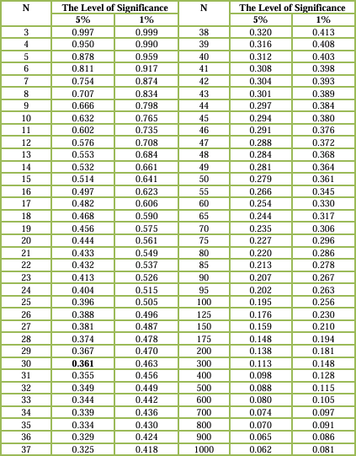

*Lampiran 14* **TABEL t**

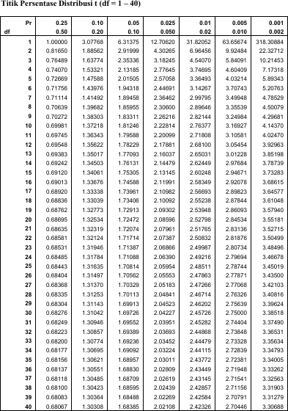

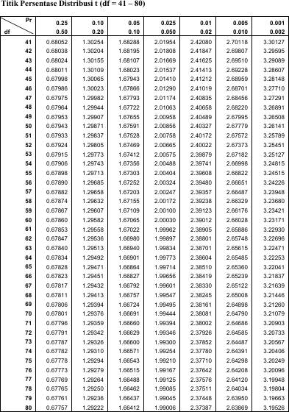

*Lampiran 15* **F Tabel**

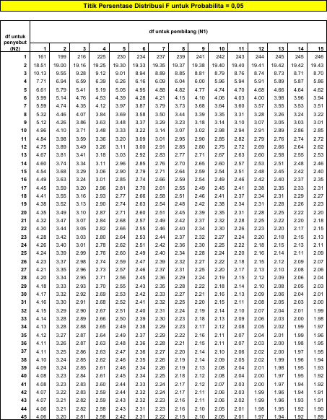

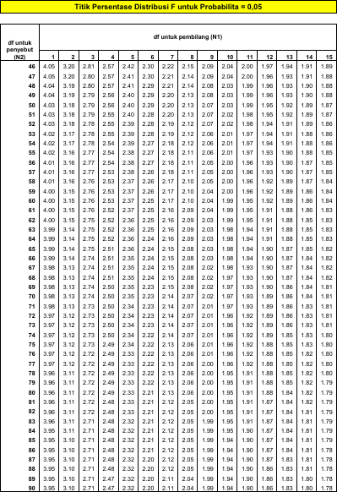

*Lampiran 16* **SURAT OBSERVASI AWAL**

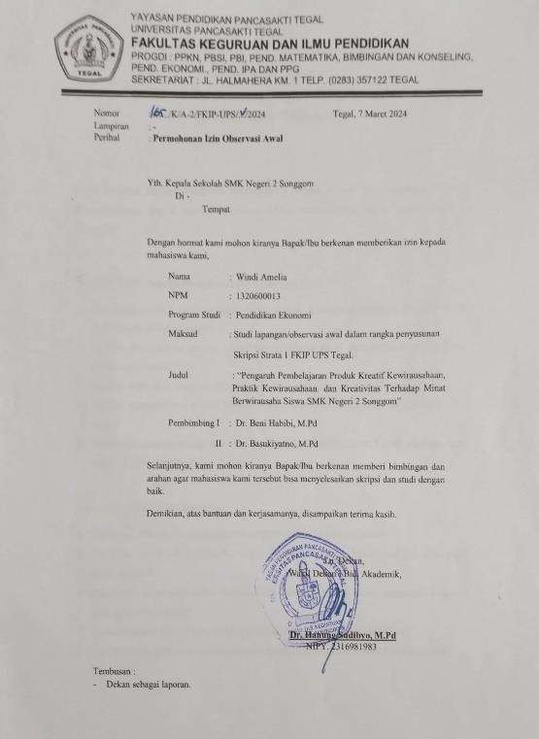

*Lampiran 17* **OBSERVASI AWAL PENELITIAN**

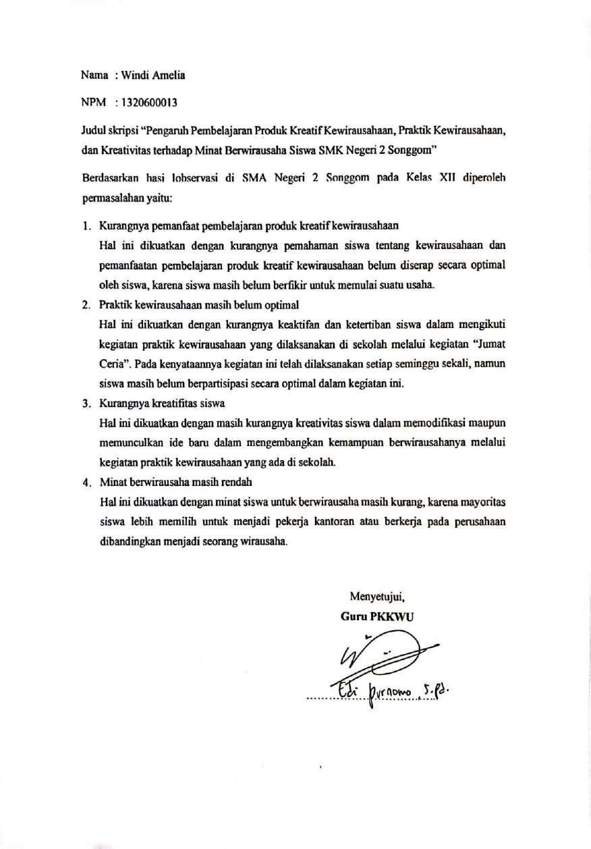

*Lampiran 18* **SURAT IZIN PENELITIAN**

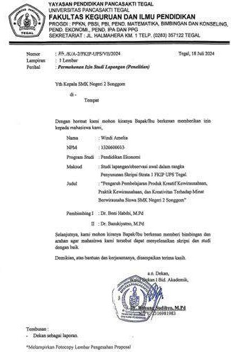

*Lampiran 19* **HASIL WAWANCARA**

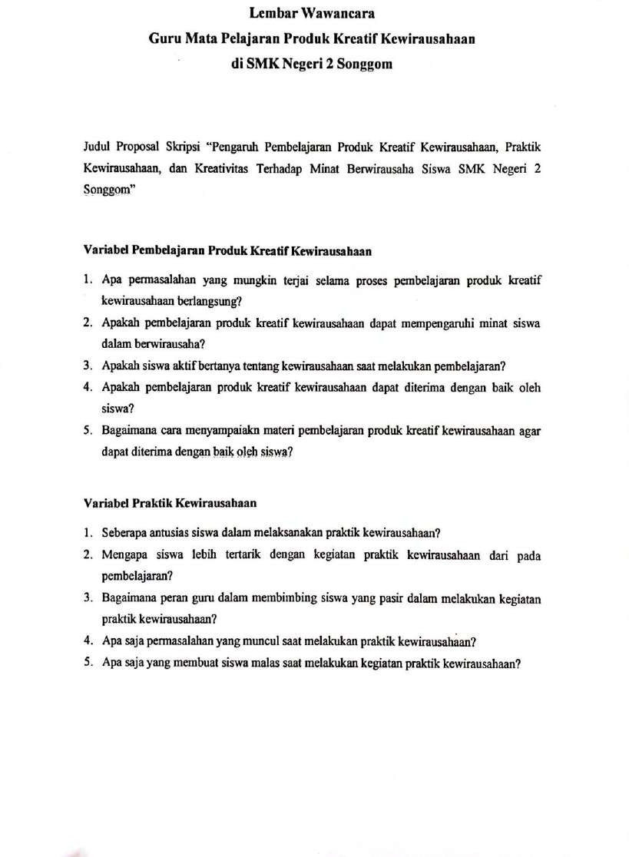

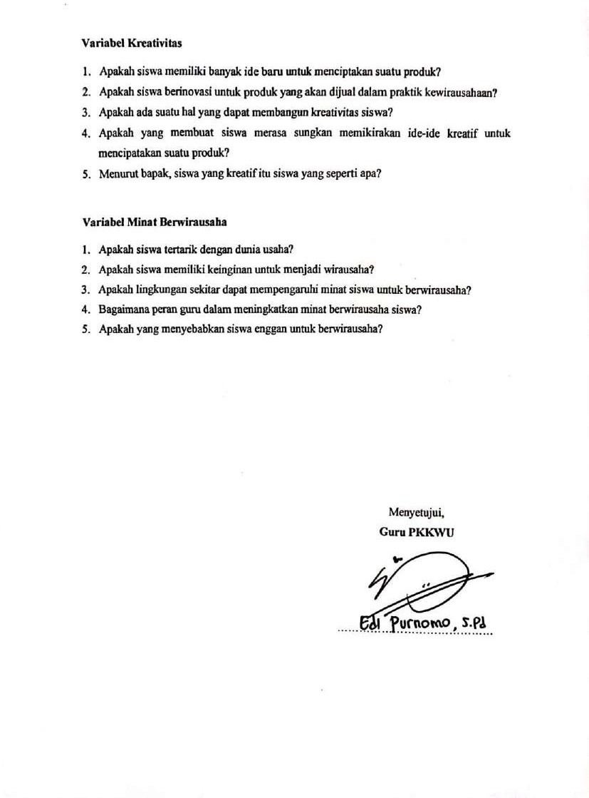

*Lampiran 20* **SURAT KETERANGAN PENELITIAN**

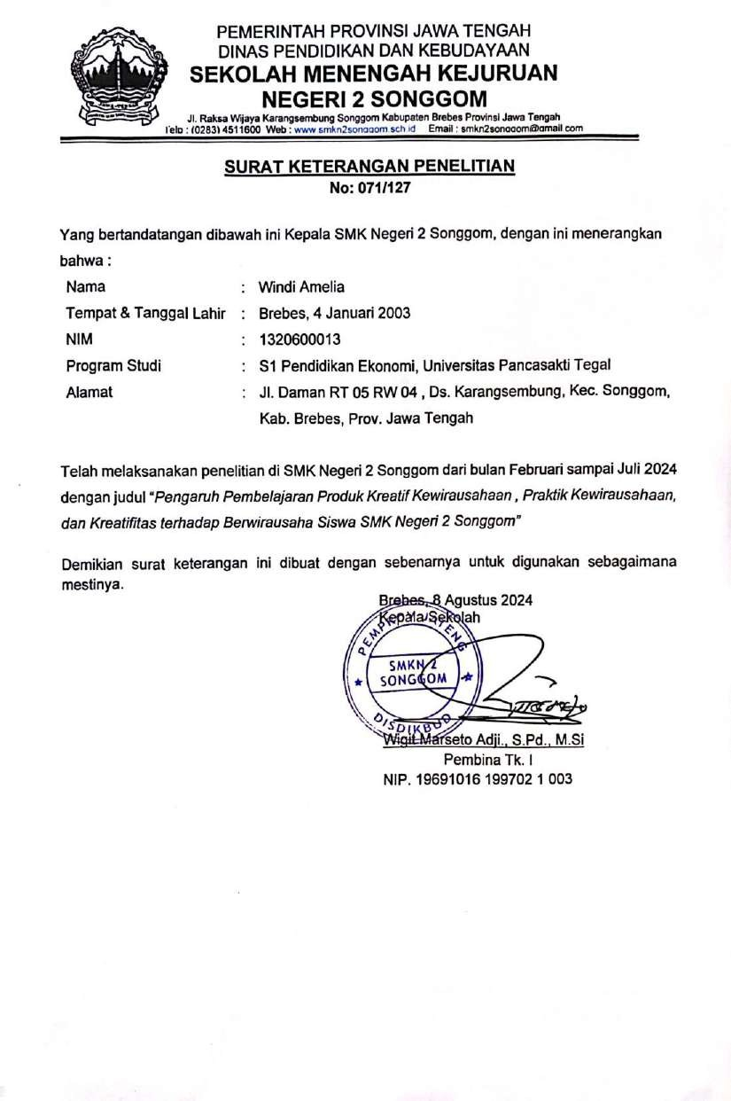

*Lampiran 21* **JURNAL BIMBINGAN SKRIPSI**

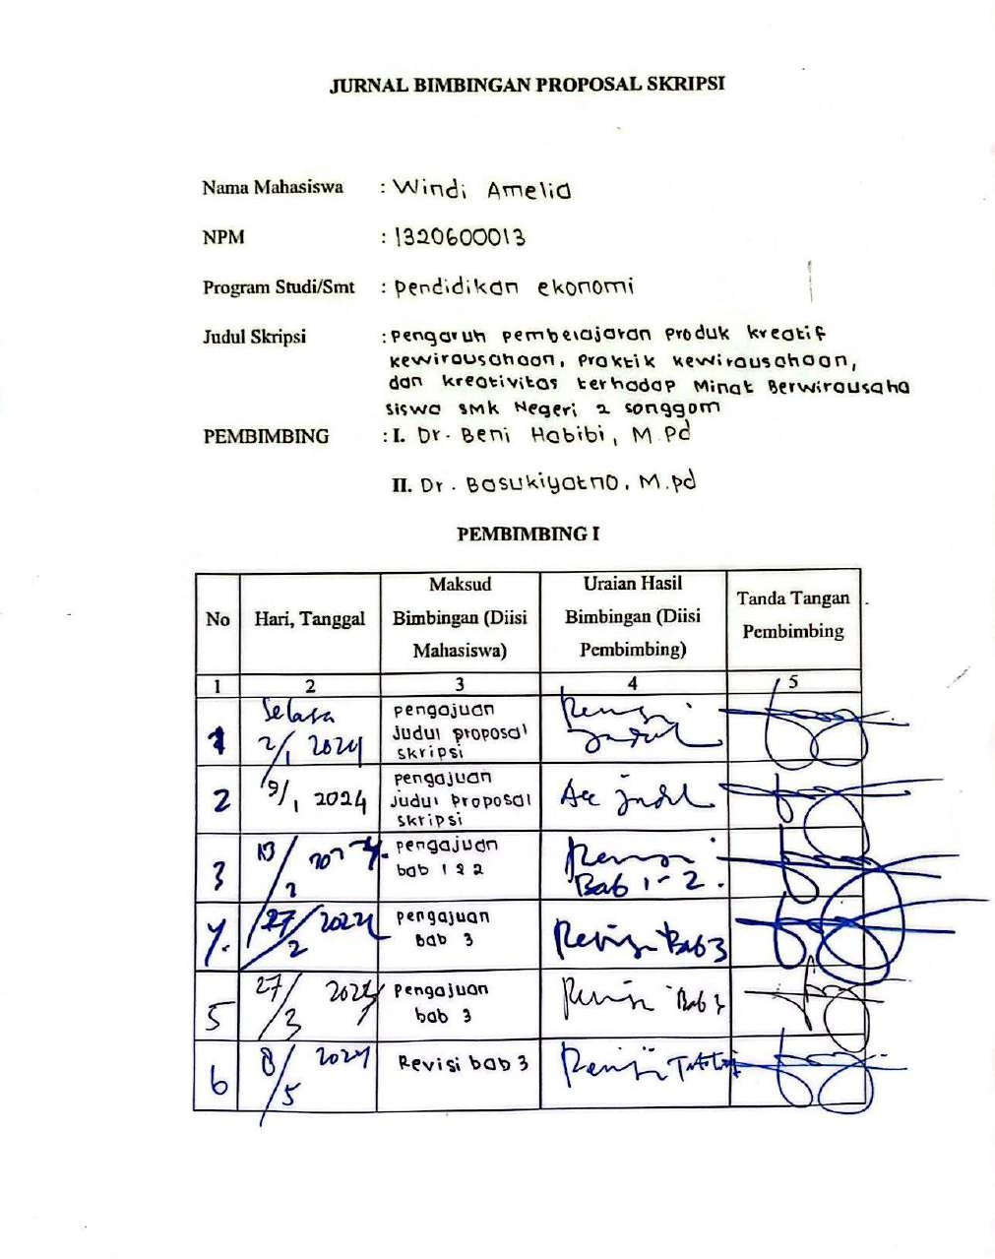

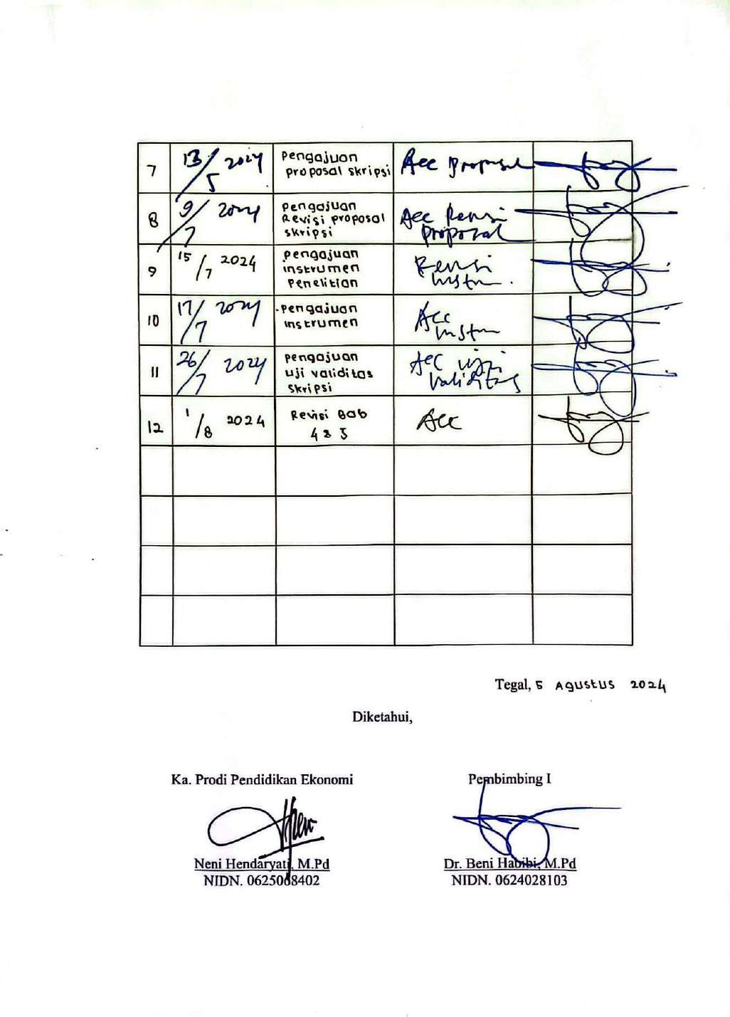

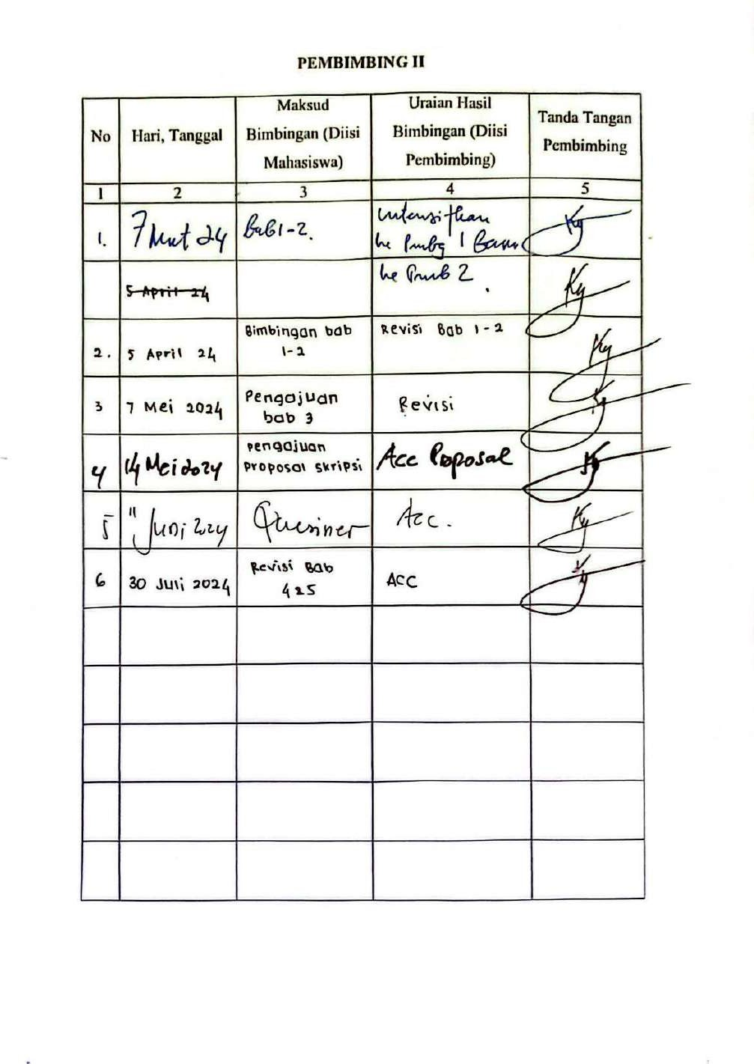

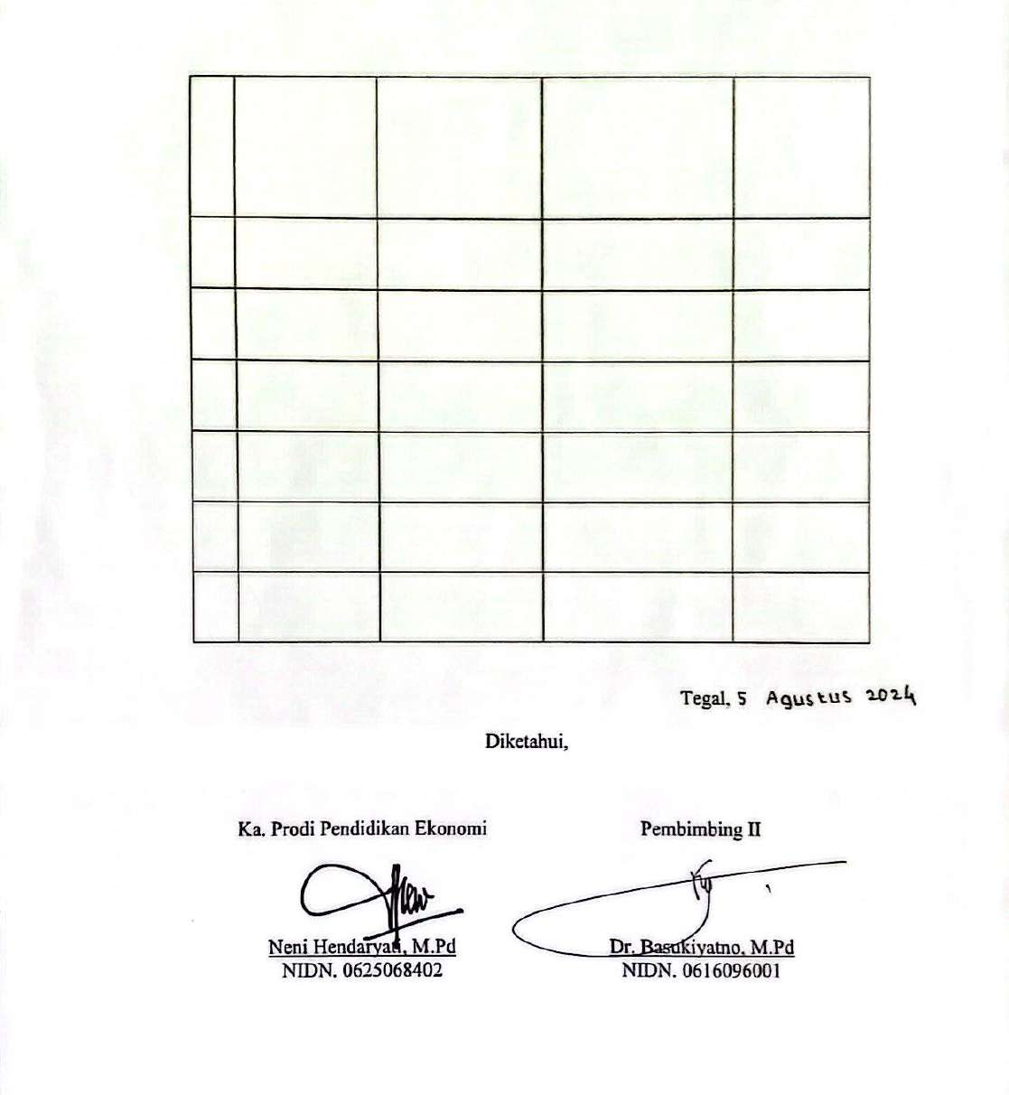

*Lampiran 22* **HASIL SCAN SILIMARITY IPI**

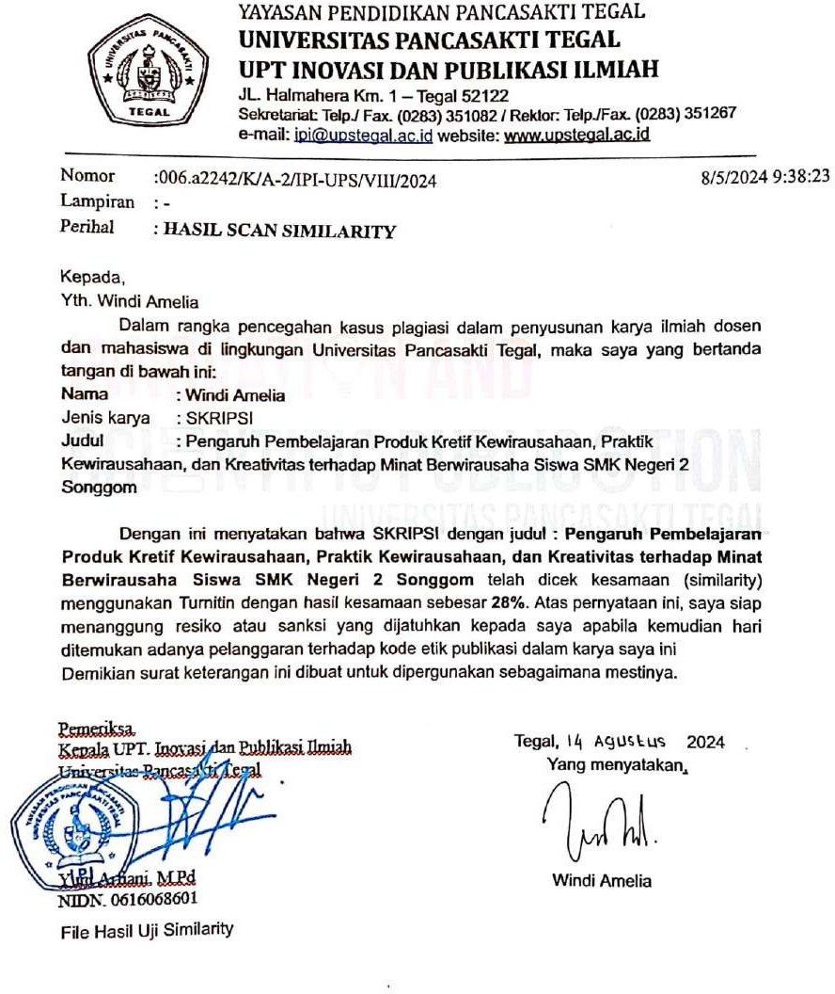

*Lampiran 23* **BERITA ACARA UJIAN SKRIPSI**

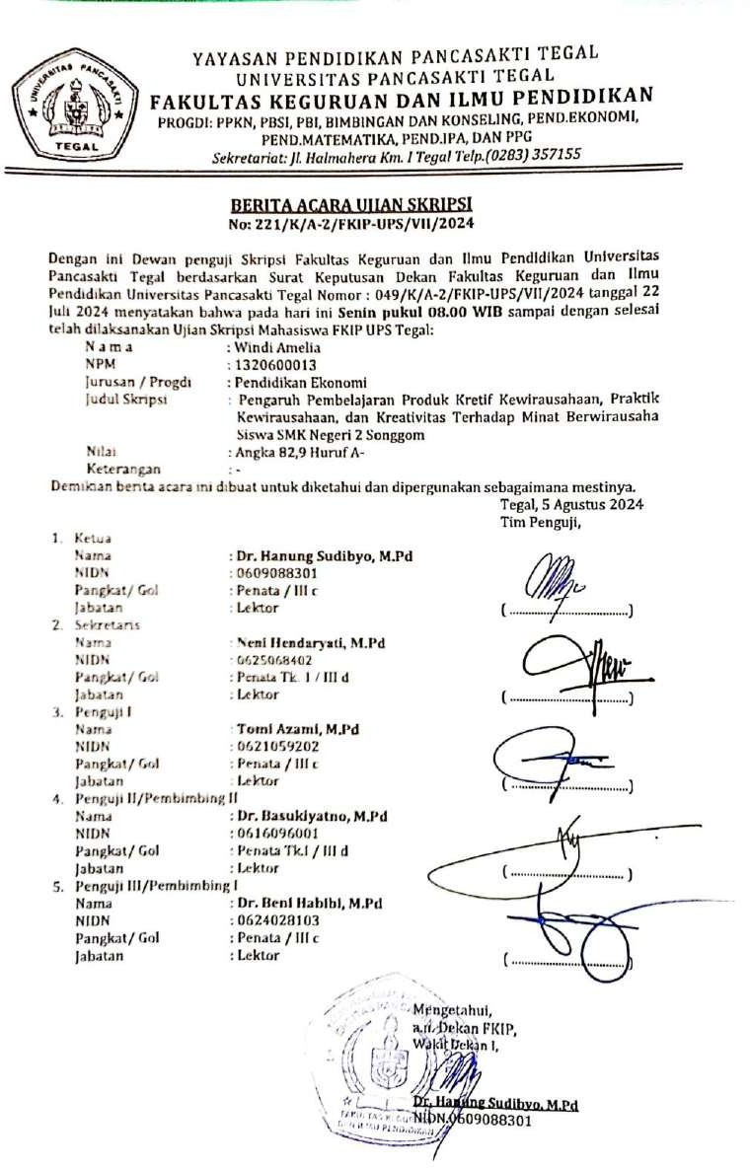

*Lampiran 24* **BERITA ACARA PENYELESAIAN REVISI SKRIPSI**

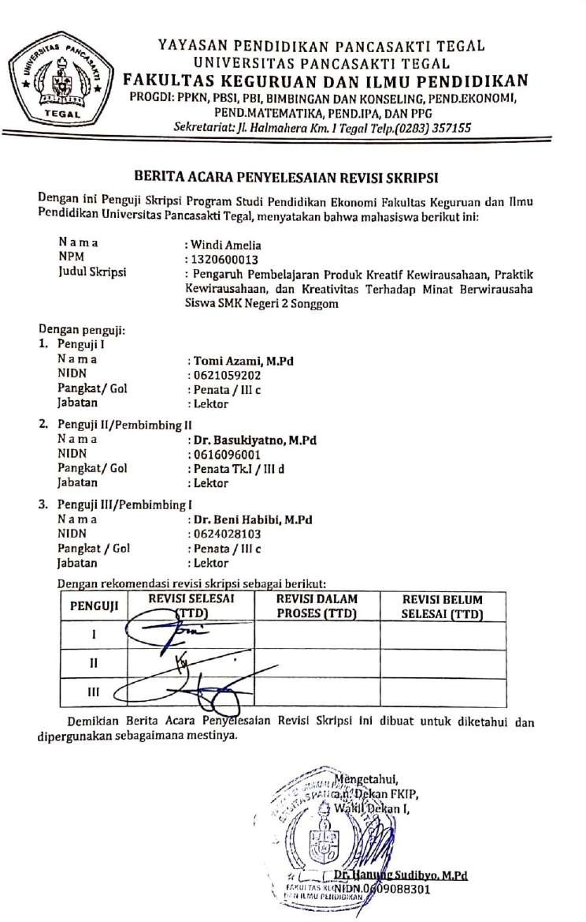

*Lampiran 25* **BERITA ACARA BIMBINGAN SKRIPSI**

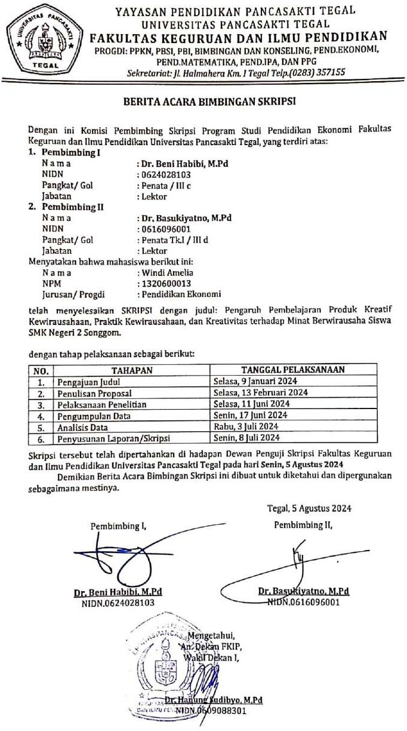

*Lampiran 26* **DOKUMENTASI**

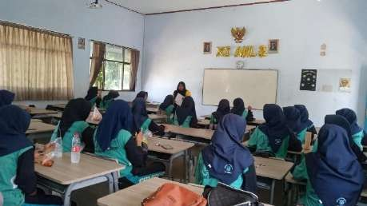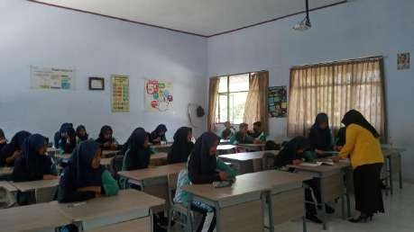

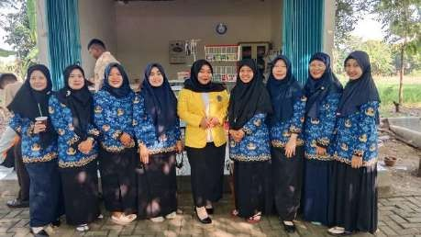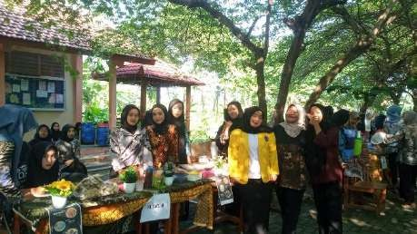

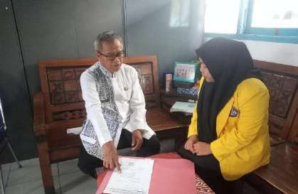

# BIODATA PENULIS

Windi Amelia adalah penulis skripsi ini. Penulis lahir di Brebes pada hari Sabtu 04 Januari 2003. Penulis merupakan anak tunggal dari pasangan suami istri Bapak Sutanto dan Ibu Nuryati. Penulis tinggal di Desa Karangsembung, RT.05/RW.04, Kecamatan Songgom, Kabupaten Brebes, Provinsi Jawa Tengah. Penulis dapat dihubungi melalui [windiamelia684@gmail.com](mailto:windiamelia684@gmail.com). Pada tahun 2008 penulis

melalui pendidikan formal SD Negeri Karangsembung 01 (2008-2014), SMP Negeri 2 Songgom (2014-2017), SMK Negeri 2 Songgom (2017-2020). Setelah selesai menempuh pendidikan menengah kejuruan, penulis melanjutkan Strata 1 (S1) di Program Studi Pendidikan Ekonomi Fakultas Keguruan dan Ilmu Pendidikan Universitas Pancasakti Tegal.