

**THE EFFECTS OF USING DIGITAL CROSSWORD PUZZLE GAME ON STUDENTS’ VOCABULARY ACHIEVEMENT**

(An Experimental Study at the Eleventh Graders of SMA Al-Irsyad Tegal)

**RESEARCH PROJECT**

**Submitted as Partial Fuilfilment of the Requirements to Conduct a Research**

**By**

**ROYIN TANJALIN NASFAR**

**NPM 1620600028**

**ENGLISH EDUCATION PROGRAM TEACHER TRAINING AND EDUCATION FACULTY PANCASAKTI TEGAL**

**2024**

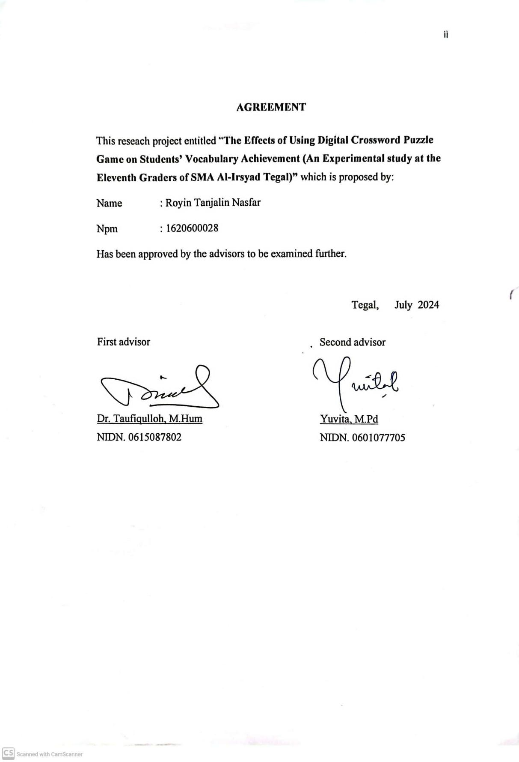

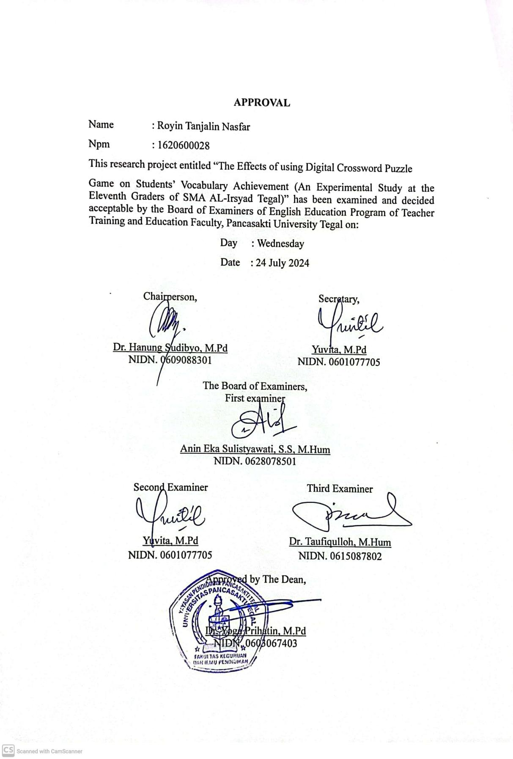

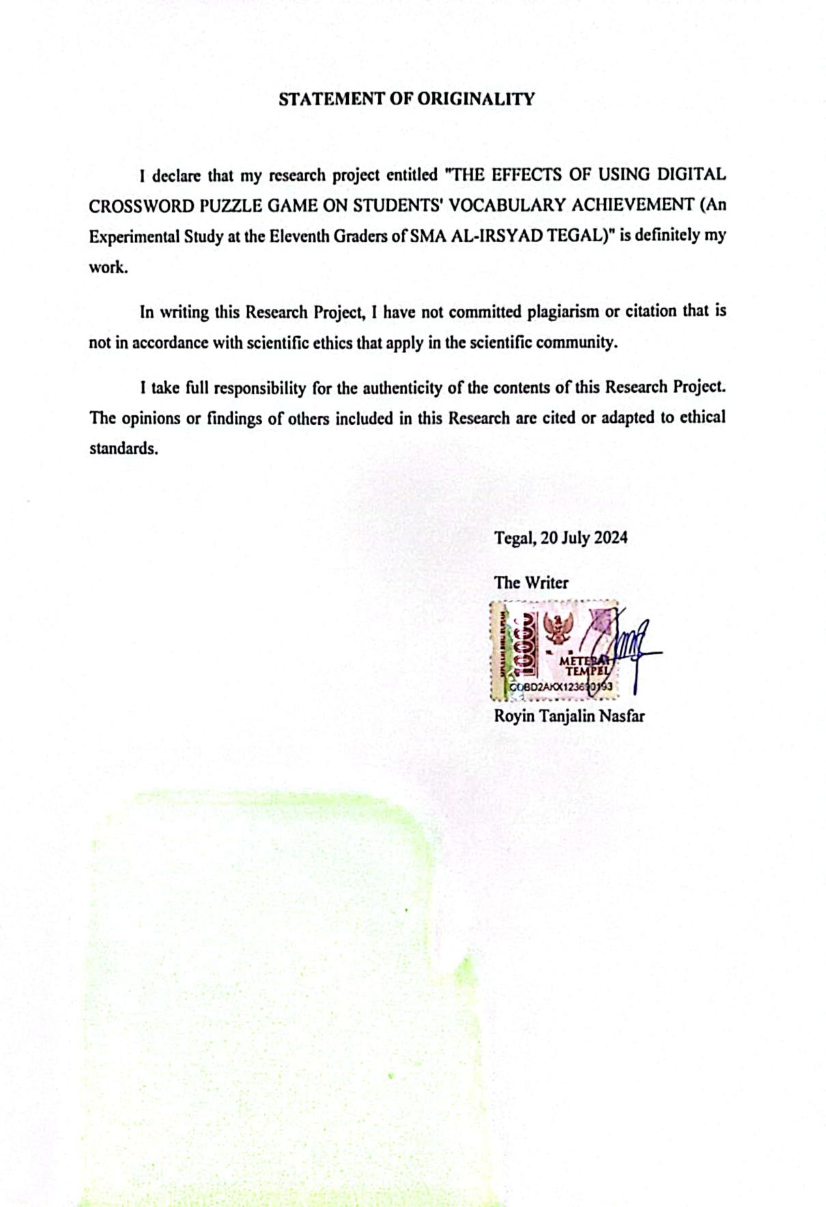

**MOTTO AND DEDICATION**

“Other people won’t be able to understand our *struggles* and hard times, they only want to know the *success stories*. Fight for yourself even if no one applauds. Our future selves will be very proud of what we strive for today, Keep Fighting!”

**DEDICATION**

* My beloved father, Mr. Ahmad Nasikhun Amin and my heavenly door, Mrs. Umu Faridah. Thank you for always fighting for the life of the researcher who never stops giving affection with love and always providing the best motivation and prayers so that the researcher is able to complete his education until the bachelor's degree.
* My older brothers, Robith Sabily and Albaith Faza Alqi. Thank you for participating in the process of the researcher education so far, thank you for the enthusiasm, prayers and love that have always been given to the researcher.
* To Noviana Rismawati, Laellatul Sadiyah, and Lutfiatul Maulidah. Thank you for always accompanying the researcher, thank you for the hand that is always stretched out, the ear that is ready to hear, and the sweet words that soothe.
* Best friends in cheerful Geng gong ceria, PBI B, and friends who cannot be mentioned one by one. Thank you for accompanying, supporting each other, providing motivation, listening to complaints during lectures. Thank you for the togetherness of joy and sorrow and kindness, hopefully we can all be successful in the future.
* Finally, thank you to myself, for being able to try hard and fight so far. Thank you for choosing to survive and try to get to this point and remain a human being who is always willing to try and not tired of trying.

**PREFACE**

First of all, I would like to thank Allah SWT, who has given me grace, guidance, and strenght me in completing this final project. All praise and gratittude is only to Him who has given me health, opportunity, and the ability to face all challenges during the research and writing this process. May all the efforts and hard work that have been done get the pleasure and blessings of Allah SWT and be useful for me and others. Aamiin.

The success in writing this thesis is certainly inseparable from various parties' assistance. Therefore, the author would like to thank:

1. Dr. Taufiqulloh M.Hum as the Rector of University of Pancasakti Tegal.
2. Dr. Yoga Prihatin, M.Pd as the Dean of Teacher Training and Education Faculty, Pancasakti University Tegal.
3. Yuvita M.Pd as the Head of English Department, Teacher Training and Education Faculty of Pancasakti University Tegal.
4. Dr. Taufiqulloh M.Hum as the first advisor who has patiently given advice, guidence, and encourangement to the researcher finishing this research.
5. Yuvita M.Pd as the second advisor who has given correction, suggestions in writing this research project.
6. Anin Eka Sulistyawati, S.S,M.Hum. as the examiners who has given suggestion during final examination.
7. Mr. Sakuri S.Pd Headmaster SMA Al-Irsyad Tegal.
8. Mr Dicky Adhiprabowo S.Pd English Teacher of SMA Al-Irsyad Tegal who help me to do my research.
9. All teachers and staff of SMA Al-Irsyad Tegal who have been helpful and friendly during my research
10. My self, thank you for being strong and hardwork.
11. My parents, who always support me during my research.
12. All my friends in English Department who has become a part of my life.
13. All my people cannot mention one by one, who have been suport and help me.

The researcher need suggestion that this research is still not perfect. The researcher need feedback and benefits from the readers to improve the research.

**ABSTRACT**

Royin Tanjalin Nasfar, 2024. 1620600028: *“The Effects of using Digital Crossword Puzzle Game on Students’ Vocabulary Achievement* (An Experimental Study at the Eleventh Graders of SMA Al-Irsyad Tegal). Research Project. Strata 1 Program, Faculty of Teacher Training and Education, Pancasakti University Tegal, The First Advisor is Dr. Taufiqulloh M.Hum and the Second Advisor is Yuvita M.Pd.

*Keywords: Digital Crossword Puzzle Game, Vocabulary Achievement.*

This study aims to determine the effectiveness of Digital Crossword Puzzle Game media on students' vocabulary achievement. The purpose of this study is to evaluate the effectiveness of Digital Crossword Puzzle Game on vocabulary achievement of eleventh-graders students of SMA Al-Irsyad Tegal and to find out whether Digital Crossword Puzzle Game media provides a significant difference in the vocabulary achievement of students taught Digital Crossword Puzzle Game.

The researcher applied true experimental with two groups of pre-test and post-test designs. The population of this study was all grade XI and the sample was 60 students of Al-Irsyad Tegal High School in the academic year 2023/2024. This study used a random sampling technique with a two-group design, namely the experimental and control groups.

The experimental group's post-test result was 76.93 and the control group's average was 73.20. The findings of this study indicate that students' vocabulary achievement increased after being taught using Digital Crossword Puzzle Game media. The result of paired & independent t-test obtained sig (2-tailed) value is 0.000 lower than 0.05 (0.000 < 0.05). This means that using Digital Crossword Puzzle Game media is effective in increasing students' vocabulary achievement, and there is a significant difference in the vocabulary achievement of students who are taught Digital Crossword Puzzle Game media and those who are not. It can be stated that the null hypothesis (HO) is rejected, while the alternative hypothesis (Ha) is accepted.

It can be concluded that the utilization of Digital Crossword Puzzle Game media has a positive impact on students' vocabulary achievement. Therefore, the use of Digital Crossword Puzzle Game as learning media is considered successful in students' vocabulary achievement. The results of this study are expected to add insight into knowledge related to research in the field of vocabulary with the help of the Crossword Puzzle Game.

**ABSTRAK**

Royin Tanjalin Nasfar, 2024. 1620600028: *“Pengaruh Penggunaan Permainan Teka-Teki Silang Digital terhadap Pencapaian Kosakata Siswa* (Studi Eksperimen pada Siswa Kelas XI SMA Al-Irsyad Tegal). Proyek Penelitian. Program Strata 1, Fakultas Keguruan dan Ilmu Pendidikan, Universitas Pancasakti Tegal, Pembimbing I Dr. Taufiqulloh M.Hum dan Pembimbing II Yuvita M.Pd.

*Kata kunci: Permainan Teka-Teki Silang Digital, Pencapaian Kosakata*.

Penelitian ini untuk mengetahu keefektifan media Digital Crossword Puzzle Game terhadap pencapaian kosakata siswa. Tujuan penelitian ini untuk mengevaluasi keefektifan Digital Crossword Puzzle Game terhadap pencapaian kosakata siswa kelas sebelas SMA Al-Irsyad Tegal dan untuk mengetahui apakah media Digital Crossword Puzzle Game memberikan perbedaan yang signifikan terhadap pencapaian kosakata siswa yang diajarkan Digital Crossword Puzzle Game.

Peneliti menerapkan eksperimental sejati dengan desain dua kelompok pre-test dan post-test. Populasi penelitian ini adalah seluruh kelas XI dan sampel nya adalah 60 siswa SMA Al-Irsyad Tegal tahun ajaran 2023/2024. Penelitian ini menggunakan teknik random sampling dengan desain dua kelompok, yaitu kelompok eksperimen dan kontrol.

Hasil post-test kelompok eksperimen adalah 76,93 dan rata-rata kelompok kontrol adalah 73,20. Temuan penelitian ini menunjukkan bahwa pencapaian kosakata siswa meningkat setelah diajar menggunakan media Digital Crossword Puzzle Game. Hasil uji t berpasangan & independent diperoleh nilai sig (2-tailed) bernilai 0,000 lebih rendah dari 0,05 (0,000 < 0,05). Artinya menggunakan media Digital Crossword Puzzle Game efektif untuk meningkatkan pencapaian kosakata siswa, dan terdapat perbedaan yang signifikan pada pencapaian kosakata siswa yang diajar media Digital Crossword Puzzle Game dan yang tidak. Dapat dinyatakan hipotesis nol (HO) ditolak, sedangkan hipotesis alternative (Ha) diterima.

Dapat disimpulkan bahwa pemanfaatan media Digital Crossword Puzzle Game mempunyai dampak positif terhadap pencapaian kosakata siswa. Oleh karena itu, penggunaan media Digital Crossword Puzzle Game sebagai media pembelajaran dianggap berhasil dalam pencapaian kosakata siswa. Hasil penelitian ini diharapkan dapat menambah wawasan pengetahuan terkait penelitian dibidang kosakata dengan bantuan Crossword Puzzle Game.

**TABLE OF CONTENTS**

AGREEMENT ii

APROVAL………………………………………………………………………..iii

STATEMENT OF ORIGINALITY…………………………………..…………..iv

MOTTO…………………………………………………………………………....v

PREFACE…………………………………………………………………….…..vi

ABSTRACT vii

ABSTRAK viii

TABLE OF CONTENTS ix

LIST OF TABLE iii

LIST OF PICTURE iv

APPENDICES v

CHAPTER I 6

INTRODUCTION 6

1.1 Background of the problem 6

1.2 Identification of the problem 10

1.3 Limitation of the problem 11

1.4 Statement of the problem 11

1.5 Objectives of the Poblems 11

1.6 Significances of the Research 12

CHAPTER II 12

REVIEW OF RELATED THEORIES, THEORITICAL FRAMEWORK, AND HYPOTHESIS 13

2.1 Previous studies 13

2.2 Review of related theories 12

2.3 Theoritical Framework 23

2.4 Hypothesis 24

CHAPTER III 25

RESEARCH METHODOLOGY 25

3.1 Approach, Type, and Design of the Research 25

3.2 Population, Sample and Technique of Sampling 29

3.2 Sample 30

3.3 Technique of sampling 31

3.4 Research Variables 32

3.5 Data Collecting Technique 34

BAB IV 45

RESEARCH RESULT AND DISCUSSION 45

4.1 Research Result 45

4.2 Data Analysis 52

4.3 Discussion 59

CHAPTER V 64

CONCLUSION AND SUGGESTION 64

5.1 Conclusions 64

5.2 Suggestions 65

REFERENCES 67

APPENDICES 70

**LIST OF TABLE**

Table 3. 1 Research Design 29

Table 3. 2 The Number students of Eleventh Grade 30

Table 3. 3 Research Procedure 35

Table 3. 4 Reliability Statistics 39

Table 4. 1 Descriptive Statistics 52

Table 4. 2 Tests of Normality 54

Table 4. 3 Test of Homogeneity 56

Table 4. 4 Paired Samples Test 57

Table 4. 5 Independent Samples Test 58

Table 4. 6 Group Statistics 59

**LIST OF PICTURE**

Figure 2. 1 Theoritical Framework 23

**APPENDICES**

Appendix 1 LESSON PLAN 71

Appendix 2 The Score of Pre-test Experimental Class 125

Appendix 3 The Score of Pre-test Control Class 127

Appendix 4 The Score of Post-test Experimental Class 129

Appendix 5 The score of Post-test Control Class 131

Appendix 6 Attandance list of Students Experimental and Control Class 133

Appendix 7 Control Class 135

Appendix 8 Research Permission Latter 137

Appendix 9 Surat Keterangan Selesai Penelitian 138

Appendix 10 Validity 139

Appendix 11 Research Instrument (Vocabulary Pre-test & Post-test) 141

Appendix 12 Documentation 153

**CHAPTER I**

**INTRODUCTION**

In this Chapter, the researcher explains background of the problem, identification of the problem, limitation of the problem, statement of the problem, objectives of the research, and the significances of the study.

1. **Background of the problem**

Teaching English at the High school level is about accommodating different learning styles and abilities while improving critical thinking, communication, and language skills. Using various teaching strategies such as group discussions, project-based learning, and multimedia resources can increase student engagement and comprehension. In addition, incorporating cultural aspects and real-life scenarios into the classroom not only deepens students’ language but also increases cultural awareness and empathy. English is an important language and the second language in the world. It is a compulsory subject in schools, and students generally learn English from the beginning of their education until high school. However, some students find it difficult to learn and master English (Ayu et al., 2020).

According to Sari et al., (2023) Teaching vocabulary is an important part of effective language learning. An effective approach to learn vocabulary is to use a variety of strategies to build deep understanding. An effective strategy is to use real-world contexts, such as reading stories or watching videos, to help students grasp the meaning of new words in appropriate contexts. In addition, students can strengthen their language skills by practicing using new words in conversations and sentences. By taking a holistic and integrative approach, teachers can help students develop vocabulary and master the language better. As stated by ulBani Ulfah & Eka Sulistyawati, n.d.(2023), foreign language learners need to be master vocabulary to effectively communicate. In conclusion, mastering vocabulary is fundamental for foreign language learners, as it is crucial for effective communication. Without a strong vocabulary, it becomes challenging to develop the essential skills of listening, speaking, writing, and reading, which are necessary for comprehensive language proficiency. Given that English is unfamiliar to some students, it's essential that English vocabulary instruction is engaging and accessible, making it easier for students to comprehend. If educators fail to deliver enjoyable and significant learning experiences, students may struggle to grasp the material.

According to Palimbunga’ et al., (2023) In learning English vocabulary, the method used can be very greatly based on students’ needs. One of the commonly used method is the repetition method. With this method, students will repeat new vocabulary over and over again to strengthen their memory. This can be done through flashcards, language learning apps, or even in the form of games that involve the use of vocabulary. Dakhi & Fitria, (2019) Effective vocabulary learning methods through games are fun and interesting approaches for students. It various types of games, such as crossword puzzle, or vocabulary Bingo. Students are indirectly involved in the learning process. Through active interaction in games, students can hone there english skills without feelings pressured or bored. According to Rahayu & Bhaskoro, (2022) to attract students’ interest in learning vocabulary, it is important to utilize interactive and fun methods. One effective way is through games.

According to N Nasurllah, (2024) Crossword Puzzle Game is a good learning media to improve students’ vocabulary achievement. Crossword puzzle games are word-based puzzles that typically consist of a grid of white and shaded squares. The objective is to fill in the white squares with letters to form words based on the given clues, both across (horizontal) and down (vertical), the clues are usually brief descriptions of the word to be filled in, ranging from straigh forward to cryptic. The shaded squares serve as barriers to separate words, creating a challenging yet solvable puzzle. Crossword puzzles come in various difficulty levels, from easy ones suitable for beginners to more complex ones that require extensive vocabulary and problem-solving skills. (Bella & Rahayu, 2023)

According to Zagoto & Laia, (2022) Crossword puzzles are an effective tool for reinforcing language skills, vocabulary achievement, and improving context understanding. In learning context, Crossword puzzle game can be an enganging strategy for teaching new vocabulary, key concept, or even important facts in a variety of subjects. Marhamah Nasution, (2023) In addition, Crossword puzzle game are a great tool to train students’ memory. By completing a crossword puzzle, students have to recall the vocabulary they have learned and relate it to the clues given. According to Taslim et al., (2019) Expanding vocabulary in English is key to improve students ability in language skills. By having more words mastered, students can be more flexible in communicating, both orally and writing. The ability to choose the right words also allows them to convey their ideas and thoughts more clearly and precisely.

Based on the results of observations when the researcher carried out PLP at SMA Al-Irsyad Kota Tegal, the researcher found that students at SMA Al-Irsyad Kota Tegal, especially in class XII Mipa 3 and XII Is 1 students had difficulty in achieving a learning indicator due to the achievement of English vocabulary. students are less adequate and low student interest in learning English. Low student interest in learning English is caused by various factors including difficulty in memorizing vocabulary, pronunciation that is different from writing, and students' fear of speaking English. Teachers as implementers of education must be able to plan a lesson that provides opportunities for students to develop the potential that exists in students through learning activities in the classroom.

The researcher was interested in exploring the potential of digital Crossword puzzle game as an innovative and enganging learning tool for students’. Crossword Puzzle Game reflects the importance of understanding how technology can be used to improve students’ vocabulary achievement. This study demonstrates the researcher concern for the limitations of students’ vocabulary achievement, which is a critical area in language learning. By choosing the tittle, researcher seeks to find creative solutions to improve students’ vocabulary achievement, which can have far-reaching positive impacts in language learning. With the proliferation of digital technologies, it is important for researchers to understand how they can be integrated into effective learning. This tittle reflects relevant and up-to-date research in the modern educational context.

Related to the gap in this study, the researcher used digital Crossword puzzle game, This is because some studies have shown some interesting result. A study regarding the use of digital Crossword puzzle game in the context of language learning found that the game can help improve students’ understanding vocabulary achievement. This is due to the active interaction with words in a fun and enganging context, which can strengthen vocabulary recall and understanding. However, it is important to remember that this effect may vary depending on the design of the game, the level of difficulty, and usage accompanied by appropriate practice. Therefore, the role of the teacher in directing the use of digital Crossword puzzle game in vocabulary learning is also important to maximize their benefits.

1. **Identification of the problem**

Problem identification based on the background of the problem above, the researcher draws the following conclusions:

1. Some students have difficulty improving their vocabulary.
2. Students are confused when reading a text because they don't understand the content of the text.
3. When students find new vocabulary, pronouncing the words is difficult because the way of reading is different from writing.
4. Students' lack of confidence to pronounce vocabulary, especially for English lessons.
5. **Limitation of the problem**

Limitations in assessing the impact of digital crossword games on vocabulary achievement may include factors such as differences in student engagement, individual learning styles, and the possible influence of foreign language learning activities outside the game. Students may experience difficulties in learning a foreign language.

1. **Statement of the problem**

Based on the background above, the following problems can be

formulated :

1. How Effective is using Digital Crossword puzzle game in improving students’ Vocabulary Achievement at the eleventh graders of SMA Al-Irsyad Tegal?
2. Is there any significance difference of digital Crossword puzzle game affect students’ vocabulary achievement at the eleventh graders of SMA Al-Irsyad Tegal?
3. **Objectives of the Poblems**
4. To evaluate the effectiveness of using digital Crossword puzzle game to improve students’ vocabulary achievement at
5. To find out significant differences in the effectiveness of using digital Crossword puzzle game in students’ vocabulary achievement at the eleventh graders of SMA Al-Irsyad Tegal.
6. **Significances of the Research**

The importance of this study lies in its potential to uncover valuable information about the impact of digital Crossword puzzle game on vocabulary achievement. This research can offer insights into effective educational strategies, benefitting students who are seeking innovative approaches to improving language skills, and contribute to a broader understanding of learning methodology. the researcher has two kinds of significance as follows :

Theoritically, this research is a source of information and reference in English language learning, especially in the achievement of student vocabulary. Practically, the results of this study will be useful for students, for teachers, for researchers and for schools. Digital media Crossword puzzle is one of the alternative learning in learning english, especially in improving students’ vocabulary achievement. For students, the lesson will be more interesting if using crossword puzzles, for teachers, teachers can find out students vocabulary achievement, the writers also gain useful experience in teaching english and this research may be useful, for schools as informative data in the use of digital learning media available in the teaching and learning process of students’ vocabulary achievement.

**CHAPTER II**

**REVIEW OF RELATED THEORIES, THEORITICAL FRAMEWORK, AND HYPOTHESIS**

In this Chapter, The Researcher presents a review of Relevant Theories, Theoritical Framework and Hyphotesis

1. **Previous studies**

The first previous study, done by Citra Julivera Nainggolan et al., (2023) entitled “The Effect of crossword puzzle game on students’ vocabulary mastery at grade Eight of SMP GKPS 3 Pematang Siantar” The aim of the research was to determine the effectiveness of crossword puzzles in enhancing students' mastery of descriptive text vocabulary. Results indicated a significant improvement in post-test scores compared to pre-test scores among students who engaged with crossword puzzles. This suggests a notable disparity in learning outcomes between students exposed to crossword puzzle games and those using conventional teaching methods to enhance descriptive text vocabulary. Specifically, students taught through crossword puzzle games demonstrated higher levels of learning. Consequently, the study concludes that crossword puzzle games effectively contribute to enhancing students' vocabulary skills. Therefore, educators are encouraged to incorporate crossword puzzles into their English classes to support students' vocabulary development. Proficient

language skills are crucial for effective communication. In their absence, students encounter difficulties expressing their thoughts and emotions and engaging in meaningful interactions with others.

The second previous study, done by Rizqi & Usman, n.d.(2023) entitled “The Effectiveness of using crossword puzzle game to increase students’ vocabulary” to assess the impact of crossword puzzle games on the vocabulary development of eighth-grade students at SMPN 1 Ampibabo. This quasi-experimental study comprised an experimental group and a control group, selected through cluster random sampling. The experimental group consisted of 20 students from class VIII A, while the control group comprised 20 students from class VIII B. Data collection involved administering pre-tests and post-tests, with results indicating that the post-test scores surpassed the pre-test scores, thus supporting the research hypothesis. Consequently, the utilization of crossword puzzle games effectively enhanced the vocabulary of students in class VII of SMPN 1 Ampibabo. These findings underscore the significance of employing innovative vocabulary teaching methods, which can significantly impact student learning outcomes. It is imperative for teachers to employ diverse strategies to enhance student learning motivation, tailored to their individual abilities and interests.

The third previous study, done by Bella & Rahayu, (2023) entitled "The Improving of the Student's Vocabulary Achievement through Crossword Game in the New Normal Era" aimed to demonstrate the effectiveness of crossword puzzles in improving the vocabulary skills of 11th-grade students at SMAN 1 Krian. Employing a class action research approach, the study was prompted by the initial pre-cycle results, which revealed that only five students met the minimum score criteria (KKM). Consequently, the researchers introduced crossword puzzles over three cycles. The study involved 28 students from class XI A2.5 and utilized observation, tests, and questionnaires as research instruments. Results indicated an improvement in scores from cycle I to cycle II, with post-test scores surpassing pretest scores. Observations highlighted increased student engagement and activity during crossword puzzle sessions, with students actively participating in the learning process. Moreover, 92% of students expressed positive feedback regarding the crossword game, citing it as enjoyable, interesting, and beneficial for vocabulary enhancement. Hence, employing crossword games as a method for teaching English vocabulary proves to be effective in enhancing students' vocabulary skills.

After reading the three previous studies above, there are some similarities between the above research and the research that I will do. the first uses the experimental method. second, using two groups for post-test and pre-test experimental research, and there are differences with previous studies. This chapter focuses on identifying the causal factors to be studied. The method used in this study is an experimental method. With a post-test and pre-test design, the dependent variable in this study is "increasing vocabulary achievement in students" and the independent variable is using a digital Crossword Puzzle game.

Related to the gap in this study, the researcher used digital Crossword puzzle game, This is because some studies have shown some interesting result. A study regarding the use of digital Crossword puzzle game in the context of language learning found that the game can help improve students’ understanding vocabulary achievement. This is due to the active interaction with words in a fun and enganging context, which can strengthen vocabulary recall and understanding. However, it is important to remember that this effect may vary depending on the design of the game, the level of difficulty, and usage accompanied by appropriate practice. Therefore, the role of the teacher in directing the use of digital Crossword puzzle game in vocabulary learning is also important to maximize their benefits.

1. **Review of related theories**
2. **Digital Digital Crossword Puzzle Game**
3. **Definition of Crossword puzzle game**

According to Rizqi & Usman, et al,. (2021) Among the many games, crossword puzzles seem to be more interesting than other learning media. To solve the crossword, students or players must fill in all the empty boxes with the exact letters that make up the word. The words are sorted based on the clues given, which can be phrases, sentences, or whole words. As crosswords are generally considered a game to be enjoyed rather than done, they tend to be fun and student-friendly. In addition to motivating students to learn, these crosswords can help students expand their vocabulary. Crosswords allow students to practice more with new words and help them master vocabulary, especially in English. The words in the crossword media can easily help students completing English assignments is essential. Nonetheless, students' struggle with learning and recalling English vocabulary poses a challenge to achieving their educational objectives. To address these obstacles, educators must devise engaging teaching methods to ensure that English learning is enjoyable and students remain motivated throughout their lessons.

In line with Zagoto & Laia, (2022) Crossword is an active learning media that encourages students to fill in the blanks and think while learning, thus making them more visible in learning. Crossword is a puzzle game that is familiar to our ears. In this game, students must fill in the empty boxes horizontally and vertically with the words in the box matching other words. In addition, crossword in the teaching and learning process also requires active participation in every learning process, not only mentally but also physically. This situation allows students to feel more comfortable and maximize their learning outcomes. This learning media makes it easier for teachers to make learning effective and fun. Crosswords are an effective learning medium to connect important terms, definitions, spellings, and concepts by leading to an increase in students' vocabulary. Completing the crossword requires correct spelling and elements linking the words.

According to Pratolo & Hafizhah, (2022) Crossword games are considered a highly effective educational tool for improving vocabulary acquisition in the classroom context. In addition, the game provides a range of significant benefits, such as encouraging more active interaction between fellow students, enriching the diversity of lesson plans, and increasing the level of student engagement in the learning process. In addition, the game creates an interesting and fun learning environment, which allows students who may be less active to be more engaged in learning.

1. **Advantages of Crossword Puzzle Game**

Ulandari, et al,. (2022) As the researcher explained above, crossword is a very interesting teaching method for vocabulary skill achievement. The advantages of this learning make it easy for students to have fun in learning English using digital crosswords for vocabulary achievement is an alternative technique to build and improve their vocabulary. In addition, crossword is one of the vocabulary training activities that can help students recognize words and memorize words. Another advantage of the digital crossword method is that it avoids monotonous lessons, so students are not bored when learning English in class, and digital crosswords are solved one by one, creating a relaxed atmosphere for students. This is meaningful and helpful when learning a language and can encourage students to excel in the learning process. Teachers need to create a warm atmosphere for the class to come alive.

In line with the researcher, the advantage of crossword puzzles is that they can increase the effectiveness of student learning in obtaining vocabulary achievement by using fun learning media. Students can also more easily understand and be active in learning English using this learning media. This game can also make it easier for students to remember vocabulary by using crossword games. Students are also not easily bored with the lessons given by the teacher because crossword games can increase students' enthusiasm for learning in class and can sharpen their brains and understand the writing of vocabulary in the crossword game.

1. **Disadvantages of digital crossword games**

The disadvantage of digital crossword puzzle games is that not all lessons can be applied with this crossword media. Requires high concentration to fill in the blanks in the answer column that matches the question so that it takes a long time. Need to set the number of columns and the ratio of letters to connect words. In this game, the lessons presented are very brief and there is no detailed explanation of the content. The crossword only studies short words so students feel confused if they cannot answer one of the questions in the game. This affects the answers to other questions, which may be a little difficult for students who are less engaged in English learning activities.

1. **Steps to Use Digital Crossword Puzzle Games**

**The steps are as follows:**

1. Before the researcher starts the Digital Crosword Puzzle Game media, the researcher will explain to the students what the Crossword Puzzle Game means.
2. Second, the researcher will ask students questions about crossword puzzle game to find out whether students understand the game.
3. Third, the researcher displays the initial display on the Digital Web Crossword puzzle game that contains all the Questions.

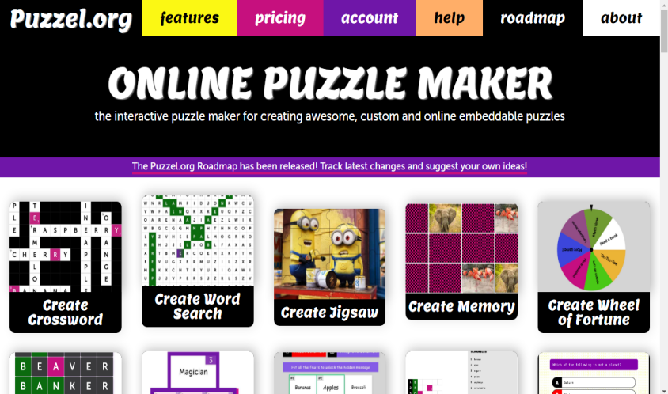

1. Then, The researcher creates a Crossword puzzle with the questions and answers, and provides links to students on the web

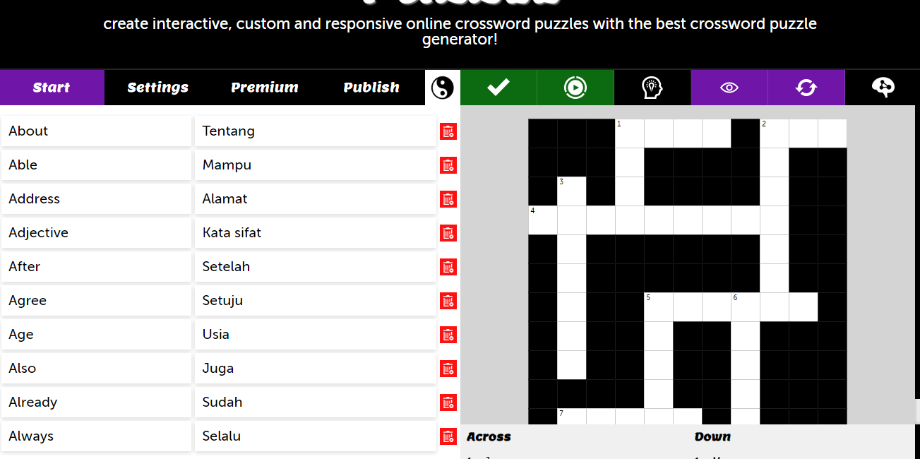

1. After that, Students answer the questions on the links that havee been shared on the Digital Crossword puzzle game web. According to the questions and fill in the answers in the empty white boxes down and horizontal. According to the instructions

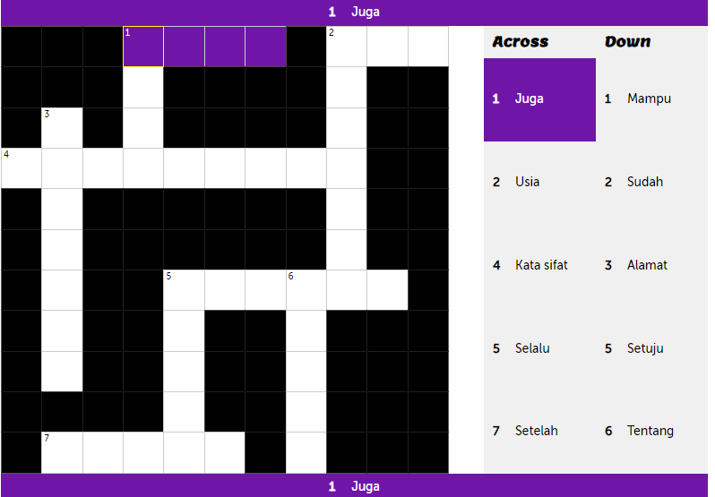

1. 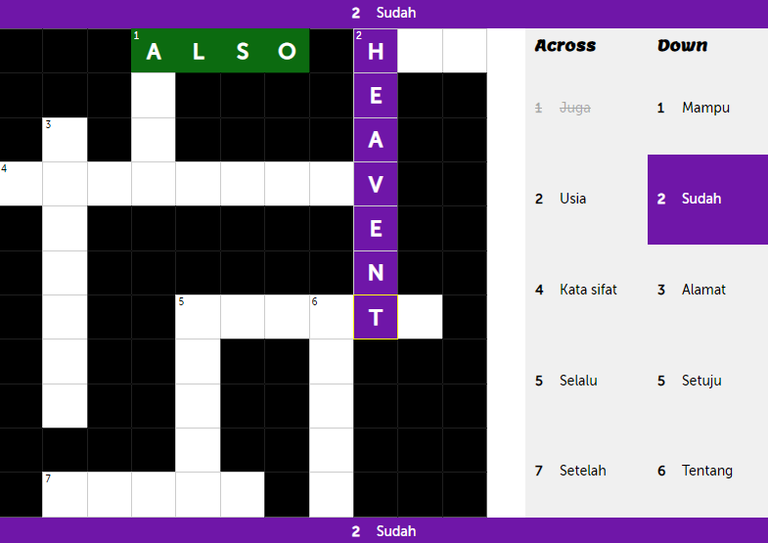And finally, if the students has answered all the questions correctly, the box will be Green, but if the box is purple, it means the students answer is still not correct
2. **Vocabulary**
3. **Definition of Vocabulary**

Vocabulary is the most important part of language learning, it is the foundation for making sentences, summarizing thoughts, and making it easier to communicate with others. Language learning is greatly helped by vocabulary. The introduction and use of vocabulary are given to high school students because it is known that students' vocabulary mastery is a barrier for students to learn English. Therefore, the purpose of this vocabulary learning is to provide an overview of effective vocabulary learning and using appropriate strategies, This study describes the learning of vocabulary mastery of high school students using crossword learning media (Susanto, 2017).

According to Putri, (2022) For English language learners, vocabulary is one of the most important things to learn. Language learners have difficulty communicating by speaking without understanding the words in a sentence or by arranging words in a sentence. Mastering vocabulary will help students speak English more confidently and it is easy to know what people around them are talking about. Learning vocabulary is not easy for all students. Each student needs a different way to understand vocabulary learning materials.

According to Haitami et al., (2022) Vocabulary is very important without adequate vocabulary, it is difficult to convey ideas. Vocabulary forms the basis of language and enables students to understand what others are saying. That is why it is important to continuously improve vocabulary achievement through reading, speaking, and writing. By increasing vocabulary achievement, students can be more precise and varied in conveying thoughts and feelings. Vocabulary also helps students understand the texts they read or hear better. Without adequate vocabulary, students may struggle to understand more complex or technical material. Therefore, increasing vocabulary attainment is a key step in language learning. By having a wide vocabulary, students can communicate more effectively in various situations.

In addition to these general findings, the researchers identified specific problems in vocabulary learning at Al-Irsyad High School. These problems cover a wide range of issues, such as students struggling to understand and remember new vocabulary, teachers relying on outdated or ineffective instructional techniques, and the lack of availability and utilization of modern educational resources and tools to enhance vocabulary learning. These factors contribute to the challenges faced by students in vocabulary learning.

1. **The Importance of Vocabulary**

According to Kosakata Bahasa et al., (2020) Vocabulary is an important aspects of a students education as it provides a solid foundation for effective communication skills. By having a rich vocabulary, students can express their thoughts, ideas, and feelings more clearly and precisely. This ability is important not only in academic contexts, but also in everyday interactions, both inside and outside the school environtment. Students who have an extensive vocabulary tend to be more confident in communicating and are better able to adjust to various communication situations.

According Hartatiningsih, (2022) Vocabulary is a key element in learning a foreign language. By understanding relvant vocabular, students can build a solid foundation for communicating in the language being studied. Having an extensive vocabulary allows students to more easily understand written texts and spoken conversations in a foreign language. Adequate vocabulary also allows students to convey thoughts and ideas more clearly and precisely. Vocabulary in a foreign language includes not only ordinary words but also phrases, and expressions. Understanding these different types of vocabulary is important for understanding the cultural and social context in which the foreign language is spoken.

1. **The Kinds of Vocabulary**

Mukura et al., n.d. (2022) Show that there are two Kinds of vocabulary, namely:

1. **Receptive Vocabulary**

Receptive vocabulary is the key to a strong understanding of language. When someone has an extensive receptove vocabulary, they can understand more complex and diverse texts. This means they can better interpret the words they hear or read. For example, if someone have a rich reseptive vocabulary in English, they will be better able to understand classic literary texts or complex scientific articles. It is important to continously expand one’s receptive vocabulary through reading, listening, and learning. Through continuous exposure to different types of texts and communication situations, one can become familiar with a wider vocabulary and the contexts in which they are used. For example, reading books from different genres or listening to different types of programs or podcasts can help one expand their reseptive vocabulary.

The ability to understand and use reseptive vocabulary is also very important in the context of second or foreign language learning. When lerning a new language, one needs to acquire enough receptive vocabulary to understand everyday conversations, read basic texts, and communicate fluently. This is why intensive vocabulary learning is often a major focus in language courses.

1. **Productive Vocabulary**

Productive Vocabulary, the cornerstone of effective communicaton, encompasses the words an individual actively utilizes in speech and writing. Cultivating a robust produvtive vocabulary is essential for conveying thougts, ideas, and emotions with precision and clarity. A rich vocabulary enables individuals to articulate themselves eloquently, captivate their audience, and engage in meaningful discourse. One significant benefit of expanding one’s productive vocabulary is the enhancement of cognitive abilities. As individuals learn new words, they develop a deeper understanding of language structures and nuances, fostering critical thinking skills.

1. **Aspects of Vocabulary**

According to Ulandari, n.d. (2022) There are several aspects that students should know in Vocabulary Achievement

1. Meaning

Meaning can be interpreted in various ways depending on context. It often refers to the significance, purpose, or interpretetion attached to something, whether it’s a word, action, or concept.

1. Use

There are some interesting ways to improve students’ vocabulary achievement by pointing out the grammatical patterns that go with the word.

1. Form

The form of a word includes its pronouncations (spoken) and spelling (written) All parts of a word that form a specific elements (prefix, root, suffix).

1. **Theoritical Framework**

The theoretical framework of this study revolves around the correlation between the independent and dependent variables. In this context, the independent variable is the Crossword Puzzle game, while the dependent variable is the enhancement of vocabulary skills. The research methodology entails the utilization of a crossword puzzle game to evaluate its impact on enriching students' vocabulary. The dependent variable, which is students' proficiency in vocabulary acquisition, is assessed through observation, testing, and the learning process. The study's findings demonstrate the influence of the crossword game on students' vocabulary abilities. To summarize, the theoretical framework suggests that employing crossword games via websites can positively affect students' vocabulary attainment.

* Digital Crossword Puzzle Game learning media

**Input**

* Observation
* Digital Crossword Puzzle Game
* test

**Process**

* To find out the results of the effectiveness of crossword puzzle game to improve students' vocabulary achievement.

**Output**

**Figure 2. 1 Theoritical Framework**

1. **Hypothesis**

Hypothesis in quantitative research, hypothesis are statements in which researchers predict or hypothesis about the results of correlations between attributes or characteristics. This study uses two different types of hypothesis as follows :

1. Noll Hypothesis (H0)

Crossword puzzle game has no effects on English vocabulary achievement of SMA Al Irsyad Tegal.

1. Alternative Hypothesis (H1)

There is a Crossword puzzle game that has a positive effects on students’ English vocabulary achievement in class XI of SMA Al Irsyad Tegal.

**CHAPTER III**

**RESEARCH METHODOLOGY**

In this Chapter, the Researcher explains approach, type, and design of the research, population, sample, and technique of sampling, research variables, data collecting technique, and technique of analyzing data.

1. **Approach, Type, and Design of the Research**
2. **Research Approach**

This study uses Quantitative research in measuring students’ vocabulary achievement using digital Crossword puzzle game learning media. According to (Rana et al., 2021) Quantitative methods are used to add up, create average, find patterns, make predictions, test causal relationships, and generalize results to a wider population.

This study used quantitative research to measure students’ vocabulary achievement using digital Crossword puzzle game learning media. According to Rana et al., (2021) Quantitative methods were employed to aggregate data, calculate averages, identify patterns, make predictions, test causal relationships, and generalize results to a wider population.

In this research, quantitative methods were applied to systematically gather and analyze numerical data on students’ vocabulary scores before and after exposure to the crossword puzzle game intervention. Researchers utilized statistical techniques to measure the effectiveness of the educational intervention objectively. By quantifying the impact of the crossword puzzle game on students' vocabulary achievement, the study aimed to provide empirical evidence supporting the use of digital learning media in enhancing educational outcomes. The application of quantitative research methods allowed for rigorous examination of causal relationships and provided insights into the broader implications of using interactive digital tools for educational purposes.

1. **Research Type**

The present study employed research methodology. According to Singh, (2021) Experimental research adhered to a scientific research design characterized by the formulation of hypotheses, manipulation of variables by the researcher, and measurement, calculation, and comparison of variables. Crucially, experimental studies were conducted within controlled environments.

In this study, researchers implemented experimental methods to investigate specific hypotheses related to the impact of crossword puzzle games on students' vocabulary achievement. They formulated hypotheses, manipulated variables such as the use of crossword puzzles as an educational tool and rigorously measured and compared the resulting data. By conducting the study in controlled environments, researchers aimed to maximize internal validity and ensure that observed effects could be confidently attributed to the independent variables under investigation. This methodological approach allowed for systematic exploration of causal relationships between variables, contributing to a deeper understanding of how educational interventions influenced student outcomes.

1. **Research Design**

In a true experimental design, researchers maintained full control over all external variables, ensuring a tightly controlled and replicable experimental setting. This enabled a high level of internal validity, as the researcher could establish the cause-and-effect relationship between the independent and dependent variables without interference from outside factors. Such high internal validity facilitated robust and reliable conclusions regarding the impact of the independent variable in the study. Consequently, true experimental designs were often regarded as the pinnacle of experimental research, offering compelling evidence of causal relationships between the variables being examined.

In this study, the researcher used a two-group design consisting of leveled subjects. The experimental group consisted of students in the first grade, while the control group comprised students in the second grade. In this design, the effect of crossword learning media on students’ vocabulary achievement was investigated. The study compared the experimental group, which used crossword puzzle games to learn English, with the control group, which did not use crossword puzzle games. The design of this research was as follows:

**Table 3. 1 Research Design**

|  |  |  |  |
| --- | --- | --- | --- |
| **Group** | **Pre-test** | **Treatment** | **Post-test** |
| Experimental group | 01 | X | 02 |
| Control group | 03 | X0 | 04 |

Notes :

O1 : Pre-test for experimental group

O3 : Pre-test for control group

X : Treatment using Crossword puzzle game

X0 : Treatment with traditional methods

O2 : Post-test for experimental group

O4 : Post-test for control group

* 1. **Population, Sample and Technique of Sampling**

**3.2.1 Population**

The population in this study consisted of the 11th-grade students of SMA Al Irsyad Tegal during the 2023/2024 academic year, totaling 164 students across six classes. These students were the source from which data was drawn for the research. Researchers considered the characteristics, attributes, and behaviors of these students within the context of the study's objectives and hypotheses.

In selecting the population, researchers identified and categorized the students into their respective classes, ensuring that they accurately represented the demographics and diversity within the school. The study aimed to generalize findings based on this defined population, focusing on understanding how the implementation of educational interventions, such as crossword puzzles, influenced students' vocabulary achievement. By delineating the population parameters, researchers could effectively apply research methodologies, such as sampling techniques, to gather data that accurately reflected the broader student body at SMA Al Irsyad Tegal during that academic year.

**Table 3. 2 The Number students of Eleventh Grade**

|  |  |  |
| --- | --- | --- |
| **No** | **Class** | **Number of students** |
| 1. | XI-1 | 21 Students |
| 2. | XI-2 | 20 Students |
| 3. | XI-3 | 33 Students |
| 4. | XI-4 | 30 Students |
| 5. | XI-5 | 30 Students |
| 6. | XI-6 | 30 Students |
|  | Total | **164 Students** |

1. **Sample**

Sugiyono (2022) stated that the sampling method utilized in the study mirrored a straightforward simple random sampling technique. Individuals from the population were chosen randomly without considering any potential population strata. This simplistic sampling method allowed for a broad depiction of the population, although it overlooked potential variations in characteristics among different population strata. However, there were instances where accounting for these strata became crucial for ensuring a more precise depiction of the entire population. In this study, researchers took samples from class XI 4 and XI 6. Class XI 4 served as the experimental group, while class XI 6 served as the control group.

1. **Technique of sampling**

Data collection techniques were the methods researchers employed to obtain the necessary data and information for their research. According to Sugiyono (2019), these techniques were the most strategic steps in a study, as the main purpose of research was to gather data. Researchers utilized simple random sampling as their preferred data collection method. This approach involved randomly sampling from the population without stratifying it based on demographic or other criteria, ensuring each member of the population had an equal chance of being selected. This methodological choice aimed to collect unbiased and representative data that could accurately reflect the characteristics of the broader population being studied.

By employing simple random sampling, researchers could minimize potential biases that could arise from selective sampling methods. This method allowed researchers to generalize findings from the sample to the larger population with greater confidence, assuming the sample was appropriately representative. The meticulous application of data collection techniques, such as simple random sampling, played a crucial role in ensuring the reliability and validity of the research findings, thereby contributing to the overall integrity of the study's conclusions.

1. **Research Variables**

Based on Sugiyono (2019), research variables encompassed individual traits, values, or elements of an activity that contributed to defining specific aspects of the research subject and served as the basis for the researchers' conclusions. Research variables typically included independent variables, which exerted influence, and dependent variables, which were influenced by the independent variables. This study specifically focused on two variables:

1. **Independent variables**

The independent variable, also known as variables, stimuli, predictors, or antecedents, was a factor that influenced or initiated changes leading to the emergence of a dependent variable. In this study, the independent variable was represented by the implementation of the Crossword puzzle game. Researchers introduced the crossword puzzle game as an educational intervention aimed at enhancing students' vocabulary skills. They hypothesized that engaging students with crossword puzzles would lead to improvements in their vocabulary achievement scores, thus making crossword puzzles the focal point of the study's intervention.

Throughout the study, researchers systematically administered pre-tests and post-tests to measure students' vocabulary proficiency before and after exposure to the independent variable. By implementing crossword puzzles in the experimental group and comparing their results with those of the control group, researchers were able to analyze the impact of the independent variable on the dependent variable. This approach provided empirical evidence regarding the effectiveness of using crossword puzzles as an educational tool to foster vocabulary development among students. The structured methodology ensured that the study's findings were grounded in objective data, facilitating a comprehensive understanding of how the independent variable influenced the outcomes related to students' vocabulary achievement.

1. **Dependent Variables**

The dependent variable, also referred to as the output variable, criterion variable, or outcome variable, was influenced by or was the outcome of the independent variable. In this research, the dependent variable was represented by the assessment of students’ vocabulary achievement. Researchers measured and evaluated how students' performance in vocabulary tests changed as a result of the independent variable, which involved the use of crossword puzzles as an educational tool. The assessment of students’ vocabulary achievement was the primary focus of the study's investigation into the impact of the educational intervention.

After collecting data on students' vocabulary scores before and after the intervention, the researchers conducted statistical analyses to examine the relationship between the use of crossword puzzles and changes in vocabulary achievement. By analyzing the data using appropriate statistical methods, such as t-tests or ANOVA, the researchers were able to determine whether there were significant improvements in vocabulary scores attributed to the intervention. This analytical approach allowed for a rigorous assessment of how the independent variable affected the dependent variable, providing insights into the effectiveness of crossword puzzles as a method to enhance students' vocabulary skills.

1. **Data Collecting Technique**

To gather data, the researchers employed tests as a means of data collection. They assessed students' scores both before and after the intervention to gather information. Pre-tests were administered to both the control and experimental classes to assess students' vocabulary proficiency before introducing crossword puzzles exclusively to the experimental group. The researchers then utilized crossword puzzles as an educational tool in the experimental class and as supplementary vocabulary resources in the control class. Following the intervention, both groups underwent post-tests to evaluate the effectiveness of crossword puzzles in enhancing students' vocabulary achievement.

After the completion of data collection through pre-tests and post-tests, the researchers proceeded to analyze the results using statistical methods to measure the impact of the educational intervention. This approach enabled them to compare the vocabulary scores of students in both the experimental and control groups before and after the intervention, providing empirical evidence of the effectiveness of using crossword puzzles as an educational tool. The structured methodology ensured that the study's findings were grounded in objective data, facilitating a comprehensive evaluation of the intervention's outcomes on students' learning outcomes in vocabulary acquisition.

**Table 3. 3 Research Timeline**

|  |  |
| --- | --- |
| **Time** | **Activity** |
| 15 January 2024 | The observation at the first at the SMA Al-Irsyad |
| 22 April 2024 | Asking permission |
| 23 April 2024 | Dealing with School |
| 27 April 2024 | Conducting an observation toward students and teacher |
| 28 April 2024 | Try out activities to check question validation |
| 3 May 2024 | Conducting oral test (pre-test) both in the experimental and control class |
| 4 May until 24 May 2024 | Teaching Vocabulary using Crossword puzzle game as media of teaching. |
| 25 May 2024 | Conducting oral test (post-test) both in the experimental and control class |
| 01 June 2024 | Comparing the score between the pre-test and post-test both in the experiment class and control class |

* 1. **Research Instrument**

According to Suharsimi Arikunto (2020), a test consisted of a series of questions or exercises and other tools used to measure skills, knowledge, intelligence, abilities, or talents of individuals or groups. Similarly, a questionnaire, as defined by Suharsimi Arikunto (2020), comprised a series of written questions designed to gather information from respondents, aimed at eliciting reports about their personality and knowledge.

Measuring instruments in research were commonly referred to as research instruments. As stated by Sugiyono (2020), research instruments served as tools for measuring observed natural and social phenomena. The testing of research instruments included validity and reliability testing. Validity testing aimed to minimize or eliminate errors in research, ensuring that the results obtained were accurate and actionable. It assessed how relevant the statements were to the research objectives and what was intended to be measured or conveyed. Conversely, reliability testing evaluated the consistency of measurements across respondents, ensuring that statements were interpreted consistently without variation in understanding. This rigorous testing process was essential in ensuring the quality and integrity of research findings, thereby enhancing the reliability and validity of the study's outcomes.

1. **Validity**

The validity test is a test that functions to measure the level of validity of the instrument or item used to obtain data in a study. The research results will be valid if there is a similarity between the data obtained and the data that actually occurs on the object of research Sugiyono, (2015). The valid level can be seen in the correlation coefficient (r) between the value of each question item and the total value of all questions through the Product Moment correlation test. If the calculated R value or Pearson correlation coefficient ≥ the R table value, the question item or instrument has validity or is valid (Ghozali, 2012).

This test is measured based on 50 questions given to 20 respondents. The statement results will be considered valid if the calculated r value is more or equal to the r table value and the significance value is less than 0.05. The r table value for 20 respondents at the 0.05 significance limit is 0.423. The following are the results of the validity test using SPSS:

**Table 3. 4 Validity**

|  |  |  |  |
| --- | --- | --- | --- |
| **Criteria** | **r count** | **Question Number** | **Amount** |
| Valid | 0.349 | 1,7,8,9,10,11,12,13,14,17,19,20,21,23,27,28,29,30,31,32,33,34,35,37,39,40,43,44,46,50 | 30 |
| Non valid | 2,3,4,5,6,15,16,18,22,24,25,26,36,38,41,42,45,47,48,49 | 20 |

Based on the table above, question items 2-6, 15, 16, 18, 22, 24-26, 36, 38, 41, 42, 45, and 47-49 have an r value less than the r table value and a significance value of more than 0.05 so that these question items are considered invalid. While the other 30 question items have an r value of more than the r table value and a significance value of less than 0.05 so that in accordance with the decision making for the validity test where the question items are considered valid if the r value is more than the r table value and the significance value is less than 0.05, the question items are considered valid.

1. **Reliability**

Reliability testing is used to obtain certainty that the instrument used is reliable, namely if the instrument has the same results even through repeated testing. According to Sugiyono, (2014) reliability is a measurement of the accuracy of the results obtained using the same object that can also produce the same data. The level of reliability of a variable is tested in the SPSS program using a statistical test, namely Cronbach AIpha (α). According to (Ghozali, 2011), a variable can be said to be reliable if it has a Cronbach AIpha value> 0.60, then the variable is reliable or trustworthy. The following are the results of testing variables using SPSS:

**Table 3. 5 Reliability Statistics**

|  |  |
| --- | --- |
| **Reliability Statistics** | |
| Cronbach's Alpha | N of Items |
| .929 | 50 |

Based on the Reliability Statistics table, the Cronbach's Alpha value of 0.929 is greater than 0.60 (> 0.60) so that the question in this test is considered reliable or can be used in other tests with the same data.

* 1. **Technique of Analyzing Data**

In the data analysis method of this study, statistical analyses of Normality, Homogeneity, and T-test were conducted to assess the effectiveness of the Crossword Puzzle Game. The statistical analysis proceeded in stages, beginning with the calculation of data using the Homogeneity test to examine the equality of variances between groups. Following this, the T-test was performed to determine whether there were significant differences in outcomes between the experimental and control groups. The calculations were carried out using SPSS 22 software, which facilitated accurate computation and interpretation of results based on the collected data.

1. **Descriptive Statistic**

According to Sugiyono (2019), descriptive statistics are utilized to analyze data by explaining or describing the collected data without aiming to draw general conclusions or generalizations. In this study, descriptive statistics were employed to examine key metrics such as the minimum, maximum, mean, and standard deviation values. These statistics provide a comprehensive overview of the dataset, offering insights into the central tendency (mean), dispersion (standard deviation), and range (minimum and maximum values) of the variables under investigation.

The application of descriptive statistics allows researchers to summarize and organize large amounts of data in a meaningful way. By calculating the mean, researchers gain an understanding of the average value of the data points, providing a central reference point. Meanwhile, standard deviation measures the variability or spread of the data around the mean, indicating how much individual data points deviate from the average. The minimum and maximum values indicate the smallest and largest observations in the dataset, respectively, giving a sense of the range or scope of the data.

In this study, the use of descriptive statistics facilitated a detailed examination of the collected data, offering valuable insights into the characteristics and distribution of variables. This approach is essential in providing a clear and concise summary of the dataset's key features, enabling researchers to make informed interpretations and decisions based on the data analyzed.

1. **Normality Test**

According to Sugiyono (2019), the normality test is used to “check whether the data is normally distributed”. Managing normality the result data with the SPSS version 22.0 program for windows (Menu with Kolmogorov-Smirnov Test) Select show data-Select analysis-Select Descriptive Statistics-Select Explore-Click on the graph-Next-Click OK. Involves decision making in the Kolmogorov-Smirnov normality test.

* If the Sig value. <0,05 then H0 that the data is normally distributed is rejected. This means that the outcome data are from the pre-test and post-test and are not normally distributed
* If the Sig value. >0,05 then H0 is accepted. This means that the sample data derived from the pre-test and post-test are normally distributed

1. **Homogeneity Test**

Homogeneity tests were conducted to compare two populations as part of the independent samples test. This test assessed whether the variances of two or more data groups were assumed to be constant. According to Masrokhah (2019:68), if the significance value was greater than 0.05, it was concluded that the variances of the two or more data groups were the same.

To determine whether the data obtained from samples were homogeneous, homogeneity tests were used to compare data types. Testers were required when comparing classes. It was also important to test homogeneity to assess whether the control group and the experimental group drawn from a population had the same variation. The author utilized statistical calculation software SPSS 22. There were two rules for determining homogeneity: if the Sig. Value was greater than 0.05, then the data were homogeneous; if it was less than 0.05, then the data were not.

1. **T-test**

According to Sugyono (Salimun and Sugayanto, 2021:573), the t-test was used to partially determine the contribution of each independent variable to the dependent variable by testing the regression coefficient of each independent variable, which is not the dependent variable. The t-test tested the difference between two means and was used to determine the difference between two variables. The t-test was used to compare the pre-test and post-test results between the experimental and control groups. The author used statistical analysis using SPSS 22 software. There were two rules for decision making: a Sig. value (two-sided) less than 0.05 indicated a significant impact, and a value greater than 0.05 meant no impact.