

# THE EFFECTIVENESS OF INFOGRAPHICS ON IMPROVING STUDENTS’ WRITING ABILITY

(An Experimental Research at the Ninth Grade of SMP N 1 Tegal in Academic Year 2023/2024)

# RESEARCH PROJECT

**Submitted as Partial Fulfilment of the Requirements for Degree of *Sarjana Pendidikan* in English Education**

# By: IZATUL GANIASIH

**1620600004**

# ENGLISH EDUCATION PROGRAM TEACHER TRAINING AND EDUCATION FACULTY

**PANCASAKTI UNIVERSITY TEGAL 2024**

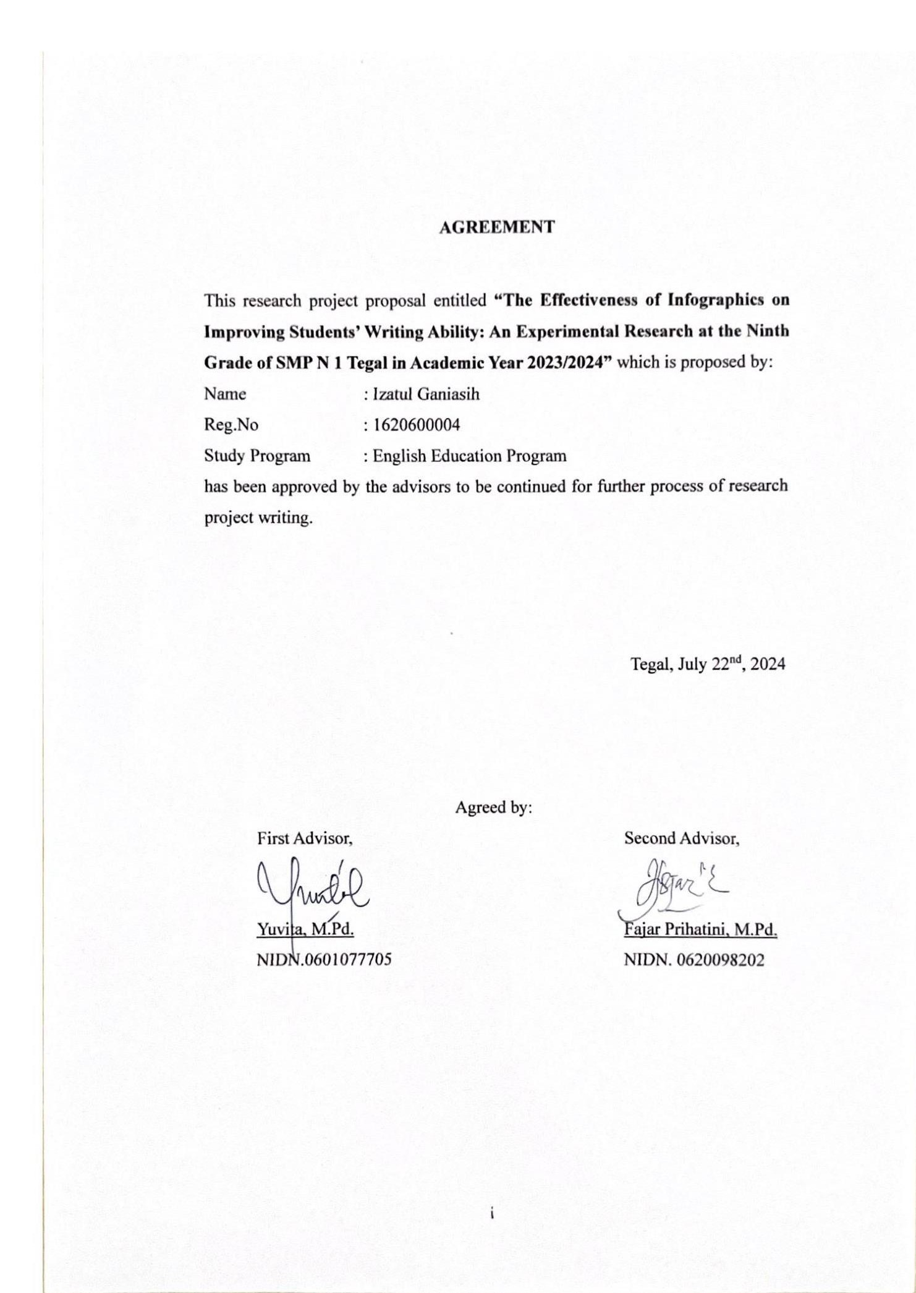

# AGREEMENT

i

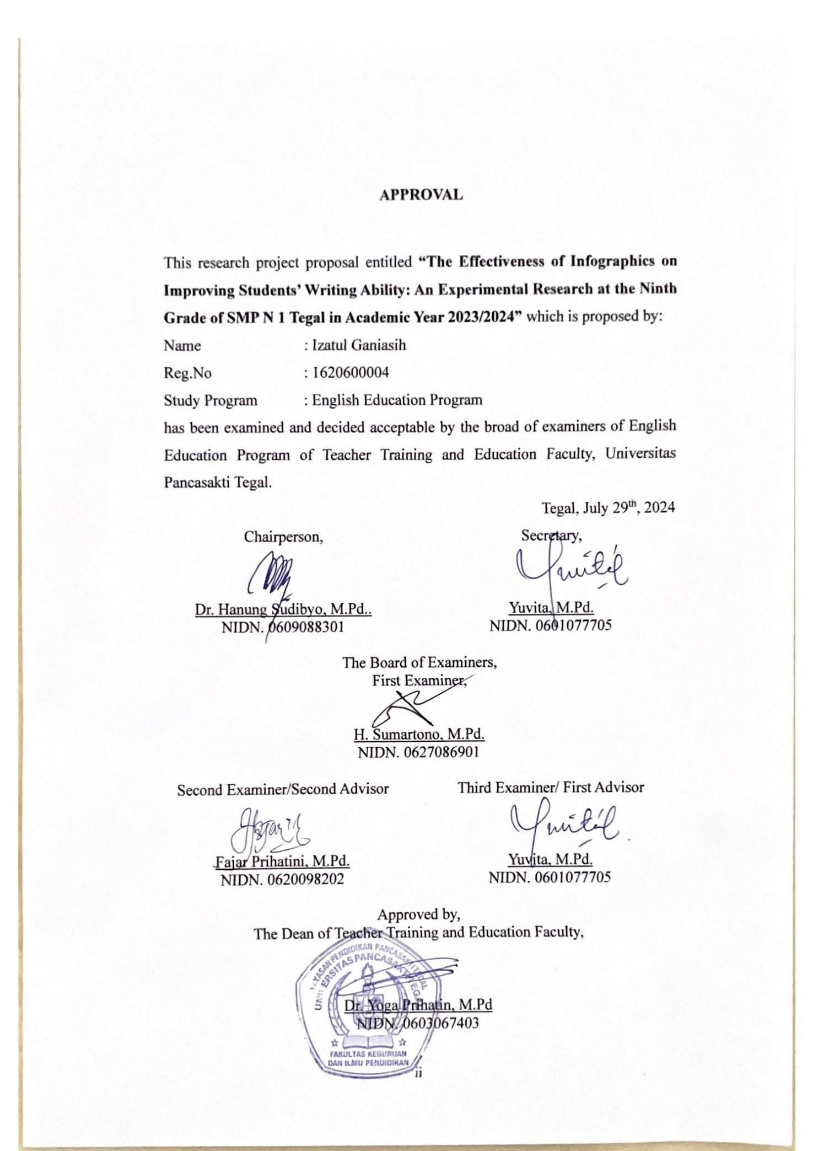

# APPROVAL

This research project proposal entitled **“The Effectiveness of Infographics on Improving Students’ Writing Ability: An Experimental Research at the Ninth Grade of SMP N 1 Tegal in Academic Year 2023/2024”** which is proposed by: Name : Izatul Ganiasih

Reg.No 1620600004

Study Program : English Education Program

has been examined and decided acceptable by the broad of examiners of English Education Program of Teacher Training and Education Faculty, Universitas Pancasakti Tegal.

Tegal, July 29th, 2024

|  |  |
| --- | --- |
| Chairperson,  Dr. Hanung Sudibyo, M.Pd..  NIDN. 0609088301 | Secretary,  Yuvita, M.Pd.  NIDN. 0601077705 |
| The Board of Examiners, First Examiner,  H. Sumartono, M.Pd. NIDN. 0627086901 | |
| Second Examiner/Second Advisor  Fajar Prihatini, M.Pd. NIDN. 0620098202 | Third Examiner/ First Advisor  Yuvita, M.Pd.  NIDN. 0601077705 |
| Approved by,  The Dean of Teacher Training and Education Faculty,  Dr. Yoga Prihatin, M.Pd NIDN. 0603067403 | |

ii

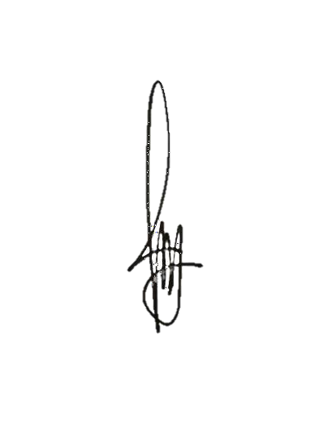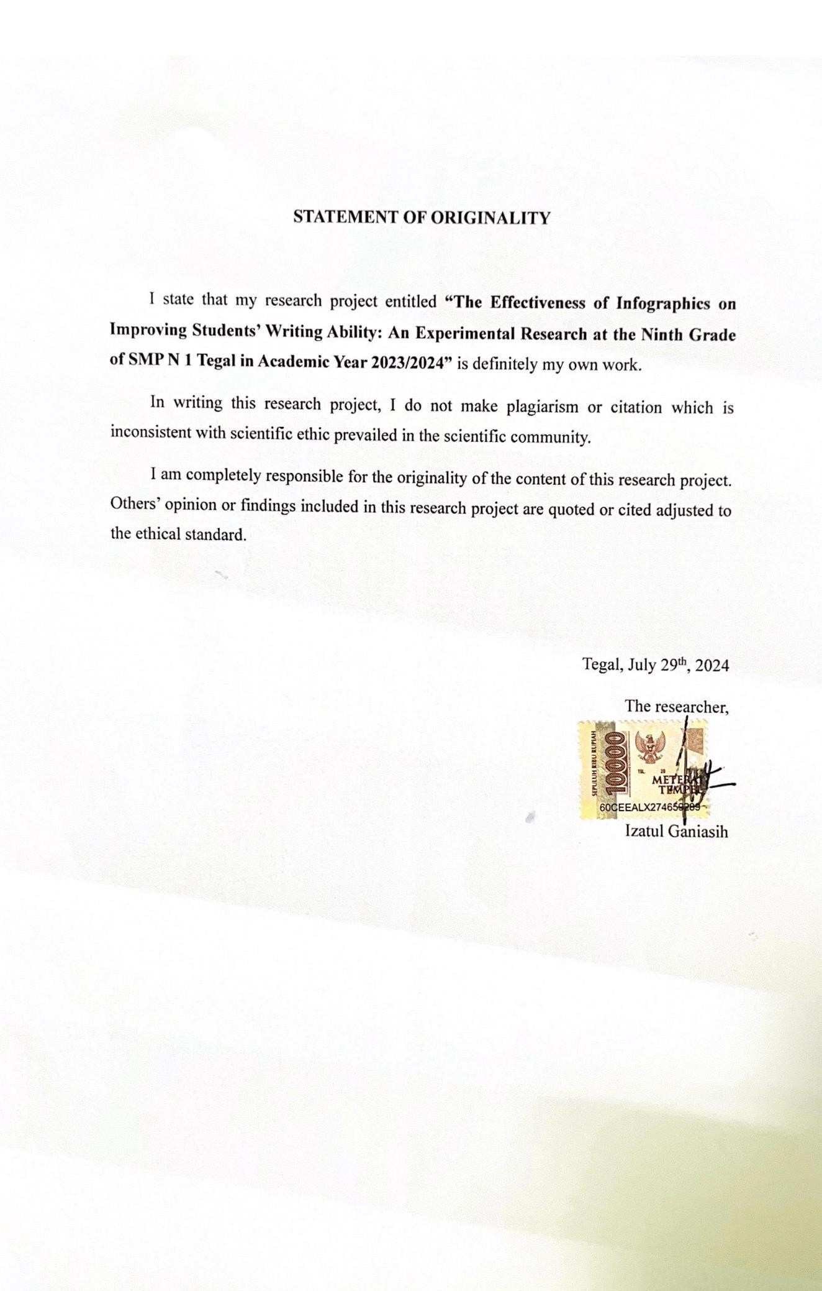

# STATEMENT OF ORIGINALITY

I state that my research project entitled **“The Effectiveness of Infographics on Improving Students’ Writing Ability: An Experimental Research at the Ninth Grade of SMP N 1 Tegal in Academic Year 2023/2024”** is definitely my own work.

In writing this research project, I do not make plagiarism or citation which is inconsistent with scientific ethic prevailed in the scientific community.

I am completely responsible for the originality of the content of this research project. Others’ opinion or findings included in this research project are quoted or cited adjusted to the ethical standard.

Tegal, July 29th, 2024 The researcher,

Izatul Ganiasih

iii

# MOTTO AND DEDICATION

**MOTTO**

1. Long story short, I survived. – Taylor Swift
2. No matter how difficult or impossible it may seem, never forget your goal.

– Monkey D. Luffy

1. My mother's prayer is as vast as the sky, and I take shelter beneath it. – Izaa

# DEDICATIONS

I dedicated this research project for:

1. Allah SWT gave his mercy, blessing, and guidance to complete my research project.
2. My beloved parents, Mama Artiyah and Alm. Abah Suhardjo, who always prays for me in every breath. Thank you a million and I love you 3000.
3. My beloved younger sister Fatichatul Asiah, my dear older brother Adi Irawan, and Fauziah, who always support, care for, and help me.
4. My beloved partner, Zainmiswa Pamungkas, who is always by my side, always there whenever I need, always supportive, and accompanies me in every situation.
5. My beloved friends, Zalza Fina Oktafiana and Almanda Tiara Mahdani who always supporting, giving suggestions and motivating during completing my research.
6. Last but not least, I want to thank me, I want to thank me for believing me, I want to thank me for doing all this hard work, I want to thank me for having no days off, I want to thank me for never quitting, I want to thank me for always being a giver and trying to give more than I receive, I want to thank me for trying do more right than wrong, I want to thank me for just being me at all time.

May God bless them all.

iv

# PREFACE

In the name of Allah SWT, the Generous and the Merciful. All praises be to Allah, the God of the Universe, who provides the researcher with direction and fortitude to complete this research project entitled “The Effectiveness of Using Infographics on Improving Students’ Writing Ability (An Experimental Research at the Ninth-Grade of SMP Negeri 1 Tegal in Academic Year 2023/2024)”. Then peace and blessings be upon the Prophet Muhammad SAW, who led us out of darkness and into the light.

This research project is presented to the English Department of the Faculty of Teacher Training and Education, Universitas Pancasakti Tegal as partial fulfilment of the requirements for the degree of *Sarjana Pendidikan* (S1). Besides that, the research project is also conducted as a guide for everyone who wants to improve his English Teaching.

The researcher believes that the assistance and counsel of various parties will enable this research project to be completed. In light of this, the researcher would like to express her gratitude to:

* 1. Dr. Taufiqullah, M.Hum., as the Rector of Pancasakti University Tegal.
  2. Yoga Prihatin, M.Pd., as the Dean of the Teacher Training and Education Faculty, Universitas Pancasakti Tegal.
  3. Yuvita, M.Pd., as the Head of English Education Program, the Faculty of Teacher Training and Education, Universitas Pancasakti Tegal.

v

* 1. Yuvita, M.Pd., as the first Advisor for the advice, guidance, patience, correction, suggestion, and information from the beginning to completion on this research project.
  2. Fajar Prihatini, M.Pd., as the second Advisor who has given the guidance, correct grammar, and information in writing this research project.
  3. H. Sumartono, M.Pd,. as the examiner who has given advice and correctness in this research project.
  4. All lectures of the English Education Program, Universitas Pancasakti Tegal who have taught and given a lot of knowledge to the researcher.
  5. Hidayat Adi Firmanto, S.Pd., as a tutor provides direction and helps when doing research.
  6. All Grade IX A and IX C students’ of SMP Negeri 1 Tegal in academic year 2023/2024 have become samples of this study.
  7. All people who cannot be mentioned one by one who has helped the researcher.

All of them may Allah, The Almighty, bless. Finally, the researcher acknowledges how far from flawless this study project still is. Therefore, in order to improve this study effort, criticism and suggestions are required. The research expects that the progress of language teaching will benefit from this study project.

Tegal, July 30th, 2024 The researcher,

Izatul Ganiasih NPM. 1620600004

vi

# ABSTRACT

**Ganiasih, Izatul. 2024**: The Effectiveness of Using Infographics on Improving Students’ Writing Ability *(An Experimental Research at the Ninth-Grade of SMP Negeri 1 Tegal in Academic Year 2023/2024).* Research Project Strata

1 Program, Faculty of Teacher Training and Education, Pancasakti University Tegal.

First Advisor : Yuvita, M.Pd. Second Advisor : Fajar Prihatini, M.Pd.

**Key Words**: *Infographics, Students, Writing Ability.*

The aims of this research are to determine the positive effect of integrating Infographics on students’ writing ability and to find out whether there is a significant difference in writing ability between students who are taught using Infographics and those who are not taught using Infographics.

The researcher used a quantitative approach with a true-experimental design. The population in this research involved the ninth-grade of SMP Negeri 1 Tegal in the academic year 2023/2024 which was carried out by random sampling and divided into two classes with 32 students each class. This research used writing test as an instrument in this research.

Based on the calculation of the Paired Sample T-Test data analysis, there is a positive effect of Infographics on improving students’ writing ability. It can be seen from the calculation of the Sig. (2-tailed) value that it is 0.000, which is lower than 0.05 (0.000 < 0.05). Then, based on computing data using an Independent Sample T-Test, it can be seen that the sig. (2-tailed) value is 0.000, which is lower than 0.05 (0.000 < 0.05). It demonstrates statistically that there is a significant difference between the writing scores of students taught using Infographics (experimental class) and those taught without Infographics (control class). The class that used infographics during two sessions improved significantly. Their average pre-test score was 77.66, which went up to 89.75 in the post-test. The control class, which did not use infographics, showed a smaller improvement, with an average pre-test score of 75.53 and a post-test score of 80.31. This shows that the class using infographics had a greater improvement in writing skills compared to the control class.

It is concluded that using Infographics effectively improves students’ writing ability. The researcher suggests that: 1) Students are given additional time to practice their writing ability at home or at school by using media so that learning activities are not boring, so they can apply them in their daily activities, 2) Teachers can use new techniques and activities to learn English writing to enhancing teaching strategies and improving students engagement; and 3) Future researcher try to explore the use and the potential benefits of Infographics for other language skills such as reading, listening, and speaking to provide a comprehensive understanding of their effectiveness in language education.

vii

# ABSTRAK

**Ganiasih, Izatul. 2024**: Efektivitas Penggunaan Infografis dalam Meningkatkan Kemampuan Menulis Siswa (Penelitian Eksperimental pada Siswa Kelas Sembilan di SMP Negeri 1 Tegal Tahun Ajaran 2023/2024). Proyek Penelitian Strata 1 Program, Fakultas Keguruan dan Ilmu Pendidikan, Universitas Pancasakti Tegal.

Pembimbing Pertama: Yuvita, M.Pd. Pembimbing Kedua: Fajar Prihatini, M.Pd.

**Kata Kunci:** Infografis, Siswa, Kemampuan Menulis.

Tujuan penelitian ini adalah untuk menentukan pengaruh positif dari integrasi infografis terhadap kemampuan menulis siswa dan untuk menilai apakah terdapat perbedaan signifikan dalam kemampuan menulis antara siswa yang diajar menggunakan infografis dan yang tidak diajar menggunakan infografis.

Peneliti menggunakan pendekatan kuantitatif dengan desain eksperimen murni. Populasi dalam penelitian ini melibatkan siswa kelas sembilan di SMP Negeri 1 Tegal pada tahun ajaran 2023/2024 yang dilakukan dengan pengambilan sampel acak dan dibagi menjadi dua kelas dengan masing-masing 32 siswa. Penelitian ini menggunakan tes menulis sebagai instrumen dalam penelitian ini.

Berdasarkan perhitungan analisis data Paired Sample T-Test, terdapat pengaruh positif dari integrasi infografis sebagai media terhadap kemampuan menulis siswa. Hal ini dapat dilihat dari perhitungan nilai Sig. (2-tailed) yaitu 0.000, yang lebih rendah dari 0.05 (0.000 < 0.05). Kemudian, berdasarkan perhitungan data menggunakan Independent Sample T-Test, dapat dilihat bahwa nilai Sig. (2- tailed) adalah 0.000, yang lebih rendah dari 0.05 (0.000 < 0.05). Hal ini menunjukkan bahwa terdapat perbedaan signifikan antara nilai menulis siswa yang diajar menggunakan infografis (kelas eksperimen) dan yang diajar tanpa menggunakan infografis (kelas kontrol). Kelas yang menggunakan infografis selama dua sesi mengalami peningkatan yang signifikan. Nilai rata-rata pre-test mereka adalah 77,66, yang meningkat menjadi 89,75 pada post-test. Sedangkan kelas kontrol menunjukkan peningkatan yang lebih kecil, dengan nilai rata-rata pre- test 75,53 dan nilai post-test 80,31. Hal ini menunjukkan bahwa kelas yang menggunakan infografis mengalami peningkatan keterampilan menulis yang lebih besar dibandingkan dengan kelas kontrol.

Disimpulkan bahwa penggunaan infografis secara efektif meningkatkan kemampuan menulis siswa. Peneliti menyarankan bahwa: 1) Siswa diberikan waktu tambahan untuk berlatih kemampuan menulis mereka di rumah atau di sekolah dengan menggunakan media agar kegiatan belajar tidak membosankan, 2) Guru dapat menggunakan teknik dan kegiatan baru dalam belajar menulis bahasa Inggris; dan 3) Peneliti selanjutnya mencoba mengeksplorasi penggunaan dan potensi manfaat infografis untuk keterampilan bahasa lainnya seperti membaca, mendengarkan, dan berbicara untuk memberikan pemahaman yang komprehensif tentang efektivitasnya dalam pendidikan bahasa.

viii

# TABLE OF CONTENT

AGREEMENT i

APPROVAL ii

STATEMENT OF ORIGINALITY iii

MOTTO AND DEDICATION iv

PREFACE v

ABSTRACT vii

TABLE OF CONTENT ix

LIST OF TABLES xi

LIST OF FIGURES xii

LIST OF APPENDICES xiii

CHAPTER 1 INTRODUCTION 1

1. 1 Background of the Problems 1

1. 2 Identification of the Problems 6

1. 3 Limitation of the Problems 6

1. 4 Statement of the Problems 6

1. 5 Objectives of the Problems 7

1. 6 Significances of the Problems 7
   * 1. Theoretical Significances 7
     2. Practical Significances 8

CHAPTER 2 REVIEW OF RELATED THEORIES, THEORETICAL FRAMEWORK, AND HYPOTHESIS 10

1. 1 Review of Previous Studies 10

2. 2 Review of Related Theories 16

* + 1. Writing 16
    2. Infographics 23
    3. Media 33
    4. Procedure Text 35

2. 3 Theoretical Framework 41

ix

1. 4 Hypothesis 42

CHAPTER 3 RESEARCH METHODOLOGY 43

1. 1 Approach, Type, and Design of the Research 43
   * 1. Approach of the Research 43
     2. Type of the Research 44
     3. Design of the Research 44

3. 2 Population, Sample, and Technique of Sampling 45

* + 1. Population 45
    2. Sample 45
    3. Technique of Sampling 46

3. 3 Research Variables 47

3. 4 Data Collecting Technique 47

* + 1. Pre-test 47
    2. Treatment 48
    3. Post-test 48

3. 5 Research Instrument 49

* + 1. Validity 52
    2. Reliability 53

3. 6 Technique of Analyzing Data 54

* + 1. Normality Test 54
    2. Homogeneity Test 54
    3. T-test 55

CHAPTER IV RESEARCH RESULT AND DISCUSSION 57

* 1. Research Result 57
     1. Implementation of Infographics 57
     2. Data Analysis 65
  2. Discussion 71

CHAPTER V CONCLUSION AND SUGGESTION 75

* 1. Conclusion 75
  2. Suggestion 76

REFERENCES 78

x

Table 1. The example of procedure text 40

Table 2. The research design 45

Table 3. Score rubrics 51

Table 4. Score measurement 52

Table 5. Descriptive Statistics 65

Table 6. Test of normality pre-test 66

Table 7. Test of normality post-test 67

Table 8. Test of homogeneity pre-test 68

Table 9. Test of homogeneity post-test 68

Table 10. Paired sample t-test 68

Table 11. Independent sample t-test 69

Table 12. Group statistics 70

xi

Figure 1. Login to Canva 27

Figure 2. Homepage Canva 28

Figure 3. Template Infographics 28

Figure 4. Pick Template to Edit 29

Figure 5. Edit Infographics 29

Figure 6. Download your Infographics 30

Figure 7. The example of Infographics 1 31

Figure 8. The example of Infographics 2 31

Figure 9. The example of Infographics 3 32

Figure 10. The example of Infographics 4 32

Figure 11. Theoretical Framework 41

Figure 12. Writing Material 59

Figure 13. Infographics Material 59

Figure 14. Procedure Text Material 60

Figure 15. Infographics Tutorial 61

Figure 16. Writing Material 62

Figure 17. Procedure Text Material 63

xii

Appendix 1. Instrument Pre-test and Post-test 81

Appendix 2. Students’ Worksheet 83

Appendix 3. Pre-test of Experimental Class 84

Appendix 4. Pre-test of Control Class 85

Appendix 5. Post-test of Experimental Class 86

Appendix 6. Post-test of Control Class 87

Appendix 7. Attendance and Score List Pre-test (Experimental Class) 88

Appendix 8. Attendance and Score List Pre-test (Control Class) 90

Appendix 9. Attendance and Score List Post-test (Experimental Class) 92

Appendix 10. Attendance and Score List Post-test (Control Class) 94

Appendix 11. Attendance of Treatment (Experimental Class) 96

Appendix 12. Attendance of Treatment (Control Class) 98

Appendix 13. Lesson Plan (Experimental Class) 100

Appendix 14. Lesson Plan (Control Class) 116

Appendix 15. Validation Sheet 131

Appendix 16. Scores of Pre-test and Post-test 137

Appendix 17. Letter of Similarity Test 140

Appendix 18. Letter of Research completion 141

Appendix 19. Interview with Mr. Hidayat 142

Appendix 20. Documentation 143

xiii

# INTRODUCTION

This chapter presents the background of the problem, identification of the problems, limitation of the problems, statement of the problems, objectives of the problems, and significance of the problems.

# 1. 1 Background of the Problems

The need for guidance in mastering English is prevalent among many students due to its widespread use as a global language. As Putra et al. (2022) asserts, developing writing skills is crucial not only for academic success but also for navigating various professional and social contexts where English proficiency is essential. Despite the importance placed on writing proficiency, students pursuing English studies often face a myriad of challenges and obstacles along their learning journey. These challenges may encompass difficulties in vocabulary acquisition, grammatical structures, spelling, and pronunciation, all of which are integral components of effective written communication. Moreover, students from diverse linguistic backgrounds who study English as a second or foreign language encounter unique challenges in mastering writing skills.

Writing is a crucial tool to enhance other abilities and a fantastic means for students to improve their vocabulary and grammar usage (Meiristiani et al., 2022). However, students often encounter challenges when attempting to write sentences, paragraphs, or texts. Common issues such as vocabulary,

1

grammar, spelling, punctuation, and organization frequently lead to a lack of interest in writing among children (Alisha et al., 2019). In addition, students make numerous basic faults in their written work when it comes to vocabulary, pronunciation, grammar, punctuation, organization, and certain flaws such as orthographic, syntactic, and lexical problems as well as when they are expressing their ideas (Wulandari, 2022). The stress and frustration associated with writing may cause students to excessively focus on spelling and grammar errors rather than the content itself, significantly affecting their motivation to write (Ramadhanty et al., 2023). These challenges are compounded by a lack of teacher expertise in teaching writing-related skills and limited classroom time devoted to writing instruction. Insufficient classroom time dedicated to teaching writing skills is inadequate for improving students' proficiency in writing (Jawas, 2019).

The predominant challenge faced by the majority of ESL/EFL students currently revolves around the difficulty and frustration associated with writing in an EFL context. This difficulty often stems from their limited vocabulary and insufficient language skills, which are the primary obstacles encountered by ESL/EFL students in writing exercises (Jawas, 2019). Due to their inadequate syntactic and lexical abilities, EFL students struggle to construct and produce coherent written work. Various factors contribute to the frequent errors made by students, with one notable example being mother tongue interference when translating from their native language to the target language, resulting in errors that stem from the learners' familiarity with their

mother tongue (Wulandari, 2022). Common writing errors among EFL students include issues related to verb tenses, prepositions, and subject-verb agreement, which are increasingly observed among this student demographic (Alisha et al., 2019).

A proposed solution to address this issue is the creation of a relevant learning environment, which is crucial in 21st-century education. Utilizing instructional media such as Infographics during the learning process can help establish a relevant learning environment that captures students' attention, particularly as they are inherently drawn to technology (Borch, 2019). Meaningful learning occurs when students can relate new concepts to familiar ones, leading to better retention compared to mere memorization. Implementing instructional media serves as a key strategy to combat the issue of student focus during the learning process. Furthermore, instructional media not only attracts students' attention but also facilitates the conveyance of information, serving as a substitute for the traditional role of the teacher and enlivening the classroom environment. In EFL writing instruction, Infographics represent a valuable teaching tool that can enhance the learning experience and aid in addressing the challenges faced by ESL/EFL students in writing tasks (Alisha et al., 2019).

Students have the opportunity to utilize Infographics as a form of instructional media. Infographics are visually appealing and efficiently condense various pieces of information. While text serves as the primary content in Infographics, graphics are employed to illustrate and visualize the

information. In today's digital era, students are immersed in a digital environment, making it imperative to employ graphic representations of data to capture their attention. By incorporating Infographics as visual aids, students may potentially circumvent common writing errors. Rather than utilizing multiple pages of text to convey a message, a single image in the form of a visual representation could suffice (Mubarok et al., 2020).

Infographics serve instructional purposes by delineating the sequence of events, establishing connections between disparate concepts, and rendering abstract ideas into visual forms. The articulation and comprehension of specific facts during the learning process can often prove challenging through oral expression alone. Visual instructional media, such as Infographics, aid students in elucidating abstract concepts (Yandra et al., 2022). Visual communication is deemed more effective than verbal communication due to the human mind's capacity to comprehend visual representations (Traboco et al., 2022). Ultimately, Infographics offer students a productive conclusion to their writing endeavors and serve as valuable aids in their academic pursuits. In the process of teaching English at SMP Negeri 1 Tegal, the researcher identified various challenges encountered by students, particularly those in the ninth grade, with regard to their writing skills. An interview with the English teacher at the school revealed that the students' English writing skills still low. During the researcher’s two-month PLP activities there, it observed that when the researcher assigned English writing tasks, the students still needed practice, especially in sentence construction, grammar, and word

choice. Through further observations, it became evidence that many ninth- grade students struggle with aspects such as vocabulary, grammar, text organization, and accurate spelling in their writing endeavors. Additionally, a notable issue lies in the lack of motivation among students when it comes to learning writing. While initially attentive to the lesson material, students often became unfocused after a few minutes, showing signs of tiredness and boredom when the teacher asks them to write a sentence in English.

To enhance the effectiveness of teaching writing and facilitate students' learning process, the researcher proposes the use of engaging and innovative instructional media, specifically Infographics. By incorporating Infographics into the curriculum, students can more easily grasp the concepts of sentence construction. Furthermore, utilizing Infographics promotes the development of students' cognitive abilities, fostering independence and creativity in their educational journey. Infographics serve as a dynamic tool to bridge the gap between knowledge acquisition and practical skill development, thus empowering students to excel in their writing endeavors (Borch, 2019).

The researcher conducted in a true-experimental research based on the issues identified in the background with the title *“The Effectiveness of Infographics on Improving Students’ Writing Ability (An Experimental Research at the Ninth Grade of SMP Negeri 1 Tegal in Academic Year 2023/2024).*

# 2 Identification of the Problems

Based on the background of the problems above, the researcher identifies the problem as follows:

* 1. Students have difficulty conveying and organizing their thoughts into written form.
  2. Students had some errors in various language components such as vocabulary, grammar, spelling, punctuation, and organizing words.
  3. Students are not interested in writing because the teacher prefer to use paper or books when teaching writing.

# 1. 3 Limitation of the Problems

The focus of this research is on the effectiveness of Infographics on improving students’ writing ability at the ninth-grade students of Junior High School. Furthermore, the researcher focuses on writing procedure text in the ninth grade of SMP Negeri 1 Tegal in academic year 2023/2024.

# 4 Statement of the Problems

The issues to be examined in the research are based on the phenomenon mentioned above, the problem that were discussed in the research are:

* 1. Does the use of Infographics give positive effect on students’ writing ability?
  2. Is there a significant difference in writing ability between students who are taught using Infographics and those who are not taught using Infographics?

# 5 Objectives of the Problems

Based on the statement of the problems above, the research objectives are stated as follows:

* 1. To determine the positive effect of using Infographics on students' writing ability.
  2. To find out whether there is a significant difference in writing ability between students who are taught using Infographics and those who are not taught using Infographics.

# 6 Significances of the Problems

The significance of the problems can be categorized into theoretical and practical significance.

# Theoretical Significances

The research contributed to language acquisition theory by investigating the effectiveness of infographics on improving students’ writing ability for second language learners. By doing so, it provided insights into innovative and impactful strategies to support students' writing development, particularly in the context of English language learning. This contribution is significant as it highlights new methods to enhance the acquisition of a second language, demonstrating the value of visual aids in this educational domain.

Furthermore, the research advances writing pedagogy by exploring how infographics can serve as visual aids to enhance students' writing abilities. This exploration offers valuable insights into the use of instructional media to

address the challenges faced by ESL/EFL students in writing tasks. As a result, the findings enrich writing pedagogy in language education, offering practical applications for educators seeking to improve their teaching methods and support students more effectively.

Additionally, the research advances writing ability research by investigating how infographics improve students’ writing skills. It provides valuable insights into the role of visual representations in promoting higher- order thinking processes, such as analyzing evidence and making informed judgments. This contribution is crucial as it adds to the scholarship on writing ability, highlighting the importance of visual tools in enhancing students' cognitive processes and overall writing performance.

# Practical Significances

The research will have practical implications for language education by providing evidence-based recommendations for integrating infographics into writing instruction. These recommendations will offer practical guidance to educators and curriculum developers on how to effectively leverage visual aids to enhance students' writing abilities, particularly in English language learning. By incorporating infographics into their teaching strategies, educators can create more effective writing programs that support students in developing stronger writing skills.

In addition to educational implications, the research will also have significant implications for professional development. It will inform language

educators about innovative strategies to address the challenges faced by ESL/EFL students in writing tasks. This information will support the professional growth of language educators by equipping them with effective pedagogical approaches that can enhance students' writing abilities. By adopting these strategies, educators can improve their teaching practices and better support their students' learning needs.

Furthermore, the research will have important implications for student engagement and motivation. It will explore the potential of infographics to capture students' attention and facilitate the conveyance of information. This exploration will provide practical insights into creating a relevant learning environment that enhances student engagement and motivation, particularly in the digital era. By using infographics, educators can make learning more interactive and appealing, fostering a more dynamic and engaging classroom experience. This can ultimately lead to improved student outcomes and a more positive learning environment.

# CHAPTER 2

**REVIEW OF RELATED THEORIES, THEORETICAL FRAMEWORK, AND HYPOTHESIS**

This chapter presents previous studies, reviews of related theories, theoretical framework, and hypothesis. Review of related theories consists of writing’s material, Infographics, media, and procedure text.

# 1 Review of Previous Studies

In this research, the researcher conducts a comparative analysis of relevant studies to demonstrate the effectiveness and originality of the research. The comparison is aimed at establishing the unique contribution and impact of the research.

The first research titled *“Infographics: Media for Improving Students’ Writing Abilities”* conducted by Mubarok et al. (2020) explores the effectiveness of using Infographics as a tool to improve students' writing skills, particularly in procedure text in an IT-related academic setting. The research aims to address challenges encountered by students in organizing and composing procedure texts, particularly in the utilization of sequence adverbs and imperative verbs. Employing Classroom Action Research (CAR), the researchers investigated the efficacy of Infographics in enhancing students' writing abilities through a structured process involving planning, implementation, observation, and reflection. The sample consisted of 30 college students enrolled in the Information Technology Department at State

10

Polytechnic of Malang. Findings revealed that Infographics were instrumental in enhancing students' writing skills, particularly in grammar aspects, as indicated by improvements in the usage of sequence adverbs and imperative verbs. The research also highlighted the benefits of Infographics in enhancing students' creativity and comprehension of concepts through the integration of visual and textual elements.

The second research entitled *“Development of Student Creativity in Social Studies Learning Based on Infographics Project”* written by Segara et al. (2023) aimed to evaluate how student creativity evolves in social studies education when utilizing project-based learning centered around Infographics. The research utilized a qualitative descriptive approach, involving 32 seventh-grade students from SMP Negeri 42 Surabaya. Data collection methods included observation of activities, semi-structured interviews, and assessment of documentation products. Creativity rubrics and infographic product rubrics were utilized for data validation, triangulation, and interactive analysis. The results indicated an increase in the percentage of student creativity indicators at each stage, with the majority of groups falling into the "quite creative" and "creative" categories. The research demonstrated that project-based learning had a positive impact on the development of student creativity, as evidenced by the gradual progress observed at each stage of the learning process.

The third research entitled "*Infographics in Higher Education: Instructional Media for Students' Writing Proficiency*" by Putra et al. (2022)

examines the influence of Infographics as instructional tools on students' writing proficiency in English Language Education. The research utilized a quantitative approach with a quasi-experimental design. Employing a quantitative approach with a quasi-experimental design, the research was conducted among third-semester students in the English Language Education department at Ganesha University of Education. A sample of 64 students was selected through random cluster sampling. The research utilized Infographics as the treatment instrument for the experimental group, while a lesson plan supported the learning process for both experimental and control groups. The data collection instrument involved a writing test administered as a post-test during the final session for each group. Results indicated a significantly higher writing proficiency among the experimental group, treated with Infographics, with a mean score of 85,97 compared to the control group's mean score of 83,48. Independent t-test outcomes revealed a significant discrepancy in writing proficiency between the two groups, affirming the experimental group's superior performance. These findings underscore the efficacy of Infographics as instructional aids in notably enhancing students' writing skills.

The fourth research conducted by Alrwele (2019) titled “*Effects of Infographics on Students Achievement and Students’ Perceptions of the Impacts of Infographics*”. The study aimed to examine how Infographics influence university female students' academic performance and their perceptions of Infographics' effectiveness. Employing a quasi-experimental

design with two groups, a pre-test/post-test approach was utilized to find out the impact of Infographics on students' achievement in an introductory curriculum course. The study involved 165 participants, primarily university female students, divided into experimental (N = 83) and control (N = 82) groups. Treatment was administered within the original sections, with the control group receiving instruction through traditional methods and the experimental group exposed to Infographics as a teaching and learning aid. The results revealed significantly higher achievement in the experimental group compared to the control group. Moreover, nearly 90% of participants in the experimental group reported positive impacts of Infographics on their cognitive, life skills, and emotional development.

The last research is written by Hamer et al. (2022) titled “*The Perceptions of Students on the Application of Infographics as Instructional Media in Promoting their Writing Abilities*” describe the process of using Infographics as a teaching tool for English writing and to identify the perceptions of students regarding the use of Infographics as a medium for teaching English writing. The research utilized a qualitative method with a descriptive approach, aiming to provide a comprehensive understanding of individuals' experiences or observations in a naturalistic manner. The data collection techniques included observation, questionnaires, interviews, and documentation. The study involved 36 students of eleventh grade of IPA and one English teacher. The findings revealed that the process of teaching English writing using Infographics ran well, with the students expressing

positive responses to Infographics. The study concluded that Infographics effectively foster learning in the English class, with students considering Infographics as an effective and time-saving medium that can be used in both online and offline classes.

The provided research presents several studies related to the use of Infographics in education. These studies highlight the effectiveness of Infographics on improving students' writing abilities, creativity, and engagement. They also emphasize the potential of Infographics as a pedagogical tool and instructional media and Infographics have impact of Infographics on student achievement. These research exploring students’ perceptions of Infographics as instructional media.

The studies employed various research designs and methodologies. There are quasi-experimental design, CAR, and qualitative descriptive method. Quasi-experimental design used to measure the effect of Infographics on writing proficiency and student achievement by comparing pre-test and post-test results between control and experimental groups. Classroom action research (CAR) implemented to find out the impact of Infographics on student creativity through cycles of planning, acting, observing, and reflecting. Qualitative descriptive method applied to gather in- depth insights into students' perceptions of Infographics through observations, interviews, and questionnaires.

The populations sampled in these studies include university students and high school students. For example, the study from Alrwele (2019)

involved 165 female undergraduate students, while the research from Hamer et al. (2022) focused on 36 eleventh-grade students. This range of educational levels helps provide a broad view of the effectiveness of Infographics across different age groups and educational settings.

There are similarities between integrating Infographics to improve students’ writing ability and previous studies. The findings from these studies consistently highlight the positive effects of using Infographics in education. Alwere (2019) found that Infographics significantly improved student achievement, with 90% of participants reporting positive impacts on their skills and affective development. The study from Hamer et al. (2022) revealed that students found Infographics engaging, easy to understand, and helpful in improving their writing abilities.

The researcher found the differences within each study. In studies from Putra et al. (2022) and Alrwele (2019) using quantitative approach with quasi- experimental to conduct the research. Meanwhile, the researcher used true- experimental design to conduct this research. The next difference in the research conducted by Mubarok et al. (2020), Putra et al. (2022) and Alrwele (2019) focused on university students. So, the researcher using Junior High School to gather the data for this research.

The purpose of this research is to determine the positive effect of integrating Infographics on students’ writing ability and to asses whether there is a significant difference in writing ability between students’ who are taught using Infographics and those who are not taught using Infographics.

To make this research different from other research, the researcher will use a quantitative approach and conducted in ninth-grade at SMP Negeri 1 Tegal.

# 2. 2 Review of Related Theories

# Writing

# Definition of Writing

According to Brown, writing is recognized as an ability demanding advanced thinking abilities and a profound comprehension of idea formation (Mubarok et al., 2020). Writing entails the capacity to structure coherent paragraphs, employ diverse vocabulary, and implement sound grammar in written compositions. It emphasizes that crafting a quality written piece necessitates the incorporation of multiple elements such as word choice, arrangement, grammatical accuracy, coherence, and logical sequence. Writing is a cognitive endeavor that demands careful planning and extensive revisions prior to publication. Additionally, the complexity of writing can present challenges for students in expressing and structuring their thoughts into written form, particularly for English as a Foreign Language (EFL) learners.

Putra et al. (2022) define that writing can be inferred as the process of conveying ideas, thoughts, and information through written language the significance of writing as a fundamental English ability, particularly in academic communication. Writing

can be defined as the process of effectively expressing and communicating ideas and information through written language, with a focus on developing language skills.

Writing is defined as a fundamental skill that enables individuals to express their ideas, information, thoughts, and opinions using appropriate vocabulary, spelling, punctuation, and grammar (Hamer et al., 2022).

# Phases of Writing Production

Writing serves a multitude of purposes and takes various forms. Initially, there are several stages in a process that outline how individuals should proceed with writing to generate content in written form. Durga et al. (2019) stated seven stages in the writing process: being motivated to write, gathering ideas, planning and outlining, taking notes, composing a first draft, revising, re-planning and re-drafting, editing, and preparing for publication. These stages encompass various facets of the writing process, there are:

* + - * 1. Pre-writing

The initial phase of the writing process wherein ideas are generated, organized, and refined before drafting. It involves activities such as brainstorming, outlining, and researching to prepare for writing.

* + - * 1. Drafting

The stage of the writing process where the researcher translates pre-writing ideas into written form. It involves composing the first version of the text, focusing on getting thoughts down on paper without worrying too much about errors or refinement.

* + - * 1. Revising

The process of reviewing and restructuring the draft to improve clarity, coherence, and effectiveness. Revising involves making substantive changes to the content, organization, and style of the writing based on feedback and self-assessment.

* + - * 1. Editing

The stage of the writing process where attention is given to correcting errors in grammar, punctuation, spelling, and mechanics. Editing ensures that the text is polished and conforms to language conventions, enhancing its readability and professionalism.

* + - * 1. Evaluating

The critical assessment of the written work to determine its effectiveness in achieving its intended purpose and audience engagement. Evaluation involves considering factors such as clarity, coherence, persuasiveness, and relevance to the topic.

* + - * 1. Post-writing.

The final phase of the writing process involves activities after completing the initial draft, such as submitting the work for feedback, reflection on the writing process, and considering revisions for future writing tasks. It may also involve sharing the writing with others or publishing it.

# Elements of Writing

As outlined by Borch (2019), certain essential elements contribute significantly to effective writing, there are:

* + - * 1. Ideas encompass various forms, ranging from personal opinions, experiences, emotions, to acquired knowledge.
        2. These ideas find expression through various means, such as narration, which recounts events within a temporal framework, exposition, and argumentation.
        3. Effective communication requires thoughtful organization of these ideas.
        4. The means of expression, including vocabulary, grammar, and style, play crucial roles in conveying ideas effectively.

# Teaching Writing in Junior High School

Habeeb et al., (2020) stated that Teaching writing aims to equip learners with the ability and skills necessary to generate various types of written texts, akin to those expected from educated

individuals in their native language. Instructing students on effective writing is among the paramount lifelong skills educators instill in their students. When teaching writing, educators must carefully choose resources and support materials that not only teach writing techniques but also prove most beneficial in aiding students' writing proficiency development.

The process of teaching writing in junior high school is complex, multi-dimensional, and focused on student development: students acquire writing ability to create various types of written texts in an effective manner. According to Habeeb et al. (2020), the selection of pertinent resources and backup materials forms the hub of developing students' writing competence. The process involves the following critical elements:

* + - * 1. Curriculum and Standards:

Junior high school writing instruction is guided by curriculum standards, typically emphasizing the objectives and expectations for what students should be able to do as researchers. The standards almost invariably stress writing in a range of genres, including narrative, expository, persuasive, and procedure texts. It falls on the teachers to draft plans for lessons that can meet such criteria and take into account their diverse background and needs.

* + - * 1. Instructional Strategies:

Effective writing instruction delivers various teaching strategies aimed at involving students in the learning process and developing their writing capabilities. Such strategies include direct instruction, modeling, collaborative writing, peer review, and writing prompts. In this respect, explicit writing instruction might involve techniques of writing, including brain storming, outlining, drafting, and revising. Explicit instruction is given by teachers with the aim of assisting students to learn about and master every part of the writing process.

* + - * 1. Assessment and Feedback:

Assessment and feedback as regular features of writing instruction, teachers use both formative and summative assessments to gauge students' writing abilities and provide constructive feedback. By using various formative assessment tools—writing conferences and peer reviews, among others— teachers can track students' progress and provide immediate guidance. Whole-class summative writing assessment tools, such as writing assignments and standardized tests, measure overall writing proficiency and point out areas that need improvement.

* + - * 1. Use of Technology and Media:

Integration of technology and new media into the writing instruction process appeals to the students and thus increases

their engagement and motivation. Digital writing tools, for example, word processing software, online writing times, and multimedia resources, offer students the moments-of-practice. The instructors also make use of visual materials like Infographics and videos, supporting instructions in ways helping to illustrate writing concepts.

* + - * 1. Differentiated Instruction:

Recognizing that all students have different learning styles and abilities, differentiated instruction enables a teacher to access the needs of each student. This may be in the form of providing more help when needed or assigning challenging tasks according to students' skill levels. Differentiated instruction ensures that every student will receive relevant experience in writing and progress according to his or her level.

* + - * 1. Setting up an encouraging writing environment:

A supportive writing environment is one in which students are allowed to take risks and express themselves freely. This attitude can be developed from the outset through the orientation of class culture, creative/collaborative values, and constructive feedback. Not only that, but it will also instill confidence in students about their writing abilities by having apparent expectations and various writing opportunities.

A good junior high school writing course needs to integrate standards, instruction, assessment, technology, and a nondirective learning environment to foster positive writing experiences and develop lifelong researchers prepared for college and career.

# Infographics

* + - 1. **Definition of Infographics**

Infographics are defined as a form of instructional media that combines visual elements such as illustrations, images, colors, and minimal text to present information in a clear and engaging manner. Infographics are used to convey complex concepts and data in a simplified and easily understandable format, making them an effective tool for teaching and learning (Hamer et al., 2022). The positive impact of Infographics on students' learning experiences and their effectiveness in enhancing students' writing abilities.

Infographics are visually engaging representations of educational content, aiming to simplify complex information, share scientific research, and influence behavior. They are designed with careful consideration of layout, colors, and fonts to ensure clear communication and appeal to the target audience. Created using online tools and AI programs, they facilitate research dissemination, patient education, and public health communication, especially in the age of social media. Infographics serve as valuable references for bibliography analytics and are vital for conveying scientific

information effectively. Understanding design principles is essential for researchers, scientists, and clinicians to effectively communicate health-related information through Infographics (Traboco et al., 2022).

# Kinds of Infographics

According to Mubarok et al., (2020), there are different types of Infographics that can be employed based on the intended purpose, there are:

* + - * 1. Static Infographics

Visual representations of information or data designed to convey complex concepts or data sets in a static, non- interactive format. Static Infographics typically include a combination of text, images, charts, and diagrams arranged in a visually appealing layout to facilitate understanding and interpretation by the audience. They are often used in presentations, reports, websites, and social media posts to enhance communication and engage viewers.

* + - * 1. Animation infographic

Dynamic visual representations of information or data that incorporate motion, interactivity, and multimedia elements to convey complex concepts or data sets. Animation Infographics often involve the use of animated graphics, transitions, and effects to illustrate processes, trends, or relationships in a

compelling and engaging manner. They are commonly utilized in digital media, online presentations, educational materials, and marketing campaigns to captivate audiences and enhance the retention of information.

* + - * 1. Interactive infographic

Interactive Infographics represent the most intricate form of Infographics compared to static Infographics and animated Infographics. In interactive Infographics, the audience for whom the information is intended can engage directly with the content. Creating a high-quality interactive infographic requires collaboration with developers or programmers to ensure smooth execution of interactive animations and programming.

# Advantages of Infographics

Infographics offer several advantages that make them a popular and effective tool for conveying information. Firstly, they are visually appealing, utilizing colors, icons, and images to present data in an engaging format. This visual appeal not only captures the audience's attention but also makes complex information more accessible and easier to understand.

Moreover, Infographics simplify information by condensing complex data into concise and easily digestible visual representations. By presenting key concepts in a clear and organized

manner, they help audiences grasp important information quickly and efficiently. This simplified presentation also aids in enhancing retention and comprehension, as people tend to remember visual content better than plain text.

Another advantage of Infographics is their ability to increase engagement. Their visually stimulating nature makes them more likely to be shared and discussed, leading to greater audience interaction and participation.

Additionally, Infographics are versatile and can be used across various platforms and formats, including websites, social media, presentations, and printed materials, making them a valuable tool for communication in diverse settings. Furthermore, Infographics are accessible to a wide range of audiences, including those with different learning styles or language preferences. They utilize universal visual elements that transcend language barriers, enabling effective communication with diverse audiences. Infographics also provide branding opportunities as they can be customized with logos and color schemes, helping to reinforce brand identity and recognition.

Lastly, Infographics excel at visualizing data and statistics, making complex information more understandable and compelling. By presenting data in a visually appealing manner, they enable audiences to interpret and analyze information more effectively.

Overall, Infographics offer a powerful way to convey information efficiently, engage audiences, and enhance understanding across various platforms and audiences.

Infographics are visually appealing, simplify complex data for better understanding, increase engagement, and are versatile across platforms. They use universal visual elements for effective communication with diverse audiences, enhance brand identity, and excel at visualizing data to improve comprehension and engagement.

# Tutorial to Create Infographics

Creating Infographics is an effective way to present complex information in a clear and engaging manner. The following is a detailed guide on how to utilize Canva for this purpose:

* + - * 1. Open the Canva application or go to [www.canva.com.](http://www.canva.com/) On this page, you will be prompted to sign in or log in to your account. Please log in using your email, google account, or other available options.



*Figure 1. Login to Canva*

* + - * 1. To begin creating your design, click on the "Create a design" button located in the top right corner of the homepage. In the search bar, type "Infographic" and select it from the options. This action will open a blank canvas with dimensions optimized specifically for Infographics.

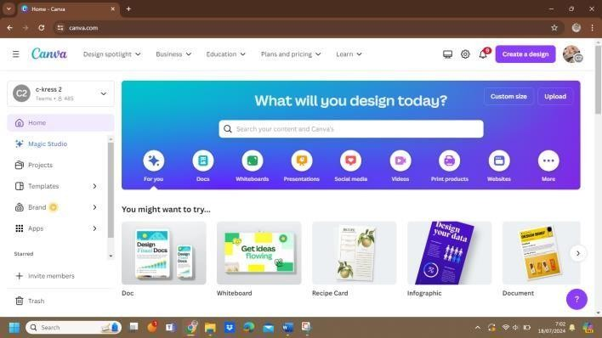

*Figure 2. Homepage Canva*

* + - * 1. On the left-hand side of the interface, browse through the available templates. Click on a template that suits your requirements, and it will be loaded onto your canvas automatically.

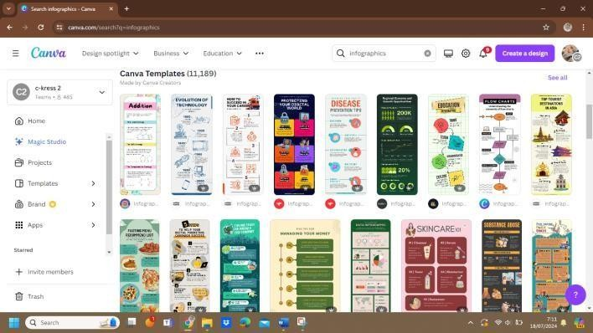

*Figure 3. Template Infographics*

Click “Customize this template” to edit this template.

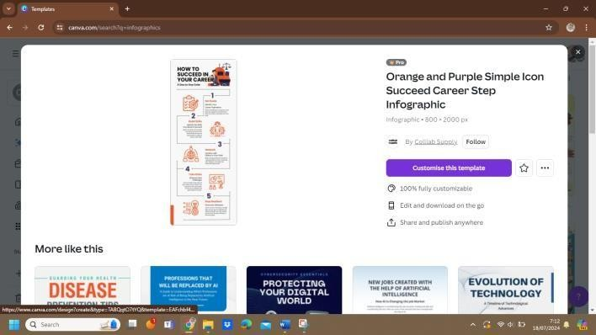

*Figure 4. Pick Template to Edit*

* + - * 1. In this step, you can edit your template. Click on any text box to modify the text, and utilize the toolbar above the canvas to adjust fonts, sizes, colors, and alignment. To add graphic elements, access the "Elements" tab on the left-hand side, where you can find icons, illustrations, charts, and other graphic elements to drag and drop onto your canvas. For including specific images, navigate to the "Uploads" tab, click on "Upload files," and select your desired images. Once uploaded, drag them onto the canvas. To modify colors, click on any element and use the color picker tool in the toolbar.

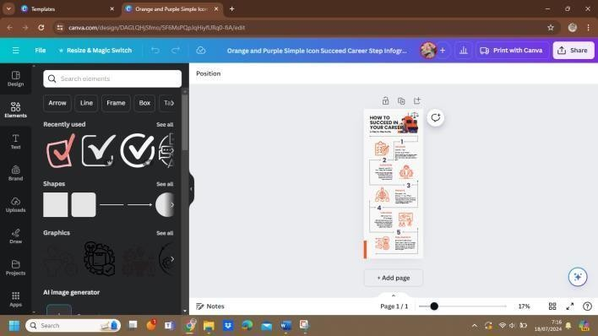

*Figure 5. Edit Infographics*

* + - * 1. To download your infographic, click on the "Share" button at the top right corner, then select "Download." Choose the desired file format (PNG, JPG, PDF) and click "Download." Canva also provides options to share your infographic directly via email, social media, or by generating a shareable link.

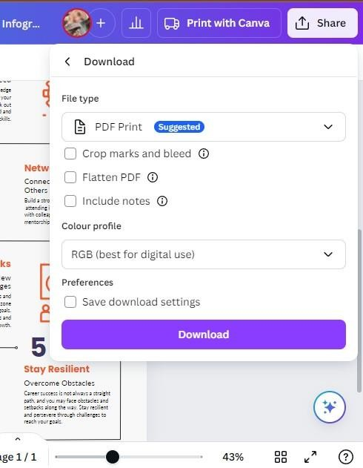

*Figure 6. Download your Infographics*

* + - * 1. Finally, your Infographics is ready.

# Examples of Infographics

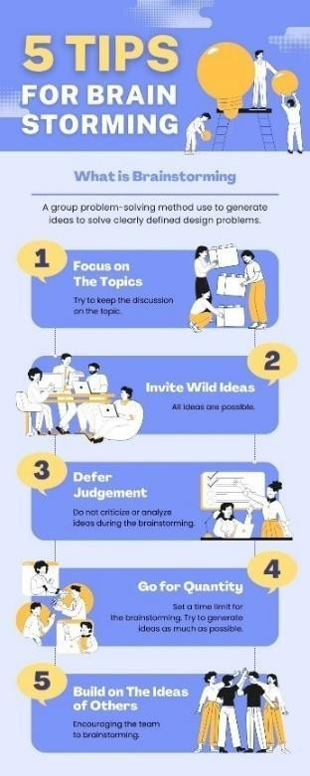

*Figure 7. The example of Infographics 1*

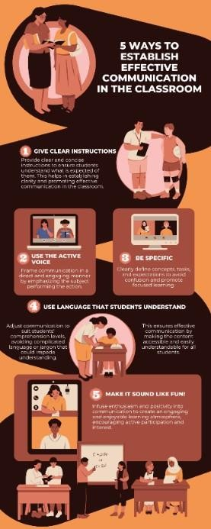

*Figure 8. The example of Infographics 2*

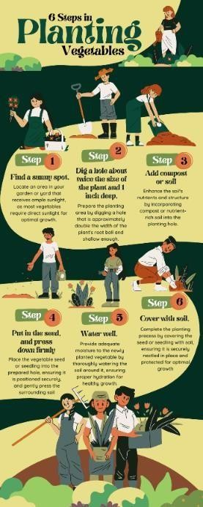

*Figure 9. The example of Infographics 3*



*Figure 10. The example of Infographics 4*

# Media

* + - 1. **Definition of Media**

As quoted by Borch (2019), media refers to tools or methods utilized to convey messages to students and engage them in learning. The teaching-learning process involves communication between teachers and students. A proficient media tool acts as a window, providing insight and facilitating understanding. Generally, teachers should employ captivating media to enhance learning experiences. With effective media, students can grasp the material more comprehensively.

In the realm of education, media encompasses various methods and techniques employed to facilitate communication and interaction between teachers and students during the teaching and learning process in schools. Furthermore, the utilization of media in learning contributes to enhancing both teaching efficacy and student motivation (Rizqi, 2022).

Based on several definitions above, it is evident that media serves as a tool for transmitting information from the source to the recipient or as a means of facilitating communication between teachers and students. Teachers can create or utilize media as tools to pique students' interest in learning activities as required.

# Kinds of Media

In teaching, various instructional media are utilized, ranging from basic to advanced, and some don't require electricity. Hamer et al. (2022) identifies six types of media, there are:

* + - * 1. Drawing or teacher mode drawings

This type of media can be drawn and prepared by the teacher at home. It is convenient for the teacher to use this media in the classroom to meet the learning objectives.

* + - * 1. Still pictures

A still picture is a representation or reproduction of real objects or events, often varying in size from the actual objects. Examples of such media include photographs, materials for bulletin boards, brochures, and so on.

* + - * 1. Audio recording

Audio recording is a reproduction of real sound events or effects.

* + - * 1. Motion picture or TV

A motion picture or TV refers to visual representations that portray moving images, which can be captured from live action or generated through graphic presentations, typically recorded on videotape. Objects or events within the recording may appear in their normal motion or can be edited as

necessary. Additionally, the recording may include sound or be silent, depending on the requirements.

* + - * 1. Real object, simulation, and models

Real objects, simulations, and models constitute a type of media that encompasses people, events, and demonstrations, providing tangible and practical representations for educational purposes. Real objects are not replaced by artificial ones or simulated events. Teachers can utilize real objects as long as they are easily accessible and affordable. Simulation refers to creating conditions or situations that resemble real-life scenarios. A model, on the other hand, is a scaled-down replica of a real object, often in miniature form.

* + - * 1. Programmed instruction and computer-assisted instruction Programmed instruction and computer-assisted instructions consist of sequences of information that are designed by a teacher to elicit predetermined responses from students. Common examples of this type of media include programmed textbooks or instructional programs prepared for computers.

# Procedure Text

* + - 1. **Definition of Procedure Text**

A text can be approached from two viewpoints. Firstly, it can be viewed as something that is documented, scrutinized, and deliberated upon. Secondly, it can be perceived as the result of a

socially constructed event. One type of text commonly studied in Junior High School is the procedure text, which provides readers with instructions for performing a task. Essentially, procedure texts offer guidance or steps for accomplishing a particular action. Moreover, in addition to outlining the steps for performing or creating something, procedure texts also include details about the necessary tools or ingredients (Knapp et al., 2005).

Knapp & Watkins asserted that procedure text focuses on presenting information to guide someone on how to perform a task. A procedure facilitates individuals in accomplishing tasks or creating something new for them, ensuring that they follow the correct sequence or order in doing so. In Junior High School, procedure texts encompass a variety of procedures, extending beyond instructions for cooking or crafting to include operational or task-based procedures. However, this research specifically concentrates on enhancing students' ability to write procedure texts.

# Purposes of Procedure Text

As we know, each text serves a distinct purpose, which varies from one another. Anderson identifies four purposes of texts: to persuade, to instruct or advise, to entertain, and to inform (Anderson et al., 2003). Procedure texts aim to persuade readers to follow the steps or instructions outlined in order to achieve a specific outcome. Additionally, they offer advice to assist readers in executing the steps

accurately. Moreover, procedure texts provide information on how to create or perform a task. It's worth noting that procedure texts are commonly found in instructional materials, making examples readily available in our surroundings.

Procedure texts are crafted for diverse audiences. When composing a procedure text, it is essential to take into account the intended audience and consider the following aspects to effectively fulfill the purpose of instructing or advising the audience on how to perform a task (Anderson et al., 2003). Different categories of audiences will necessitate distinct types of procedures tailored to their specific needs or objectives. Here are the considerations for procedure text:

* + - * 1. The age range of the audience

The consideration of age is the text is suitable for whom. If the procedure text is purposed for the kids, the instructions or steps should be suitable for the kids with the simple sentences. Meanwhile, if the procedure text is purposed for adults, it should consist of more complex steps because it should adjust with their background knowledge.

* + - * 1. The audience's familiarity with the procedure

The second consideration still relates to the first consideration. The researcher must take into account the reader's prior knowledge, as the success of the process hinges on their

comprehension of the steps or instructions. Therefore, it is imperative for the researcher to ensure that the reader can grasp the procedure.

* + - * 1. Whether the audience requires specific guidance regarding the necessary equipment or the steps to be undertaken.

# Generic Structure of Procedure Text

According to the Oxford Dictionary, "general" (noun) pertains to characteristics of or pertaining to a class or group of things. Conversely, "structure" (noun) refers to the arrangement and relationship between the parts or components of something complex. Hence, the generic structure of a procedure text denotes the characteristics that outline the procedure or elucidate how to create, perform, or operate something in sequence. The generic structure should be aligned with the topic being discussed, focusing on the objective. Similar to other text types, procedure texts serve a communicative purpose, which is to demonstrate or inform how to create or operate something(Anderson et al, 2003).

There are three generic structure of procedure text, which are:

* + - * 1. Goal
        2. Materials or ingredients
        3. Steps

Therefore, based on the explanation before, it can be concluded that there are three essential components of the generic

structure of a procedure text, each indispensable and inseparable. These components form a unified whole aimed at fulfilling a social function, which is to provide guidance on how to perform a task or how to create/operate something.

# Grammatical Features of Procedure Text

In addition to fulfilling a social purpose and following a standard structure, procedure texts also integrate essential grammatical elements that influence the text's form. These elements comprise:

* + - * 1. Simple present tense

The primary social function of a procedure text is to provide instructions on how to perform a specific task. Therefore, the instructions provided utilize imperative verbs in the present tense. For Examples: chop, serve, put, stir, add, cut, grind, boil, etc.

* + - * 1. Connective of sequence

In procedure text, depending solely on the imperative form in the present tense may not be adequate to ensure the clarity of instructions. However, to enhance clarity and ease of understanding, it is beneficial to incorporate words. For example: then, after that, next, finally, and so on. These are referred to as comparative sequences.

* + - * 1. Numbering

Numbering serves a similar function to comparative sequences in procedure text. It becomes necessary when the researcher aims to present various sequences or steps. For examples: first, second, third, fourth, and so forth, to illustrate the order of actions.

# Example of Procedure Text

|  |  |
| --- | --- |
| Goal | How to make Fried Rice |
| Ingredients | The ingredients required for the recipe are as follows:   * 2 plates of rice * 1 clove each of garlic and onion * 1 tablespoon of tomato sauce * 1 beaten egg * 100 grams of chicken meat * 1 tablespoon of cooking oil * Salt |
| Steps | Here are the steps to prepare the fried rice:   1. Start by heating cooking oil in a pan and stir-frying the garlic and onion until it smells out. 2. After that, add the chicken and stir briefly until partially cooked. 3. Next, add the beaten eggs and stir until they are cooked and scrambled. 4. Then, add the white rice, tomato sauce, and salt. Mix thoroughly with the other ingredients. 5. Optionally, you can add fried shrimp or crackers according to your preference. 6. Finally, serve the fried rice and enjoy   your meal. |

*Table 1. The example of procedure text*

# 2. 3 Theoretical Framework



**Students’ Writing Ability**

SMP Negeri 1 Tegal

Teaching Writing

Teaching Writing

Problem in Classroom:

Students cannot write sentences, paragraphs, or texts with appropriate vocabulary, spelling, punctuation, and grammar

Infographics

Conventional Media (books)

Digital Media

(Infographics)

Infographics can improve students’ writing ability

Infographics: Procedure text

*Figure 11. Theoretical Framework*

This research is about students’ writing ability at SMP Negeri 1 Tegal. While the researcher and the teacher teaching writing there, the researcher and the teacher found the problem in their classroom. The problem is students cannot write sentences, paragraphs, or text with appropriate vocabulary, spelling, punctuation, and grammar. Because of this problem, the researcher suggested an idea that is using Infographics as a media in teaching writing. Then, the researcher conducted research with two-groups design. The researcher used two classes, there are experimental class (IX-A) and control class (IX-C). In experimental class, the researcher used Infographics in learning process, meanwhile in control class, the researcher used student’s books in learning process. In this research, the researcher teaching writing in procedure text. In experimental class, students create or write

procedure text using Infographics. Based on this research, the researcher found that Infographics give positive effects in writing learning process and Infographics can improve students’ writing ability.

# 4 Hypothesis

A hypothesis is a suggested explanation or prediction regarding a phenomenon or the relationship between variables, derived from existing knowledge or observations. Following a review of related literature and the framework, the research hypothesis is as follows:

* 1. Research Hypothesis (Ha): There is a positive effect of integrating Infographics as a media on students’ writing ability.
  2. Null Hypothesis (Ho): there is no positive effect of integrating Infographics as a media on students’ writing ability.

# CHAPTER 3 RESEARCH METHODOLOGY

This chapter presents the research methodology. It discusses design of the research, sample and population, research variable, and data collecting technique.

# 1 Approach, Type, and Design of the Research

# Approach of the Research

This research used quantitative approach to examines the impact of utilizing Infographics as a media on improving students’ writing ability. According to Siyoto &Sodik (2015) cited in Ahyar et al. (2020), quantitative research is a research that mainly consists of numerical data in the form of numbers within the process of data collection, data analysis and data presentation. Quantitative research also uses statistical methods that are adapted to existing numerical data.

In addition, according to Ahyar et al. (2002), the theory of quantitative research is a set of interrelated variables and the relationship between hypotheses and variables that explain a specific phenomenon. Based on the explanation above, quantitative research is a research approach that consists of a relationship between hypothesis and variables to explain a phenomenon that uses numerical data to analyze data and process it with statistical methods.

43

# Type of the Research

This research uses the type of experimental research. The experiment research explains the relationship between one or more related variables or finds out and shows the effect of a variable on other variables. This is also supported by Fenti (2020) claims that experiments are one type of quantitative research has a certain degree in looking for causal relationships between independent and dependent variables and others.

In addition, according to Ahyar et al. (2020), experimental research provides action to research subjects so they can observe events and the consequences they cause. In this case, the researcher can manipulate variables through the actions given and control other existing variables

# Design of the Research

This research used experimental research, including the two classes pre- test and post-test design. In this research, the experimental class received an intervention involving the use of Infographics. This research design was chosen to assess the influence of infographic as a media on students’ writing ability. Differential treatment was administered to the experimental class and the control class to identify any significant differences between the two groups.

The research focuses on ninth-grade students at SMP Negeri 1 Tegal during the academic year 2023/2024. The researcher aims to compare the effects of Infographics on students’ writing ability, particularly among

students with poor writing skills. The researcher seeks to determine which method is more effective and beneficial. Additionally, the researcher draws upon articles, journals, and prior studies to support this research. The research design is outlined in the following table:

|  |  |  |
| --- | --- | --- |
| **No.** | **Experimental Class** | **Control Class** |
| 1. | Pre-test | Pre-test |
| 2. | Treatment | No treatment |
| 3. | Post-test | Post-test |

*Table 2. The research design*

# 3. 2 Population, Sample, and Technique of Sampling

# Population

The research population comprised ninth-grade students enrolled at SMP Negeri 1 Tegal during the academic year 2023/2024. This educational institution accommodates a total of 254 students, distributed across 8 distinct classes. The diverse composition of the student body ensures a comprehensive representation of the target demographic, providing the researcher with valuable insights into the effectiveness of Infographics as a media tool for enhancing students' writing ability.

# Sample

The research sample for this research was selected using a random sampling technique, where samples were chosen randomly from the population. The sample consisted of two classes, each comprising 32 students, there are IX A and IX C. The first class (IX A) was randomly

assigned as the experimental class, while the second class (IX B) was randomly designed as the control class. This random selection process ensured that each class had an equal opportunity to be assigned to either class, thus providing a more balanced and representative sample for the research.

# Technique of Sampling

The research employed a random sampling technique. Random sampling involves selecting samples from the population in a random manner, ensuring that each member of the population has an equal opportunity of being chosen (Ahyar et al, 2020). This research was conducted at SMP Negeri 1 Tegal, the researcher was to randomly select two classes from the population of ninth-grade students during the academic year 2023/2024. Each of the selected classes consisted of 32 students. The first class was randomly assigned as the experimental class, while the second class was designed as the control class using the same random selection process. This method minimizes bias and ensures that the sample accurately represents the population, thereby allowing for the findings to be generalized to the broader student body. Utilizing random sampling enhanced the validity and reliability of the research outcomes by providing an unbiased representation of the student population.

# 3. 3 Research Variables

In this research, the researcher used an independent variable (X) called "Infographics". This manipulated factor involved the deliberate incorporation of Infographics into the instructional process for teaching procedure text writing. The research aims to investigate the impact of this intervention on various dependent variables.

Meanwhile the dependent variable (Y) is "writing ability" which measures students' ability to analyze, synthesize, and evaluate information critically. This assessment focused particularly on their writing ability. This variable encompasses the clarity, conciseness, and overall effectiveness of students' written outputs in the specific genre of procedure texts. These dependent variables collectively form the foundation for assessing the effectiveness of Infographics in enhancing students’ writing ability.

# 3. 4 Data Collecting Technique

Considering the strong emphasis on employing quantitative approach and an experimental method, the primary focus of data collection techniques utilized in quantitative measures to evaluate the influence of incorporating Infographics on students' writing ability within the realm of procedure texts.

# Pre-test

During the pre-test, the researcher asked students to complete a "writing test" that involved creating a procedure text. The test aims to find out the students' writing abilities prior to the treatment. The

students were not allowed to use a dictionary and have a time limit of 40 minutes to complete the test. The findings from the pre-test indicate that students exhibited a significant number of grammar errors, particularly in the omission of sequence adverbs and imperative verbs within sentences. This pre-test served as an initial evaluation of the students' writing abilities before the introduction of the treatment.

# Treatment

During the treatment phase, Infographics was employed as a means to improve students' writing proficiency. Throughout this phase, researchers guided students in composing procedure texts, placing particular emphasis on incorporating imperative verbs and sequencing adverbs into their sentences. Following this, students were assigned the task of transferring their written compositions onto Infographics, aided by a tutorial on infographic creation using Canva. Additionally, researchers provided constructive feedback to students, allowing them to revise and enhance their work based on input from both the researchers and their peers.

# Post-test

The post-test was conducted using the same conditions as during the pre-test. During the post-test, the researcher asked students to complete a "writing test" that involves creating a procedure text. The test aims to find out the students' writing abilities after the treatment.

The students were not allowed to use a dictionary and had a time limit of 40 minutes to complete the test. The findings from the post-test show improvements in the students' grammar skills, specifically in the use of sequence adverbs and imperative verbs in writing procedure texts. This post-test serves as an evaluation of the effectiveness of Infographics media in enhancing students' writing abilities.

# 3. 5 Research Instrument

As stated by Traboco (2022), a research instrument is a mechanism used by researchers to collect data. In this research, the research instrument took the form of a written test. The researcher instructed students to complete a written assessment both as a pre-test and a post-test for both the experimental and control classes. Additionally, photographic documentation and files including syllabus sheets, lesson plans, and students' test papers were utilized. The researcher employed a rubric outlined by Heaton (1998:16) to assess and evaluate students' performance. Rubrics offer a structured framework for evaluating various aspects of student work, providing clear criteria and benchmarks for assessment, thus ensuring objectivity and

consistency in the evaluation process.

|  |  |  |
| --- | --- | --- |
| **Component** | **Score** | **Criteria** |
| **Content** | 30-27  (excellent to very good) | * knowledgeable * substantive * and so on |
| 26-22  (good to average) | * basic understanding of the topic * little substance |

|  |  |  |
| --- | --- | --- |
|  |  | - and so on |
| 21-17  (fair to poor) | * limited familiarity with the topic * lack of depth or significance * and so on |
| 16-13  (very poor) | * lacks evidence of understanding the subject * lacks substance or depth * and so on |
| **Organization** | 20-18  (excellent to very good) | * fluent expression * concepts expressed clearly * and so on |
| 17-14  (good to average) | * unsteady * loosely structured but main concepts are discernible * and so on |
| 13-10  (fair to poor) | * non fluent * concepts are muddled or disjointed * and so on |
| 9-7  (very poor) | * fails to convey information * lack of structure * and so on |
| **Vocabulary** | 20-18  (excellent to very good) | * advanced variety * skillful selection and use of words and idioms * and so on |
| 17-14  (good to average) | * sufficient variety * occasional mistakes in the word or idiom form * selection * usage, but the intended meaning remains clear * and so on |
| 13-10  (fair to poor) | * restricted variety * frequent errors in word or idiom form * selection * usage |

|  |  |  |
| --- | --- | --- |
|  |  | - and so on |
| 9-7  (very poor) | * essentially translation * limited English vocabulary knowledge * and so on |
| **Language use** | 25-22  (excellent to very good) | * effective complex constructions * and so on |
| 21-19  (good to average) | * clear and straightforward constructions * and so on |
| 17-11  (fair to poor) | * significant issues in both simple and complex constructions * and so on |
| 10-5  (very poor) | * almost no command of rules governing sentence construction * and so on |
| **Mechanics** | 5  (excellent to very good) | * demonstrates mastery of conventions * and so on |
| 4  (good to average) | * infrequent mistakes in spelling and punctuation * and so on |
| 3  (fair to poor) | * frequent mistakes in spelling and punctuation * and so on |
| 2  (very poor) | * lacks proficiency in conventions * riddled with errors in spelling, punctuation, capitalization, paragraphing * and so on |

*Table 3. Score rubrics*

The measurement of the students’ achievement based on the criteria by Reid (1993:237)

|  |  |  |
| --- | --- | --- |
| **No.** | **Score** | **Criteria** |
| 1. | 91-100 | Excellent |
| 2. | 81-90 | Very good |
| 3. | 71-80 | Good |
| 4. | 61-70 | Average |
| 5. | >60 | Poor |

*Table 4. Score measurement*

Guide of scoring: C+O+V+L+M = Score

When assessing a research instrument, it is important to consider both its validity and reliability. The following descriptions provide an understanding of how each instrument's validity and reliability are determined.

# Validity

According to Ahyar et al. (2020), validity is a measurement scale for testing an evaluation instrument appropriately. Validity has an important role in ensuring the validity of the variables’ measurements. In addition, validity relates to whether the research results align with the stated research objectives, which is seen from the extent to which a final research conclusion is obtained.

Research results are valid if the data gathered and the data that actually occurs in the item under study are similar. The test instrument can be a tool or medium to measure the state and whether the form of the test is valid or not. In this study, the researcher used content validity and construct validity.

# Content Validity

The instrument's validity was assessed by an expert, Mrs. Noeris Meiristiani, M.Hum, who is a writing lecturer and Mr. Hidayat Adi Firmanto, S.Pd. as an English teacher at SMP Negeri 1 Tegal. This evaluation ensures that the instrument accurately represents the intended content. The assessment was aligned with the school's syllabus and curriculum to confirm the content's legitimacy. The researcher consulted with the tenth-grade English teacher at SMP Negeri 1 Tegal to verify the instrument's validity according to the school's syllabus and curriculum.

# Construct Validity

To test construct validity, one can use the judgments of experts. In this case, the instrument was constructed on the aspects to be measured on the basis of a particular theory, then consulted with experts. The researcher communicated with the adviser and English teacher at SMP Negeri 1 Tegal to find out whether or not the instruments meet the competence criteria, basic competencies, and indicators contained in the curriculum.

# Reliability

A good research instrument must be valid and reliable. Reliability is used to determine the degree of stability of an instrument used by researchers. Some elements, including (1) the administration

procedures and conditions, (2) the clarity of the rubric regarding the many abilities that the tests are expected to accomplish, and (3) the scoring technique, have an impact on reliability. The scoring rubric proposed by (Brown and Heaton, 1998:16) was used by the researcher to assess writing ability.

# 3. 6 Technique of Analyzing Data

After obtaining the data, the researcher summarized it using a t-test. The t-test analyzed the data to compare the experimental and control classes by calculating the mean. This research uses IBM SPSS Statistics 25 to perform the calculations.

# Normality Test

In this study, the researcher uses the Shapiro-Wilk method, an effective and valid normality test for small samples. The Shapiro-Wilk test, with a significance level of 0.05, is performed to determine the normality of the data. If the score is more than 0.05, the data distribution is considered normal. Conversely, if the score is less than 0.05, the data distribution is not normal. The normality test is conducted using IBM SPSS Statistics 25.

# Homogeneity Test

To evaluate if the data gathered has the same variance, a homogeneity test is carried out. The Levene statistic in the IBM SPSS

Statistics 25 application is used to conduct this test with a significance level of 0.05. Similarly, if the homogeneity test value is greater than 0.05, the data is considered homogeneous and has similar variances. Conversely, a value less than 0.05 indicates that the data is not homogeneous.

# T-test

The next step is to test whether the data is normally distributed. The research hypothesis uses an independent sample t-test with the help of IBM SPSS Statistics 25 software. This independent sample t-test compares the means of two sets of samples from distinct populations. The objective is to determine if the means of two populations or samples differ. Specifically, it aims to determine if the experimental class that received treatment differs from the control class that received no treatment in terms of average student learning outcomes. This test uses a two-tailed test with a significance level of 5%.

H0: μ1 = μ2: There is no difference between students who are taught using Infographics and students who are not taught using Infographics.

H0: μ1 ≠ μ2: There is a difference between students who are taught using Infographics and students who are not taught using Infographics.

* + - 1. The decision criteria are as follows:
         1. If - ttable < - tcount < ttable then H0 is accepted.
         2. If - ttable > - tcount > ttable then H0 is rejected.
      2. Based on significance value are as follows:

If Sig. (2-tailed) > 0.05 then H0 is rejected.

If Sig. (2-tailed) < 0.05 then H0 is accepted.