

**THE EFFECT OF USING PADLET APPLICATION ON STUDENTS**’ **WRITING ACHIEVEMENT**

(An Experimental Research at the Eleventh Grade Students of SMK PGRI 2 Taman Pemalang in Academic Year 2023/2024)

**RESEARCH PROJECT**

**Submitted as Partial Fulfilment of the Requirements for the Degree of Sarjana Pendidikan in English Education**

**By**

**AYYASY SHIHABBUDIN**

**NPM 1620600046**

**ENGLISH EDUCATION PROGRAM**

**TEACHER TRAINING AND EDUCATION FACULTY**

**PANCASAKTI UNIVERSITY TEGAL**

**2024**

# 

# APPROVAL

This Research Project entitled “THE EFFECT OF USING PADLET APPLICATION ON STUDENTS’ WRITING ACHIEVEMENT (An Experimental Research at Eleventh Grade of SMK PGRI 2 Taman Pemalang in Academic Year 2023/2024)” has been examined and decided acceptable by the Board of Examiners of English Education Program of Teacher Training and Education Faculty, Pancasakti Tegal on:

Day : Tuesday

Date : 30th July 2024

|  |  |  |  |
| --- | --- | --- | --- |
| Chairperson, | | Secretary, | |
|  |  |  |  |
| Dr. Hanung Sudibyo, M.Pd | | Yuvita, M.Pd | |
| NIDN. 0609088301 | | NIDN. 0601077705 | |
|  | The Board of Examiners,  First Examiners, | |  |
|  |  | |  |
|  | Drs. H. Masfuad ES, M.Pd | |  |
|  | NIDN.0630086302 | |  |
| Second Examiner/Second Advisor, | | Third Examiner/First Advisor, | |
|  |  |  |  |
| Anin Eka Sulistyawati, SS,M.Hum | | Yuvita, M.Pd | |
| NIDN. 0628078501 | | NIDN. 0601077705 | |
|  | Approved by; | |  |
| The Dean of Teacher Training and Education Faculty | | | |
|  |  |  |  |
|  | Dr. Yoga Prihatin, M.Pd | |  |
|  | NIDN. 0603067403 | |  |

# AGREEMENT

# STATEMENT OF ORIGINALITY

I State that my research project entitled “THE EFFECT OF USING PADLET APPLICATION ON STUDENTS’ WRITING ACHIEVEMENT (An Experimental Research at Eleventh Grade of SMK PGRI 2 Taman Pemalang in Academic Year 2023/2024)” is definitely my own work.

In writing this Research Project, I do not make plagiarism or citation which is inconsistent with scientific ethic prevailed in the scientific community.

I am completely responsible for the originality of the content of this Research Project. Others’ opinion or findings included in this Research Project are quoted or cited adjusted to the ethical standard.

Tegal, July 30th 2024

Ayyasy Shihabbudin

NPM 1620600046

# MOTTO AND DEDICATION

**MOTTO**

* *“Don´t be sad, verily Allah Swt is always with us” (Qur´an Surah At-Taubah:40)*
* *“It´s okay if people come and go” (Diaryanjas Eccedentesiast)*

**DEDICATION**

* Allah Subhanahu Wa Ta'ala who always gives me blessing, love, opportunity, health, and mercy to complete this research.
* Deepest appreciation to my beloved parents (Bapak Kalsum and Ibu Sri Harti) for the endless love, pray, and support.
* My sister (Zulfa Alyani) I appreciate your support and assistance with everything.
* My friends from the English Education Program, I appreciate all experiences we've shared together.
* Thanks to everyone who cannot be mentioned personally for giving me motivation and support to complete my research project.

**PREFACE**

All praise be to Allah Subhanahu Wa Ta'ala, Lord of the Universe, who has bestowed upon the writer His Blessing and Mercy in finishing this research project entitled “**THE EFFECT OF USING PADLET APPLICATION ON STUDENTS’ WRITING ACHIEVEMENT**.” Peace and salutations be upon the Prophet Muhammad Shallallahu Alaihi Wasallam, who led us out of darkness into the light.

This research project is presented to the English Department of Faculty of Teacher Training and Education, Pancasakti University Tegal as partial fulfillment of the requirements for the degree of Sarjana Pendidikan (S1).

In order to complete this research project, the writer received advice, help, and suggestions from several people. Therefore, the writer would like to express appreciation to the following persons:

1. Dr. Taufiqulloh, M. Hum., as the rector of Pancasakti University Tegal.
2. Dr. Yoga Prihatin, M.Pd., as the Dean of Teacher Training and Education Faculty of Pancasakti University Tegal.
3. Yuvita, M.Pd., as the Head of the English Department of Teacher Training and Education Faculty of Pancasakti University Tegal.
4. Yuvita, M.Pd. as the first advisor, has given advice, many corrections, and helpful guidance to the writer in writing this research project. The writer thanks for her kindness and wisdom from the beginning to the end of this research.
5. Anin Eka Sulistyawati, SS,M.Hum, as the second advisor, has given advice, many corrections, and helpful guidance to the writer in writing this research project. The writer thanks for her kindness and wisdom from the beginning to the end of this research.
6. All students of the English Department 2020 have supported me to finish this research.
7. Drs. Karso, M.H as the Headmaster of SMK PGRI 2 Taman Pemalang.
8. Cuci Desi Mustikayani, S.Pd as English teacher of SMK PGRI 2 Taman Pemalang who help and guide me to do my research.
9. All teachers and staff of SMK PGRI 2 Taman Pemalang who have been helpful and friendly during my research.
10. All students at SMK PGRI 2 Taman Pemalang, particularly those in classes XI DKV 2 and XI TJKT 4 as research samples.
11. Last but not least, I wanna thank me, I wanna thank me for believing in me, I wanna thank me for doing all this hard work, I wanna thank me for having no days off, I wanna thank me for, for never quitting, I wanna thank me for tryna do more right than wrong, I wanna thank me for being me at all times.

The writer recognizes that this research is still not perfect. Therefore, feedback and suggestions are required to improve this research project. The writer expects that this research project will contribute to the development of English language teaching. The writer apologizes sincerely for all the flaws, shortcomings, and limits in this research project, and I pray that Allah Subhanahu Wa Ta'ala will bless the lecturers in the English Education Program at the University of Pancasakati Tegal for their generosity.

Tegal, July 30th 2024

The writer

**ABSTRACT**

**Shihabbudin, Ayyasy. 2024. 1620600046**, *“The Effect of Using Padlet Application on Students’ Writing Achievement* (An experimental research at eleventh grade of SMK PGRI 2 Taman Pemalang in Academic Year 2023/2024)” Research Project. Strata I Program, Faculty of Teacher and Education, Pancasakti University Tegal, The first Advisor is Yuvita, M.Pd and The Second Advisor is Anin Eka Sulistyawati, SS,M.Hum.

*Keywords:* *Padlet Application, Writing Achievement, Procedure Text, Quantitative Method.*

The purposes of this research are to find out a positive effect of using the Padlet application on students' writing achievement and a significant difference in students' writing achievement after they were taught by the Padlet application, especially in learning procedure text. The total sample taken in this research was 60 eleventh-grade students of SMK PGRI 2 Taman Pemalang with 30 students in X1 DKV 2 as experimental group and 30 students in XI TJKT 4 as control group. The calculation of this research was conducted through SPSS 29.

To collect the data, each group was given pre-test and post-test of writing. The statistical calculations showed that the one-sided and two-sided sig. values were 0.001<0.050. Afterwards, the writer consulted the score in t-table and it showed that t-count was 9.496 while the value of t-table was 2.064, which means it is proven that there is a positive effect of using Padlet application towards students' writing achievement. Meanwhile, the result from Independent Sample t-test showed that the one-sided and two-sided sig. values were 0.001<0.050. It means there is a significant difference in writing scores between students who are taught by using Padlet application and those who are not.

In a nutshell, Padlet application has been proven to be an effective learning media, and it gives a positive effect on students’ writing achievement. The writer suggests that: 1) Teachers can use Padlet as a learning tool, especially to teach writing and content in various English materials. Because the Padlet app is easy to use by both teachers and students. 2) Students should be more interested in learning English, especially writing. The writer suggests that students improve their writing ability by paying more attention during the teaching and learning process; and 3) The writer expects that future researchers try to focus and develop the use of the Padlet application as a learning media in the field of education.

# ABSTRAK

**Shihabbudin, Ayyasy. 2024. 1620600046,** *“Pengaruh Penggunaan Aplikasi Padlet terhadap Pencapaian Menulis Siswa*(Penelitian Eksperimen pada Siswa Kelas XI SMK PGRI 2 Taman Pemalang Tahun Ajaran 2023/2024)” Proyek Penelitian. Program Strata I, Fakultas Keguruan dan Ilmu Pendidikan, Universitas Pancasakti Tegal, Pembimbing Pertama Yuvita, M.Pd dan Pembimbing Kedua Anin Eka Sulistyawati, SS,M.Hum.

*Kata Kunci:* *Aplikasi Padlet, Pencapaian Menulis, Teks Prosedur, Metode Kuantitatif.*

Tujuan dari penelitian ini adalah untuk mengetahui pengaruh positif dari penggunaan aplikasi Padlet terhadap prestasi menulis siswa dan perbedaan yang signifikan pada prestasi menulis siswa setelah mereka diajar dengan menggunakan aplikasi Padlet, khususnya dalam pembelajaran teks prosedur. Jumlah sampel yang diambil dalam penelitian ini adalah 60 siswa kelas XI SMK PGRI 2 Taman Pemalang dengan 30 siswa kelas X1 DKV 2 sebagai kelompok eksperimen dan 30 siswa kelas XI TJKT 4 sebagai kelompok kontrol. Perhitungan penelitian ini dilakukan melalui SPSS 29.

Untuk mengumpulkan data, masing-masing kelompok diberikan pre-test dan post-test menulis. Hasil perhitungan statistik menunjukkan bahwa nilai sig. satu sisi dan dua sisi adalah 0.001<0.050. Setelah itu, penulis mengkonsultasikan nilai tersebut dengan t-tabel dan menunjukkan bahwa t-hitung adalah 9,496 sedangkan nilai t-tabel adalah 2,064, yang berarti membuktikan bahwa ada pengaruh positif dari penggunaan aplikasi Padlet terhadap pencapaian menulis siswa. Sementara itu, hasil dari Independent Sample t-test menunjukkan bahwa nilai sig. satu sisi dan dua sisi adalah 0,001<0,050. Hal ini berarti ada perbedaan yang signifikan dalam nilai menulis antara siswa yang diajar dengan menggunakan aplikasi Padlet dan yang tidak.

Singkatnya, aplikasi Padlet telah terbukti sebagai media pembelajaran yang efektif, dan memberikan efek positif terhadap pencapaian menulis siswa. Penulis menyarankan bahwa: 1) Guru dapat menggunakan Padlet sebagai alat bantu pembelajaran, terutama untuk mengajarkan penulisan dan konten dalam berbagai materi bahasa Inggris. Karena aplikasi Padlet mudah digunakan oleh guru dan siswa. 2) Siswa harus lebih tertarik untuk belajar bahasa Inggris, terutama menulis. Penulis menyarankan agar siswa meningkatkan kemampuan menulis mereka dengan memberikan perhatian lebih selama proses belajar mengajar; dan 3) Penulis mengharapkan agar peneliti selanjutnya mencoba untuk fokus dan mengembangkan penggunaan aplikasi Padlet sebagai media pembelajaran di bidang pendidikan.

**TABLE OF CONTENT**

**APPROVAL** i

**AGREEMENT** ii

**STATEMENT OF ORIGINALITY** iii

**MOTTO AND DEDICATION** iv

**PREFACE** v

**ABSTRACT** vii

**ABSTRAK** viii

**TABLE OF CONTENT** ix

**LIST OF TABLE** xi

**LIST OF PICTURE** xii

**LIST OF APPENDIXES** xiii

**CHAPTER I INTRODUCTION** 1

1.1. Background of the problem 1

1.2. Identification of the problem 4

1.3. Limitation of the problem 4

1.4. Statement of the problem 5

1.5. Objectives of the Research 5

1.6. Significances of the Research 6

1.6.1. Theoretical significances 6

1.6.2. Practical Significances 6

**CHAPTER II REVIEW OF RELATED THEORIES, THEORITICAL FRAMEWORK, AND HYPOTESIS** 7

2.1. Previous Studies 7

2.2. Review of Related Theories 12

2.2.1. Application 12

2.2.2. Padlet 14

2.2.3. Concept of Writing 24

2.2.4. The description of teaching writing to eleventh grade students of SMK PGRI 2 Taman Pemalang 32

2.2.5. Procedure text 33

2.3. Theoretical Framework 39

2.4. Hypothesis 40

**CHAPTER III RESEARCH METHODOLOGY** 41

3.1. Approach, Type, and Design of the Research 41

3.1.1. Approach 41

3.1.2. Type 42

3.1.3. Design of the Research 42

3.2. Population, Sample and Technique of Sampling 43

3.2.1. Population 43

3.2.2. Sample 45

3.2.3. Technique of Sampling 45

3.3. Research Variables 46

3.4. Data Collecting Technique 46

3.5. Research Instrument 47

3.6. Technique of Analyzing Data 51

**CHAPTER IV RESEARCH RESULT AND DISCUSSION** 58

4.1. Description of Research Process 58

4.1.1. Pre test 60

4.1.2. Treatment 60

4.1.3. Post test 65

4.2. Research Results 69

4.2.1. The positive effect of Using Padlet application 80

4.2.2. The significant difference of Using Padlet application 85

4.3. Discussion 87

**CHAPTER V CONCLUSION AND SUGGESTION** 91

5.1. Conclusion 91

5.2. Suggestions 92

**REFERENCES** 94

**APPENDICES** 99

# LIST OF TABLE

Table 1 Design of the research 43

Table 2 Population of the student at the eleventh grade 44

Table 3 Categories of Evaluation Writing 52

Table 4 The Classification of Students’ Score 55

Table 5 Research Schedule for Experimental Group 66

Table 6 Research Schedule for Control Group 68

Table 7 Experimental Group Pre-test score 75

Table 8 Control Group Pre-test score 76

Table 9 Experimental Group Post-test score 78

Table 10 Control Group Post-test score 79

Table 11 Descriptive Statistics 80

Table 12 Normality Test 82

Table 13 Homogeneity Test 83

Table 14 Paired Sample t-test 84

Table 15 Independent Sample t-test 85

# LIST OF PICTURE

Picture 1 Padlet’s Login or Sign Up Page 16

Picture 2 Padlet’s Sign Up Page 17

Picture 3 Membership Page of Padlet 17

Picture 4 Padlet’s Starting Page 19

Picture 5 Padlet’s User Page 19

Picture 6 Padlet’s Join Page from other users 20

Picture 7 Heading setting options 21

Picture 8 Privacy Options in Platform Settings 21

Picture 9 Main Page Added Posts 22

Picture 10 Page Share Posts via Links and Other Applications 22

Picture 11 Post Export Page Using a Variety of Formats 23

Picture 12 Recipe type procedure text 37

Picture 13 Instruction manual type procedure text 38

Picture 14 Directions type procedure text 38

Picture 15 Students’ Worksheet of Pre-test from Experimental Group 70

Picture 16 Students’ Worksheet of Post-test from Experimental Group 71

Picture 17 Students’ Worksheet of Pre-test from Control Group 73

Picture 18 Students’ Worksheet of Post-test from Control Group 74

# LIST OF APPENDIXES

Appendix 1 Research Validation 99

Appendix 2 Pre-Test Question Sheet 107

Appendix 3 Post-Test Question Sheet 108

Appendix 4 Research Documentation 109

Appendix 5 Research Completion Letter 115

Appendix 6 Teaching Module 116

Appendix 7 Students' writing results in the Padlet app 141

Appendix 8 Daily attendance of students 143

Appendix 9 The similarity result of this research 147

Appendix 10 Students’ Worksheet 148

Appendix 11 Record of bachelor thesis mentoring letter 152

Appendix 12 Record of bachelor thesis defense letter 153

Appendix 13 The similarity result of Icotion article 154

# CHAPTER I INTRODUCTION

The discussion of this chapter focuses on the background of the problem, the identification of the problem, the limitation of the problem, the statement of the problem, the objectives of the research, the significance of the research, the theoretical significances, and the practical significances.

## Background of the problem

English is one of the most important subjects to learn at school because English is a foreign language and international language that is widely used for communication in most countries in the world. In addition, English is also often used to write technical and informational articles, magazines or other academic books. In Indonesia, from junior high school to university, English is taught as a foreign language. There are four component parts of learning English in an educational setting, namely reading, writing, listening and speaking.

In learning English, One of the most important skills for students to master is writing. According to Nurmalita & Hafrison (2022:15), Writing skills are very important for students because they have the ability to pour their ideas and thoughts into readable language. Writing is the important language skills in the learning besides listening, reading, and speaking. Writing is the creative process of putting ideas into words. This is in line with the opinion of Muchlisin Riadi (2022), who argues that in learning to write, students are expected to be able to express their thoughts, ideas, desires, or feelings through written language or written works so that others can read, understand, and relate to them. Writing is a way to speak and give ideas indirectly to others. Writing practice is important because writing involves grammatical complexity. They must be able to write to develop their ideas and keep readers interested in their writing.

Furthermore, writing is the most difficult skill as it is said by Utami et al. (2023:2) that of the four language skills, which consist of listening, writing, speaking, and reading, writing is one of the most difficult language skills. His statement was supported by Harmer (2007), who said that writing involves many complex elements, including idea development, grammar, syntax, vocabulary, organization, punctuation use, content, and communication skills.

All those skills help people to express their ideas, thoughts, and feelings, which means that to make it easier to communicate and deliver thoughts or opinions, everyone should learn and also master all those skills. According to Mhd. Syahdan lubis (2021:98), Learning can be defined as a relatively permanent change in student behavior caused by experience and practice. In general, someone will usually look for a teacher to learn something because the teacher is the main driver when there are students who have learning difficulties. Then there was the learning activity of teaching between the teacher and the disciple. In order to learning goals more effectively, sharpen creativity in the learning process, and facilitate the delivery of material, teachers usually create learning strategies, language skills strategies, teaching strategies, and so on. As time passed, teachers' efforts to facilitate and improve teaching and learning were changing and evolving in many ways. It's influenced by many factors, one of which is technology. With the presence of technology, the learning and teaching processes can produce new innovations that support learning anytime and anywhere as long as there are adequate devices and internet connections. Technology can also be used in classroom activities to attract students' interest and improve learning efficiency. One technology that can help students learn at school is the Padlet application.

According to Fitriani (2021:3), Padlet app is a digital whiteboard that can attract students' attention and make them excited in writing their ideas on the Padlet wall. By using the Padlet app, it allows people to share data, upload documents, PDFs, videos, pictures, and comments, and create public or private walls. It is an online wall with many great features that encourage people to communicate and help them express themselves. To be able to take advantage of this application, users can use it on any device that can be connected to the Internet, such as a computer, smartphone, iPad, or other device. Users can enjoy the app without creating an account or registering, but it would be better if they created an account. This is due to the fact that users can more easily regulate how they interact and work (Haris et al., 2017:784). Whenever someone responds to a user's Padlet wall, a notification will appear and be sent to the user via email.

After the writer conducted interviews with English teachers of eleventh grade students at SMK PGRI 2 Taman Pemalang, the writer finds that eleventh grade students have difficulty in creating the text of the procedure. Actually, they have a lot of ideas in their minds, but it's hard for them to deliver their ideas into text. They have difficulty on making Procedure texts due to a lack of vocabulary, grammatical confusion, and a lack of self-confidence. In addition, students have had difficulty creating procedural texts due to conventional methods of submission, a lack of incentive, and the belief that writing in English is difficult.

Hence, the writer wants to do a research using the Padlet application as a learning tool to solve the problem. The title of the research is “THE EFFECT OF USING PADLET APPLICATION ON STUDENTS’ WRITING ACHIEVEMENT”.

## Identification of the problem

Based on the background of the problems described above, several problems can be identified as follows:

* + 1. Students have limitation time to practice
    2. Students need to study development of educational technology
    3. Students often make mistakes in grammar
    4. Students lack of vocabularies
    5. Some students have a belief that writing English is difficult
    6. Students do not know how to write well

## Limitation of the problem

The limitation of this research focuses in using Padlet application to enhance students writing skill. Based on the background of the research and the identification of the problem, the problem of this research is limited on the effect of Padlet application in teaching writing of procedure text at the second grade students of SMK PGRI 2 Taman Pemalang in the Academic Year 2023/2024. This research addressed to measure whether Padlet application is effective in teaching writing of procedure text or not.

## Statement of the problem

Based on the limitation of the problem above, the writer measured students' ability in writing Procedure text. Then the writer formulated the following questions:

* + 1. Does Padlet application give any positive effect on students’ writing achievement?
    2. Is there any significant difference on students’ writing achievement after they use Padlet application?

## Objectives of the Research

The objectives of this research is to study the Padlet app, which is intended to help students improve their writing skills. Based on the research background and statement of the problem, the objectives of the research are:

* + 1. To find out a positive effect of using Padlet application on students’ writing achievement.
    2. To find out a significant difference on students’ writing achievement after they use the Padlet application.

## Significances of the Research

### Theoretical significances

The results of this research are expected to be a reference for further research, even though it has the same theme but uses different media for the advancement of science and technology, as well as providing more interesting and fun media for students to learn English at school, and this research is also expected to improve students' writing skills.

### Practical Significances

1. For Teacher

By using the Padlet app as a media to teach writing skills, it is expected that teachers can improve their students' writing skills by providing different types of media to teach writing in the modern era.

1. For Students

As a research subject, it can be a new experience and knowledge in writing classes and increase their writing ability.

1. For other researchers

For other researchers, this research can be used as reference material if they plan to investigate the same subject.

# CHAPTER II REVIEW OF RELATED THEORIES, THEORITICAL FRAMEWORK, AND HYPOTESIS

This chapter covers previous studies, review of related theories, a theoretical framework, and a hypothesis. Reviewing related theories consists of explanations of writing and implementation of Padlet application to improve students’ writing achievement.

* 1. Previous Studies

The first related research was conducted by Herminawati et al. (2022), with the title “The Effect of Padlet application Towards Students’ Writing Skill of Recount Text At the Tenth Grade of SMAN 1 Malingping Lebak-Banten”. The purpose of this study is to find out if there is a significant difference in the achievement of writing recount texts. This study used a quantitative approach. The research design used in this study is an experimental design using a quasi-experimental design. The population in this study was 280 students. The technique used in this study to select samples was cluster random sampling by selecting two classes that were used as research objects, namely class 10 IPA 2 which amounted to 32 students as an experimental class using the Padlet application, and class 10 IPA 4 which amounted to 32 students as a control class using Google classroom media. So, the total sample in this study was 64 students. In data collection techniques, the researchers gave pre-tests and post-

tests. The researchers analyzed the data to evaluate the hypothesis testing. They did so using SPSS 22 statistical calculations, as well as post-test results from both the control and experimental classes. Thus, this study concludes that students who learned using the Padlet app had significantly better recount writing skills.

The second related research was conducted by Simbolon et al. (2023), with the title “The Effectiveness of Padlet application on Teaching Writing Descriptive Text In Eleventh Grade At SMA N 1 Girsang Sipangan Bolon”. The purpose of this study is to find out how well Padlet App helps students write descriptive text. The population of this study was class XI of SMA N1 Girsang Sipanganbolon, of which there were four classes from social studies and four classes from science, consisting of 282 students from two large classes. In this study, the researchers took two classes as samples, namely classes IIS3 and IIS4, totaling 60 students at SMA N 1 Girsang Sipanganbolon. This study used a quantitative approach and applies a true-experimental design. The instrument used in this study was a writing test. In collecting the data, this study used a pre-test and a post-test. This study used two classes, namely the experimental class and the control class. In the experimental class, a pre-test was given before the treatment was given, and after the treatment was given, a post-test was given. Then, in class control, a pre-test was given, then conventional teaching was given, and then a post-test was given. Thus, this study concluded that the use of Padlet application has a significant impact on learning to write descriptive text.

The third related research was done by Alfia Rachma Firnanda (2021), with the title “The Use of Padlet application to Improve Students’ Writing Skill”. The purpose of this study is to find out how the use of the Padlet application can improve the ability to write narratives in Class XI. Cultural and Language Sciences at MAN 1 Pasuruan in the academic year 2020/2021. The subjects in this study were eleventh grade students of Culture and Language Sciences at MAN 1 Pasuruan, totaling 40 students, consisting of 4 male students and 36 female students. This study used classroom action research, which contains four steps, including planning, observation, implementation, and reflection. This study used two types of instruments, namely a writing test designed to assess student progress in improving students' writing skills after implementing the Padlet application and an interview guide developed to find out teachers' thoughts on implementing the Padlet application as a learning tool in learning and teaching narrative texts. This study states that using the Padlet application as a media for teaching and learning English has succeeded in improving students' writing skills, especially in writing narrative essays, by choosing more appropriate tenses and vocabulary, using correct spelling and punctuation, and being able to produce and develop ideas. Thus, this study concludes that using the Padlet application as a learning media can improve students' writing skills in narrative texts in the eleventh class of Culture and Language Science MAN 1 Pasuruan in the academic year 2020/2021.

The fourth related research was done by Sehuddin et al. (2021), with the title “The Implementation of Padlet to Foster EFL Students’ Achievement in Writing”. The purpose of this study is to find out whether the Padlet app has a positive impact on students' writing skills. The subjects in this study were eleventh grade students of MIA 1 which amounted to 30 students as an experimental class using the Padlet application and eleventh grade students of MIA 5 which amounted to 30 students as a control class using the Conventional Way at MAN 1 Makassar. This study used quantitative approach with experiment method by using quasi-experimental. The instruments that have been prepared to collect data for this study are pre-test, treatment, and post-test. The sampling technique in this study is random sampling clusters. This study analyzed the data using a writing test. Thus, this study concludes that the use of Padlet produces positive effects to encourage people to write in English.

The fifth related research was done by Betty Mahardica Ismawardani and Irwan Sulistyanto (2019), with the title “The Effectiveness of Teaching Writing by Using Padlet as The Media”. The purpose of this study is to find out how effective the use of Padlet as a media in the classroom to teach writing recount texts. The subjects in this study were tenth grade students of IIS1 which amounted to 36 students as an experimental class using the Padlet application and tenth grade students of IIS 2 which amounted to 37 students as a control class using the Conventional Way at MAN 4 Kediri. This study uses a quantitative approach with quasi-experimental methods by using a post-test only control-group design. This study uses a writing test as an instrument. Test and Treatment are the tools that have been prepared to obtain this research data. The data used in this study was analyzed using a t-test. Thus, this study concludes that Padlet is an effective tool for teaching language, especially teaching writing.

From some of the above studies, it can be concluded that the use of Padlet app helps students write better, especially in English learning. Therefore, in this research, the writer wants to study the results of the application of Padlet application as a learning media against the increase in activity and writing ability of students. Based on the explanation of the five previous studies above, the writer finds similarities and differences between the five previous studies and this research. The similarity between the five previous studies and this research is the use of the Padlet application as a learning media to improve students’ writing achievement. The next similarity is the research by Herminawati et al. (2022), Simbolon et al. (2023), Sehuddin et al. (2021) and Betty Mahardica Ismawardani and Irwan Sulistyanto, (2019) using quantitative approaches except for research by Alfia Rachma Firnanda, (2021) using a qualitative approach. Whereas the difference between the five previous studies and this research is that this research uses the Padlet application which has been applied to procedural text material., while the previous five studies used the Padlet application to be applied to narrative texts, namely the research by Alfia Rachma Firnanda, (2021) and Sehuddin et al. (2021), the recount text is the research by Herminawati et al. (2022) and Betty Mahardica Ismawardani and Irwan Sulistyanto (2019), and the descriptive text material is the research by Simbolon et al. (2023).

* 1. Review of Related Theories
     1. Application
        1. **Definition Application**

According to Muhajir Arman & Rahmat Maberur (2022:45), The word "aplikasi" comes from the word "application," which means "runs a usage proposal." An application is a piece of software that allows users to access certain features.

In today's era of technological advancement, users of smartphones and computers use applications on them for a wide variety of everyday needs. Examples include office programs like Word, Excel, and PowerPoint; social media programs like WhatsApp and Instagram; and media players like YouTube and Spotify. The app can be used on a variety of platforms and is available both for free and for a fee. Mobile application types include apps that run on handheld platforms such as smartphones and tablets.

1. **Mobile Applications**

According to Roger S. Pressman and Bruce R. Maxim (2015:9), Mobile apps are apps that are created for specific mobile platforms, such as Windows Mobile, Android, or iOS. From this definition, it can be concluded that mobile applications have interfaces and interaction mechanisms that are customized to make them easy to use on mobile devices, such as tablets and smartphones. The interoperability of mobile applications with web-based resources allows access to a wide range of application-relevant information as well as local processing capabilities for data collection, analysis, and format in the way that best suits mobile platforms.

1. **Using Mobile Applications as Learning Media**

The increasing development of information and communication technologies and the emergence of mobile devices such as smartphones and tablets, applications designed as learning media help the education sector. A learning platform installed on mobile devices in the educational sector is called mobile learning.

According to Warsita (2018:63), Mobile learning is a learning model that links mobile devices so that students can access learning materials, guides and applications without being limited by location and time. Education through online media requires a special challenge for educators. Initially, teachers have to give lessons and guidance face-to-face through online media, and teachers also have to keep up with technological developments. A learning model that is compatible with online learning applications such as Zoom, Google Meet, and Microsoft Team. In schools where the writer conducts teaching practices (PLP), teachers have used a variety of learning tools and applications that can be used to involve students in the learning process. This can increase student learning motivation. There are many applications that can be used to maximize the use of online learning. One of the online media that can be used as an alternative to help students in learning at school is the Padlet application.

* + 1. Padlet

1. **Definition of Padlet**

According to Fisher (2017:163), Padlet, formerly known as Wallwisher, is a free Web 2.0 application that offers a virtual wall and collaborative workspace accessible from any Internet device.. It is a collaborative platform that allows users to create live internet bulletin boards, described by its creators as "living, breathing homepages" and "the simplest way to create and collaborate on the planet." On the Padlet app, everyone can simultaneously manage, utilize, view, contribute, and reorganize material, collaborate on forms such as text, photos, links, videos, files, or other content, and connect directly to the website. To use the app, you must have an account or login to access and upload things. Teachers and students do not need to be too tech-savvy because this Padlet application is very easy to use, simple, and free. This application allows students to participate in online discussions, provide feedback, and share ideas that actively involve teachers and students in the learning process. This makes it easy for students to use the portable app by utilizing the Padlet app wisely and maximizing the learning potential it provides.

Furthermore, according to Deni & Zainal, (2018), Padlet is a free web 2.0 application for creating knowledge media through the collaboration of word documents, photos, audio files, and videos that can be added to a virtual wall that functions similar to a bulletin board or whiteboard that supports online learning programs. The user of the wall has control when creating a Padlet wall. For example, the user can include a unique wallpaper in the background to make it look more attractive and can also set some features in it, such as the shape of the grid, flow pattern, or free form, according to the user's wishes. Besides that, the user can also design the content, style, layout, and privacy.

Padlet, which can be accessed at www.padlet.com, is a web-based learning platform and application that offers a free white board with various multimedia features that allow for real-time assessment and overall student participation (Fuchs, 2014:7). Padlet provides an online media experience that can be used by teachers and learners in both free and paid versions by conducting classroom activities where they allow students to write text, add images, upload videos, insert links, or attach files on the Padlet board or wall that is already available. Therefore, Padlet is a useful tool in the digital literacy classroom, as it can be used with various devices as a tool to create an interesting and different learning experience during class.Based on all these explanations, the writer can conclude that Padlet is a free Web 2.0 application that provides an attractive collaboration venue and digital wall accessible from any Internet-connected device that allows users to be more creative, flexible, interactive, and easy to use to create attractive digital bulletin boards and collaborate.

On the Padlet app, multiple users can write text, add images, upload videos, insert links, or attach files, allowing users to share information and reproduce digital boards with different types of content. Therefore, users should be able to utilize Padlet wisely and maximize the potential of its engaging learning features.

1. **Procedure to use Padlet**

According to Musdir et al. (2018), The steps for using the Padlet app are as follows:

Go to the Padlet application page by typing https://padlet.com/ in the search platform, after which there are two choices between log in or sign up accounts first, click on login if the user already has an account or click on sign up if the user does not already have an account.

**Picture 1. Padlet’s Login or Sign Up Page**

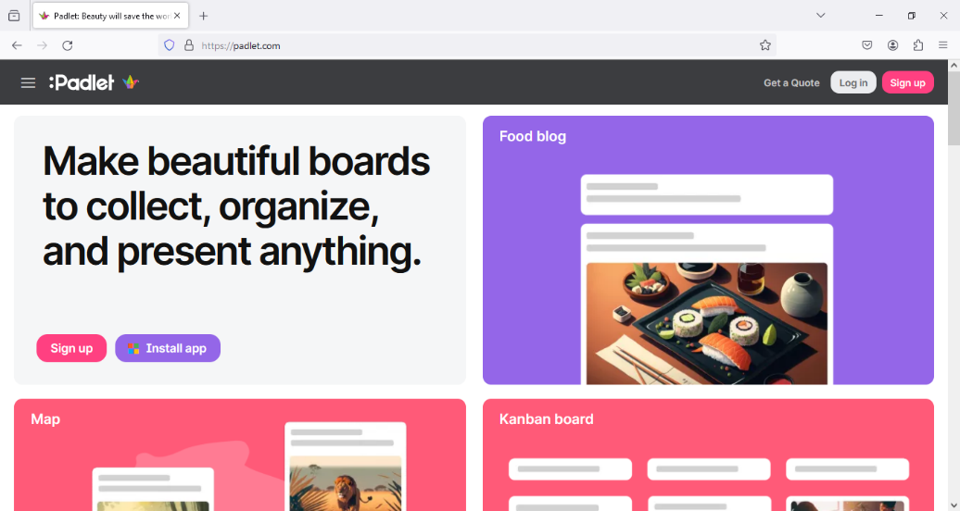

Users can create accounts in Padlet in a variety of ways, including using a Google, Apple, or Microsoft account. Another way to create an account is by email, which can also be used to sign up.

**Picture 2. Padlet’s Sign Up Page**

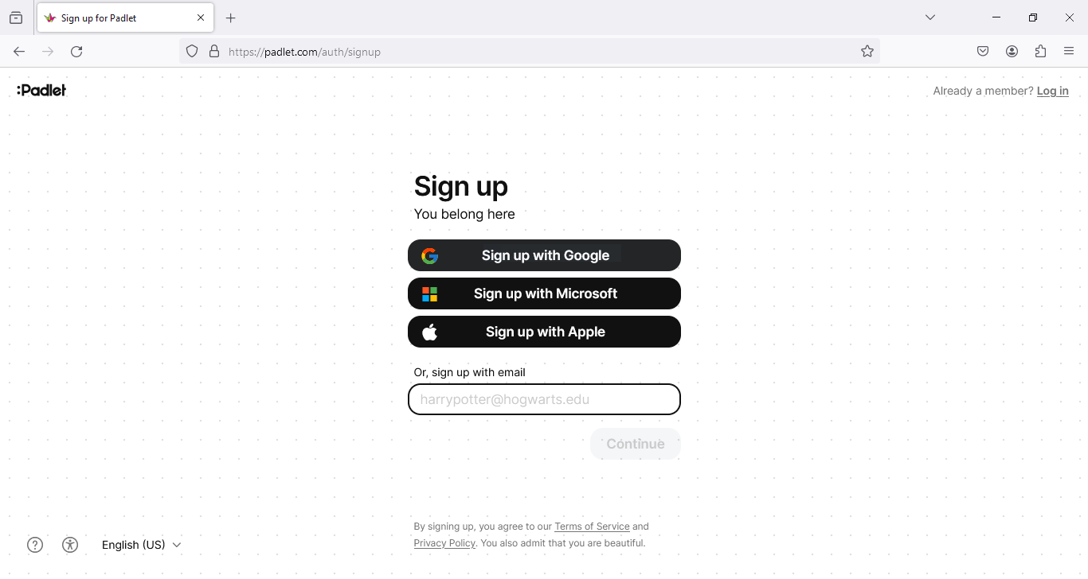

After users register in Padlet, they will see a page to select membership. After creating a membership plan, they can start Padlet.

**Picture 3. Membership Page of Padlet**

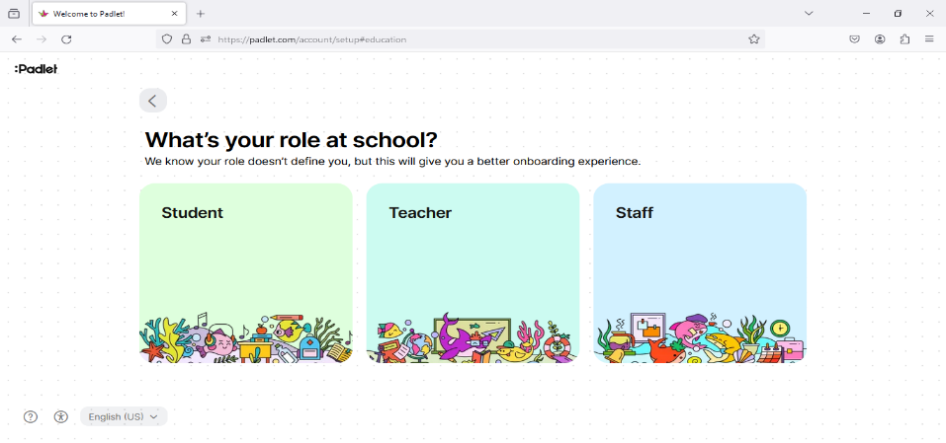

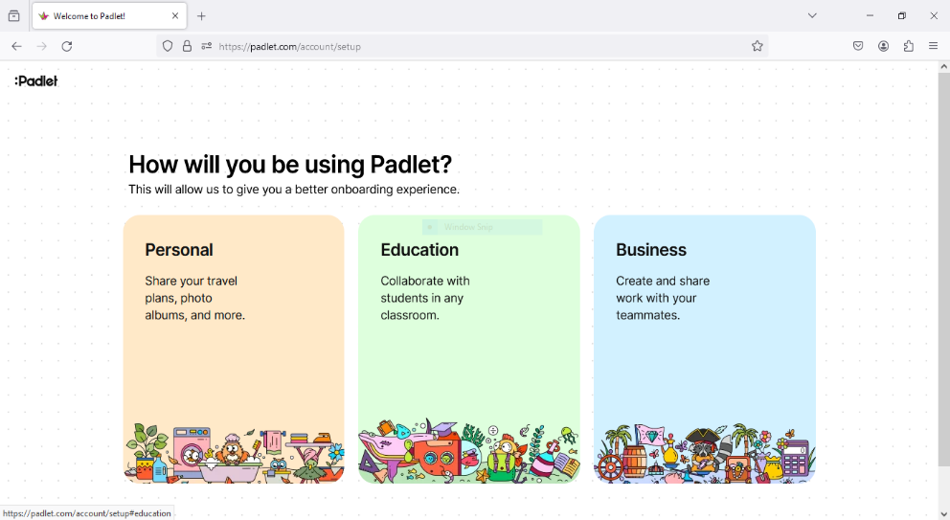

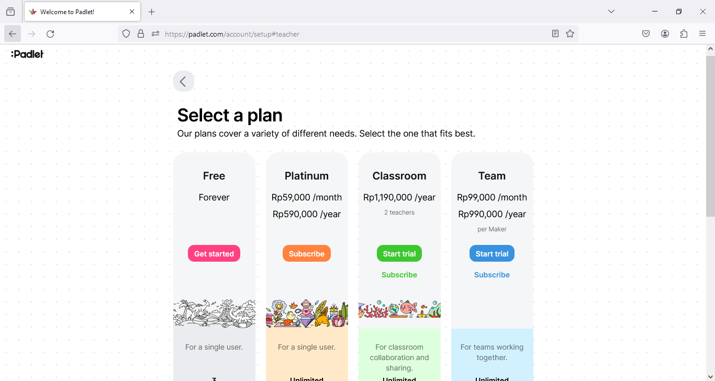

On the main page, users will see the folders along the side of the homepage to stay organized, as well as several colored buttons on the top right that allow users to create their own boards, join other users' boards and also view the Padlet Gallery located on the left side of a main page to get inspiration about the different ways users can use the Padlets.

**Picture 4. Pdlet’s Starting Page**

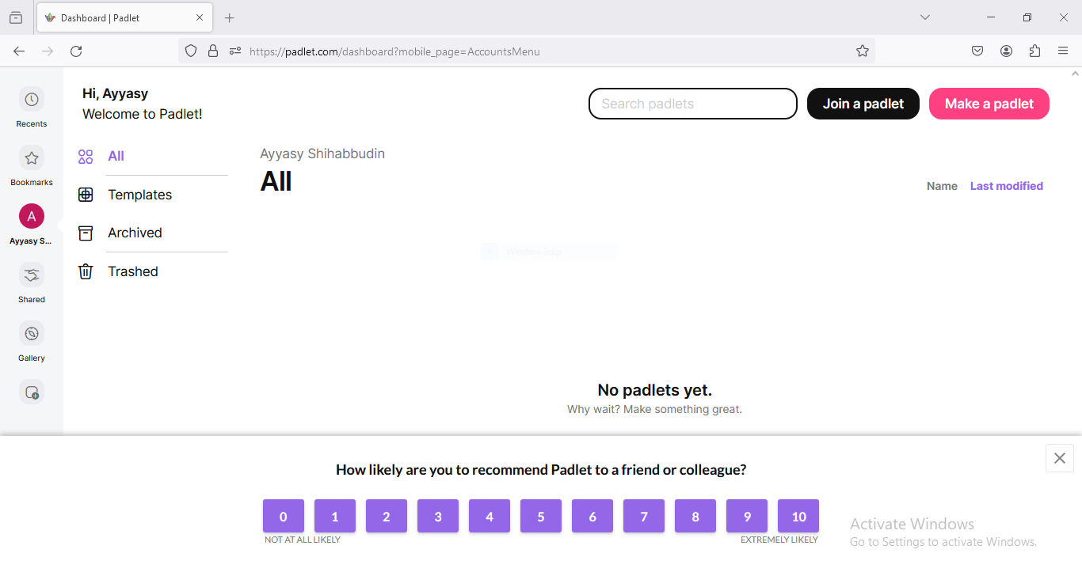

To start the user's first board, click Make a Padlet. Then, the user can choose the template format for displaying the content.

**Picture 5. Padlet’s User Page**

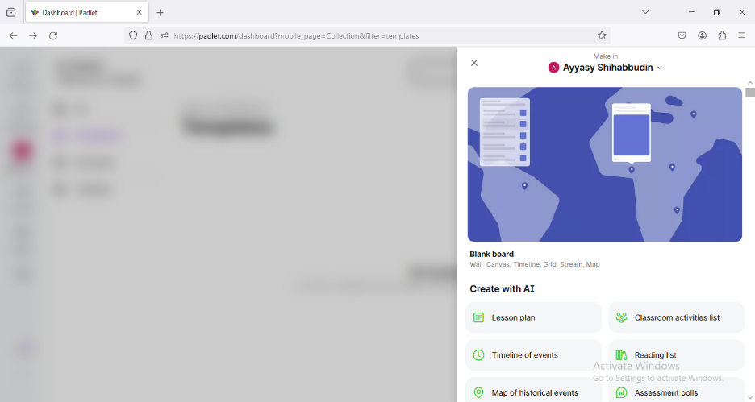

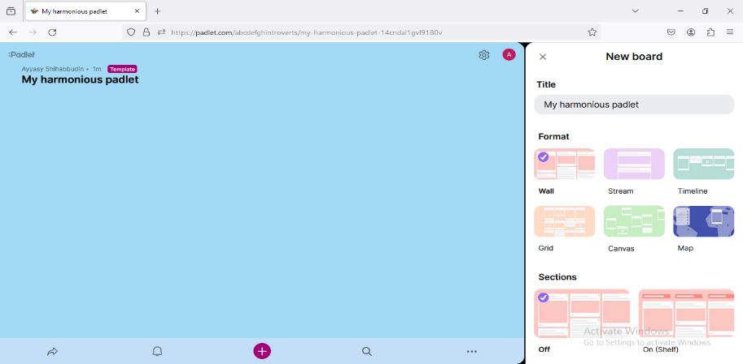

Furthermore, Users can join other users' Padlet pages available by clicking join and then entering the link address.

**Picture 6 Padlet’s Join Page from other users**

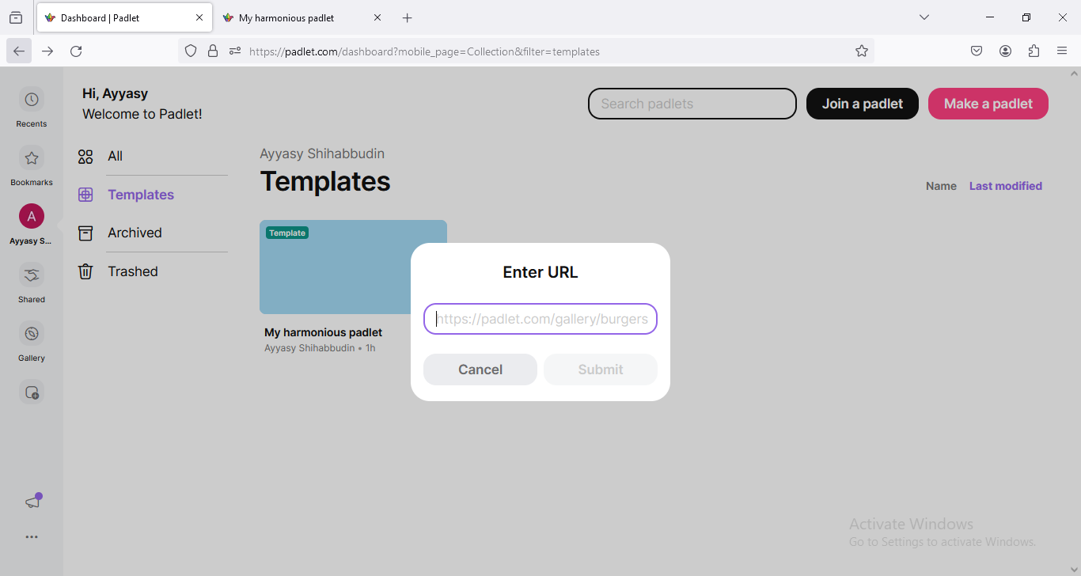

Now the users can change and configure their own walls. To change walls, users can click on the setting icon to provide title, description, andchange the background image to make the user page more attractive.

**Picture 7. Heading setting options**

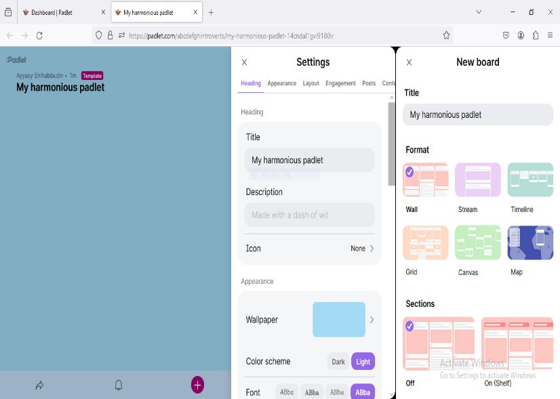

For the next step, the user can configure the privacy of the Padlet wall. To provide feedback on a post, users can enable comments and reactions to the post so they can exchange ideas and discuss more in depth.

**Picture 8. Privacy Options in Platform Settings**

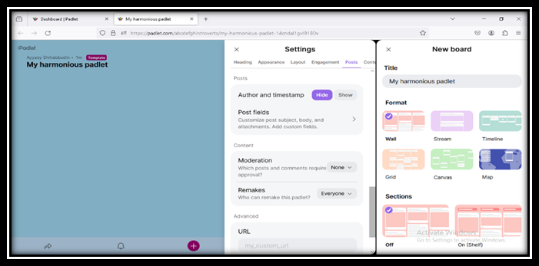

After setting privacy, users can start posting on a blank wall by clicking the "plus" button. Then can add images, videos, or documents from the desktop.

**Picture 9. Main Page Added Posts**

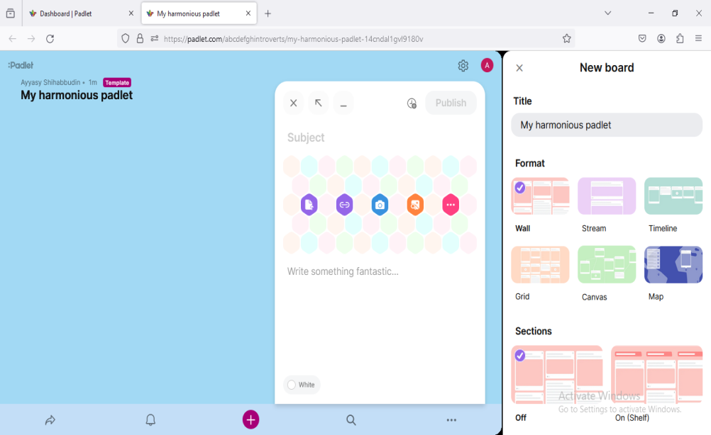

In the last step, Users can share Padlets easily through various social platforms and emails. Click the "three dots" button and "Share".

**Picture 10. Page Share Posts via Links and Other Application**

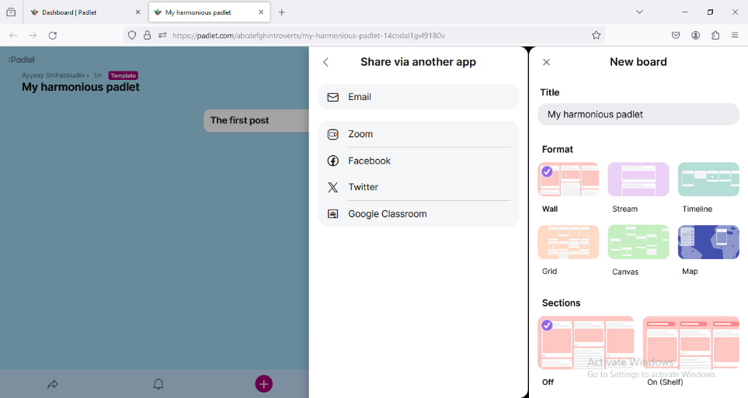

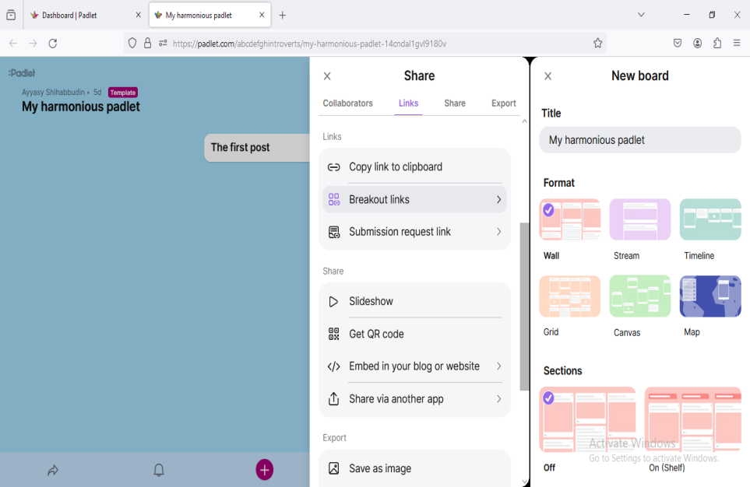

In addition, users can also export padlets after completing tasks in

various formats, such as CSV, Excel, and PDF. This allows users to store data and share it with others.

**Picture 11. Post Export Page Using a Variety of Formats**

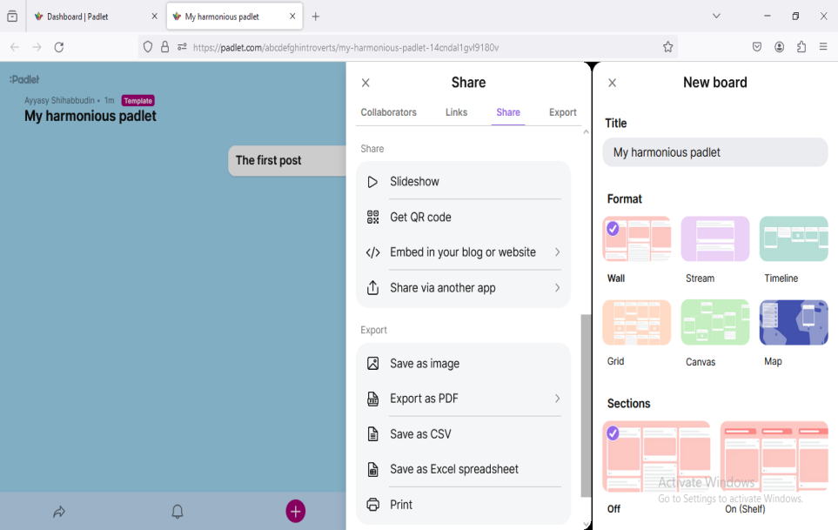

1. **Advantages and disadvantages of using Padlet in the learning process**

According to Musdir et al. (2018), there are advantages and disadvantages to using Padlet in the learning process.

* + - 1. Advantages of using the Padlet application

1. Padlet provides a variety of interesting layouts and display options, so it can increase students' creativity to learn.
2. Padlet is free, and there is technology that is easily accessible and utilized with the available features.
3. Padlet can be used on both computers and smartphones.
4. Padlet has many features that are very supportive of learning materials, such as natural science, math, English, etc.
   * + 1. Disadvantages of using the Padlet application
5. In the Padlet application, students can share any idea they think of so that the teacher can no longer know the student's character. As a result, the teacher becomes curious about things that can be of concern to students when learning.
6. Padlet requires a stable internet connection, so it will hamper the learning process if students have problematic internet connections.
   * 1. Concept of Writing
7. **Definition of Writing**

According to Harmer in his book, writing can be described as a task that encourages students to focus on using the correct language and sparks language growth because students utilize it to address problems that have been written in their minds (Harmer, 2004). Harmer states that writing is the process of expressing in writing ideas, thoughts, and feelings as well as a process of creating language. He also states that writing is a complex, intricate skill, which includes or involves a series of smaller skills. Writing has nothing to do with talent. Writing can indeed feel easy and can also feel difficult, easy if you do it often and difficult if you are not used to it. Because writing is a skill as much as any other skill to acquire it must learn, practice, and familiarize yourself is the key. As a result, these factors should be included in learning activities at school and elsewhere. Therefore, writing is a way of creating language that comes from ideas or ideas that contain additional value, uniqueness, and the work of a writer. This is supported by the many platforms that facilitate a person to write and can also form a concept, emotion, or point of view developed as a result of the writer's hard work. In addition, writing is an activity that produces a personal activity either composing which consists of ideas, feelings, and thoughts through writing or media.

Good writing has a good flow, content, and language. From the point of view of flow, good writing has a thought flow that is magical and continuous. In terms of content, good writing contains accurate information, and its truth is scientifically accountable. In terms of language, a good narrative uses correct spelling, variable diction, effective sentences, and consistent paragraphs (Permanasari, 2017).

Based on the previous definition, the writer can conclude that writing is a process of activity that pours out one's thoughts, ideas, and feelings expressed in the form of writing intended to be read by readers and serves as information conveyed to others in the form of written works and also as an indirect communication channel.

1. **Purposes of Writing**

(Whitaker, 2009) states that the purpose of the article is to answer the question given as the topic. The question provides a rationale. The three most common purposes of academic writing are persuasion, analysis/synthesis, and information. The purpose of writing is to make the reader agree with the content of the essay written by the writer. This is closely related to how the writer conveys an idea in writing that can attract and interest readers. Therefore, the level of writing ability of a writer must be truly mastered to produce good writing or essays supported by high initiative and creativity.

1. **Persuasive purpose**

In persuasive writing, logic and reasoning are used to prove that a particular idea is more reasonable or legitimate than another idea. Persuasive academic writing usually seeks to seduce, persuade, and get the audience to accept the offered solution to a problem. As a result, choose one answer to a question, defend that answer using strong evidence and logic, and try to influence the reader's opinion on the subject. The genres of persuasive writing include argumentative essays and position papers commonly known as persuasive essays. Based on the explanation above, it can be seen that the purpose of persuasive writing is to convince and influence readers towards a belief, opinion, or idea to do something and lead them to action.

1. **Analytical purpose**

The purpose of analytical academic writing is to explain, clarify, and evaluate the various responses to the question provided, with the best response chosen based on the writer's criteria. Although analytical writing builds on descriptive writing, it also requires reorganizing the facts and information described into sections, categories, groups, types, or relationships. Therefore, to write a true analytical essay, a writer must start with a strong framework. Analytical academic writers add to the growth of knowledge in their field by analyzing things in depth. This encourages the writer to examine various logical arguments, perspectives and evaluate evidence. Analysis academic writing assignments often take the form of analyzing others' arguments, examining effects, evaluating effectiveness, finding connections between different ideas, assessing ways to solve problems, or investigating causes. Examples of analysis writing include critical analysis and analysis papers.

1. **Informative purpose**

The purpose of informative academic writing is to introduce and inform the reader about a topic by breaking down the potential solutions to a problem available. In contrast to analytical writing, the informative writer aims to increase the reader's perspective on all aspects of a topic, from which one can draw their own conclusions.

1. **Content of Writing**

According to Jacob et al (1981), there are five components of writing:

1. **Content**

Completion and unity belong to the two components of content. A knowledgeable and skillful reader can concentrate on a few words or phrases that display textual completeness and coherence so that the reader can quickly grasp the meaning textually and contextually so that the recipient can understand the meaning contained in the discourse.

1. **Language use/grammar**

Writing requires the use of correct language and grammar. A writer who has a nice knowledge of grammar can understand what makes for effective writing that captures the reader's attention and understanding. Writing in English requires the use of proper forms of adverbs, adjectives, subjects, and verbs. The meaning of a sentence will be more easily understood by the reader if the form of the sentence is grammatically correct. Proper use of grammar, spelling, and punctuation allows the writer to be able to convey his thoughts quickly and precisely so that the reader can easily read and understand them.

1. **Organization**

Organization and coherence go hand in hand as good guidelines for effective writing. A text is said to be organized if one phrase leads to another and continues, which means they are related to each other as a rounded or holistic system that shows that the main point of the message is not interrupted. This means that the elements in the writing should harmonize with each other in form and meaning. In the process, organization and coherence add elegance and accessibility to a work.

1. **Mechanic**

There are several components to the writing process, including capitalization, spelling, and punctuation. A good and correct form of writing is one that pays attention to the use of letters, punctuation marks, and others. A sentence can be misunderstood if the punctuation, spelling, or capitalization are wrong. In the process of writing paragraphs, capitalization and punctuation need to be improved and understood by everyone to support the improvement of language skills.

1. **Vocabulary**

Vocabulary and word choice are interrelated because both are used in sentences. The words used in a sentence need to be chosen properly and correctly so that they can express the meaning properly and correctly as well. This can make it easier for readers to understand the user's intention. If a word is used incorrectly, the meaning of the sentence will also be wrong. The terms used must be in accordance with the writing rules for the text message available.

1. **Process of writing**

According to Harmer (2004) in his book, the process of writing has four elements. They are:

1. **Planning**

There are three main things that writers should consider when planning. Firstly, the purpose of their writing should be considered because, as a writer, they aim to entertain, inform, clarify, prove, or persuade the reader. If this is not the case, it can affect the type of text they want to write as well as the language and materials they use. Therefore, writers should know and understand why they are writing on their chosen topic.

Secondly, the writer must be adept at considering and paying attention to the target or reader; if this is not done well, it will affect the organization of the writing (how paragraphs are put together, how to understand and use organizational patterns, etc.) and can also affect language choices, such as whether the writing is standard or non-standard.

Thirdly, the writer needs to organize the ideas for writing in the form of an outline, which is used by a writer to prepare for writing as the last phase of pre-writing. Also, the writer must check the structure of the content of the work or know how to most effectively structure the arguments, facts, or ideas they choose to include in the framework.

1. **Drafting**

Drafting is the process of putting down all the ideas and thoughts about everything developed during prewriting. While this stage may only take a few minutes or hours, it is very important to include as much information as possible in this initial draft. Therefore, during this stage of writing, don't concentrate too much on grammar and spelling. Instead, focus on transforming ideas into paragraphs and sentences because this stage requires editing to check the text as the first version of a draft.

1. **Editing**

After a writer completes his or her draft, it is on to the editing part, which aims to improve or revise the first draft that has been made earlier. This part is important in preparing a piece of writing to be published or read by the public. Editing includes double-checking unclear or confusing writing and changing style, organization, grammatical and lexical accuracy, and appropriateness. To determine what works and what doesn't, they often re-examine it by rearranging paragraphs or writing a new introduction. They may use a different form of wording with the revised writing. Good writers prefer to consider overall meaning and organization and also focus on small details such as grammatical correctness and specific words. The latter two are very important and are usually discussed at the end of the writing process. Therefore, to assist the writer in making modifications to a piece of writing, it is necessary to have some feedback from other readers on the piece in the form of comments and recommendations from other readers (or editors) as a form of reflection and rewriting.

1. **Final draft**

After the writer has revised and made any necessary changes to the draft, the writer then composes the final draft, which is commonly referred to as the final product of a piece of writing. As a result of the editing process, the initial plan and first draft of a document will have many drastic changes. Therefore, the writer is ready to publish the content to the intended readers.

* + 1. The description of teaching writing to eleventh grade students of SMK PGRI 2 Taman Pemalang

Writing is one of the English language skills that is considered difficult by students. From the results of a survey or interview with an English teacher at SMK PGRI 2 Taman Pemalang, on that occasion, the writer obtained information about English learning materials according to the eleventh-grade syllabus learning tools of SMK PGRI 2 Taman Pemalang on the independent curriculum. One of the English teachers at SMK PGRI 2 Taman Pemalang provides information related to the material taught in the second semester of eleventh grade, one of the materials to be taught in the second semester of eleventh grade is procedure text. One of the writing skills that students must master is procedure text. Many students experience difficulties in learning to write, especially on procedural text material. This is caused by several factors, including the low ability of students to think ideas/ideas related to the theme of the essay in English, the low motivation of students in writing English, and the willingness and perseverance to practice writing students lack. In addition, students often experience boredom during the learning process of writing English because the media is not interesting and they very rarely use learning media. Based on this, padlet media is very appropriate to be used to train procedure text writing skills in class XI SMK PGRI 2 Taman. With this padlet application, students can easily understand the learning process of writing English because English lessons rarely use learning media in learning to write procedure texts.

* + 1. Procedure text

**Definition of Procedure text**

A procedure text is a text that explains how to do something (Safitri & Maisaroh, 2022). This shows that procedure text is used to explain how to make or complete something in a series of steps or instructions to produce something interesting. Examples are recipes from cooking manuals, game rules, travel instructions, tool assembly instructions, and following processes in school textbooks to acquire new knowledge. People usually use procedural literature in various places. Other terms for procedural literature include instructions, "how to make something" guides, technical writing, and instructions. Therefore, we can conclude that a procedural text is one that explains how people perform various processes or steps in a sequence of actions or steps.

**Purpose of Procedure text**

A procedure text defines how to do, make, and operate something interestingly so that others can easily be interested in imitating it. Some writers give advice that aims to make the steps easier. Before starting the steps, the writer usually explains in detail the materials, equipment, and procedures needed to make something in the form of text that contains several diagrams, photos, or drawings to help the reader see the process. Photos of finished products can also be given as examples to be published to the general public.

**Structure of Procedure text**

Each type of text needs a generic structure to organize and describe the content of the text or as a differentiator from other types of text with the characteristics of each text. According to Peter Knapp and Megan Watkins (2005), the generic structure of procedure text commonly referred to as the structure of procedure text is focused on instructing readers on how to make and perform a certain action with the communicative purpose of informing and showing how to make or how to operate something. The generic structure must be appropriate to the topic discussed, which means it must focus on the purpose. Therefore, procedure texts are often associated with a title (goals), materials or tools, and steps or processes.

**Language features of Procedure text**

According to Peter Knapp and Megan Watkins (2005), there are five common components of language features in procedure texts that support the preparation of procedure texts. The five components are imperative sentences, action verbs, connectives, adverbs, and present tense.

1. **Imperative sentence**

Imperative sentences are sentences that contain the delivery of orders, prohibitions, or requests to give warnings or do something according to what is discussed in the text with the aim that the reader does what the text commands. Examples of procedure texts with command sentences: use liquid soap to make it cleaner, use cooking oil for better results, boil water until it boils, etc.

1. **Action verbs**

Action verbs are activities that physically involve the subject describing the action. Procedure text is one type of text that has certain types of action verbs, such as put, move, cut, serve, pour, etc.

1. **Connectives**

Connectives is a word that connects between two clauses or phrases that have a function to sequence one step with the step after it. With the presence of connective words in the procedure text it will help readers understand that the instructions must be followed in the correct order of steps or processes such as, finally, next, after that, then, first, etc.

1. **Adverbials**

Adverbial is a word that gives information to other words, such as adjectives and verbs that have several components of language features in procedure texts which include size, weight, time, etc. for example 2 kilograms of sugar, 45 seconds, 50 inches, etc.

1. **Simple present tense**

The simple present tense is a tense used to describe facts that show activity in the present. Procedure texts use simple present tense to describe the situation at the same time as the activity of using or making something that is being done. It is as if the procedure is taking place in real time, helping the reader complete the task.

**Example**

The writer found three examples of types of procedure texts, namely recipes, instruction manuals, and directions. There are stages of making procedure texts that need to be remembered, such as identifying the title, setting objectives, making a list of tools and materials, compiling steps, and finishing with a closing or conclusion. Therefore, when the reader wants to make or do something it must do it according to the steps, because if the reader does it randomly or not according to the instructions, it can be fatal. To make the results clearer and easier to understand, the procedure text must include the structure and language rules, such as the three examples of procedure text below sourced from Ahmad Muhammad's teaching module.

1. **Procedure Text : Recipe type**

**Picture 12. Recipe type procedure text**

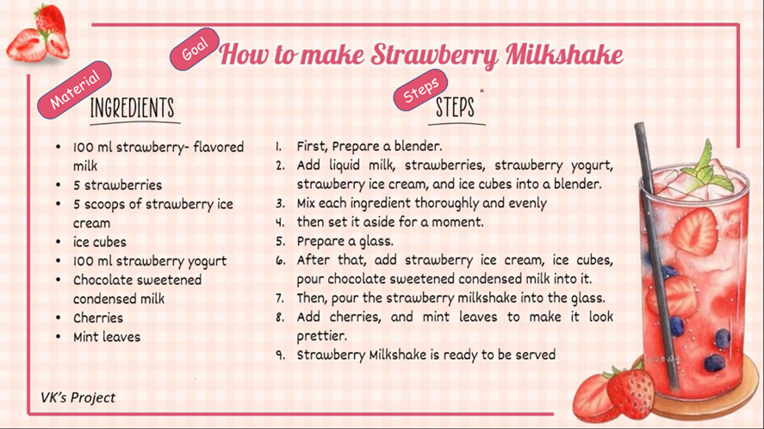

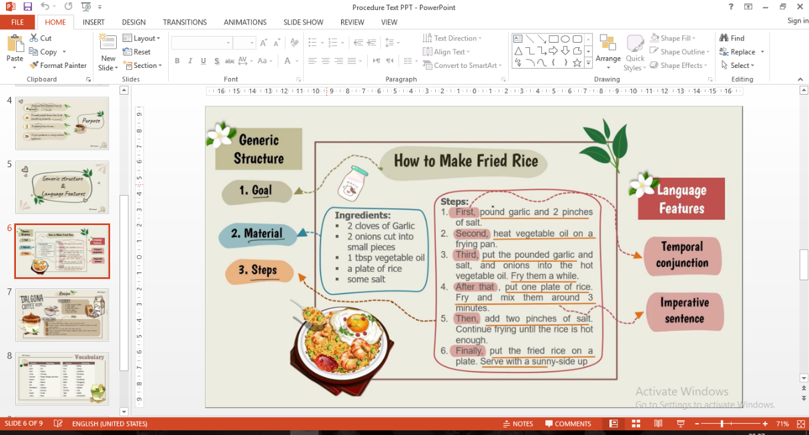

**2) Procedure Text : Instruction Manual type**

**Picture 13. Instruction manual type procedure text**

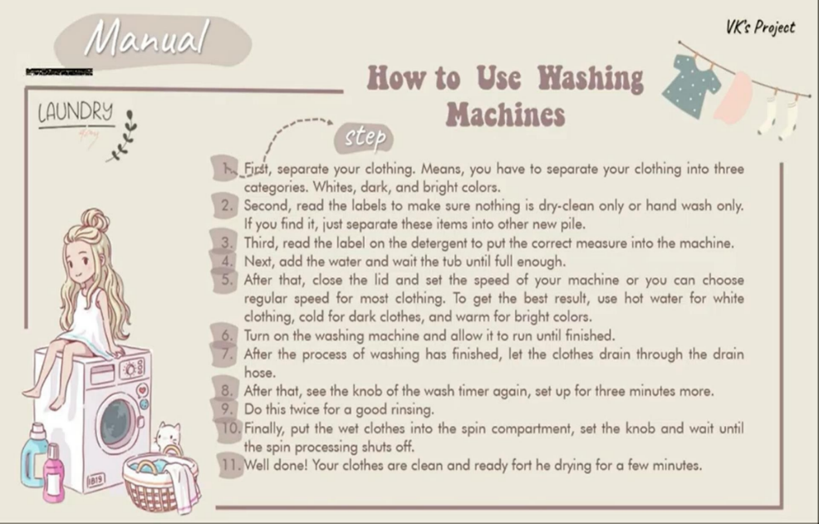

**3) Procedure Text : Directions type**

**Picture 14. Directions type procedure text**

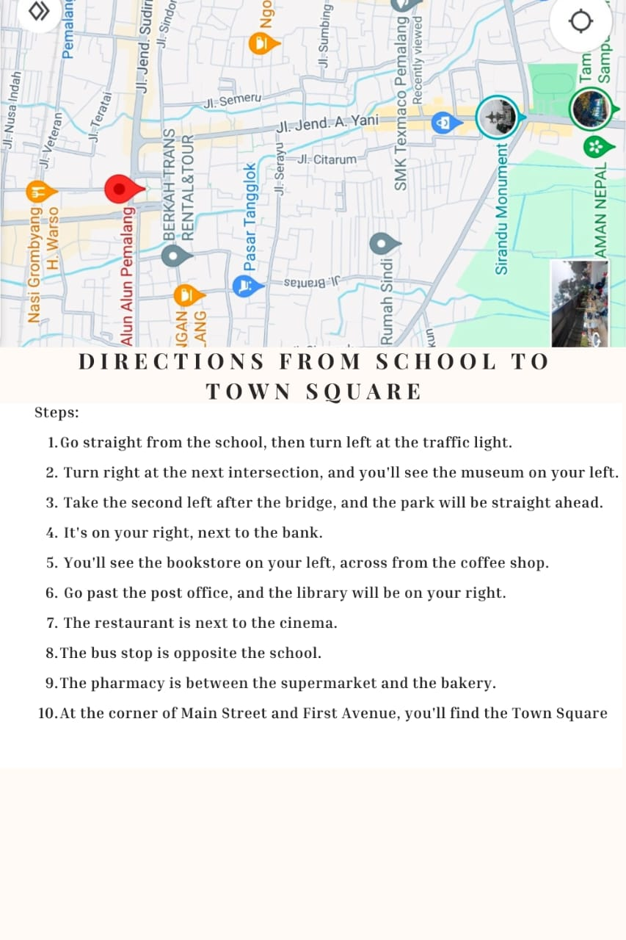

* 1. Theoretical Framework

Teaching procedure text writing class in the eleventh grade of SMK PGRI 2 Taman

**Problems in writing**

Students´difficulties in developing their idea in writing

Vocabulary mastery of students is still low

Writing becomes a boring and difficult activity

There needs to be a solution, a suitable media to help students in writing

Applying Padlet application in writing classes

**Learning method that can be used**

Discussion method

Lecture method

**Goal**

The improvement of students´ writing proficiency by using Padlet application

* 1. Hypothesis

1. **Null Hypothesis (H0)**

There is no positive effect of using the Padlet application as a learning media on students’ procedure text writing achievement.

1. **Alternative Hypothesis (H1)**

There is a positive effect of using the Padlet application as a learning media on students’ procedure text writing achievement.

# 

# CHAPTER III RESEARCH METHODOLOGY

This chapter covers the research approach, type, and design of the research, as well as the population, sample, technique of sampling, research variables, data collecting technique, research instrument, and technique of analyzing data.

* 1. Approach, Type, and Design of the Research
     1. Approach

This research used a quantitative approach. According to Apuke (2017:41), quantitative research is concerned with the analysis and measurement of variables to achieve results that include the use and analysis of numerical data using special statistical techniques to answer research questions or test previously established hypotheses. In the quantitative research method approach, there are several types of methods, one of which is the experimental method. The writer used a two-group design (an experimental group and a control group) in this research. This research was based on a survey conducted at SMK PGRI 2 Taman Pemalang regarding the influence of the Padlet application on students’ writing achievement. This research used procedural text material.

* + 1. Type

The type of research the writer used was experimental research. This research was conducted on eleventh grade students in the even semester of SMK PGRI 2 Taman Pemalang in the academic year 2023/2024. This is to determine the effect of the application of Padlet on students’ writing achievement.

* + 1. Design of the Research

This research design was a quasi-experimental research. According to Creswell (2018), a quasi-experiment is a method in which the researcher has little or no control over randomly assigning participants to levels of the variable of interest. Meanwhile, quasi-experimental research is designed to determine and observe the cause-and-effect of variables and determine whether there is an effect of the treatment given. The writer selected one class as the experimental class and one class as the control class. The experimental class was given treatment using the Padlet application, while the control class was given the conventional method usually given by the teacher.

At the beginning of the research, the writer gave a pre-test, which is a test before being given treatment, in the two research classes. In the last meeting, the writer gave a post-test in which students wrote procedure texts after both classes received treatment. Before the post-test, the writer conducted six treatments in both classes.

**Table 1. The Design of the Research**

|  |  |  |  |
| --- | --- | --- | --- |
| **Group** | **Pre-test** | **Treatment** | **Post-test** |
| **Experimental Group** | Written test: writing a procedure text on paper sheet | Treated by using Padlet application | Written test: writing a procedure text on paper sheet |
| **Control Group** | Written test: writing a procedure text on paper sheet | Conventional method (only using PowerPoint presentations) | Written test: writing a Procedure text on paper sheet |

* 1. Population, Sample and Technique of Sampling
     1. Population

In this research, the research population was the eleventh grade students of SMK PGRI 2 Taman Pemalang in the academic year 2023/2024. There are eighteen classes of eleventh grade students at SMK PGRI 2 Taman Pemalang. The total number for eleventh grade is 590 students.

**Table 2. Population of The Students at the Eleventh grade**

|  |  |  |
| --- | --- | --- |
| **No** | **Class** | **Number of student** |
| 1 | XI DKV 1 | 31 |
| 2 | XI DKV 2 | 30 |
| 3 | XI DKV 3 | 30 |
| 4 | XI PPLG 1 | 33 |
| 5 | XI PPLG 2 | 28 |
| 6 | XI PPLG 3 | 30 |
| 7 | XI MPLB 1 | 36 |
| 8 | XI MPLB 2 | 35 |
| 9 | XI MPLB 3 | 36 |
| 10 | XI MPLB 4 | 36 |
| 11 | XI AKL 1 | 34 |
| 12 | XI AKL 2 | 35 |
| 13 | XI AKL 3 | 36 |
| 14 | XI AKL 4 | 34 |
| 15 | XI TKJ 1 | 33 |
| 16 | XI TKJ 2 | 33 |
| 17 | XI TKJ 3 | 33 |
| 18 | XI TKJ 4 | 30 |
| **TOTAL** | | **590** |

* + 1. Sample

According to Alvi (2016:11), a sample is a small group of the population that is the source of research data where the research will be conducted.

In this research, the writer took two classes, namely XI DKV 2 and XI TJKT 4, each class consisting of 30 students. The first group was XI DKV 2 as the experimental group, and the second group was XI TJKT 4 as the control group. Therefore, the total number of students in the two classes was 60 students. The reason the writer chose the class as a sample was because, according to the writer's experience during the teaching practice at SMK PGRI 2 Taman Pemalang, the class was more active and more diligent than the other classes.

* + 1. Technique of Sampling

The technique of sampling used by the writer in this research was a cluster random technique. According to Fenti Hikmawati, (2020:65), Cluster Random Sampling is a random sampling method based on groups, not individuals. However, the groups must have the same characteristics. Then the writer's sampling decision was supported by the teacher's recommendation to research in class XI DKV 2 and class XI TJKT 4 because the class was a class that had not received procedure text material in the even semester of the academic year 2023/2024, so the writer chose class XI DKV 2 as the experimental group and class XI TJKT 4 as the control group, each of which had 30 students as the research sample. Therefore, XI DKV 2 as the experimental group was given treatment using the Padlet application media, while XI TJKT 4 as the control group without using Padlet application media.

* 1. Research Variables

According to Fraser Health Authority (2011:20), variables are characteristics of people and objects that have variations in quantity and quality. Variables are manipulated, observed, and measured to determine if there is a correlation or influence between variables in the population. In addition, he also said that there are two types of variables, namely dependent and independent variables. The dependent variable is the response variable that is influenced by the independent variable. Meanwhile, the independent variable is a variable that is measured, observed, and manipulated by researchers to influence changes or the onset of dependent variables. In this research, there are two variables:

1. Independent Variable

The independent variable (x) in this research is the use of the Padlet application as learning media.

1. Dependent Variable

The dependent variable (y) in this research is the improvement of students’ writing achievement.

* 1. Data Collecting Technique

The writer used a data collection method in this research, namely a written test consisting of a pre-test and a post-test. The data analysis for this research came from the administered test, which was used to measure the positive impact of the treatment on students' academic performance. The writer gave an achievement test to the students to measure their ability in writing procedure texts.

* 1. Research Instrument

The purpose of this instrument was to measure research variables. According to Rahmat, (2018:138-139), A research instrument is all the tools used to collect, monitor, and apply data from respondents using the same measurement method. By choosing the right tools, data can be reliable. There are some instruments in research, such as tests, questionnaires, observations, ratings, documentation, and interviews.

In this research, the writer used a writing test as a research instrument. A writing test was conducted to evaluate students' writing skills and to find out the results of research after students were treated using a Padlet application. The writer collected the data by using several steps:

1. **Pre-test**

Before using the Padlet application to teach writing, the writer conducted a pre-test. The purpose of this pre-test was to measure students' understanding and initial abilities on procedure text material before students received treatment. Students in the experimental group and control group were given pre-test questions to create procedure texts. The writer gave the students 45 minutes to work on the procedure text questions on the paper sheet that the writer had prepared. The writer has prepared three types of procedure text questions, namely recipes, instructions, and instructions. Students are asked to choose one of these types of questions. The test lasted for 45 minutes. When they have finished working, the answers are collected.

1. **Treatment**

Then the writer gave treatment to the experimental group by using the Padlet application. Meanwhile, the control group was asked to use the conventional method (only using PowerPoint presentations). The writer created a teaching module on writing procedure text using the Padlet application. The materials given to students were related to writing procedure texts. The writer also explained how to create procedure texts by using the Padlet application and writing assessments related to procedure text materials, which include content, vocabulary, mechanics, grammar, and organization. The treatment was only given to the experimental group. The treatment was given offline, so a cell phone or computer was needed as a tool to use or open the Padlet application in the experimental class. The purpose of this treatment was to find out whether the use of the Padlet application resulted in a significant improvement in the quality of writing procedure text. The experimental class received treatment for six meetings, each lasting 2x45 minutes. While in the control group, the writer gave six treatments by giving procedure text material not using the Padlet application but using conventional methods (only using PowerPoint presentations).

1. **Post-test**

The writer used the post-test as the second test after using the Padlet app to teach writing. The post-test was used to measure students’ achievement and scores after receiving the treatment. Students in the experimental group and control group received the post-test. Students in the experimental and control groups were given post-test questions on creating procedure texts. The writer gave the students 45 minutes to work on the procedure text questions on the paper sheet that the writer had prepared. The writer has prepared three types of procedure text questions, namely recipes, instructions, and instructions. Students are asked to choose one type of procedure text question. When they have finished working, the answers are collected.

Therefore, validity is an important factor to be considered when evaluating the quality of research instruments. The writer uses the content and validity of the construction proposed by Sugiyono (2013:129), that the evaluation of this research instrument is based on the themes contained in the measured instrument of each component of the eleventh grade curriculum, the opinion of the experts, and the specific learning objectives of the learning plan.

1. **Validity of test**

A good instrument must be valid, reliable, and qualified. According to Akbar (2011), Validity is a measure of how carefully an instrument performs its task. A measuring instrument can only be considered valid if it can measure the object in question precisely. Instrument validity can be divided into three categories: Content Validity, Construct Validity, and Criterion Validity. In this research, the result can be said to be valid if the instrument has been tested according to the material taught based on the validity of the content.

1. **Content Validity**

Content validity was used because the instrument relates to the topics in the eleventh grade syllabus. Since the instrument used in this research was a writing test, the validity of the instrument was evaluated by an expert or validator, namely an English teacher who teaches eleventh grade students at SMK PGRI 2 Taman Pemalang and a lecturer in the English language education study program who is an expert in writing materials. This validity was used to evaluate whether the instrument accurately displayed the required content. The test was adapted to vocational high school materials and school learning objectives to verify content validity. The materials should be organized in a way that corresponds to the school's learning objectives for eleventh grade vocational students. First, the writer consulted with the lecturer of the English study program who was an expert in the topic of writing. Next, the writer consulted with the eleventh grade English teacher at SMK PGRI 2 Taman Pemalang to determine whether the instrument was valid or not.

1. **Construct Validity**

Construction validity was used because the subject of the instrument measures each element in accordance with the instruction objectives of the teaching module. In other words, a test is a tool to evaluate one's ability to write text. Test design determines construct validity. Harmer created a new scoring rubric by including five writing criteria: content, organization, vocabulary, language use, and mechanics. All of these criteria were used to assess students' writing abilities. The writer consulted with the tenth grade English teacher at SMK PGRI 2 Taman Pemalang and one of the lecturers of the English education study program to assess the validity of the research instruments based on the competencies, materials, indicators, instructions, and instrument types offered in the subject syllabus.

Therefore, content validity and construction validity used to measure the research instrument. Based on the description above, the research instrument was valid because it matches the topics in the SMK PGRI 2 Taman Pemalang syllabus. In addition, the topics fulfill the specific instructional objectives in the teaching module.

* 1. Technique of Analyzing Data

After the test was completed, the student's work was collected and evaluated using the already created instruments. The writer assessed student work based on five factors: content, organization, vocabulary, language use, and mechanics. The table criteria below shows the many types evaluation writing which adopted from (Brown, 2007).

**Table 3. Categories of Evaluation Writing**

|  |  |  |
| --- | --- | --- |
| **The aspect of writing** | **Score** | **Description** |
| Content | 1 | The details have nothing to do with the topic and the topic is unclear |
| 2 | The details have nothing to do with the topic but the topic is very clear |
| 3 | The details have almost nothing to do with the topic but the topic is clear and complete |
| 4 | The details have something to do with the topic and the topic is clear and complete |
| Vocabulary | 1 | lack of knowledge of words, word forms, and unstable |
| 2 | Limited number of words and confusing forms |
| 3 | Few misuse of vocabulary and word forms, but does not change the meaning |
| 4 | Effective choice of tenses and words |
| Mechanics | 1 | too many errors in capitalization, punctuation, and spelling |
| 2 | frequent errors in the use of capital letters, punctuation, and spelling |
| 3 | sometimes there are errors in capitalization, punctuation, and spelling |
| 4 | correct use of capital letters, punctuation, and spelling |
| Grammar | 1 | Frequent inaccuracies in grammar or agreement |
| 2 | Lots of confusion or grammatical errors |
| 3 | Some discrepancies or grammatical errors |
| 4 | Minimum inaccuracies in grammar or agreement |
| Organization | 1 | Incomplete identification and description, and unrelated relationships between sentences |
| 2 | Incomplete identification and description but little relationship between sentences |
| 3 | Incomplete identification and description but almost related sentences |
| 4 | Complete identification and description and relationship between related sentences |

1. **Formula of Writing Assessment**

To get the description of the total score of the aspect of writing by the students, the writer use the following formula:

**TS= C+O+V+L-M**

**TS** : Total score

**C** : Content

**O :** Organization

**V** : Vocabulary

**L** : Language use

**M** : Mechanic

To know the final score of each students, it was calculated by:

**FS** = $\frac{TS}{20}X 100$

**FS** : Final score of each students

**TS** : Total score of the aspect of writing

Based on the description above, the classification of students’ writing skills and their scores are classified as follows:

**Table 4. The Classification of Students’ Score**

|  |  |
| --- | --- |
| **Score** | **Categories** |
| **80-100** | **Very Good** |
| **66-79** | **Good** |
| **56-65** | **Enough** |
| **40-55** | **Less** |
| **30-39** | **Fail** |

1. **The Application for Data Analysis**

After the writer collected the pre-test and post-test data, Microsoft Excel and IBM SPSS 29 (Special Package for Social Sciences 29) application for Windows 10: 64-bit was used to calculate and analyze the research data.

1. **Test Requirements for Analysis**
2. **Descriptive Statistics**

The writer showed the total number of individuals in the sample, mean, standard deviation, and minimum and maximum scores using descriptive statistics. Data was collected using the pre and post writing test scores of the experimental and control groups.

1. **Normality Test**

This research used a normality test to analyze the research data. This was done to determine whether the distribution of the data collected was normal or not. To determine the normality of the research, the Shapiro-Wilk formula was used with a significance level of 0.050. The data was considered normal if the results exceeded the 5% alpha level of significance (Sig. > 0.050). Conversely, an abnormal distribution of data occurs when the score is less than 0.050.

1. **Homogeneity Test**

After checking whether the data was normally distributed, the writer conducted a homogeneity test. The homogeneity test determines whether the data distributions for these classes are similar or different, so the writer can use the t-test to evaluate the hypothesis. The writer conducted the homogeneity test in this research with a value of 0.050, using Levene's statistics on the SPSS 29 program. The data is considered homogeneous if it is significantly less than 0.05. In the same way, if the significance of Alpha 5% (Sig. 0.050) is significantly lower, then the variance is not homogeneous or not significant (Starkweather, 1988). Conversely, a value of 0.050 means that the data is not homogeneous. However, the variances will not be significantly different if the Alpha 5% significance (Sig. > 0.050) is significantly greater.

1. **Hypothesis Test**
2. **Paired-Samples T-Test**

The paired sample t-test was used to determine whether two paired samples have different means. For the paired sample t-test, the data must have a normal distribution. The writer first analyzed the pre-test and post-test data. Furthermore, in this research, the paired sample t-test was used to answer the first statement of the problem. The purpose of this t-test is to determine whether or not the use of Padlet apps can improve students' writing skills. This test was used to determine whether the research hypothesis was accepted or rejected.

1. **Independent Samples T-test**

The independent sample t-test is used to compare the means of two unpaired samples. The writer used the writing results from the post-test data. Furthermore, to answer the second statement of the problem, the writer used the independent sample t-test. This method investigates whether there is a significant difference in the writing quality of students using the Padlet app compared to students using the conventional method. The post-test results of the experimental and control groups were compared using the independent sample t-test.