

**THE EFFECT OF USING BBC LEARNING ENGLISH YOUTUBE CHANNEL TO IMPROVE STUDENTS’ LISTENING SKILLS**

(An Experimental Research on Fourth Semester of English Department Student

Universitas Pancasakti Tegal in Academic Year 2023/2024)

**RESEARCH PROJECT**

**Submitted as Partial Fulfilment of the Requirement for the Degree of Sarjana Pendidikan in English Educational Department**

**By:**

**AULIA NAILIN NI’MAH**

**NPM 1620600005**

**ENGLISH EDUCATION PROGRAM**

**TEACHER TRAINING AND EDUCATION FACULTY**

**PANCASAKTI UNIVERSITY TEGAL**

**2024**

# 

# 

# 

# MOTTO AND DEDICATION

**MOTTO:**

"Allah does not burden a soul beyond that it can bear." (Quran 2:286)

**DEDICATION:**

This Research Project dedicated to:

1. The love of my life, my parents, thank you for your encouragement in everything, unwavering sacrifices, endless patience, wise counsel, and unconditional love.
2. Me, thank you for overcoming obstacles and hardships without giving up.
3. My beloved brothers, my family, thank you for the love, support, encouragement, and sacrifices.
4. Mrs. Hj. N. L. Molla, S.Pd., M.Hum, and Mrs. Fajar Prihatini, M.Pd as the first and second advisor, who provided invaluable guidance, encouragement, and expertise in completing this research.
5. All of the lecturers of English Education Department, who have generously shared their knowledge and guidance throughout my learning process at university.
6. My one and only, thank you for always being there with love, valuable feedback, and moral support during challenging times.
7. All of my friends, thank you for your support, togetherness, time, and love.

# PREFACE

Praise and gratitude to Allah SWT for His infinite blessings and guidance that have been given so that the researcher can complete this final project entitled “The Effect of Using BBC Learning English YouTube Channel to Improve Students’ Listening Skills”. The researcher acknowledges that the completion of this research project was made possible through the guidance and advice received from several parties. Therefore, the researcher extends heartfelt gratitude to:

1. Mr. Dr. Taufiqulloh, M. Hum., as the Rector of Pancasakti University Tegal.
2. Mrs. Dr. Yoga Prihatin, M. Pd., as the Dean of Teacher Training and Education Faculty of Universitas Pancasakti Tegal.
3. Mrs. Yuvita, M. Pd., as the Head of English Department of Teacher Training and Education Faculty of Universitas Pancasakti Tegal.
4. Mrs. Hj. N. L. Molla, S.Pd., M.Hum as my first advisor, thank you for your invaluable guidance, encouragement, and expertise in completing this research.
5. Mrs. Fajar Prihatini, M.Pd as my second advisor, thank you for your invaluable guidance, encouragement, and expertise in completing this research.
6. Mrs. Endang Sulistianingsih, M.Pd as the lecturer of Comprehensive Listening subject, also all students of fourth semester of English Department of Universitas Pancasakti Tegal who have already helped me to be the participants of this research.
7. All of the lecturers of the English Education Department of Universitas Pancasakti Tegal.

# ABSTRACT

**NI’MAH, AULIA NAILIN, 2024. 1620600005**:“The Effect of Using BBC Learning English YouTube Channel to Improve Students’ Listening Skills **(**An Experimental Research on Fourth Semester of English Department Student Universitas Pancasakti Tegal in Academic Year 2023/2024)”. Research project. Strata 1 Program. Faculty of Teacher Training and Education. Pancasakti University Tegal. The First Advisor is Hj. N. L. Molla, S.Pd., M.Hum and The Second Advisor is Fajar Prihatini, M.Pd.

Keywords: *Listening, Learning Media, BBC Learning English*

The use of teaching media as a tool to learn listening is one of the best ways to overcome problems or difficulties in students' listening skills which are influenced by several factors. The purpose of this research is to find out whether there is any significant difference on the students’ listening skills before and after taught by using BBC Learning English YouTube channel.

This research uses quantitative method with the pre-experimental design with one group of pretest-posttest design. The population of this research involved all of students of English department of Universitas Pancasakti Tegal in the academic year 2023/2024. Meanwhile, by using the purposive sampling technique, the sample of this research consists of 38 students of fourth semester. The instrument of this research was listening test with 40 multiple choice items. The data collection in this research was analyzed by using SPSS version 27.

The results obtained that the mean scores of pre-test was 54.53, whereas the mean scores of post-test was 74.01. Furthermore, the sig. value showed 0,000, which is less than (<) 0.05, which means that the alternative hypothesis (H1) is accepted and null hypothesis (H0) is rejected at the 95% significance level. So, it can be concluded that there is any significant difference of students’ scores before and after taught by using BBC Learning English YouTube channel.

In conclusion, the use of BBC Learning English YouTube channel has a positive effect on students’ listening skills. The researcher suggests that teachers should use appropriate methodology and technique in presenting the material to create interactive and up-to-date learning and attract students’ attention. Teachers can encourage students to learn English not just in class, but also in any learning platform and resource that easily accessible. Teachers can also encourage students to improve their listening skill in English regularly by watching the interesting digital learning media in their cellphone, such as BBC Learning English YouTube channel.

# ABSTRAK

**NI'MAH, AULIA NAILIN, 2024. 1620600005:** "Pengaruh Penggunaan Channel YouTube BBC Learning English untuk Meningkatkan Kemampuan Menyimak Siswa (Sebuah Penelitian Eksperimen pada Mahasiswa Semester Empat Jurusan Bahasa Inggris Universitas Pancasakti Tegal Tahun Ajaran 2023/2024)". Proyek penelitian. Program Strata 1. Fakultas Keguruan dan Ilmu Pendidikan. Fakultas Keguruan dan Ilmu Pendidikan. Universitas Pancasakti Tegal. Pembimbing I Hj. N. L. Molla, S.Pd., M.Hum dan Pembimbing II Fajar Prihatini, M.Pd.

Kata kunci: Menyimak, Media Pembelajaran, BBC Learning English

Penggunaan media pembelajaran sebagai alat bantu dalam pembelajaran listening merupakan salah satu cara terbaik untuk mengatasi masalah atau kesulitan dalam kemampuan listening siswa yang dipengaruhi oleh beberapa faktor. Tujuan dari penelitian ini adalah untuk mengetahui apakah terdapat perbedaan yang signifikan pada kemampuan listening siswa sebelum dan sesudah diajar dengan menggunakan channel YouTube BBC Learning English.

Penelitian ini menggunakan metode kuantitatif dengan desain pre-experimental dengan one group pretest-posttest design. Populasi penelitian ini adalah seluruh mahasiswa program studi Bahasa Inggris Universitas Pancasakti Tegal tahun ajaran 2023/2024. Sementara itu, dengan menggunakan teknik purposive sampling, sampel penelitian ini terdiri dari 38 mahasiswa semester empat. Instrumen penelitian ini adalah tes menyimak dengan 40 butir soal pilihan ganda. Data yang terkumpul dalam penelitian ini dianalisis dengan menggunakan SPSS versi 27.

Hasil penelitian menunjukkan bahwa nilai rata-rata pre-test adalah 54,53, sedangkan nilai rata-rata post-test adalah 74,01. Selanjutnya, nilai sig. menunjukkan 0,000 yang kurang dari (<) 0,05, yang berarti bahwa hipotesis alternatif (H1) diterima dan hipotesis nol (H0) ditolak pada tingkat signifikansi 95%. Jadi, dapat disimpulkan bahwa terdapat perbedaan yang signifikan antara nilai siswa sebelum dan sesudah diajar dengan menggunakan saluran YouTube BBC Learning English.

Kesimpulannya, penggunaan saluran YouTube BBC Learning English memiliki efek positif terhadap kemampuan mendengarkan siswa. Peneliti menyarankan agar guru menggunakan metode dan teknik yang tepat dalam menyajikan materi untuk menciptakan pembelajaran yang interaktif dan up-to-date serta menarik perhatian siswa. Guru dapat mendorong siswa untuk belajar bahasa Inggris tidak hanya di kelas, tetapi juga di platform dan sumber belajar apa pun yang mudah diakses. Guru juga dapat mendorong siswa untuk meningkatkan kemampuan mendengarkan bahasa Inggris mereka secara teratur dengan menonton media pembelajaran digital yang menarik di ponsel mereka, seperti saluran YouTube BBC Learning English.

# TABLE OF CONTENT

**AGREEMENT i**

**APPROVAL ii**

**STATEMENT OF ORIGINALITY iii**

**MOTTO AND DEDICATION iv**

**PREFACE v**

**ABSTRACT vi**

**ABSTRAK vii**

**TABLE OF CONTENT viii**

**LIST OF TABLE x**

**LIST OF PICTURE xi**

**LIST OF APPENDICES xii**

**CHAPTER I INTRODUCTION 1**

1.1 Background of the Problems 1

1.2 Identification of the Problems 4

1.3 Limitation of the Problems 4

1.4 Statement of the Problems 4

1.5 Objectives of the Research 5

1.6 Significances of the Research 5

**CHAPTER II REVIEW OF RELATED THEORIES, THEORETICAL FRAMEWORK, AND HYPOTHESIS 7**

2.1 Previous Studies 7

2.2 Review of Related Theories 12

2.3 Theoretical Framework 29

2.4 Hypothesis 31

**CHAPTER III RESEARCH METHODOLOGY 32**

3.1 Approach, Type, and Design of the Research 32

3.2 Population, Sample, and Technique of Sampling 34

3.3 Research Variables 36

3.4 Data Collecting Technique 37

3.5 Research Instrument 39

3.6 Technique of Analyzing Data 41

**CHAPTER IV RESEARCH RESULTS AND DISCUSSION 44**

4.1 Research Results 44

4.2 Data Analysis 54

4.3 Discussion 57

**CHAPTER V CONCLUSION AND SUGGESTION 59**

5.1 Conclusion 59

5.2 Suggestion 60

**REFERENCES 62**

# LIST OF TABLE

Table 3. 1 Design of the Research 34

Table 3. 2 Rubric Scoring of Listening Test 40

Table 4. 1 The Score of Pre-Test 45

Table 4. 2 The Score of Post-Test 52

Table 4. 3 Distribution of Pre-test and Post-test Scores 54

# LIST OF PICTURE

Figure 2. 1 Process of Listening 13

Figure 2. 2 Google search menu 28

Figure 2. 3 YouTube page 28

Figure 2. 4 BBC Learning English Channel page 29

Figure 2. 5 Video of 6 Minute English content 29

Figure 2. 6 Theoretical Framework 30

Figure 3. 1 Design of the Research 37

Figure 4. 1 The frequency of pre-test 47

Figure 4. 2 The frequency of post-test 53

# LIST OF APPENDICES

**Appendix 1: Research Instrument** 66

**Appendix 2: Instrument Validity by Expert** 78

**Appendix 3: RPP** 83

**Appendix 4: Documentation** 95

**Appendix 5: Research Permission Letter** 97

**Appendix 6: Plagiarism Result** 98

# CHAPTER I

# INTRODUCTION

This chapter presents background of the problems, the identification of the problems, the limitation and statement of the problems, objectives of the research, and significances of the research which divided into two parts; theoretical significances and practical significances.

## 1.1 Background of the Problems

One of the most important skills of English that is used for communication is listening skill. According to Darti & Asmawati (2017), listening is extremely important as it is the most used skills in daily life. In addition, listening skill can also increase speaking skill and help EFL learners to learn more about other things such as grammar, vocabulary, pronunciation, etc. Listening skill is also the skill which most often used in communication. Our daily communication is estimated to be composed of forty percent listening, thirty-five percent speaking, sixteen percent reading, and only nine percent writing (Kavaliauskienė, 2019). Based on the statement above, to meet the growing demands of worldwide communication, students must improve their listening skill in English.

However, according to Gilakjani & Sabouri (2016), students have a lot of difficulties comprehending when they listen to English language. There are many students complain about their difficulties in listening English. These difficulties might be caused by some factors. As Hamouda (2013) stated that elements that lead to students' listening comprehension issues are divided into several categories, such as issues pertaining to the listening text, issues pertaining to tasks and activities, issues pertaining to the listener and the teacher's approach. Some difficulties faced by the student such as the lack of vocabulary, inability to recognize structure, inability to comprehend natural spoken, lack of confidence, poor concentration, and bad recording (Darti & Asmawati, 2017). In addition, the other factor that influences listening skill is the environment. For example, Indonesian students who have an environment that uses Indonesian for daily language. So, they do not have a supportive environment to listen English.

Furthermore, universities only concern on grammar, reading, and vocabulary, EFL students have to struggle greatly with listening comprehension (Hamouda, 2013). Because of that, universities should pay attention too in teaching listening for students. In this case, teachers or lecturers have an important role. Teacher’s methodology is also the important part of teaching listening. So, teachers should have the idea of what learning methods and learning tools that support teaching listening in the classroom.

Both of these factors that related to the learners themselves and teacher’s methodology, use of teaching media as a tool to learn listening is one of the best ways. In this digital era, there are many supportive learning tools that can be used in listening classroom. There are in audio form such as podcast and in video form. In video form, there are many medium such as applications that can be used. YouTube is one of the applications that contain much of videos including language learning videos. For student, it can be a tool to learn independently. Because, with its growth to become the biggest and most popular online video-sharing platform, YouTube has gained attention for its potential educational applications (Snelson, 2011). Students can use YouTube as viewing material that is accessed every day. It can familiarize students to listening English every day. It is because, as with reading skills, listening skills can only be improved by hard work and repetition. In addition, for teacher it can also be an easily accessible learning tool. Each author competes to present the best contents. So, there are many learning channels which contain the excellent contents. Because of that, there are many choices of channel that can be watched or used.

Thus, YouTube is a media that can be used for learning English, especially learning listening, which is very useful and helpful. One of the channels of YouTube that used for language learning is BBC Learning English. It contains the contents that inform, entertain, and of course educate the viewers. Considering the background above, the researcher is interested in conducting research with the following title, “The Effect of Using BBC Learning English YouTube Channel to Improve Listening Skills”. The researcher hopes that the result of this research will be evidence that BBC Learning English YouTube channel can be an appropriate media for improving students’ listening skill.

## 1.2 Identification of the Problems

Based on the background of the problems above, in this research the problems are formulated as follows:

1. The students have difficulties to know the meaning due to lack of vocabulary and understanding structure.
2. The students are unable in maintaining concentration.
3. The students have limited supportive environment to listen English.

## 1.3 Limitation of the Problems

Based on the problems that mentioned in the statement above, this can provide the researcher with guidance to limit the problem on skill of students in listening. The researcher is also limited the study by choose the fourth semester of English department of Universitas Pancasakti Tegal and do the study on the effect of BBC Learning English YouTube channel to improve students’ listening skill.

## 1.4 Statement of the Problems

Based on the background, the problems of this research are identified as follows:

1. How is the implementation of BBC Learning English YouTube channel on the students’ listening skills?
2. Is there any significant effect of using BBC Learning English YouTube channel on the students’ listening skills?

## 1.5 Objectives of the Research

Through the statement of the problems proposed formerly, the aims of this research are identified as follows:

1. To describe the implementation of using BBC Learning English YouTube channel on students’ listening skills.
2. To investigate any significant different in leaning listening using BBC Learning English YouTube channel.

## 1.6 Significances of the Research

This research is expected to give significances that divided into theoretical and practical significances as follow:

**1.6.1 Theoretical Significances**

The significance of this study is to introduce learning using BBC Learning English YouTube channel as one of the digital media that can be used in teaching listening skill for EFL learners. It also expected that it can be used as information and reference for teachers and readers about BBC Learning English YouTube channel in teaching listening skill. The research findings are to provide scientific contributions in the science of English education especially about the use of BBC Learning English YouTube channel to improve listening skill in learning English.

**1.6.2 Practical Significances**

In practical terms, this study is expected to contribute to:

1. The Students

The result of this study is hoped to motivate students to learn listening English. The students are hopefully more interested to increase their listening skill by applying interesting media such as BBC Learning English YouTube channel.

1. The Teachers

The result of this study, toward teachers, is hoped can giving the new perspectives that listening should also be more important for learning English. They can turn their English listening class to the more interesting class which using interesting digital media as a learning tool. One of the interesting media that can be used is BBC Learning English YouTube channel.

1. For Other Researchers

The result of this study hopefully helps the other researchers to get information and reference for further studies which are related to BBC Learning English YouTube channel for improving listening skill.

# CHAPTER II

# REVIEW OF RELATED THEORIES, THEORETICAL FRAMEWORK, AND HYPOTHESIS

This chapter presents previous studies, review of related theories, theoretical framework, and hypothesis of the research. Previous studies have been reviewed to establish a foundation for understanding the context and background of the research topic. Theoretical frameworks are formulated based on these perspectives, serving as a foundational structure for understanding the relationships between variables and guiding the research design and analysis. The hypotheses derived from this framework delineate the expected outcomes and provide a framework for testing and validating the research objectives. This structured approach ensures that the study builds upon established knowledge and contributes to advancing understanding in the field.

## 2.1 Previous Studies

The researcher refers to several previous studies related to this research. Previous studies are often used to support and compare new results or findings with previous research. In addition, researchers can also identify gaps or deficiencies in previous research that can be filled with new research. Thus, researchers can enrich their understanding and contribution to the field of knowledge they research or study. These are some previous studies related to this research:

The first study entitled “Using BBC Learning English Podcasts to develop university students’ listenin g skills” by Davydenko (2021). The researcher found that teachers and EFL students can utilize podcast which have a crucial role in enhancing their teaching and learning processes. This is because podcast has fully changed class communication methods, modifying teaching and learning English, and contributing to communication and cooperation in the EFL learning environment. This research aimed to investigate significant different or impact of using BBC Learning English podcasts on the students’ listening skills for EFL learners. The researcher used questionnaire, initial and final testing, and observation to collect the data. To analyze data, the researcher used quantitative and qualitative methods. In Nizhyn Gogol State University, Ukraine, this research was carried out. The study's findings showed that engaging, relevant, and entertaining activities in BBC Learning English podcasts draw students in, enhance motivation, and enhance their listening comprehension.

The second relevant study is by Setiadi (2021) from Universitas Muhammadiyah Makassar with the title of the research is “The Effect of Utilizing British Broadcasting Corporation (BBC) Learning English to the Students’ Speaking Accuracy”. The researcher found that improving pronunciation is very influential when using medium such as listening the recording; watching television that using English language, such as BBC/CNN/Fox or other channels to learn formal English speech style; reading English books by repeating an unfamiliar word; etc. The purpose of this research is to determine if using British Broadcasting Corporation (BBC) Learning English can enhance students' speaking skill in learning English. The quantitative method was used in this research with the pre experimental design by using speaking pre-test and post-test. This research was conducted on the eleventh grade students of SMA Muhammadiyah Sungguminasa. The finding showed the use of BBC Learning English provides positive effect of student such as giving them a boost of confidence, a sense of relaxation, and a great deal of help while learning English speaking. It can conclude that BBC Learning English was regarded as a useful media for learning the English language.

Further research was done by Aini et al. (2023) from Institut Agama Islam Negeri (IAIN) Kediri entitled “BBC Learning English Channel in Listening Skill of EFL Classroom”. The purpose of this study is to determine how students’ perception on using BBC Learning English in learning listening. The researchers used a descriptive qualitative research approach as a design to analysis the data by using a semi-structured interview with the six-item questions as the research instrument. The respondents are 11 EFL students of university. The research indicates that BBC Learning English is an effective resource for improving listening skills. According to the findings, students derive various benefits from watching and listening to content on the BBC Learning English Channel, particularly in terms of enhancing their listening abilities and familiarity with British accents. Overall, utilizing BBC Learning English is shown to optimize the learning process, encouraging greater engagement with English learning and offering an alternative approach to improving listening skills.

The next study is conducted by Yuyun & Simamora (2021) from Universitas Kristen Krida Wacana (UKRIDA) entitled “The Use of YouTube to Support EFL Students’ Listening Skills”. The researcher found that using YouTube videos can enhance students' listening skills because it brings many benefits to learners. This study aimed to find out how using YouTube videos as a teaching tool might help students to improve their listening skills. This research used qualitative method by using an exploratory study. There were eight participants from English Department in a private university in Jakarta. To collect the data, the researcher used class observation and interviews. This study revealed that YouTube videos help EFL students in several of ways, including increasing their self-esteem, making learning more enjoyable, and increasing their interest in the subject matter.

The last study entitled “Enhancing Students’ Listening Skills through the English Easy Practice YouTube Channel at Junior High School” by Elizabeth (2023) from Universitas Islam Negeri Syarif Hidayatullah Jakarta. This study was aimed to find whether using YouTube videos of English Easy Practice as a learning media can improve students’ listening skills at 8th grade students of SMPN 11 Tangerang. The quantitative method was used in this research which was conducted on eighth grade students of SMPN 11 Tangerang by using quasi-experimental design and listening test as the research instrument. The result of this study showed that the use of English Easy Practice YouTube Channel video as a media in learning listening is effective.

Some previous studies above discussed about the applying YouTube in listening learning, even though there is another one which used it in speaking learning. Some of them used BBC Learning English YouTube channel as the media, although the other one used other YouTube channel, namely “English Easy Practice”. Also, some of them used quantitative approach, although there are which used qualitative and mix method (quantitative and qualitative method). From those previous studies, there is a gap between this study and those journals. This study used quantitative approach by using pre-experimental design. To collect the data, the researcher used a pre-test and post-test in eight meetings include treatment sessions. The participant of this study is 38 students of fourth semester of English Department of Universitas Pancasakti Tegal. The researcher were interested in determining whether the use of BBC Learning English YouTube channel in teaching English provide the effect on the students’ listening skill because those journals found that the use of BBC Learning English provide the positive effects for students’ listening skill.

## 2.2 Review of Related Theories

**2.2.1 Listening Concept**

1. **Definition of Listening**

Listening is one of the most important skills which require our understanding in hearing a context both directly and through the media. According to Lynch & Mendelsohn (2010), listening involves making understanding of spoken language-which is typically accompanied by additional sounds and visual input, with the help of our relevant prior knowledge and the context of the situation. Even though many language learners do not pay enough attention to learn listening, but listening is the most important skill especially in communication.

According to Lynch & Mendelsohn (2010), traditionally, listening was seen as a passive process, our ears are recipients of the information, and the thing that we do is only passively register the message. However, today we realize that listening is an active process, and that a good listener will be as active when listening as the speaker when speaking. We can become a good speaker if we have good listening skills. We can also understand about something both it is conveyed directly or through the media, such as listening to news, podcasts, songs, or watching films or videos if we have good listening skills.

1. **Process of Listening**

According to Tyagi (2013), the process of listening occurs in five stages, they are:

Step 1

Receiving

(Hearing)

Step 5

Responding

(Answering)

Step 2

Understanding

(Learning)

Step 4

Evaluating

(Judguing)

Step 3

Remembering

(Recalling)

Figure 2. 1 Process of Listening

1. Hearing

Hearing happens when sound waves hit the ear and the ear responds. It's a physical thing. Hearing is how we understand sound. We have to hear to be able to listen, but we don't have to listen to hear (we have to pay attention to listen). The brain filters out things and only focuses on a few. This is called attention and it's important for good listening.

1. Understanding

Understanding the things we have seen and heard help us to understand symbols. We must consider the implications of what we have heard and seen. Symbolic stimuli include not just words but also sounds and visuals that have symbolic connotations, such as the blue uniform and applause. These meanings come from our past experiences and the situation in which the symbols are used. In order for communication to work well between people, the person listening needs to understand what the speaker means and the situation they are talking about.

1. Remembering

Remembering is an essential component of the listening process because it shows that someone has understood and retained the information. A person has retained a message in their mind in addition to having comprehended it. In listening, we choose what to pay attention to, and our memory works the same way. We may remember things differently from how they originally happened.

1. Evaluating

Only people who are really paying attention and listening carefully are allowed to take part in the Listening stage. Right now, the listener is thinking about the information, separating what is true from what is someone's opinion, and deciding if there is any unfairness in the message. A good listener waits until the whole message is finished before doing this. If we try to do this too early, we stop paying attention to the message and we can't listen anymore.

1. Responding

In this step, the person getting the message needs to show if they understood it by talking or using body language. This is the main way for the person sending the message to know if it was received and understood.

1. **Types of Listening**

As Lynch & Mendelsohn (2010), these following are the types of listening:

1. One way listening

Teaching listening to L2 learners has been greatly impacted by the long-standing public belief that listening is a transactional function of language. It caused monologue is used almost exclusively in listening practice. One way listening is the important thing, such as listening in order to learn, the examples are lectures and school lessons. The other example of one way listening is when watching film or television, or listening radio.

1. Two way listening

Given that two-way listening entails conversation or dialogue, the term "listening-and-speaking" may be a more appropriate description. These are the reasons why listening is very important, listeners should give appropriate response, pay attention to time in processing what is said, and avoid misinterpreting.

1. **Difficulty in Listening**

According to Bingol et al. (2014), there are several problems in listening learning classes. Some of them are:

1. Quality of recorded material

Even though it's the 21st century and we have a lot of technology, some classrooms still don't have computers, smart boards, or other electronic systems. The sound system's quality also affects how we can hear and understand well what we're listening to.

1. Cultural differences

Not knowing about the culture and language can make it hard to understand the situation. The marriage between language and culture is indivisible. The subject might have a different culture than what the students are used to. In this situation, students might find it hard to picture what has been explained. The teachers need to teach about the topic before starting the class. For example, if the listening activity is about Easter Day, and people in the area don't know much about it, students might not understand some parts.

1. Accent

Munro & Derwing (1998) said that having too many different ways of speaking with an accent can make it hard to understand. Students of English are typically used to the standard forms of British or American English as well as the manner in which their teachers talk. In this case, educators must assist students in learning both the American and British accents. The topic of what is considered Standard English is an ongoing debate. Some people believe that British English is the standard form. English is used by people from India, Australia, China, Turkey, and many other countries all over the world. The best people are people who are easy to talk to.

1. Unfamiliar vocabulary

When students listen to something with words they already know, even if they don't understand the main topic, it is easier for them to understand. His study showed that understanding the words can make students more interested in learning and improve their ability to listen.

1. Length and speed of the listening

Bingol et al. (2014) said that how well students can understand and remember information while listening to long pieces can be influenced by their skill level. It's really difficult for students at a lower level. After more than three minutes of listening, complete the listening activities. Listening to short passages helps learners understand better and makes them less tired. Listening can be hard if the speaker talks too fast. If the teachers talk too fast, students might have a hard time understanding words in a second language. In this situation, people can't control how fast others speak and this can make it hard to understand what they're saying.

1. Physical conditions

Sometimes it's hard for students to understand what is being said in class because of the noise or other distractions. In big classrooms, students at the back might not be able to hear the recording because they are sitting behind other students. Students who like sitting by the windows are also bothered by the noise from outside. As a teacher, we need to consider all these factors in a person's body. The classroom is too small for the teacher to control the entire class during group activities or to hear from all the students. The temperature in the classroom can make it hard to understand what is being said. The room without air conditioning or heating can get really hot in the summer and really cold in the winter.

1. Lack of concentration

A student's desire to learn is very important for understanding what they hear. Students might find it hard to stay focused in a foreign language class. In listening, even a short moment of not paying attention can make it hard to understand. When students like the topic they are listening to, it will be easier for them to understand. Even if they are interested in the subject, students frequently find listening to be quite boring because it requires a lot of work to understand.

**2.2.2 Comprehensive Listening**

Murray (1979), the influential scholar in writing and communication, emphasizes the role of discovery and exploration in comprehensive listening. Murray (1979) argues that effective listeners engage in a process of active listening similar to writers who use writing to explore and refine their thoughts. According to Murray (1979), comprehensive listening involves not only decoding auditory input (bottom-up) but also actively engaging with and responding to the content and context of the spoken language (top-down). This approach fosters deeper understanding and engagement with the material being listened to, promoting enhanced comprehension and retention of information. Murray's perspective highlights the importance of listeners' active participation and cognitive processing in the listening process to achieve meaningful comprehension.

Furthermore, Rost (2011), known for his work in listening comprehension research, expands on the interactive nature of listening models. Rost (2011)'s research underscores the active role of listeners in continuously adjusting their strategies based on the complexity and familiarity of the listening context. He argues that effective listening involves the simultaneous use of both linguistic processing skills and cognitive strategies such as schema activation and prediction-making. Rost (2011)'s perspective underscores the importance of teaching learners to employ flexible listening strategies that adapt to different types of spoken language and contexts.

Additionally, Susan Gass, a leading scholar in second language acquisition, contributes insights into how listeners build and use mental representations (schemas) during listening tasks. Gass (2009) suggests that listeners rely on schemas—internal frameworks of knowledge and experience—to organize and interpret incoming auditory information. These schemas enable listeners to predict content, make inferences, and fill in gaps in understanding. Gass (2009)'s research emphasizes the role of schema theory in enhancing listening proficiency by facilitating more efficient and effective comprehension processes.

Comprehensive listening becomes one of the subjects of fourth semester of English Department, Universitas Pancasakti Tegal. The importance of comprehensive listening as a subject in university education lies in its crucial role in language acquisition and communication skills development. By focusing on comprehensive listening, universities equip students with essential abilities to understand and interpret spoken language effectively, which is fundamental in academic settings and beyond. Wolvin & Coakley (1985), known for his expertise in communication studies and particularly in listening, has contributed significantly to understanding the importance of comprehensive listening subjects in university education. Based on his work and insights, here are the important aspects:

1. **Academic Success**: Comprehensive listening subject help students achieve academic success by improving their ability to comprehend and retain information presented in lectures, discussions, and academic materials.
2. **Critical Thinking**: Engaging in comprehensive listening encourages critical thinking skills such as analyzing information, evaluating arguments, and synthesizing complex concepts. This active processing of information enhances students' ability to think critically and make informed judgments.
3. **Effective Communication**: Listening is fundamental to effective communication. Wolvin & Coakley (1985) emphasizes that comprehensive listening subjects equip students with essential listening skills, enabling them to better understand others, ask relevant questions, and engage in meaningful dialogue both inside and outside the classroom.
4. **Professional Development**: Developing strong listening skills through comprehensive listening subjects prepares students for professional environments where effective communication is crucial. This includes active listening in meetings, understanding client needs, and collaborating with colleagues.
5. **Personal Growth**: Beyond academic and professional benefits, Wolvin & Coakley (1985) highlights that comprehensive listening promotes personal growth by fostering empathy, understanding diverse perspectives, and enhancing interpersonal relationships.
6. **Integration with Technology**: In contemporary contexts, Wolvin & Coakley (1985) also emphasizes the integration of technology in comprehensive listening subjects, such as using digital tools for audiovisual learning experiences and simulations that enhance listening comprehension in realistic scenarios.

In summary, Wolvin & Coakley (1985)'s insights underscore that comprehensive listening subject in university education play a vital role in enhancing academic success, developing critical thinking and communication skills, preparing students for professional careers, fostering personal growth, and leveraging technology for effective learning experiences. These aspects collectively contribute to a well-rounded education that prepares students for the challenges and opportunities in their academic and professional lives.

**2.2.3 General Concept of Teaching Listening**

Listening skills courses are important in language programs all over the world. The increasing demand for English fluency worldwide is because English is used as the global language. This has made it important to find better ways to teach English. The teaching of listening has become more popular in recent years than before. Nowadays, tests to get into college, tests to finish school, and other exams usually have a part where you have to listen and understand. This is due to the fact that mastering listening skills is crucial to learning a second language. It also shows that if listening isn't part of the test, teachers might not focus on teaching it.

1. **Teaching Solutions in Teaching Listening**

According to Hayrapetyan (2016), there are some of helpful ideas in effective listening strategies. First, it is arrange listening materials based on the students' ability and give them real materials instead of perfect ones. It's hard to grade natural speech and students find it tough to tell the voices apart and cope with frequent overlaps.

Second, create design task-oriented exercises that will help them improve their listening skills without them even realizing it. Listening activities work best when they involve tasks, such as agreeing or disagreeing, taking notes, following instructions to mark a picture or diagram, and answering questions.

Third, give students various types of information, such as talks, radio news, movies, announcements, regular conversations, English music, and more. Choose easy listening materials with fewer repeated information for beginners and more advanced materials with more repeated information for advanced learners. Provide information and language skills like difficult sentences and casual words when necessary.

1. **Selecting Materials**

Hayrapetyan (2016) stated that the information in the material also affects how well we understand it. When choosing what to listen to, think about these things:

1. The topic of communication: If students can understand it and what problems they might have.
2. The type of communication: whether it is a description or a narration.

Description is a kind of communication that is not very emotional or exciting, so it's hard for the teacher to get students interested in listening to it. Storytelling is more fun to listen to. So, this kind of communication is good for understanding what others are saying.

It is very important for the students to be ready and able to understand the context. The way the story unfolds is really important. It can be from the beginning, middle, or end of the story. The story's title can help you understand what the story is about. When the story is easier to understand, students can improve their listening skills.

1. Form of communication

Find out if the text is a dialogue or monologue. The second option is easier for students to do, so it's better for help them improve their listening skills.

1. The number of times of presenting the material for listening: should the students listen to the text once, twice, three times, or more.

Students need to learn to listen to the text the first time and keep doing it. However, sometimes they only understand 50% of the information or even less, so showing it to them again could be useful. If students can't understand the information, repeating it many times doesn't really help. It's important to help students understand by talking with the class and repeating the material as much as needed.

**2.2.4 YouTube Application**

YouTube is a platform where people share videos. It is one of the best and most popular digital media websites in the world that many people visit. People of every age, from kids to grown-ups, can now be found all over the world. People who use YouTube can share videos, look for videos, watch videos, and put videos on the website for others to see. YouTube is the largest Video portal and the second largest video search engine (Brunner, 2013).

According to Brunner (2013), YouTube is available in 56 countries and can be used in 61 different languages. There are lots of different videos on many subjects and languages. With content ID, over 200 million videos have been claimed. It is up to the educators and learners to make educational use of these videos. Many studies have revealed that although students need and enjoy using educational technology, they frequently have difficulty locating or making efficient use of digital materials. In the 21st century, teachers need to give students useful assignments that help them learn language. Teachers should provide resources for students to use.

Brunner (2013) stated that one of the main reasons why YouTube is successful is because it is easy to use anywhere and anytime for free. YouTube is real and has lots of different videos that teach about different cultures. It helps to understand different cultures better. It's easy to connect with other social media platforms and work together by sharing videos and talking about them with ratings and comments. It can be used on many devices, like cellphone, so it's great for learning. Using media that students use every day is important when choosing educational resources. Unfortunately, YouTube now has a lot of ads and inappropriate content. Videos can be taken down and some videos that are copyrighted are uploaded on YouTube without permission.

**2.2.5 BBC Learning English YouTube Channel**

The BBC (British Broadcasting Corporation) is the biggest broadcasting company in the world, as stated on its website. The aim is to improve people's lives by offering programs that enlighten, educate, and entertain them. The British Broadcasting Corporation offers an instructional channel and online resource called BBC Learning English (BBC) (Aini et al., 2023).

BBC Learning English is a captivating website made for English language learners and educators. BBC can also be accessed on the YouTube application for free. There are a range of resources for learning English language, such as videos, shorts, lives, and podcasts. According to Aini et al. (2023), The British English daily life and culture are the main topics of the BBC podcast.

**2.2.6 The Step and Procedures Teaching and Learning Listening by Using BBC Learning English YouTube Channel**

1. First, prepare all the equipment for teaching and learning activities, such as laptop, projector, and loudspeaker. Also, make sure the laptop is connected to the internet.
2. 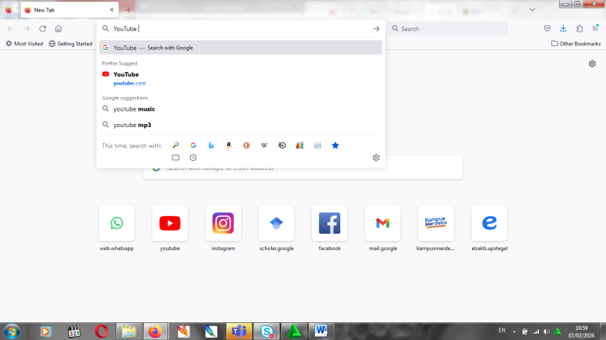Then open Mozilla Firefox/Google Chrome, type “YouTube” in Google search menu.

Figure 2. 2 Google search menu

1. On YouTube page, type BBC Learning English in the search menu and click the channel.

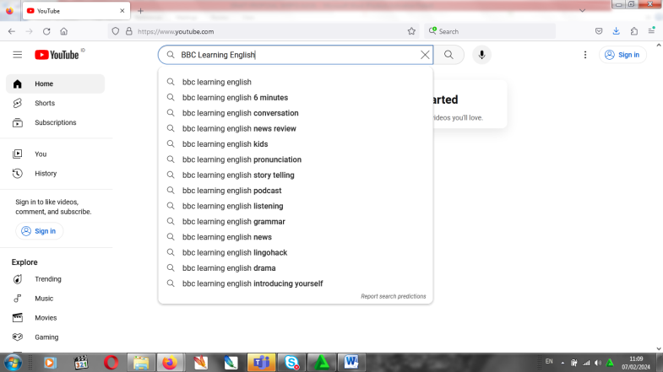

Figure 2. 3 YouTube page

1. 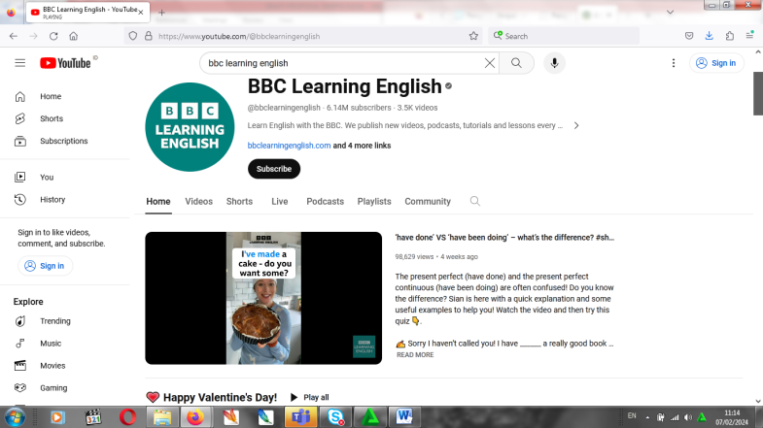Choose podcast menu, and click 6 Minute English.

Figure 2. 4 BBC Learning English Channel page

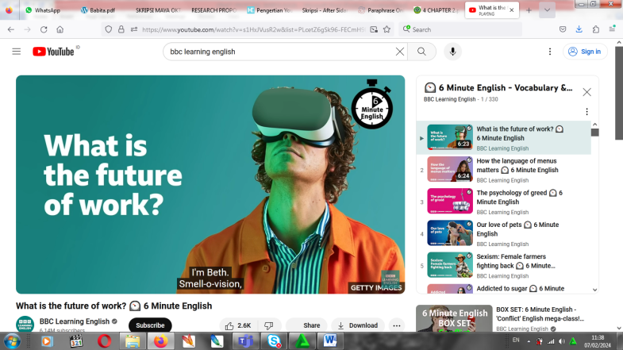

Figure 2. 5 Video of 6 Minute English content

## 2.3 Theoretical Framework

Listening is the most crucial skill after speaking, reading, and writing. It is because listening is the most widely used in daily life. Listening is an active process because it needs the understanding in hearing a context, and that a good listener will be as active when listening as the speaker when speaking. The most frequent issues that listening class students faced are environment and personality problems. In this case, the use of effective, applicative, and interesting material and media as a learning tool is truly needed. The researcher choose BBC Learning English YouTube channel as digital media to improve students listening skill at comprehensive listening class of fourth semester of English department.

Based on the conceptual framework, the researcher used pre experimental to define this research. First, for the input, the researcher prepared material in the form of a listening test for the pre-test. This aims to find out first the students’ listening ability before carrying out treatment. Then, for the process, the researcher conducted the teaching process by using BBC Learning English YouTube channel in the classroom. Last, the output, the researcher gave a post-test. After conducting the pre-test and treatment, the researcher found whether or not there was any significant different in students’ listening skill. The theoretical framework of this research is illustrated as follows:

INPUT

PRE-TEST (Listening Test)

PROCESS (Treatment)

Teaching Listening using BBC Learning English YouTube channel

OUTPUT

POST-TEST (Listening Test)

The Improvement of the Student’s Listening Skill

Figure 2. 1 Theoretical Framework

Figure 2. 6 Theoretical Framework

## 2.4 Hypothesis

Based on the research question, the researcher draws the following hypothesis of the research:

1. (Ho): There is no significant effect at students’ listening skill by using BBC Learning English YouTube channel as digital media in teaching listening on fourth semester students of English department of Universitas Pancasakti Tegal.
2. (H1): There is significant effect at students’ listening skill by using BBC Learning English YouTube channel as digital media in teaching listening on fourth semester students of English department of Universitas Pancasakti Tegal.

# 

# CHAPTER III

# RESEARCH METHODOLOGY

In this chapter consists of approach, type, and design of the research, population, sample, and technique of sampling, research variables, data collecting technique, research instrument, and technique of analyzing data.

## 3.1 Approach, Type, and Design of the Research

* + 1. **Research Approach**

This study was conducted using quantitative research. Quantitative research is a means of testing objective theories by examining the relationship between variables (Creswell, 2009). The theory testing is carried out by measuring numerical research variables and analyzing data using statistical procedures. A detailed operational design and a structure, formal, and specific design are used in the conduct of quantitative research (Nurlan, 2019). The researcher used quantitative research because the researcher wants to find out the effect of BBC Learning English YouTube channel on students’ listening skill. The researcher needs to figure out the numeric data from the test that was given to the students before and after used BBC Learning English YouTube channel.

* + 1. **Research Type**

This research used experimental design to find out whether or not the use of BBC Learning English YouTube channel affects students’ listening skill on the fourth semester students of English department of Universitas Pancasakti Tegal. Experimental study is used to determine whether a specific treatment has an impact on a result (Creswell, 2009). The researcher can manipulate one variable, the independent variable, and see how it affects another variable, the dependent variable. An experiment that is designed well that matches the research question and hypotheses gives a strong foundation for drawing conclusions about causation (Cox, 2019).

* + 1. **Research Design**

The design of this research used pre-experimental design with one group of pretest-posttest design. Pre-experimental design is commonly known as before and after or pre- and post-test design. This design involves the selection of participants, pre-tested, exposure to an educational intervention, and then post-tested (Marsden & Torgerson, 2012). In the first meeting, the researcher gave pre-test to know the students’ listening skill before attempting learning using BBC Learning English YouTube channel. Then, the students were given treatment. At the end, the researcher gave post-test to measure students’ listening ability after applying BBC Learning English YouTube channel in comprehensive listening learning.

Table 3. 1 Design of the Research

|  |  |  |  |
| --- | --- | --- | --- |
| Group | Pre-test | Treatment | Post-test |
| A | T1 | X | T2 |

Notes:

A: Experimental class

X: Treatment of experimental group

T1: Pre-test

T2: Post-test

## Population, Sample, and Technique of Sampling

* + 1. **Population**

According to Paramita (2015), population is a combination of all elements in the form of items, events, objects, or individuals that share the same characteristics which are the focus of a researcher's attention. In other word, population is the subject of the research. The population of this research is the students of English department of Universitas Pancasakti Tegal.

* + 1. **Sample**

A sample is an element of a population that includes multiple individuals from the population (Paramita, 2015). The sample of this research was 38 students of fourth semester of English department of Universitas Pancasakti Tegal.

* + 1. **Technique of Sampling**

The technique of sampling that was used in this study is purposive sampling. Purposive sampling is subjective sample selection. It is because the researcher understands that the information needed can be obtained from certain groups or targets that fit the criteria set by the researcher based on the research objectives (Paramita, 2015). And the researcher thinks that the information needed can be obtained from fourth semester students of English department of Universitas Pancasakti Tegal because based on the research objectives, they match the criteria set by the researcher.

The type of purposive sampling that was used is judgment sampling. According to Paramita (2015), judgment sampling is selected with certain consideration that tailored to the research objectives or research problems. The researcher chooses fourth semester students of English department of Universitas Pancasakti Tegal because they have received learning about listening in the previous semesters. There are intensive listening, extensive listening, and critical listening. So, the researcher thinks that they already have fairly good listening skills.

## Research Variables

A variable is an attribute or trait of an individual or an organization that can be measured, observed, and varies depending on the person or organization under study (Creswell, 2007). A variable will vary in two or more and can be measured with a scale. In this study, there were two variables, namely dependent and independent variable. Dependent variable depends on or is impacted by the independent variable. This is a variable that represents the effects or outcomes of the independent variables (Creswell, 2009). The dependent variable of this research is the students’ listening skill (Y).

Meanwhile, independent variables are those that (probably) impact, influence, or cause outcomes (Creswell, 2009). This variable also known as predictor, antecedent, treatment, or manipulated variable (Creswell, 2009). In this study, the independent variable is the use of BBC Learning English YouTube channel (X).

X Y

BBC Learning English Students’ listening skill

YouTube channel

Figure 3. 1 Design of the Research

## Data Collecting Technique

In this research, the researcher used tests to collect the data. Pre-test and post-test are the test that were used. In conducting this research, the researcher organized eight meetings. It includes a meeting to give pre-test in the first meeting, six meetings for treatments, and a meeting to give post-test in the last meetings.

1. Pre-test

In the first meeting, the researcher gave a pre-test to the students before giving the treatment. It is because the researcher wants to know the students’ listening skill before attempting learning using BBC Learning English YouTube channel. In organizing the pre-test, first, the students were given answer sheet of listening test. Then, the researcher played the audio of listening test. The listening test consists of three parts, all of which contain long talks/long conversations. The total numbers of questions is forty questions.

1. Treatment

In the treatment sessions, the researcher used BBC Learning English YouTube channel to improve students’ listening skill in comprehensive listening class. The researcher administrated the treatment sessions in six meetings. Each meeting was administrated in about 100 minutes. In each meeting during the treatment sessions, the researcher used the different videos of 6 Minute English contents of BBC Learning English YouTube channel. The researcher played the video and instructed students to listen and pay attention to the video carefully. After play the video, the researcher organized class for discussion. After listen the video, students were asked to express their opinions and other students responded it. During the discussion session, the researcher asked students to pay attention to the words that they do not get it and write it in the books. These words can become their new vocabulary. So, the listening activity also gave positive impact on their vocabulary mastery.

1. Post-test

After giving six sessions of treatment using BBC Learning English YouTube channel, the students were given post-test. The goal of the post-test is to see whether their listening skill had improved significantly after treatment sessions. The test is the same as the pre-test. It is forty questions include three parts, all of which contain long talks/long conversations.

## Research Instrument

A research instrument is a tool to gather data (Yin, 2011). The instruments of this research are pre-test and post-test in form of listening test. Multiple choice is the form that is used for the listening test with total numbers of questions is forty questions. There are three parts of the test, all of which contain long talks/long conversations. The audio of the listening test was played with the time allocation is 45 minutes.

For testing the instrument, there are two aspects used by the researcher, validity and reliability. Validity and reliability are two aspects that must be considered while evaluating a research instrument. The explanations of each validity and reliability are given below:

1. Validity

Validity is often defined as the extent to which an instrument measures what it purports to measure (Kimberlin & Winterstein, 2008). As far as the interpretations of the results of a test is accurate, true, and depends on what the test is supposed to be used for, it can be said to be valid. In this research, the researcher evaluated the content of the research instrument by using expert judgment procedure.

Expert judgment evaluation involves getting a group of people to decide on an instrument or share their opinion on a certain element (Almenara, 2013). So, before doing pre-test and post-test, the researcher consulted and discussed about listening test that was used as the research instrument with expert and the lecturer of the class in order to know the test is valid.

1. Reliability

After do the validity of the test, then the reliability test. According to Kimberlin & Winterstein (2008), reliability estimates assess the internal consistency of measuring tools, the inter-rater reliability of instrument scores, and the stability of measures. If a test is trustworthy and consistent, then the test is said to be reliable. To assess students’ listening test, the researcher used the rubric of listening assessment based on Ita Adryani Syam (2017) as follow:

Table 3. 2 Rubric Scoring of Listening Test

|  |  |  |
| --- | --- | --- |
| **Score** | **Level** | **Description** |
| Listening  Comprehension | 91 – 100 | **EXCELLENT:** Understand all instructions without understanding difficulties and able to perform all instructions in a fast and precise manner. |
| 81 – 90 | **VERY GOOD:** Understands most of the instructions, although there is repetition in certain parts, but can do all the instructions correctly, although a little slow. |
| 71 – 80 | **GOOD:** Understands most of what is said/instructed when instructions are somewhat lengthened and repeated so that they are slow in doing what is instructed, sometimes even incorrectly |
|  | 61 – 70 | **AVERAGE:** Struggles to follow what is instructed but many/most instructions are carried out correctly |
| 51 – 60 | **BAD:** Hard to do what is instructed, only a small part of it is instructed |
| 1 – 50 | **VERY BAD:** Unable to carry out what is instructed, even one instruction only. |

## Technique of Analyzing Data

The researcher using several techniques of data analysis in analyzing research data, they are descriptive statistic, normality test, homogeneity test, and paired sample t-test.

1. Descriptive Statistic

Descriptive statistic is the method of analysis that used to describe data. This analysis is used to provide an empirical description of the data collected in the research (Paramita, 2015). It is used to describe research data, such as the total number of participant in the sample (N), the quantity, maximum, minimum, and mean scores. The researcher presented descriptive analysis produced by statistical data processing using SPSS 27.

1. Normality test

A normality test is carried out to determine if the research data is normally distributed population or is within a normal distribution (Nuryadi et al., 2017). If the significance value is more than 0.05, the data is normally distributed. To calculate data, the researcher used SPSS tool.

1. Paired Sample T-test

Paired t-test is a technique for testing hypotheses when the data are not independent (paired) (Nuryadi et al., 2017). In this research, the researcher obtain two sample data, they are pre-test and post-test data. The researcher calculated paired sample t-test to see the significant effect of pre-test and post-test value after the students were given treatment in the experimental group. In calculating data, the researcher used SPSS program. The formula of paired sample t-test is as follows (Nuryadi et al., 2017):

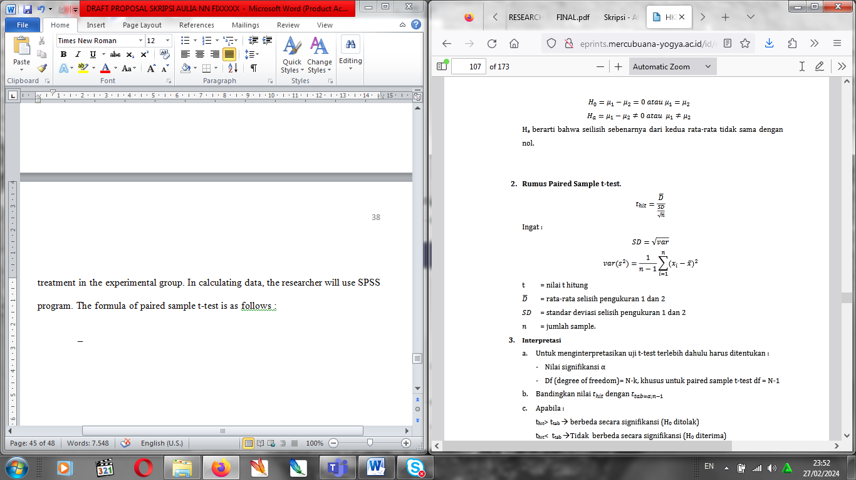

Notes:

t = the value of t calculated

_

*D* = average measurement difference of pre-test and post-test

*SD* = standard deviation measurement difference of pre-test and post-test

n = number of sample

Interpretation:

1. To interpret the t-test, firstly determine:

* Significance value α
* Df (degree of freedom)= N-k, specifically for paired sample t-test df = N-1

1. Compare the value of thit and ttab= α;n-1
2. If:

thit > ttab = significantly different (H0 is rejected)

thit < ttab = not significantly different (H0 is accepted