# REFERENCES

Aini, N., Abdillah, E. C., & Nurhandayani, N. (2023). *Bbc Learning English Channel in Listening Skill of Efl Classroom*. *2002*. https://jurnalfaktarbiyah.iainkediri.ac.id/index.php/proceedings/article/download/1814/673

Almenara, J.-M. (2013). The Expert’s Judgment Application as A Technique Evaluate Information and Communication Technology (ICT). *International Technology, Science, and Society Review*, *7(2)*, 11–22.

Bingol, M. A., Mart, C. T., Celik, B., & Yildiz, N. (2014). Listening comprehension difficulties encountered by students in second language learning class. *Journal Of Educational And Instructional Studies In The World*, *4*(4), 25–30.

Brunner, I. (2013). *International Conference ICT for Language Learning*.

Cox, K. A. (2019). *Research Design And Methods*. Sage Publications.

Creswell, J. W. (2007). Qualitative inquiry and research design: Choosing among five approaches (3rd ed.). *Thousand Oaks, CA: Sage*.

Creswell, J. W. (2009). Qualitative, Quantitative, and Mixed-Methods Research. In *Sage Publications, Inc* (Vol. 4, Issue 11). https://doi.org/10.1128/microbe.4.485.1

Darti, & Asmawati, A. (2017). Analyzing Students’ Difficulties Toward Listening Comprehension. *English, Teaching, Learning and Research Journal*, *3*(2), 206–220. https://doi.org/10.24252/eternal.v32.2017.a9

Davydenko, O. (2021). Using BBC Learning English Podcasts to develop university students’ listening skills. *E-Mentor*, *92*(5), 26–35. https://doi.org/10.15219/em92.1545

Elizabeth, S. (2023). Enhancing Students’ Listening Skills Through The English Easy Practice Youtube Channel At Junior High School. *UIN Syarif Hidayatullah Institutional Repository*.

Gass, S. (2009). *Second Language Acquisition*. Palgrave Macmillan, London. https://doi.org/https://doi.org/10.1057/9780230240780_6

Gilakjani, A. P., & Sabouri, N. B. (2016). Learners’ Listening Comprehension Difficulties in English Language Learning: A Literature Review. *English Language Teaching*, *9*(6), 123. https://doi.org/10.5539/elt.v9n6p123

Hamouda, A. (2013). An Investigation of listening Comprehension Problems Encountered by Saudi Students in the EL Listening Classroom. *International Journal of Academic Research in Progressive Education and Development*.

Hayrapetyan, N. (2016). Teaching Listening : Problems And Solutions. *Journals.Ysu.Am*, *2*(20), 1–2.

Kavaliauskienė, G. (2019). Podcasting: A Tool for Improving Listening Skills. *The Journal of Teaching English with Technology (TEwT)*, *8*(4), 1–17. http://www.tewtjournal.org/vol%5cn8/issue%5cn4/a%5cnword%5cnfrom%5cna%5cntechie.pdf

Kimberlin, C. L., & Winterstein, A. G. (2008). Validity and reliability of measurement instruments used in research. *American Journal of Health-System Pharmacy*, *65*(23), 2276–2284. https://doi.org/10.2146/ajhp070364

Lynch, T., & Mendelsohn, D. (2010). Applied Linguistics. In *Hodder & Stoughton Ltd* (Vol. 19, Issue 4). https://doi.org/10.1177/000608446801900406

Marsden, E., & Torgerson, C. J. (2012). Single group, pre- and post-test research designs: Some methodological concerns. *Oxford Review of Education*, *38*(5), 583–616. https://doi.org/10.1080/03054985.2012.731208

Munro, M. J., & Derwing, T. M. (1998). The effects of speaking rate on listener evaluations of native and foreign-accented speech. *Language Learning*, *48*(2), 159–182. https://doi.org/10.1111/1467-9922.00038

Murray, D. M. (1979). The Listening Eye: Reflections on the Writing Conference. *National Council of Teachers of English*, *41*. http://www.jstor.org/stable/376356

Nurlan, F. (2019). *Metodologi Penelitian Kuantitatif*. CV. Pilar Nusantara.

Nuryadi, Astuti, T. D., Utami, E. S., & Budiantara, M. (2017). *Dasar-Dasar Statistika Penelitian*. Sibuku Media.

Paramita, R. W. D. (2015). Buku Ajar Metodelogi Penetilitan. *Angewandte Chemie International Edition*, 5–24.

Rost, M. (2011). *Teaching and Researching: Listening (2nd ed.)*. Routledge. https://doi.org/https://doi.org/10.4324/9781315833705

Setiadi, M. A. (2021). *The Effect of Utilizing British Broadcasting Corporation (BBC) Learning English to the Students’ Speaking Accuracy at SMA Muhammadiyah Sungguminasa*. *1996*, 6.

Snelson, C. (2011). YouTube across the Disciplines : A Review of the Literature. *Journal of Online Learning and Teaching*, *7*(1), 159–169.

Tyagi, B. (2013). Listening: an important skill and its various aspects. *The Criterion: An International Journal in English*, *12*(1), 1–8. https://www.the-criterion.com/V4/n1/Babita.pdf

Wolvin, A. D., & Coakley, C. G. (1985). *Listening. Second Edition.* Eric. https://eric.ed.gov/?id=ED253878

Yin, R. . (2011). Qualitative research from start to finish. *Guilford Publications*.

Yuyun, I., & Simamora, F. Y. (2021). Use of Youtube To Support Efl Students’ Listening Skills. *Ellter Journal*, *2*(2), 1–12. https://doi.org/10.22236

/ellter.v2i2.7512

**APPENDICES**

**Appendix 1: Research Instrument**

**INSTRUMENT OF PRE-TEST AND POST-TEST**

**MULTIPLE CHOICE**

**Listen to the dialogue and answer the questions correctly.**

**Directions:** In this part of the test, you will hear longer conversations. After each conversation, you will hear several questions. The conversations and questions will not be repeated. After you hear a question, read the four possible answers in your test book and choose the best answer. Then, on your answer sheet, find the number of the question and fill in the space that corresponds to the letter of the answer you have chosen.

**Now begin work on the questions.**

**Audio 1 (**Addicted to Sugar)

Neil: Hello. This is 6 Minute English from BBC Learning English. I’m Neil and I’m Georgie.

Georgie: Would you like a cup of tea, Neil?

Neil: Oh yes thanks Georgie, with milk and three sugars, please.

Georgie: Three sugars, wow! You really have a sweet tooth, you like eating sweet things. Aren’t you worried about your weight?

Neil: Yes, but I can’t say no to sugar. Just as our addiction to oil is causing a climate emergency, our addiction to sugar is causing a health emergency for our bodies. Sugar gives us an instant hit at the chemical hormone dopamine making us feel good, but in the long run causing obesity, tooth decay and diseases like diabetes.

Georgie: But how did our addiction to the sweet stuff begin? That’s what we will be discussing in this programme. And as usual we will be learning some useful new vocabulary as well. Anyway, here’s your tea, Neil. I just put one sugar.

Neil: Thanks Georgie. I’ll give it a try. Now, before we go on, I have a question for you. Sugar cane, which grows naturally in Asia, Africa, and the Americas first came to England in the 11th century. Back then it was an expensive luxury item affordable only to kings, queens, and the very rich. So, which English monarch loved earing sugar so much their teeth turned black? Was it a) king henry VIII, b) queen Elizabeth I, or c) Mary Queen of Scots?

Georgie: I Know Henry VIII was very unhealthy so I’ll guess it’s him.

Neil: Ok G. We’ll find out the answer later in the programme. Just now, I compared sugar to oil as the world’s most important commodity, a commodity is a product or natural resource that can be traded, bought and sold. Today, economies, governments and wars are based on controlling oil, but in earlier centuries, the same was true of sugar.

Georgie: For 400 years sugar, along with coffee and tobacco, was grown in slavery plantations and shipped across the Atlantic Ocean to Europe. By the time slavery was ended in 1834, the demand for sugar in Europe and the United States was at a record high. Here’s Professor of international history Ulbe Bosma explaining more to BBC Radio 4 programme ‘Thinking Allowed’: sugar was already an extremely important commodity in the 16th and 17th and 18th century, and the 19th century, we see a staggering growth of sugar consumption in Europe and United States and so with that sugar became the fuel for human bodies whereas oil became the fuel for vehicles in the 20th century.

Neil: Professor Bosma talks about the staggering growth in the popularity of sugar. The adjective ‘staggering’ means shocking or surprising. Just like oil became the fuel for machine engines, sugar became the fuel for the human body. Fuel is a substance that is burned to provide heat or power.

Georgie: Trading companies had become rich selling sugar grown using slave labour. When people began to realize the health problems of sugar in the 20th century, these companies needed new ways to sell their product and began using sugar in food which had previously contained none, food like bread, cereal and yoghurt. Here’s Professor Bosma again, taking up the story for BBC Radio 4’s ‘Thinking Allowed’.

Proffesor Bosma: You can flood the market with a certain commodity, with sugar in this case, but that still does not mean that people will consume it. So the eating habits of people had to change. People until the early 19th century, they had a few spoons of sugar per week, but not a kilo, which people consume today in many countries in the world.

Neil: Sugar companies flooded the marker with their commodity. If you flood the market, you make a lot of your product available for sale, often at a low price.

Georgie: But just because something is cheap and easily available, doesn’t mean people will eat it. So, sugar companies tried to increase sugar consumption by changing people’s eating habits-the way a group of people eat, for example, which types of food they eat, how much of it and how often.

Neil: Instead of one or two spoons of sugar per week, people started eating kilos with results we see around us every day- worldwide obesity and heart disease have tripled in the last 50 years. What’s more because sugary food is cheaper, it’s often the poorest in society who are worst affected.

Georgie: Hmm, maybe it’s time to try having your tea without any sugar, Neil? And to reveal the answer to your question, which English monarchs famous love of sugar turned their teeth black? I guessed it was the notorious overeater, Henry VIII.

Neil: Which was the wrong answer. I’m afraid, Georgie. in fact, during the years before toothpaste and dentists, those black stumpy teeth belonged to queen Elizabeth I. ok let’s recap the vocabulary we’ve learned from this programme about sugar, starting with ‘a sweet tooth’ – a fondness for eating sweet, sugary food and drinks.

Georgie: A commodity is a product or natural resource that can be traded, bought and sold.

Neil: Fuel is a substance such as oil or coal that is burned to provide heat or power.

Georgie: The adjective ‘staggering’ means very shocking and surprising.

Neil: If a company floods the market, they release a lot of a particular product for sale, often at a low price.

Georgie: And finally eating habits, describe the way a particular group of people eat, for example, which types of food they eat, how much and how often. Once again, our six minutes are up. Join us again soon for more trending topics and useful vocabulary here at 6 Minute English. Goodbye for now. Bye!

1. What are they talking about?
2. Benefits of sugar for body health
3. **History and impact of sugar consumption**
4. Efforts by sugar companies to increase consumption
5. The cultural significance of sugar in different societies
6. According to the text, which English monarch had such a fondness for sugar that their teeth turned black?
   1. King Henry VIII
   2. Mary Queen of Scots
   3. **Queen Elizabeth I**
   4. King Henry VII
7. What was sugar compared to in terms of its importance as a commodity?
   1. Gold **c. Oil**
   2. Wheat d.Water
8. Who is responsible for the famous quote "sugar became the fuel for human bodies whereas oil became the fuel for vehicles in the 20th century"?
   1. Neil
   2. Georgie
   3. **Professor Ulbe Bosma**
   4. Mary Queen of Scots
9. Where did sugar cane originally grow naturally?
10. Europe
11. Australia
12. Antarctica
13. **Asia, Africa, and the Americas**
14. What was the main reason behind sugar companies using sugar in new food products?
    1. To address the shortage of sugar in the market
    2. To promote healthier eating habits among consumers
    3. **To increase consumption of sugar and boost sales**
    4. To reduce the cost of sugar production
15. What was the primary role of sugar in earlier centuries?
    1. It was used primarily for medicinal purposes.
    2. **It was a luxury item affordable only to the wealthy.**
    3. It was widely available and consumed by all social classes.
    4. It was used for agricultural cultivation practices.
16. How did sugar companies attempt to increase consumption in the 20th century?
    1. By promoting healthier alternatives to sugar
    2. By decreasing the availability of sugary products
    3. By limiting sugar sales to certain demographics
    4. **By flooding the market with cheap sugar**
17. What was sugar's role in European and American economies during the 16th to 19th centuries?
    1. Currency c. Commodity
    2. Medicine
    3. Commodity
    4. Decoration
18. What is the main consequence of the increased consumption of sugary food mentioned in the text?
    1. Reduced demand for sugary products
    2. Decreased availability of sugary food
    3. **Increased rates of obesity and heart disease**
    4. Improved overall health and well-being
19. What is the meaning of ’sweet tooth’?
20. A fondness for eating salty foods.
21. A fondness for eating spicy foods.
22. **A fondness for eating sweet, sugary food and drinks.**
23. A fondness for eating bitter foods.
24. What does it mean to "flood the market" with a commodity?
    1. Reduce supply
    2. Increase demand
    3. **Increase supply**
    4. Stabilize prices
25. What does the adjective "staggering" mean in the conversation?
    1. **Surprising**
    2. Scratching
    3. Sneezing
    4. Sipping

**Audio 2** (Why Sitting is Bad for Health)

Phil: Hello. This is 6 Minute English from BBC Learning English. I’m Phil

Georgie: And I’m Georgie. We all know how important exercise is to stay fit and reduce the risk of heart disease. Do you exercise much, Phil?

Phil: I try to. I ride my bike at the weekend, but to be honest, I do spend a lot of time sitting down.

Georgie: Sitting too much is becoming an increasing problem in the modern world. Maybe you take the bus or train to work, then sit at a desk all day, then go home feeling tired and just sit in front of the television all evening as well. Added together, that’s hours of sitting every single day.

Phil: In this programme, we’ll be finding out exactly how much sitting is too much and of course, we’ll be learning some useful new vocabulary.

Georgie: But first, are you sitting comfortably, Phil? Because I have a question for you, on average, how many hours a day do British adults spend sitting down? Is it a. 7 hours, b. 9 hours, or c. 12 hours?

Phil: I’ll guess it is seven hours.

Georgie: Ok, Phil, I’ll reveal the correct answer later. Charlotte Edwardson is a professor of health and behavior studies who has investigated the link between sitting and health problems in her lab at Leicester University. Here she talks to BBC Radio Four Programme ‘inside health’.

Prof: If you think about our daily activities, a lot of activities are done sitting down. Movement in our everyday lives has really been engineered out with advance in technology and our bodies just weren’t designed to sit this much so it’s going to cause problems with our health. So when you sit down, you’re not using the largest muscles in your body. So these are the ones in your legs and you bum. So that means that your muscle activity goes down. When your muscle activity goes down, your blood circulation reduces.

Georgie: Throughout history, humans have always walked and moved their bodies. Now, modern technologies like motorized vehicles and office jobs means we spend more and more time sitting. Modern life has engineered out the need for us to move. When you engineer something out, you designed things in such a way that it is no longer required, for example CD drives have been engineered out of laptops because downloads are more popular.

Phil: Charlotte says human are not used to sitting this much. Here, the words ‘this much’ mean ‘in such large amounts’ it’s negative thing. One negative being the harm to blood circulation, the flow of blood through the heart and blood vehicles, which carries oxygen around the body.

Georgie: When we sit, we stop using important muscles. This reduces blood circulation and causes a range of other effects like increased level of glucose and fat and decreased energy levels. The body uses 20% more energy when simply standing than when sitting down and walking uses 92% more energy and that’s not to mention the damage sitting too much causes to muscle movement and blood pressure.

Phil: But the hard truth is that sitting is a big part of modern life. Everything is geared around sitting. It is organized towards that particular activity and that makes it hard to stop. Here’s prof. Edwardson again, talking with James Gallagher, presenter of BBC Radio Four Program ‘Inside Health’.

Prof: How much do you feel like you’re just swimming against the tide with all of this? Like the whole of society is like driving us more and more towards, you know, sitting down all the time and you’re like ‘please don’t’.

Presenter: Sitting is so much part of our everyday activities. You know, you go into a meeting someone’s “come and take a seat”. You go in to your GP surgary “come and take a seat”. Everything’s geared around sitting. As technology advances and it tries to make our life easier, it them leads to us sitting even more.

Georgie: James asks if Charlotte is swimming against the tide of modern life. If you’re swimming against the tide you’re doing the opposite of what most people are doing. He also says that society is driving us towards sitting more. To drive someone towards something means pushing them to accept a new situation. Even when the situation isn’t so good.

Phil: Luckily, there’s some simple advice to help. Break up periods of sitting 30 minutes or more with a few minutes of walking or moving your arms. Also, try to spend less than half of your waking hours sitting down. Good to know. Now, about your question, Georgie.

Georgie: Right, my question was how long does the average British adult spend sitting each day? Phil guessed it was seven hours, which was close, but not right, I’m afraid. In fact, on average, we spend nine hours per day sitting down. That’s about sixty percent of our waking life. So, remember to take regular breaks, even just a minute or two.

Phil: Ok, let’s recap the vocabulary we’ve learnt. Starting with to engineer something out, meaning to design or plan in such a way that something is no longer needed.

Georgie: The phrase ‘this much’ or ‘so much’ means in such large amounts.

Phil: Blood circulation is the movement of blood through the heart and blood vessels which carries oxygen around the body.

Georgie: If things are geared around a certain activity or purpose, they’re organized to support it.

Phil: The idiom to swim against the tide means to not follow what most people are doing.

Georgie: And finally, to drive someone towards a new situation means to push them towards accepting it. Once again, our six minutes are up. Remember to join us again next time for more topical discussion and useful vocabulary. Here at 6 Minute English. Goodbye for now. Bye!

1. On average, how many hours per day do British adults spend sitting down?
   1. 5 hours **c. 9 hours**
   2. 7 hours d. 11 hours
2. Who mentioned riding a bike on weekends as part of their exercise routine?
   1. **Phil**
   2. Georgie
   3. Neil
   4. Charlotte
3. What health problems can arise from sitting too much?
   1. Increased energy levels
   2. Improved blood circulation
   3. Decreased risk of heart disease
   4. **Increased levels of glucose and fat**
4. What percentage of waking life do British adults spend sitting down?
   1. 30%
   2. 40%
   3. 50%
   4. **60%**
5. What advice is given to combat the negative effects of sitting?
   1. Sit for longer periods without breaks
   2. **Take regular breaks from sitting every 30 minutes**
   3. Avoid standing or walking
   4. Increase sitting time during waking hours
6. What is the main reason for the increase in sitting time in modern society?
   1. Decrease in office jobs
   2. Increase in physical activity
   3. **Advances in technology**
   4. Cultural preferences
7. What does the idiom "swimming against the tide" mean?
   1. Following the majority
   2. **Going against the majority**
   3. Floating with the current
   4. Being indifferent to the current
8. What does Charlotte Edwardson recommend to break up periods of sitting?
   1. Take longer breaks every hour
   2. Sit continuously for 30 minutes
   3. **Stand or move your arms for a few minutes**
   4. Avoid breaks altogether
9. How does sitting too much affect muscle movement and blood pressure?
   1. It improves muscle movement and lowers blood pressure
   2. It has no effect on muscle movement or blood pressure
   3. **It reduces muscle movement and increases blood pressure**
   4. It increases muscle movement and lowers blood pressure
10. What is the increasing problem in the modern world discussed in the conversation?
    1. Lack of sleep
    2. Overeating
    3. **Excessive sitting**
    4. Lack of physical activity
11. What percentage of energy does the body use when standing compared to sitting?
    1. 5% **c. 20%**
    2. 10% d. 30%
12. According to Charlotte Edwardson, what happens to muscle activity when you sit down for long periods?
    1. Muscle activity increases
    2. Muscle activity stays the same
    3. **Muscle activity decreases**
    4. Muscle activity becomes erratic
13. How does modern technology contribute to increased sitting time?
    1. By encouraging more physical activity
    2. By discouraging sedentary behavior
    3. By providing opportunities for standing desks
    4. **By making tasks easier to accomplish while sitting**

**Audio 3** (Can We Live Without Plastic?)

Neil: Hello. This is 6 Minute English from BBC Learning English. I’m Neil

Beth: And I’m Beth. ‘Plastic is fantastic’. This phrase was used a lot in the 1950s when mass-produced plastic items started to become part of our everyday lives. The following decades saw a revolution as plastic became the most commonly used material in modern life, found in everything from cars to furniture to packaging. Take a quick look around and you’ll soon see how many everyday items contain plastic.

Neil: But now, our love of plastic is being questioned, mostly thanks to climate change and pollution caused by single use plastics- plastic products which are designed to be used just once before being thrown away. 11 million tonnes of plastic waste are dumped into our oceans every year. It’s believed that single-use plastics make up 40% of all plastic pollution globally.

Beth: What’s more, it’s not just land and water being polluted- tiny plastic pieces known as microbeads have even been found inside the human body and can be passed from mother to child through breast milk. And because plastic comes from fossil fuels, the process of making it creates problems at every stage, from burning coal, to transportation, to recycling. In this programme we’ll be asking: is it time to live without plastic? And as usual we’ll be learning some useful new vocabulary as well.

Neil: But first, I have a question for you Beth. One reason why plastic became so popular is that it’s a very flexible material. It can be formed into different shapes, making it useful for keeping food fresh, or holding liquid. Originally, plastic was invented to replace the decreasing supply of natural materials like metal, wood and glass. So which items did plastic first replace? Was it: a. snooker balls, b. shopping bags or c. hairbrushes?

Beth: Hmm, I guess the first thing to be made of plastic was a hairbrush.

Neil: Ok Beth, I’ll reveal the answer later in the programme. Dr. sherry mason is professor of Chemistry at Penn State University in the US, and a specialist in plastic pollution. Her award-winning 2017 research into microplastics in rivers led to the US congress banning microbeads. Here she explains the problem of plastic to BBC World Service Programme, The Real Story.

Prof: Plastic is synthetic and, as a consequence of that nature doesn’t really know what to do with it. Like, a paper bag that’s sitting on the side of the road- it’s unsightly, but within weeks there are organisms in the soil they can use that paper bag as a food source right. They have evolved to basically chew up that paper bag and turn it back into soil, turn it back into carbon and nitrogen and oxygen. But with regard to plastic, because it is synthetic material, you don’t have that evolution. There are some organisms that can use it as a food source, but they’re few and far between especially when you’re talking about water systems, aquatic systems and the temperatures that exist, and so they can’t really use it as a food source so plastic doesn’t biodegrade. Plastic is a synthetic material, meaning that it’s made by combining manmade chemicals, instead of existing naturally. Natural materials like paper decay and harmlessly turn back into soil- they biodegrade. But plastic is not like this. It doesn’t decay and get broken down by microbes and bacteria.

Neil: In fact, some plastic-eating microbes and bacteria do exist, but these are few and far between, they’re rare- they don’t happen very often. It is the fact that plastic doesn’t decay which is responsible for the waste we see in the environment. Waste which is often unsightly, meaning ugly and unpleasant to look at.

Beth: Fortunately, help is at hand. The plastic-eating micobes Neil mentioned especially one called Rhodococcus ruber have been tested by scientists and seemed capable of breaking down plastic into its basic components. What’s also needed is an emphasis on reducing plastic production, especially packaging and other single-use products, rather than simply recycling. Action like this should help plastic achieve its original purpose- to help preserve, not polute our natural resources. And speaking of the origins plastic, isn’t it time to reveal the answer to your question, Neil?

Neil: Right, I asked you which object made of natural materials was the first to be replaced by plastic? You said it was a hairbrushes which was, the wrong answer, I’m afraid Beth. In fact, the first plastic-moulding macine was used in 1872 to produce snooker balls. Ok, let’s recap the vocabulary we have learned from this programme, starting with single-use-plastics- plastic products which are designed to be used just once, before being thrown away.

Beth: Microbeads are tiny plastic particles found in products like toothpastes and body scrubs, which can enter and pollute rivers, seas and the human body.

Neil: The adjective synthetic describes a non-natural material made by combining chemicals.

Beth: To biodegrade means to decay naturally in a way that is not harmful to the environment.

Neil: The phrases few and far between means very rare or not happening very often.

Beth: And finally, if something is described as unsightly, it’s ugly and unpleasant to look at. Once again, our six minutes are up. Join us again soon for more trending topics and useful vocabulary here at 6 Minute English. Goodbye for now. Bye!

1. What are they talking about
   1. The history of plastic production
   2. **The environmental impact of plastic pollution**
   3. The benefits of plastic in modern life
   4. The development of plastic-eating microbes
2. Where have microbeads been found, according to the text?
   1. Only in oceans
   2. Only in landfills
   3. **Inside the human body and water bodies**
   4. Only in rivers
3. Who is Dr. Sherry Mason?
   1. **A chemist specializing in plastic pollution**
   2. A politician advocating for plastic bans
   3. An oceanographer studying marine life
   4. An engineer developing plastic alternatives
4. How much plastic waste is dumped into oceans annually?
   1. 5 million tonnes
   2. **11 million tonnes**
   3. 20 million tonnes
   4. 30 million tonnes
5. What percentage of global plastic pollution is attributed to single-use plastics?
   1. 10% **c. 40%**
   2. 25% d. 60%
6. What did Dr. Sherry Mason's research lead to?
   1. A breakthrough in plastic production methods
   2. A ban on plastic packaging
   3. **A congressional ban on microbeads**
   4. A new type of plastic-eating microbe
7. Which organism did Dr. Sherry Mason mention can break down paper bags but not plastic?
   1. **Microbes**
   2. Bacteria
   3. Fungi
   4. Protozoa
8. What is Rhodococcus ruber mentioned for in the text?
   1. Its role in plastic production
   2. **Its ability to break down plastic**
   3. Its resistance to plastic pollution
   4. Its use in plastic recycling
9. What action is suggested to address plastic pollution?
   1. Increase plastic production
   2. Focus on recycling alone
   3. **Reduce plastic production, especially single-use items**
   4. Ban all plastic products
10. When was the first plastic-moulding machine used?
    1. 1850 c. 1900
    2. **1872** d. 1925
11. What are microbeads?
    1. **Small plastic particles found in certain products**
    2. Large plastic containers used for storage
    3. Microscopic organisms that break down plastic
    4. Specialized tools for plastic recycling
12. What does the term "synthetic" mean?
    1. Naturally occurring
    2. **Manmade**
    3. Biodegradable
    4. Organic
13. What phrase describes something that is very rare or infrequent?
    1. Scarce but present
    2. Seldom seen
    3. **Few and far between**
    4. Sporadic occurrences
14. How is something described if it's "unsightly"?
    1. Beautiful and attractive
    2. **Ugly and unpleasant to look at**
    3. Clean and tidy
    4. Appealing and charming

**Appendix 2: Instrument Validity by Expert**

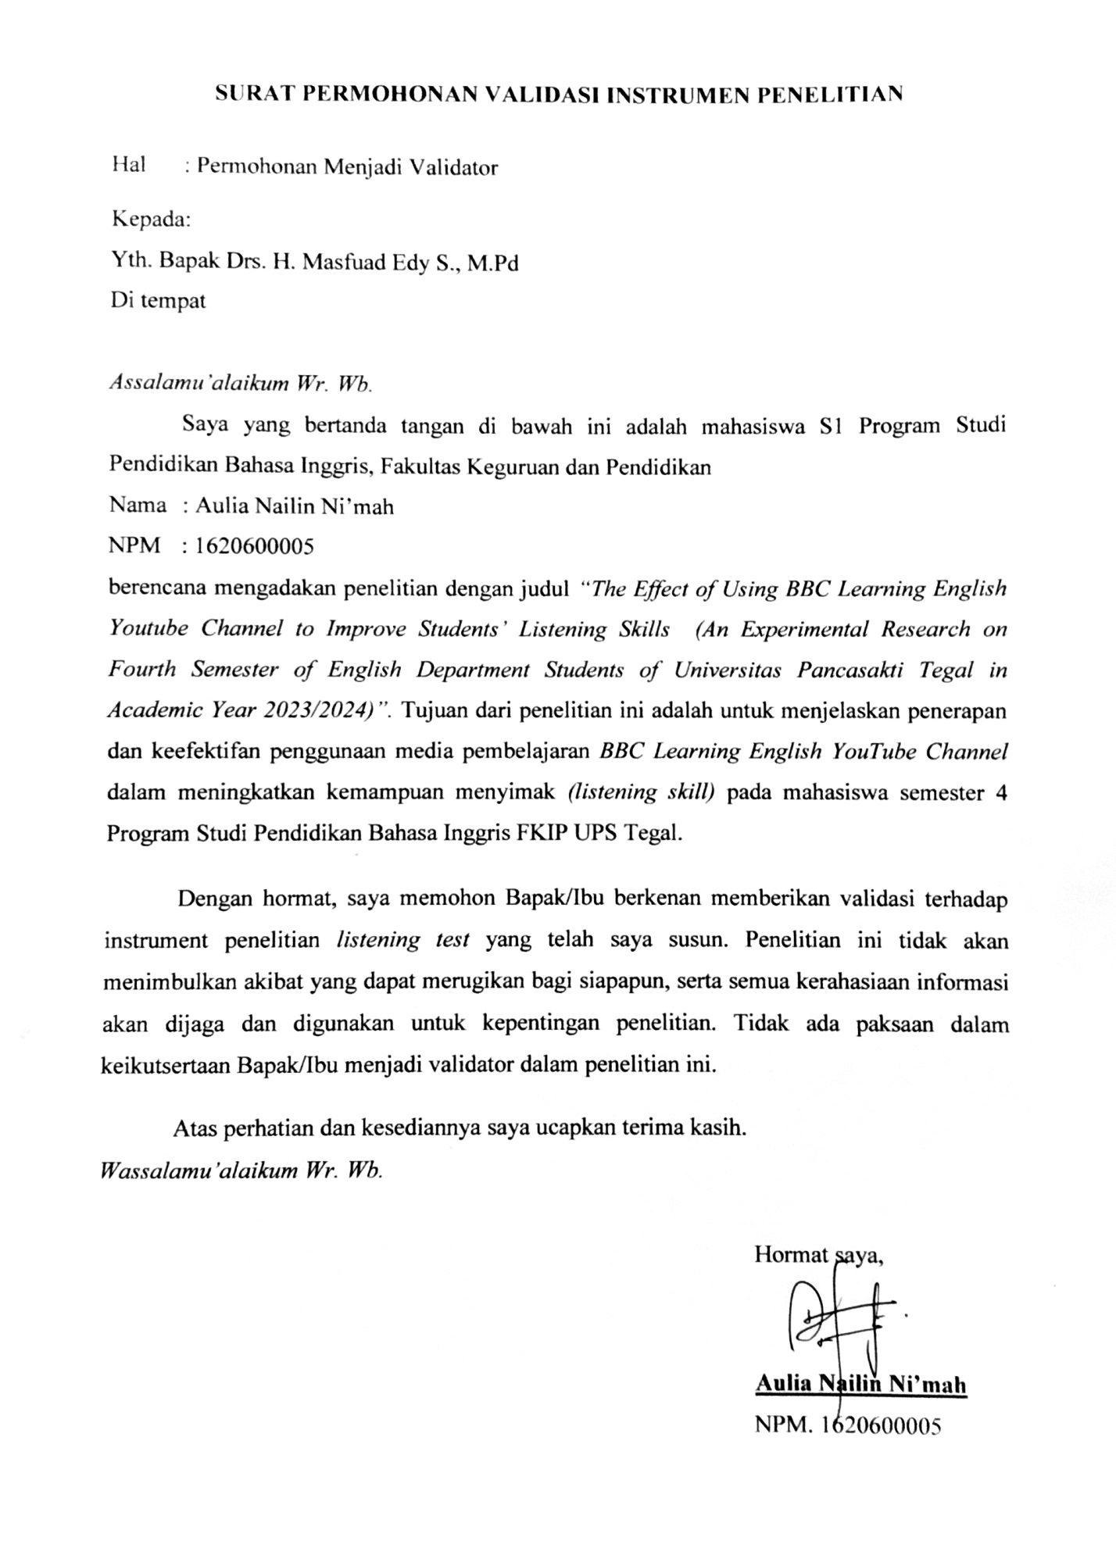

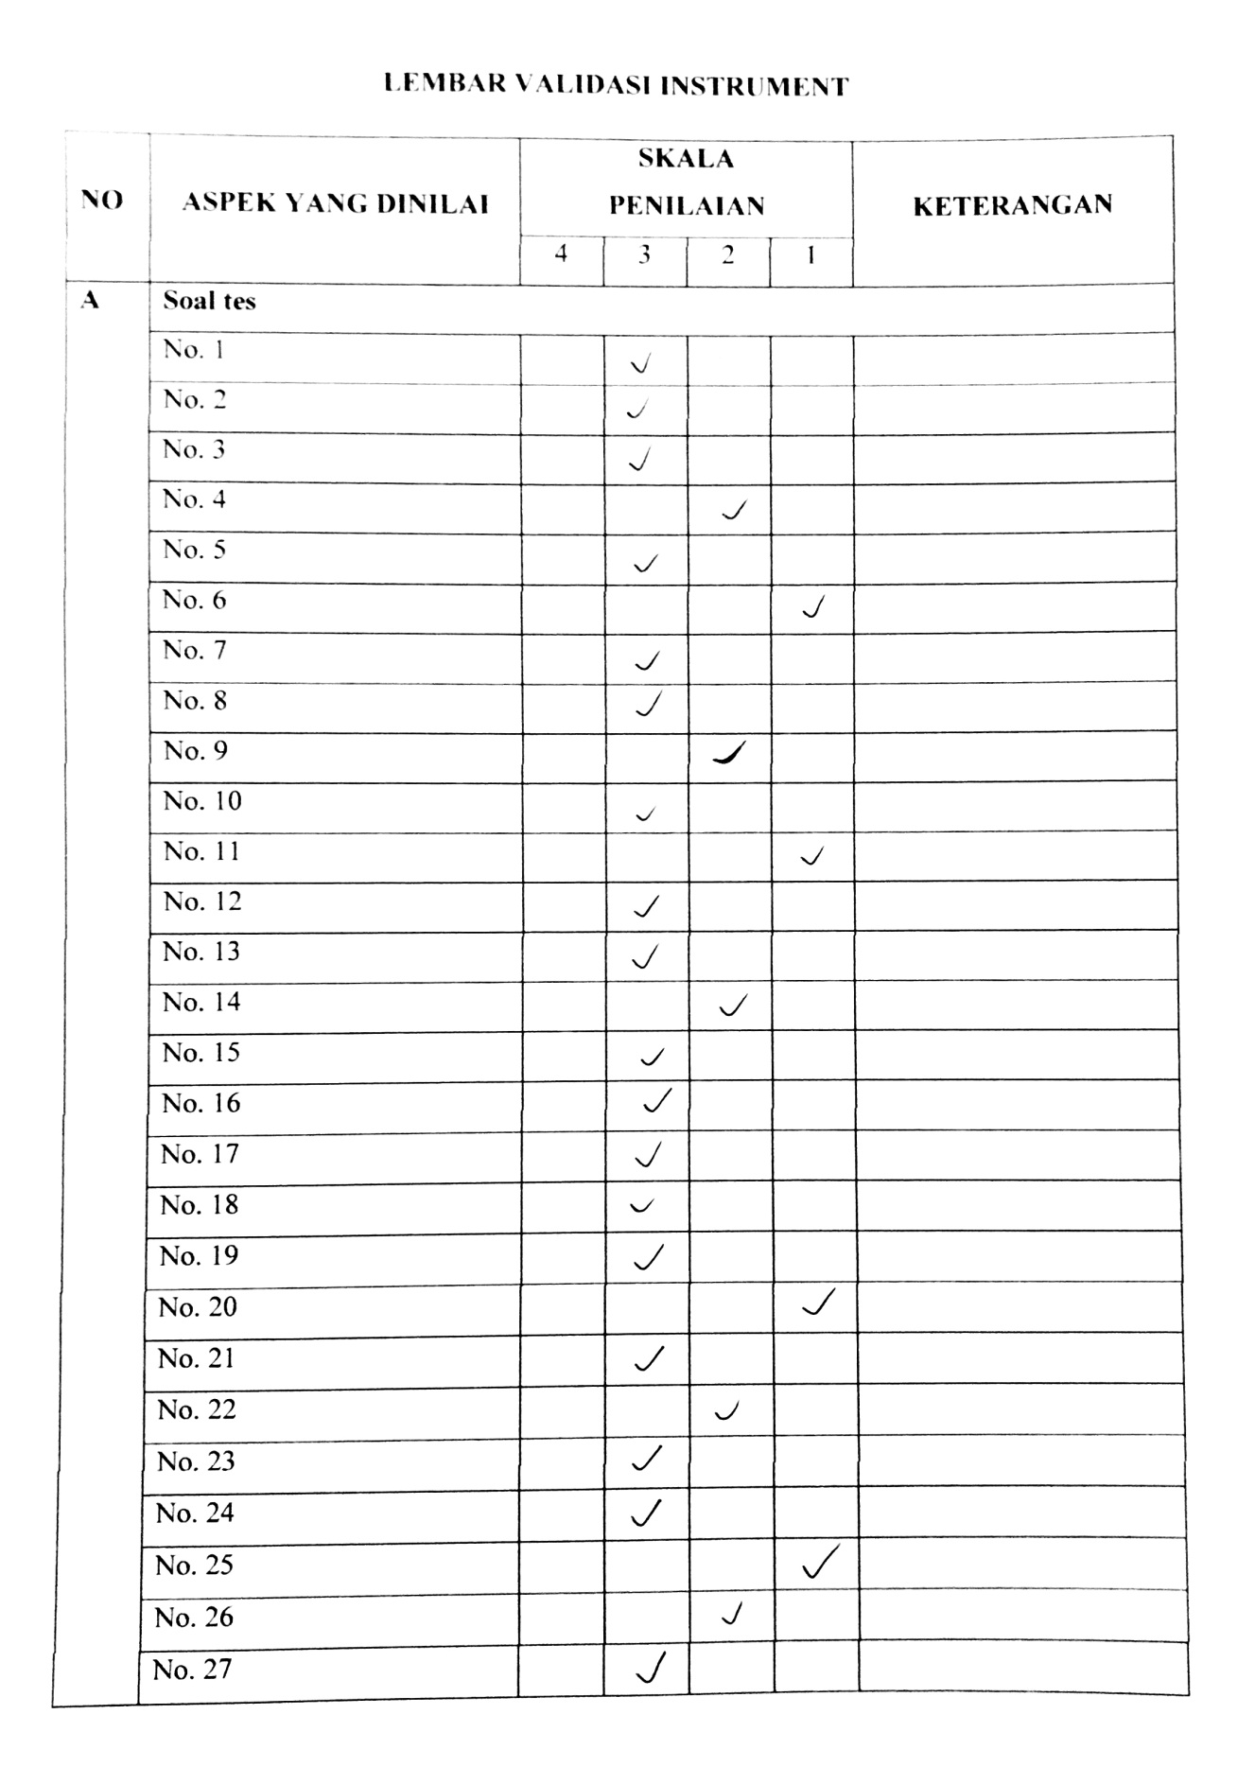

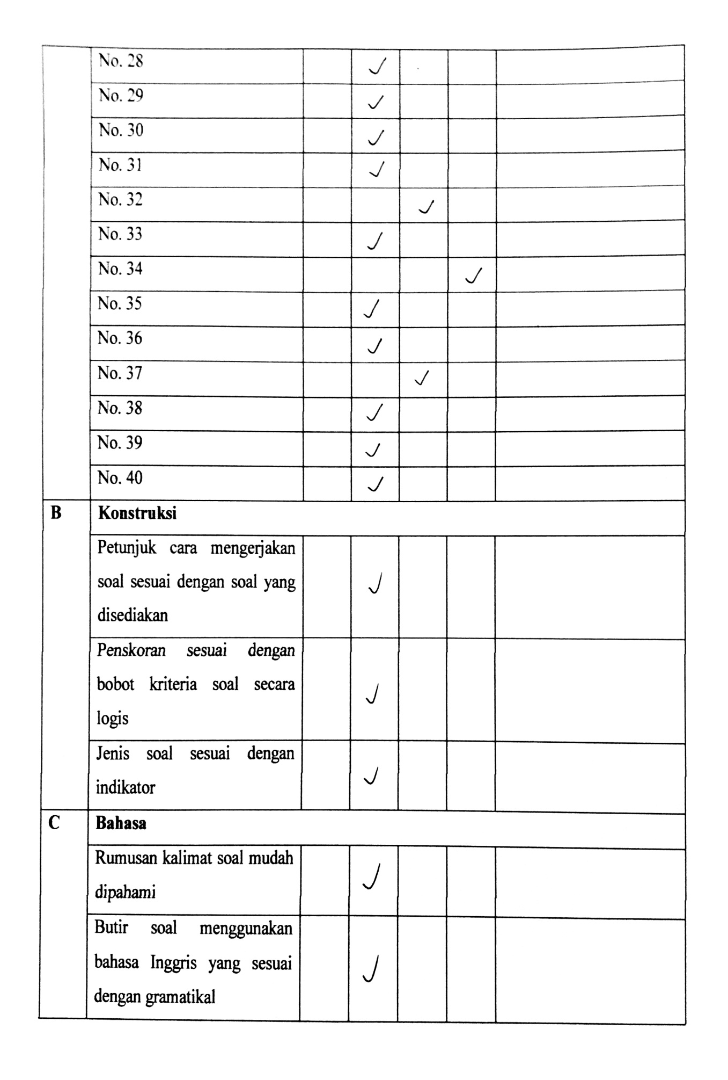

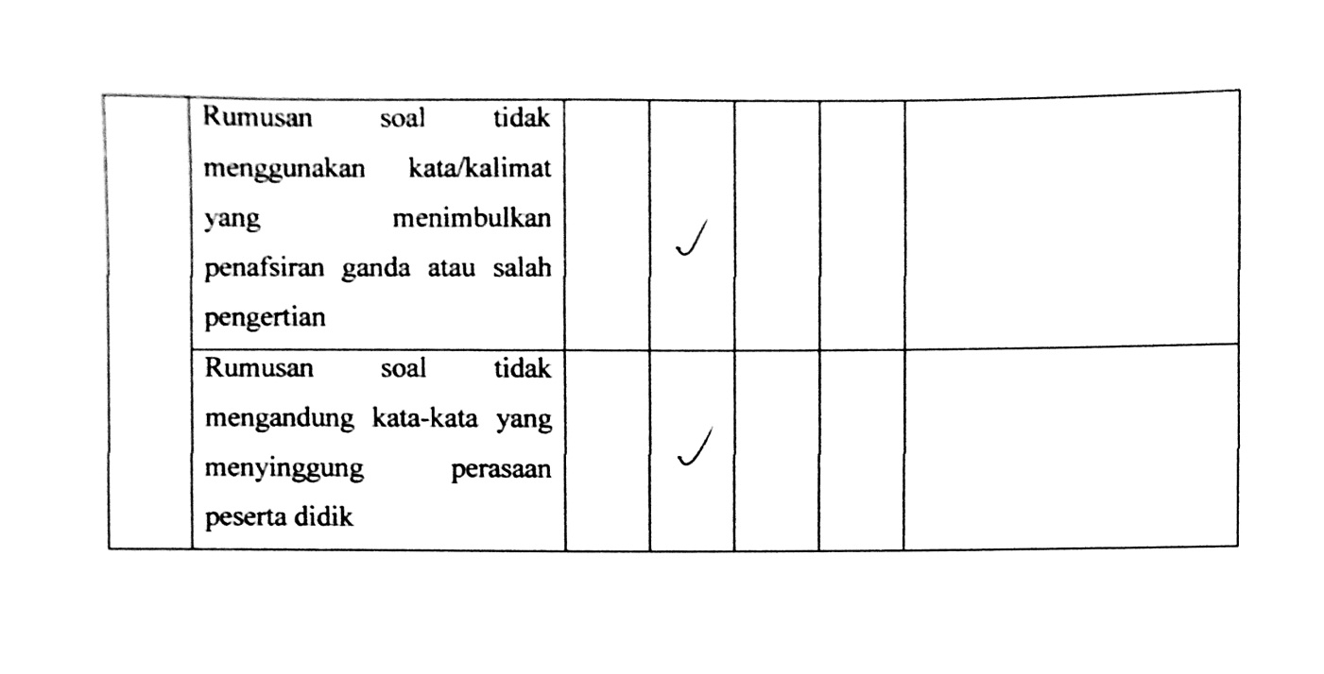

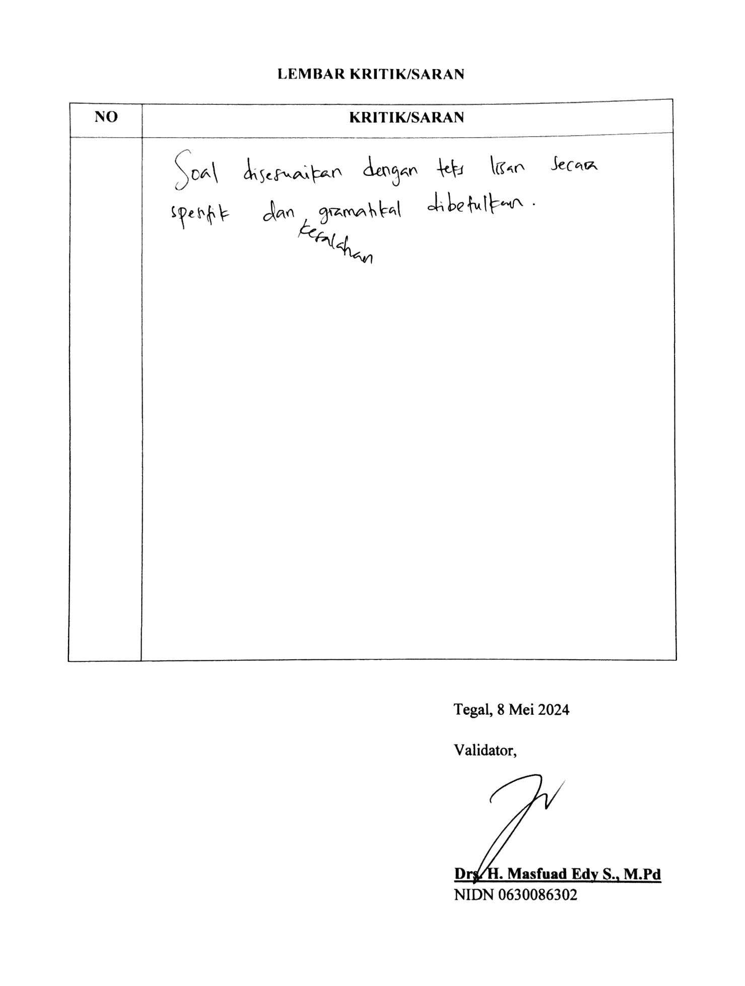

**Appendix 3: RPP**

**RENCANA PELAKSANAAN PERKULIAHAN**

|  |  |  |
| --- | --- | --- |
| **Mata Kuliah** | **: Comprehensive Listening** |  |
| **Capaian Pembelajaran Matakuliah (CPMK)** | **:** **Mata kuliah ini bertujuan untuk membantu mahasiswa memahami teks-teks lisan yang disampaikan dengan kecepatan normal, membuat catatan atas informasi yang disampaikan secara lisan (lectures), membedakan makna secara harfiah dan tersirat, memahami gagasan pokok dan ide-ide pendukung dalam teks oral, mengatasi dan memahami berbagai variasi wacana menyimak pada beberapa teks Bahasa Inggris standar.** |  |
| **Kemampuan Akhir yang direncanakan (Sub CPMK)** | **: Di akhir perkuliahan mahasiswa dapat:**  **Mahasiswa mampu menyimak informasi dari sebuah percakapan.** |  |
| **Alokasi Waktu** | **: 100’** |  |
| **Materi Pokok** | **: Long Conversation (1)** |  |
| **Langkah Kegiatan** | **:** |  |

|  |  |  |  |  |
| --- | --- | --- | --- | --- |
| Komponen  Langkah | Aktivitas Dosen | Aktivitas  Mahasiswa | Bentuk  Pembelajaran | Estimasi  Waktu |
| Pendahuluan | * Membuka Perkuliahan * Menyampaikan Capaian Pembelajaran Matakuliah * Menyampaikan Kemampuan Akhir yang direncanakan (Sub CPMK) | * Menyimak * Menyimak | * Penjelasan | 10 |
| Penyajia n Materi | * Membahas materi tentang Listening, Comprehensive Listening * Berdiskusi dengan mahasiswa tentang Listening, Comprehensive Listening, dan kesulitan yang dihadapi dalam listening * Menampilkan video dari “BBC Learning English” * Berdiskusi dengan mahasiswa tentang video tersebut | * Menyimak * Memberikan respon atau pendapat tentang materi bahasan * Menyimak * Memberikan respon atau pendapat tentang isi dari video | * Penjelasan melalui tampilan ppt * Active learning * Diskusi * Menyimak | 70 |
| Penutup | * Refleksi * Menutup Perkuliahan | * Menyimak |  | 20 |

**RENCANA PELAKSANAAN PERKULIAHAN**

|  |  |  |
| --- | --- | --- |
| **Mata Kuliah** | **: Comprehensive Listening** |  |
| **Capaian Pembelajaran Matakuliah (CPMK)** | **:** **Mata kuliah ini bertujuan untuk membantu mahasiswa memahami teks-teks lisan yang disampaikan dengan kecepatan normal, membuat catatan atas informasi yang disampaikan secara lisan (lectures), membedakan makna secara harfiah dan tersirat, memahami gagasan pokok dan ide-ide pendukung dalam teks oral, mengatasi dan memahami berbagai variasi wacana menyimak pada beberapa teks Bahasa Inggris standar.** |  |
| **Kemampuan Akhir yang direncanakan (Sub CPMK)** | **: Di akhir perkuliahan mahasiswa dapat:**  **Mahasiswa mampu menyimak informasi dari sebuah percakapan.** |  |
| **Alokasi Waktu** | **: 100’** |  |
| **Materi Pokok** | **: Long Conversation (2)** |  |
| **Langkah Kegiatan** | **:** |  |

|  |  |  |  |  |
| --- | --- | --- | --- | --- |
| Komponen  Langkah | Aktivitas Dosen | Aktivitas  Mahasiswa | Bentuk  Pembelajaran | Estimasi  Waktu |
| Pendahuluan | * Membuka Perkuliahan * Menyampaikan Capaian Pembelajaran Matakuliah * Menyampaikan Kemampuan Akhir yang direncanakan (Sub CPMK) | * Menyimak * Menyimak | * Penjelasan | 10 |
| Penyajia n Materi | * Mereview dan berdikusi dengan mahasiswa terakit materi tentang Listening, Comprehensive Listening, dan Long Conversation * Menampilkan video dari “BBC Learning English” * Berdiskusi dengan mahasiswa tentang video tersebut * Memberikan latihan soal listening | * Menyimak penjelasan * Memberikan respon atau pendapat tentang materi bahasan * Menyimak * Memberikan respon atau pendapat tentang isi dari video * Mengerjakan latihan soal | * Active learning * Menyimak * Diskusi * Latihan | 80 |
| Penutup | * Refleksi * Menutup Perkuliahan | * Menyimak |  | 10 |

**RENCANA PELAKSANAAN PERKULIAHAN**

|  |  |  |
| --- | --- | --- |
| **Mata Kuliah** | **: Comprehensive Listening** |  |
| **Capaian Pembelajaran Matakuliah (CPMK)** | **:** **Mata kuliah ini bertujuan untuk membantu mahasiswa memahami teks-teks lisan yang disampaikan dengan kecepatan normal, membuat catatan atas informasi yang disampaikan secara lisan (lectures), membedakan makna secara harfiah dan tersirat, memahami gagasan pokok dan ide-ide pendukung dalam teks oral, mengatasi dan memahami berbagai variasi wacana menyimak pada beberapa teks Bahasa Inggris standar.** |  |
| **Kemampuan Akhir yang direncanakan (Sub CPMK)** | **: Di akhir perkuliahan mahasiswa dapat:**  **Mahasiswa mampu menyimak ungkapan -ungkapan yang bermakna idiom.** |  |
| **Alokasi Waktu** | **: 100’** |  |
| **Materi Pokok** | **: Idiomatics Language (1)** |  |
| **Langkah Kegiatan** | **:** |  |

|  |  |  |  |  |
| --- | --- | --- | --- | --- |
| Komponen  Langkah | Aktivitas Dosen | Aktivitas  Mahasiswa | Bentuk  Pembelajaran | Estimasi  Waktu |
| Pendahuluan | * Membuka Perkuliahan * Menyampaikan Capaian Pembelajaran Matakuliah * Menyampaikan Kemampuan Akhir yang direncanakan (Sub CPMK) | * Menyimak * Menyimak | * Penjelasan | 10 |
| Penyajia n Materi | * Membahas materi tentang idiom, idiomatic language * Berdiskusi dengan mahasiswa tentang contoh idiom * Menampilkan video dari “BBC Learning English” * Berdiskusi dengan mahasiswa tentang video tersebut | * Menyimak penjelasan * Menjawab atau merespon pertanyaan tentang contoh idiom * Menyimak dan menemukan idiom dalam video * Memberikan respon atau pendapat tentang isi dari video | * Penjelasan melalui tampilan ppt * Active learning * Diskusi * Menyimak | 75 |
| Penutup | * Refleksi * Menutup Perkuliahan | * Menyimak |  | 15 |

**RENCANA PELAKSANAAN PERKULIAHAN**

|  |  |  |
| --- | --- | --- |
| **Mata Kuliah** | **: Comprehensive Listening** |  |
| **Capaian Pembelajaran Matakuliah (CPMK)** | **:** **Mata kuliah ini bertujuan untuk membantu mahasiswa memahami teks-teks lisan yang disampaikan dengan kecepatan normal, membuat catatan atas informasi yang disampaikan secara lisan (lectures), membedakan makna secara harfiah dan tersirat, memahami gagasan pokok dan ide-ide pendukung dalam teks oral, mengatasi dan memahami berbagai variasi wacana menyimak pada beberapa teks Bahasa Inggris standar.** |  |
| **Kemampuan Akhir yang direncanakan (Sub CPMK)** | **: Di akhir perkuliahan mahasiswa dapat:**  **Mahasiswa mampu menyimak ungkapan -ungkapan yang bermakna idiom.** |  |
| **Alokasi Waktu** | **: 100’** |  |
| **Materi Pokok** | **: Idiomatics Language (2)** |  |
| **Langkah Kegiatan** | **:** |  |

|  |  |  |  |  |
| --- | --- | --- | --- | --- |
| Komponen  Langkah | Aktivitas Dosen | Aktivitas  Mahasiswa | Bentuk  Pembelajaran | Estimasi  Waktu |
| Pendahuluan | * Membuka Perkuliahan * Menyampaikan Capaian Pembelajaran Matakuliah * Menyampaikan Kemampuan Akhir yang direncanakan (Sub CPMK) | * Menyimak * Menyimak | * Penjelasan | 10 |
| Penyajia n Materi | * Mereview materi tentang idiom, idiomatic language * Berdiskusi dengan mahasiswa tentang contoh idiom * Menampilkan video dari “BBC Learning English” * Berdiskusi dengan mahasiswa tentang video tersebut * Memberikan penugasan untuk merekap idiom yang terdapat dalam video | * Menyimak penjelasan * Menjawab atau merespon pertanyaan tentang contoh idiom * Menyimak dan menemukan idiom dalam video * Memberikan respon atau pendapat tentang isi dari video * Membuat rekap idiom | * Active learning * Menyimak * Diskusi | 75 |
| Penutup | * Refleksi * Menutup Perkuliahan | * Menyimak |  | 15 |

**RENCANA PELAKSANAAN PERKULIAHAN**

|  |  |  |
| --- | --- | --- |
| **Mata Kuliah** | **: Comprehensive Listening** |  |
| **Capaian Pembelajaran Matakuliah (CPMK)** | **:** **Mata kuliah ini bertujuan untuk membantu mahasiswa memahami teks-teks lisan yang disampaikan dengan kecepatan normal, membuat catatan atas informasi yang disampaikan secara lisan (lectures), membedakan makna secara harfiah dan tersirat, memahami gagasan pokok dan ide-ide pendukung dalam teks oral, mengatasi dan memahami berbagai variasi wacana menyimak pada beberapa teks Bahasa Inggris standar.** |  |
| **Kemampuan Akhir yang direncanakan (Sub CPMK)** | **: Di akhir perkuliahan mahasiswa dapat:**  **Mahasiswa mampu menyimak informasi dari narator.** |  |
| **Alokasi Waktu** | **: 100’** |  |
| **Materi Pokok** | **: Long Talks (1)** |  |
| **Langkah Kegiatan** | **:** |  |

|  |  |  |  |  |
| --- | --- | --- | --- | --- |
| Komponen  Langkah | Aktivitas Dosen | Aktivitas  Mahasiswa | Bentuk  Pembelajaran | Estimasi  Waktu |
| Pendahuluan | * Membuka Perkuliahan * Menyampaikan Capaian Pembelajaran Matakuliah * Menyampaikan Kemampuan Akhir yang direncanakan (Sub CPMK) | * Menyimak * Menyimak | * Penjelasan | 10 |
| Penyajia n Materi | * Membahas dan berdiskusi dengan mahasiswa tentang Long Talks * Menampilkan video dari “BBC Learning English” * Berdiskusi dengan mahasiswa tentang video tersebut | * Menyimak * Memberikan respon atau pendapat tentang materi bahasan * Menyimak * Memberikan respon atau pendapat tentang isi dari video | * Active learning * Menyimak * Diskusi | 70 |
| Penutup | * Refleksi * Menutup Perkuliahan | * Menyimak |  | 20 |

**RENCANA PELAKSANAAN PERKULIAHAN**

|  |  |  |
| --- | --- | --- |
| **Mata Kuliah** | **: Comprehensive Listening** |  |
| **Capaian Pembelajaran Matakuliah (CPMK)** | **:** **Mata kuliah ini bertujuan untuk membantu mahasiswa memahami teks-teks lisan yang disampaikan dengan kecepatan normal, membuat catatan atas informasi yang disampaikan secara lisan (lectures), membedakan makna secara harfiah dan tersirat, memahami gagasan pokok dan ide-ide pendukung dalam teks oral, mengatasi dan memahami berbagai variasi wacana menyimak pada beberapa teks Bahasa Inggris standar.** |  |
| **Kemampuan Akhir yang direncanakan (Sub CPMK)** | **: Di akhir perkuliahan mahasiswa dapat:**  **Mahasiswa mampu menyimak informasi dari narator.** |  |
| **Alokasi Waktu** | **: 100’** |  |
| **Materi Pokok** | **: Long Talks (2)** |  |
| **Langkah Kegiatan** | **:** |  |

|  |  |  |  |  |
| --- | --- | --- | --- | --- |
| Komponen  Langkah | Aktivitas Dosen | Aktivitas  Mahasiswa | Bentuk  Pembelajaran | Estimasi  Waktu |
| Pendahuluan | * Membuka Perkuliahan * Menyampaikan Capaian Pembelajaran Matakuliah * Menyampaikan Kemampuan Akhir yang direncanakan (Sub CPMK) | * Menyimak * Menyimak | * Penjelasan | 10 |
| Penyajia n Materi | * Mereview dan berdiskusi dengan mahasiswa tentang Long Talks * Menampilkan video dari “BBC Learning English” * Berdiskusi dengan mahasiswa tentang video tersebut * Memberikan latihan soal listening | * Menyimak * Memberikan respon atau pendapat tentang materi bahasan * Menyimak * Memberikan respon atau pendapat tentang isi dari video * Mengerjakan latihan soal | * Active learning * Menyimak * Diskusi * Latihan soal | 80 |
| Penutup | * Refleksi * Menutup Perkuliahan | * Menyimak |  | 10 |

**Appendix 4: Documentation**

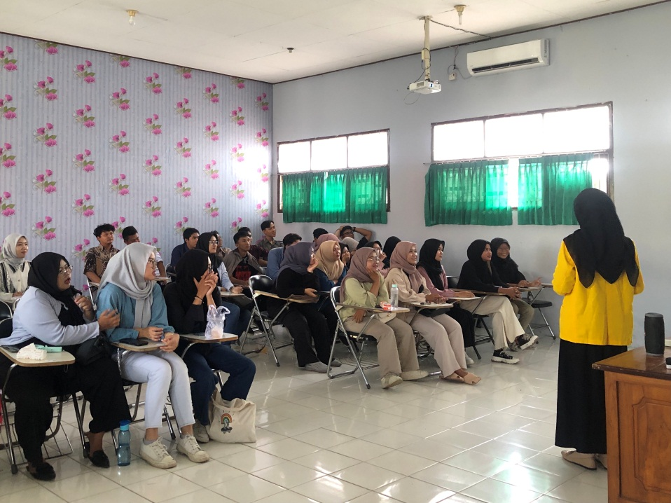

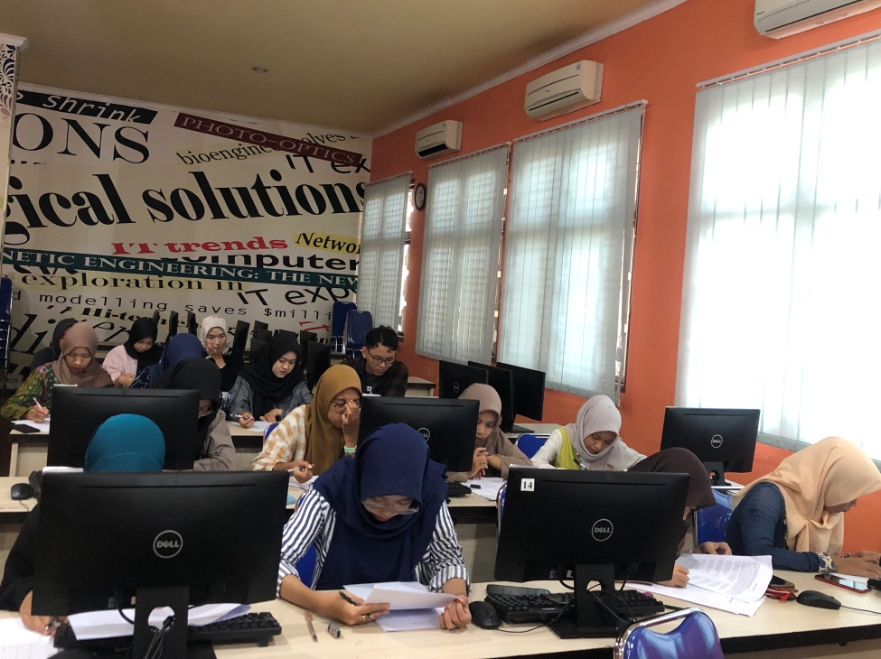

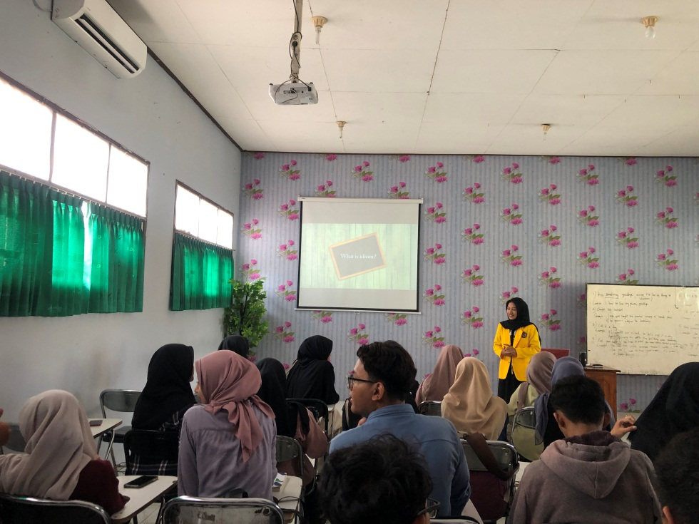

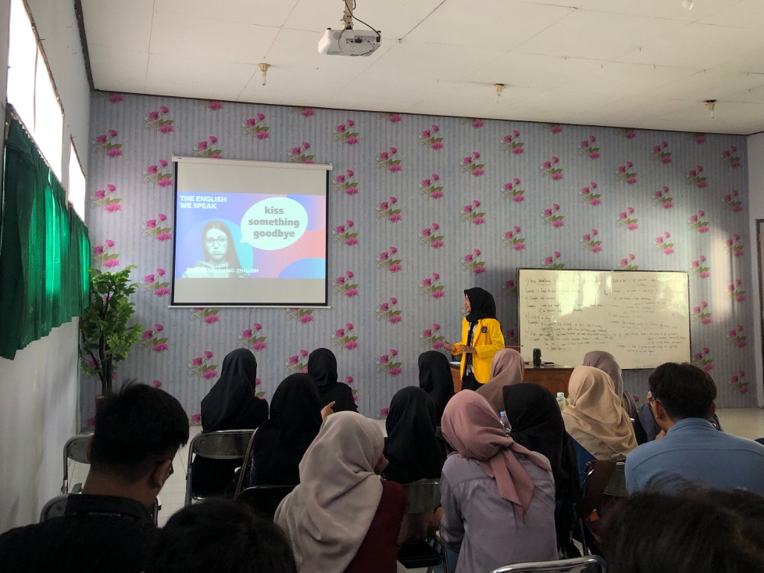

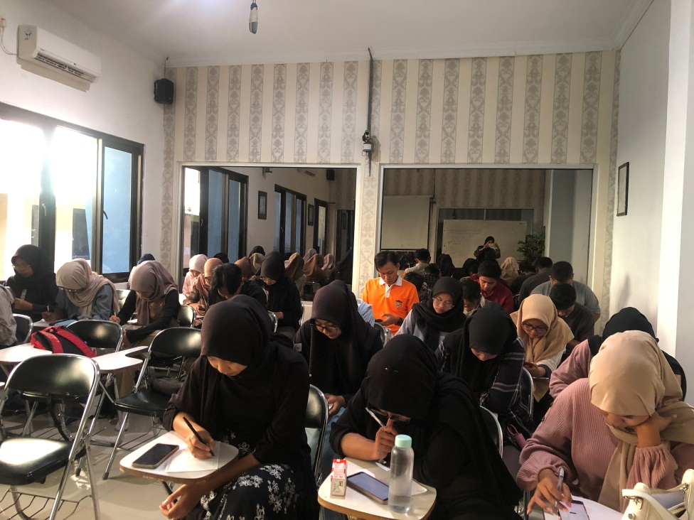

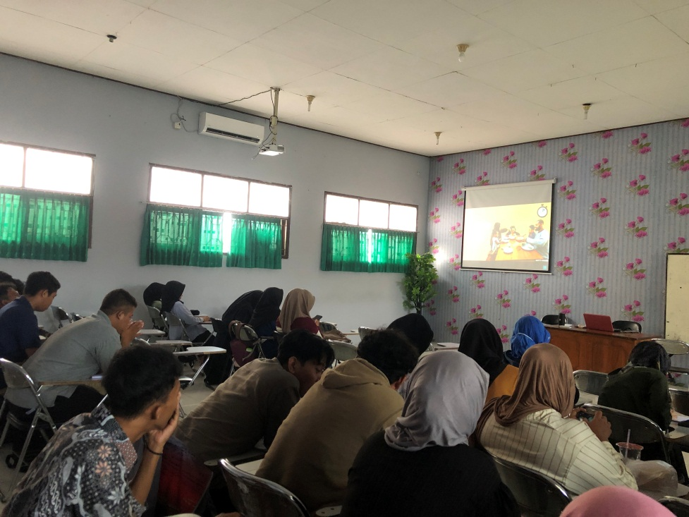

**Appendix 5: Research Permission Letter**

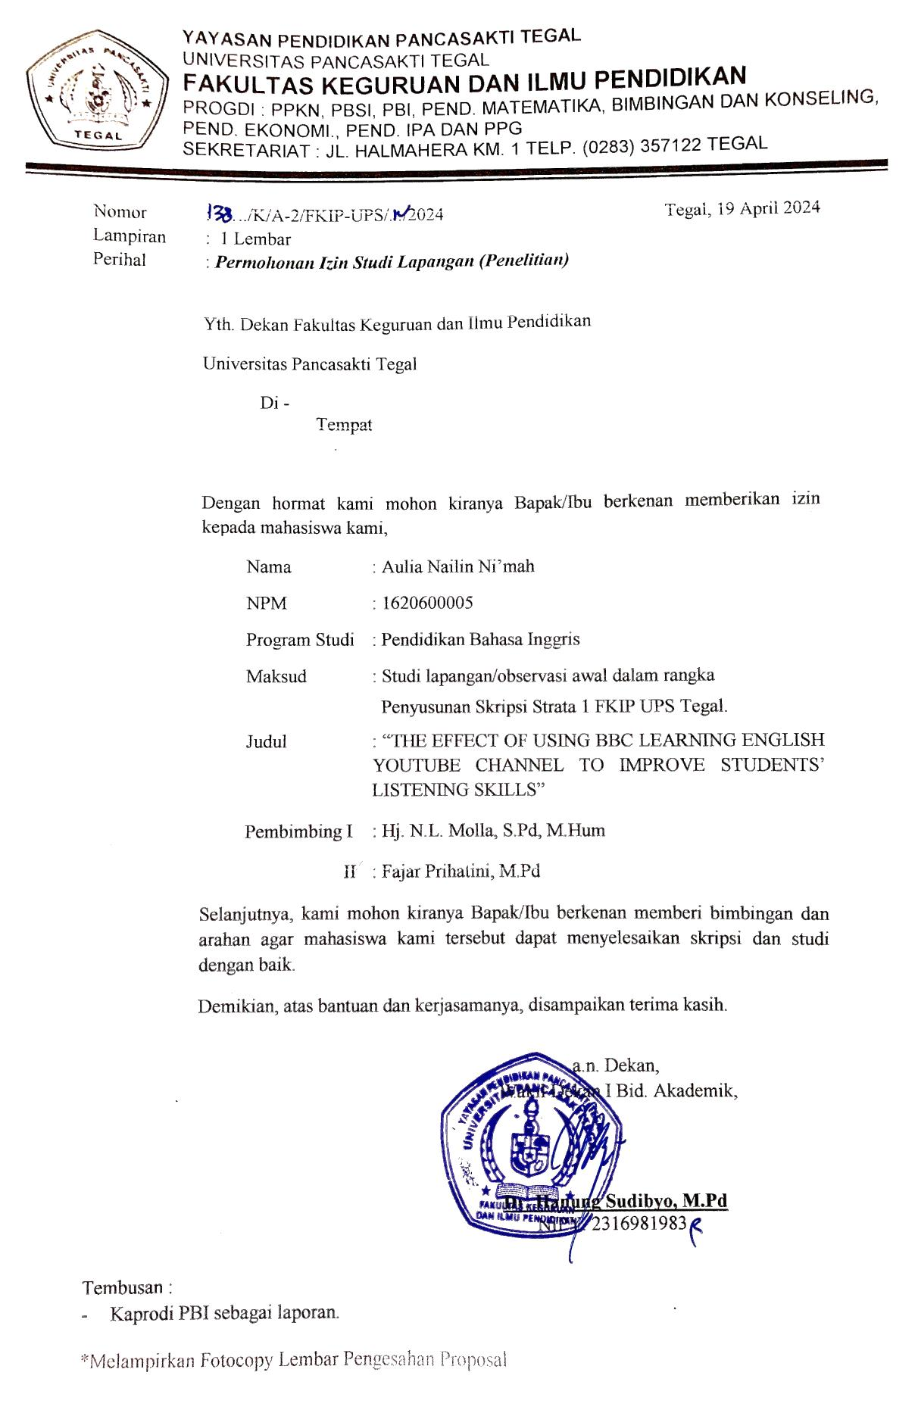

**Appendix 6: Plagiarism Result**

