

**THE EFFECT OF CLUSTERING TECHNIQUE IN TEACHING JUNIOR HIGH SCHOOL STUDENTS TO IMPROVE THEIR ABILITY ON WRITING DESCRIPTIVE TEXT**

(An Experimental Research at Seven Grade of MTs Al-Ikhlas Kluwut in the Academic Year of 2023/2024)

**RESEARCH PROJECT**

**Submitted as Partial Fulfilment of the Requirements to**

**Conduct a Research**

**By**

**BERLIANA SEFY ANGGRAENI**

**NPM 1620600011**

**ENGLISH EDUCATION PROGRAM**

**TEACHER TRAINING AND EDUCATION FACULTY**

**UNIVERSITAS PANCASAKTI TEGAL**

**2024**

# AGREEMENT

# 

# APPROVAL

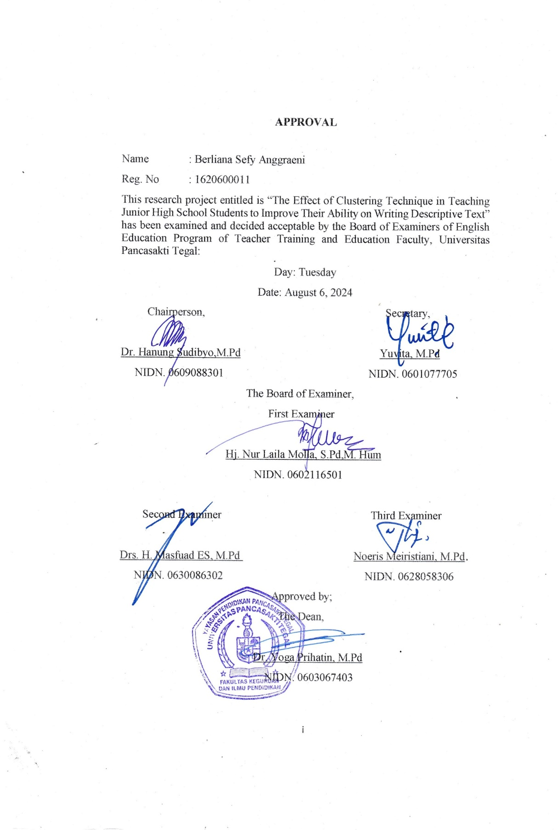

# STATEMENT OF ORIGINALITY

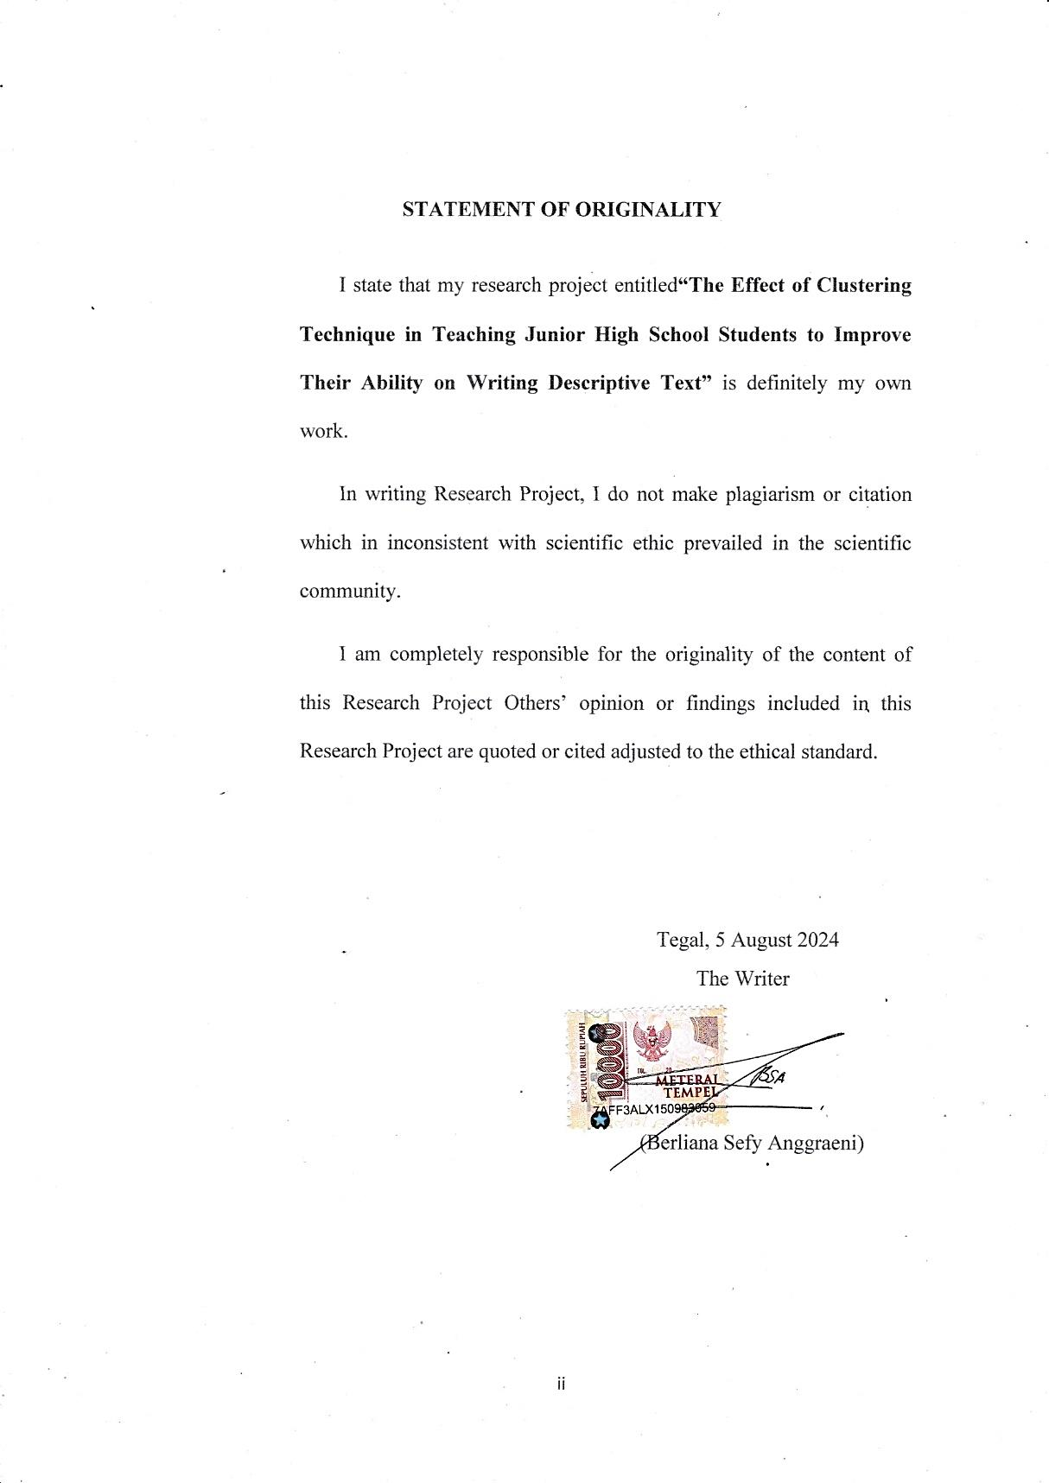

# MOTTO AND DEDICATION

**Motto:**

“Jangan mundur, selesaikan apa yang sudah kamu mulai” -Ivel

**Dedication:**

1. Allah who always give His full of rohmah and blessing.
2. My beloved parents (Mr. Sugeng Wijaya and Mrs. Efa Miliyan Umami) who have been sporting in moral and material in my life. They always motivate me to get my dream come true. Thank you papah and mamah for, I'll do the best for you. You are everything in my life, without you I can't do anything. I do love you papah and mamah.
3. My beloved sisters (Aulia Puja Dewi Arimbi and Nacita Maharani Kirana) who always support me.
4. All of my lecturer who were giving me knowledge.
5. I, myself, who have worked hard to complete this research project.

# PREFACE

Alhamdulillah, all praises be to Allah SWT, who has given and bestowed the resarcher with His mercy, graces, and blessings in completing this research as a final project for the Bachelor's degree at Pancasakti University entitled " The Effect of Clustering Technique in Teaching Junior High School Students to Improve Their Ability on Writing Descriptive Text (An Experimental Research at Seven Grade of MTs Al-Ikhlas Kluwut in the Academic Year 2023/2024)".

This project is presented to the English Department of Faculty of Teacher Training and Education, Pancasakti University. It was arranged based on the research conducted at English education program teacher training and education faculty Pancasakti University Tegal as a partial fulfillment of the requirements for the degree of Sarjana Pendidikan (S1).

In the process of writing this research project, it cannot be separated from the advice, guidance and support from several parties so that this project can be completed as it should. Because of that reason, the researcher would like to express gratitude to the following parties who have contributed to this project:

1. Mr. Dr. Taufiqulloh, M. Hum., as the Rector of Universitas Pancasakti Tegal
2. Mrs. Dr. Yoga Prihatin, M. Pd., as the Dean of Teacher Training and Education Faculty of Universitas Pancasakti Tegal
3. Mrs. Yuvita, M. Pd., as the Head of English Department of Teacher Training and Education Faculty of Universitas Pancasakti Tegal
4. Mrs. Noeris Meiristiani, M. Pd., as my first advisor, who has provided with direction, knowledge, and insightful this research process. Dedication and patience in guiding the researcher. Thank you for guidance and direction in completing this thesis.
5. Mr. Drs. H. Masfuad E. S, M. Pd., as the second advisor, who has provided with direction, knowledge, and insightful this research process. Thank you for guidance and direction in completing this thesis.
6. My partner Mr. A for being the support system.
7. ⁠My entire friends, especially for member “rahasia masuk surga” and “girlss oyee” who always support me.
8. Students class A at Seven Grade of MTs Al-Ikhlas Kluwut as the samples of this reseache project.

Furthermore, the writer recognizes many shortcomings in the writing of this project, so suggestions and critics are needed. The writer also hopes this project can provide benefits and an overview of research for all the parties, especially in the educational field. May Allah SWT always gives His mercy on us Aamiin.

# ABSTRACT

**ANGGRAENI SEFY, BERLIANA. 2024. 1620600011:** *“The Effect of Clustering Technique in Teaching Junior High School Students to Improve Their Ability on Writing Descriptive Text (An Experimental Research at Seven Grade of MTs Al-Ikhlas Kluwut in the Academic Year 2023/2024”* Research Project. Stara 1 Program, Faculty of Teacher Training and Education, Pancasakti University Tegal. The first advisor is Noeris Meiristiani, M.Pd and the second advisor is Drs. H. Masfuad ES, M.Pd

**Key Words:** *Clustering Technique, Writing Ability, Descriptive Text*

The use of technique to reach a functional level by providing appropriate technique for learning. The aim of this research is to find the effective of clustering technique in teaching writing descriptive text or not. This study used the quantitative approach with the quasi-experimental design with one group design. The population of this research is 65 students at 7th grade of MTs Al-Ikhlas Kluwut in the Academic Year 2023/2024. Meanwhile, by using the purposive sampling technique, the sample of this research consists of 30 students in experimental class. The instrument of this research is created Descriptive text. The experimental class was taught by Clustering technique in seven meetings include pre and post-test. The data collection in this research was analyzed by using SPSS version 24. The researcher used the judgment experts as the data instrument some technique in collecting data; which are normality and paired sample t-test. The results obtained that the mean scores of pre-test was 48.93, whereas the mean scores of post-test was 72.73. Furthermore, the Sig. score of normality test was 0.062 and 0.097 in the pre-test and post-test for experimental class. It means that data is normally distributed for experimental class. The result of this research used the paired sample t-test data showed that sig. 2 tailed was 0.000 which lower than 0.005, which means that the alternative hypothesis (H1) is accepted and null hypothesis (H0) is rejected at the 95% significant difference of students’ scores before and after taught by using Clustering technique. In conclusion, Clustering Technique effective on 7th to improve students ability in Junior High School. The researcher suggests that teachers; first, classroom management, where teachers need to build pleasant classroom atmosphere in the process of learning English, especially in writing. Second, teacher’s explanation also needs to be considered in delivering the steps of clustering technique, because there are some students need repeated explanations by the teacher. Third, the application of vocabulary building, which is one of the important factors for constructing a sentence.

# ABSTRAK

**ANGGRAENI SEFY, BERLIANA. 2024. 1620600011**: "Pengaruh Teknik Clustering dalam Pengajaran Siswa Sekolah Menengah Pertama untuk Meningkatkan Kemampuan Mereka dalam Menulis Teks Deskriptif (Sebuah Penelitian Eksperimen di Kelas Tujuh MTs Al-Ikhlas Kluwut pada Tahun Ajaran 2023/2024" Proyek Penelitian. Program Studi Strata 1, Fakultas Keguruan dan Ilmu Pendidikan, Universitas Pancasakti Tegal. Pembimbing I Noeris Meiristiani, M.Pd dan Pembimbing II Drs. H. Masfuad ES, M.Pd

Kata Kunci: Teknik Clustering, Kemampuan Menulis, Teks Deskriptif

Penggunaan teknik untuk mencapai tingkat fungsional dengan menyediakan teknik yang tepat untuk pembelajaran. Penelitian ini bertujuan untuk mengetahui apakah teknik clustering efektif digunakan dalam pembelajaran menulis teks deskriptif atau tidak. Penelitian ini menggunakan pendekatan kuantitatif dengan desain kuasi eksperimen dengan desain satu kelompok. Populasi penelitian ini adalah 65 siswa kelas 7 MTs Al-Ikhlas Kluwut pada Tahun Ajaran 2023/2024. Sementara itu, dengan menggunakan teknik purposive sampling, sampel penelitian ini terdiri dari 30 siswa di kelas eksperimen. Instrumen penelitian ini membuat teks deskriptif. Kelas eksperimen diajar dengan teknik Clustering dalam tujuh kali pertemuan termasuk pre-test dan post-test. Pengumpulan data dalam penelitian ini dianalisis dengan menggunakan SPSS versi 24. Peneliti menggunakan judgement experts sebagai instrumen data dengan beberapa teknik dalam mengumpulkan data, yaitu uji normalitas dan uji-t sampel berpasangan. Hasil penelitian menunjukkan bahwa nilai rata-rata pre-test adalah 48,93, sedangkan nilai rata-rata post-test adalah 72,73. Selanjutnya, nilai Sig. dari uji normalitas adalah 0,062 dan 0,097 pada pre-test dan post-test untuk kelas eksperimen. Hal ini berarti bahwa data berdistribusi normal untuk kelas eksperimen. Hasil penelitian ini menggunakan data paired sample t-test menunjukkan bahwa nilai sig. 2 tailed sebesar 0,000 yang lebih rendah dari 0,005, yang berarti bahwa hipotesis alternatif (H1) diterima dan hipotesis nol (H0) ditolak pada tingkat signifikan 95% perbedaan nilai siswa sebelum dan sesudah diajar dengan menggunakan teknik Clustering. Kesimpulannya, Teknik Clustering efektif untuk meningkatkan kemampuan siswa kelas 7 di Sekolah Menengah Pertama. Peneliti menyarankan agar guru; pertama, manajemen kelas, dimana guru perlu membangun suasana kelas yang menyenangkan dalam proses pembelajaran bahasa Inggris, terutama dalam menulis. Kedua, penjelasan guru juga perlu diperhatikan dalam menyampaikan langkah-langkah teknik clustering, karena ada beberapa siswa yang membutuhkan penjelasan berulang-ulang oleh guru. Ketiga, penerapan vocabulary building yang merupakan salah satu faktor penting dalam membangun sebuah kalimat.

# TABLE OF CONTENTS

AGREEMENT ii

APPROVAL iii

STATEMENT OF ORIGINALITY iv

MOTTO AND DEDICATION v

PREFACE vi

ABSTRACT viii

ABSTRAK ix

TABLE OF CONTENTS x

LIST OF TABLES xii

LIST OF PICTURE xiii

LIST OF APPENDICES xiv

CHAPTER I INTRODUCTION 1

1. 1 Background of the Problems 1

1. 2 Identification of the Problems 4

1. 3 Limitation of the Problems 4

1. 4 Statement of the Problems 5

1. 5 Objective of the Research 5

1. 6 Significance of the research 5

1.6.1 Theoretical Significance 5

1.6.2 Practical Significance 6

CHAPTER II REVIEW OF RELATED THEORIES, THEORETICAL FRAMEWORK, AND HYPOTHESIS 7

2. 1 Previous Studies 7

2. 2 Review of Related Theories 10

2. 3 Theoretical Framework 20

2. 4 Hypothesis 21

CHAPTER III RESEARCH METHODOLOGY 22

3. 1 Approach, Type, and Design of the Research 22

3. 2 Population, Sample and Technique of Sampling 24

3. 3 Research Variables 25

3. 4 Data Collection Technique 26

3. 5 Research Instrument 27

3. 6 Technique of Analyzing Data 34

CHAPTER IV RESEARCH RESULT AND DISCUSSION 37

4. 1 Research Result 37

4.2 Discussion 42

CHAPTER V CONCLUSION AND SUGGESTION 46

5.1. Conclusion 46

5.2. Suggestion 47

REFERENCES 49

APPENDICES 52

# LIST OF TABLES

**Table 3. 1 Design of This Research 24**

**Table 3. 2 Population of The Research in Mts Al-Ikhlas Kluwut 25**

**Table 3. 3 Scoring Rubric of Descriptive Text 31** **Table 4.1 Normality Sample Test Result………………………………………41**

**Table 4.2 Paired Sample Test Result…………………………………………..42**

# LIST OF PICTURE

**Figure 2. 1 Example clustering technique** 18

# LIST OF APPENDICES

**Appendices 1 Research Instrument……………………………………………51**

**Appendices 2 Picture…………………………………………..……..…………53  
Appendices 3 Permohonan Izin Studi Lapangan (Penelitian)……….……....56  
Appendices 4 Surat Keterangan Selesai Penelitian ………………..………...57  
Appendices 5 Validity………………………………………………...………...58  
Appendices 6 Score Pre Post-Test…………………………………..……...….64  
Appendices 7 Students Pre Post-Test………………………………….………65  
Appendices 8 Rencana Pembelajaran Descriptive Text……………………...71  
Appendices 9 Modul Pembelajaran……………………………………………83**

# CHAPTER I INTRODUCTION

This chapter introduces the background of the problems, identification of the problems, limitation of the problems, statement of the problem, objective of the research and significance of the research.

## **Background of the Problems**

English is one of the international languages in the world and an important language in schools, business, and social as well as communication in internet among countries to another countries. Students utilize it in classrooms and nations for communication. English is thought to be a necessary language in the age of globalization. English is taught in elementary school, junior high school, senior high school, and university. Some of the branches are listening, speaking, reading and writing Tarigan (2021). One of the four branches of learning that is discussed here is writing (Hamzah, 2006).

One of the language skills for communication tools is writing. Based on Langan (2005), writing is not only for written communication, but also a way to express ideas, opinions, experiences, and information in written form. And writing is a really important skill for everyday life. Additionally, writing is the act of creating or constructing words, phrases, sentences, and paragraphs to create good writing. It is one ofthe language skills that students need to master. It is a process that requires writing language to create a message. It becomes a way of acquiring knowledge in everyday life, especially in education. Writing is one of the fundamental skills that is very important in school. These are skills learned in the first year of educational life. It has always been part of the classroom curriculum. Although it only involves writing a few words, it can be learned at any educational age (Harmer, 2010). In Indonesia how to write was learned at all school levels. Zahira et al. (2021) defined that writing is the most difficult language skill because of the different pronunciations and formats.

The researcher also focuses on learning language skills; which is also complex. Writing requires thinking ability. Mastering vocabulary and tenses are the main keys to good writing. Students need to learn to write because writing is where people think and how to speak better. As stated by Hidayah (2019), English language instruction at the middle school level, especially writing, aims to develop students’ communicative skills in written language to reach the functional level. To reach a functional level by providing appropriate techniques for learning. However, most students have not yet reached functional level.

An experience when the researcher taught at MTs Al-Ikhlas Kluwut, the students are having difficulties during learning writing especially in Descriptive Text. The researcher observation showed, the students face cannot arrange the sentence because give up on writing and believe they cannot write. This often takes a lot of time, so middle school thought often use writing technique to make it easier for students to write and to increase their interest in writing, especially in writing descriptive text. Because the problem occurred primarily in teach descriptive writing class. Based on the students’ problem in writing, the researcher applied clustering technique to help students generate ideas for writing descriptive text.

The researcher uses clustering technique to generate, develop and organize ideas. It is to turn a board subject into a limited and more manageable. Axelrod (2015) stated that clustering can be useful for any kind of writing. Langan (2005) said that clustering technique is also known as diagramming or mapping which is another strategy that can be used to generate material for a paragraph. It helps thinkers assess the quality of their thinking and serves as a guide for writing. Therefore, clustering can be thought of as a goal (clustering as the final product) or as a pre-writing strategy (clusters as an organizing guide for writing) no matter how it is used, clustering is a dynamic process that is best understood by experiencing it firsthand.

This technique helps students to collect and give idea and create explanatory text easily. This technique used diagrams and circle to capture ideas and connect them like a branched. Theme ideas are connected using lines like branches. Clustering helps students to start the writing. Students can easily brainstorm ideas by writing many words as keywords related to the topic. This technique is useful for students who have trouble starting a sentence. In addition, clustering technique can increase students’ writing ability and simulate the ideas. Additionally, this technique helps students organize their thoughts before creating a paragraph.

Based on the explanation, this research is aimed to obtain the empirical about the effect of result. And the researcher takes a title “The Effect of Clustering Technique in Teaching Junior High School Students to Improve Their Ability on Writing Descriptive Text”.

## **Identification of the Problems**

As stated in the background of the problem, the problems are formulated in this research as follow:

1. The students faced difficulties making their own sentences when answering a question because they lack of vocabulary.
2. The students often make grammatical errors in their writing because they poor grammar skills.

## **Limitation of the Problems**

The limitation of this research conduct in seven grade at MTs Al-Ikhlas Kluwut, the writing problem is big and many technique was used to improve the writing. It is not possible for researcher to investigate all. The researcher is focused in Clustering Technique to increase students’ writing ability. The researcher chosen the Seven Grade academic year 2023/2024 MTs Al-Ikhlas Kluwut.

## **Statement of the Problems**

Statement of the Problem this research is “How effective is clustering technique in teaching Writing Descriptive Text at Seven Grade of MTs Al-Ikhlas Kluwut?”

## **Objective of the Research**

Objective of the research is to find the effective of clustering technique in teaching writing descriptive text at Seven Grade of MTs Al-Ikhlas Kluwut.

## **Significance of the research**

This significance of the research to give of both of the theoretical significance and practical significance below:

### 1.6.1 Theoretical Significance

The researcher hopes that through this study is gave experience and knowledge regarding the research that was useful in the future. Additionally, researcher hopes to find more effective ways to teach writing using another technique.

### 1.6.2 Practical Significance

This research of the study can contribute some benefits to the teacher, students and another researcher. The benefits are:

1. For Teachers

The teachers have an alternative technique to teach writing ability by using Clustering Technique. Additionally, the teacher can make this technique to be interesting and the students are easier to understand in learning writing descriptive text.

1. For Students

The students can easier to understand the material of writing, especially on descriptive text. It is increased their ability on writing text. The students are understood to write descriptive text by using this method.

1. For Other Researchers

This research of this study can be used a reference. It is hope can give more information and contributes the knowledge about clustering technique in writing descriptive text. In other researcher, the researcher hopes that she got some experiences and knowledge about her study and it was useful in the future. Additionally, the researcher hopes can find the effective way to teach writing by using another technique.

# 

# CHAPTER II REVIEW OF RELATED THEORIES, THEORETICAL FRAMEWORK, AND HYPOTHESIS

This chapter presents the review of the previous studies, review of the related literature, theoretical framework and hypothesis of the research.

## **Previous Studies**

The researcher took three main articles related to conducting this research. The first article is conducted by Anggitaningrum et al (2021). The title of this research is “Investigating Clustering Technique on Students’ Writing Skill in Narrative Text”. This study set out to elucidate how the clustering technique affected students’ ability to write narrative texts. In this study, the control group was limited to the post-test and the design was quasi-experimental. The ANOVA result indicated that either the observed df (1/58) or the Ftable (28.185>4.01) is higher than the value of sig (significance), which is less than 0.05 (0.000<0.05). Based on data analysis, the study has experimentally demonstrated that the clustering technique has an impact on ten grade students’ ability to write narrative texts at SMA Tulus Bhakti Bekasi.

The first research has similarities, namely using clustering technique as a teaching writing. There are some differences of this research; first research using narrative text focus on senior high school students but in this research using descriptive text is focused in junior high school the researcher wants to find out whether or not the use of Clustering technique. The first research using 2 group design but, in this research used one group design, the researcher wants to find out this technique in this research is effective or not.

The second article is conducted by Simorangkir et al. (2022). The title of this research is “The Effect of Clustering Technique in Teaching Writing Recount Text at SMA Negeri 3 Pamangsiantar”. The purpose of this research was to investigate how clustering technique affect learning how to write recount texts in SMA Negeri 3 Pamangsiantar. This study used a quantitative method with a quasi-experimental design and selected two group, an experimental group and a control group. The data collection phase requires completing phases: Pre-test, treatment, and post-test. According to the research result, the average score of the child in the experimental group was 83,03 points, while in the control group scored 78,53 points. The result shows a significant change in technique of using clustering in learning how to write recount text in SMA Negeri 3 Pamangsiantar.

The second research has similarities, namely using clustering technique as a teaching writing. There are some differences of this research; first research using recount text focus on senior high school students but in this research using descriptive text and focused in junior high school the researcher wants to find out whether or not the use of Clustering technique. The second research using two-group design but, in this research used one group design, the researcher wants to find out this method in this research is effective or not.

The third article is conducted by Arwida et al. (2023). The title of this article is “The Effectiveness of Clustering Technique on Students’ Writing Skill: A Study on Islamic Senior High School in Mandailing Natal Indonesian”. This study aims to investigate the effectiveness of clustering techniques on the writing ability of students. This study utilized a quantitative study using the experimental method. Data were collected pre and posttest in the form of an essay test and analyzed using the independent samples T-test. The results of this study showed that the mean value of the experimental group of was higher than the mean value of the control group. After conducting T-test the researcher found that tcount>ttable (6,98>2,012). This means Ha is accepted and H0 is rejected.

The third research has similarities, namely using clustering technique as a teaching writing descriptive text. There are some differences of this research; third research focus on senior high school students but in this research and focused in junior high school the researcher wants to find out whether or not the use of Clustering technique. The third research using 2 group design, but in this research used one group design, the researcher wants to find out this method in this research is effective or not.

## **Review of Related Theories**

This research addresses some of the concerns discussed in the literature review. There are writing concept, common concepts for junior high school of teaching writing,

* + 1. **Teaching Writing in Junior High School**

Simorangkir et al. (2022) showed that exploring knowledge through learning activities is the process of teaching. In addition to trying to establish a conducive learning environment where students feel comfortable, teachers also have a responsibility to lead and encourage learning activities so that students can grasp the information. From the explanation, the teachers play an important role in students’ academic performance. The teacher’s main job is to help students learn by imparting knowledge and creating situations in which students can and learn effectively. It can be defined as an educational process. When teaching, teachers need to convey appropriate knowledge and information to the students’ level in a very clear and easy way so that students can learn and conceptualize new information. Harmer (2015) stated that education is a process involving the transmission and reception of information, skills, and values, with a particular focus on language learning.

Writing is one of the four English skills, along with listening, speaking, and reading. It has always been part of the English curriculum. The way writing is taught is fundamentally different from other skills such as listening, speaking, and reading. Writing is a challenging and difficult language productive skill to master and teach as it requires careful attention to accuracy (Parra, 2019). Understanding this complexity is the key to effective writing instruction. According to Aprillia (2021), an important goal for writing teachers to consider is to help students become better writers by learning to write in different genres and in different registers. A better writer here means that this writing has only grammatically correct sentences, word choices, sentence variations, punctuation choices, and other relevant consistent linguistic devices, but also micro and macro this means that it also includes how to structure and develop an argument.

The main skill targeted in English classes is communication and students are expected to be able to communicate both orally and writing. Students need to be made aware that very few writers have an innate “native-like” ability to write in English as a lingua franca (Canagarajah, 2006). If students want to write well, they must learn the skill explicitly and use intentional strategies to improve their writing skills. Therefore, from the above we can conclude that writing instruction consists of systematically conveying information to students about how they can reproduce expressions, characters or information in writing.

Therefore, to teach writing effectively teachers need to be aware clearly of the skills and processes involved. This is one of the important things that needs to be done properly as it affects the students’ ability to develop their writing skills for students who learning English.

* + 1. **Writing**

1. **Definition of Writing**

Writing is require balanced consideration of several aspect, it such as content, structure, purpose, vocabulary, pronunciation and spelling. Arwida et al. (2023) revealed that writing is the process of constructing words, phrases, sentences, and paragraphs into a well written piece of writing. It is a language skill that students need to be proficient in. Writing is an activity that requires language description in order to generate a message. It is a means of acquiring knowledge for everyday life, particularly in the context of schooling. Meyers (2005) states, “Writing is the way we produce language and what we do naturally when we speak. Writing allows us to spend more time thinking about our topic, the people we were discussing it with or the goals we want to achieve with that discussion. There is not much of a difference except that you spend more. It also takes more time to review your work”.

From explanation above shows that writing is a process that generates language. It is like the conversations and interactions we have in our daily lives. However, it needs more time to revise and statements after re-reading the draft. According to Hyland (2003), writing is a process that can refer to two activities. One is writing on a medium for the purpose of forming words and other linguistic structure that represent a language and for recording information conveyed through written language. This means that writers need a process of recording something and writing about it. Written text is considered a product of communication which usually involves a thought process. The writers need to think about what topics and ideas to choose think about word choice, vocabulary, content, and grammar.

In summary, writing is a language skill that students need to be proficient. On the other hand, writing is an activity that requires language description in order to generate a message.

1. **Components of Writing**

Weigle (2002) stated there are five components in writing. They are content, organization, grammar, vocabulary, and mechanics.

1. Content

Content is the ideas contained in a text, speech, or film. Additionally, the content should be well-coordinated and comprehensive. Content may also be viewed as a topic of conversation. It could be based on fact, opinions, or personal experiences. In descriptive content is describes a single location, object, event, person or place. Content generation problems are thought to be a component of cognitive problems (Arwida et al., 2023).

1. Organization

Writing arrangement needs to be addressed by organization for readers to easily understand the writing’s structure. Since many writers find it difficult to generate and arrange their ideas, organization is one of the most common problems with writing. Writing organization issues include the challenge of separating topics and supporting ideas (Alfaki, 2015). The students have trouble developing their topics, themes, and paragraph structure that is one of the cognitive obstacles by conducting the research (Alfaki, 2015).

1. Grammar

Grammar is the main cause of language difficulty. Sentences written with proper grammar application enable the researcher to convey their views clearly and effectively. Composing entails arranging thoughts into meaningful language. Sentences come in three different varieties: simple, compound, and complicated. It is supported by Arwida et al. (2023), one of the aspects to linguistics test is the difficulty in implementing grammar rules.

1. Vocabulary

A vocabulary is a list of words and sometimes phrases, usually arranged alphabetically. Vocabulary including spelling is a major topic that poses a variety of learning problems for students. This is also an area where a reference list in the form of vocabulary sentences for clothing, furniture, food, etc. Simorangkir et al (2022) state that students have difficulty sufficient in mastering vocabulary.

1. Mechanics

Implementation of this mechanism is achieved through correct capitalization, punctuation, and spelling. Such elements are very important because they help the reader understand and recognize them quickly. Applying advantageous mechanisms to a document makes it easier for the reader to group ideas and convey a message in the document. Alfaki (2015) said that the difficulty in applying punctuation, spelling, and capitalization is include in cognitive problems.

From five components of writing that explain. The researcher focused all of them for teach students. They are content, organization, grammar, vocabulary and mechanics.

1. **The Process of Writing**

As stated by there are four main steps for the process of writing. They are planning, drafting, editing and final version.

1. Planning

The first step is for a writer to plan and decide what they want to say before they start writing.

1. Drafting

After creating a plan, the author must create a draft. Author bring their writing concepts, such as topic, identification, and description.

1. Editing

The author must read the work after finishing the draft. This is necessary to detect typos. Discussion and revisions are often supported by other readers who provide comments and suggestions. The responses of other readers then help the author make compatible changes to the written text.

1. Final version

Once the author has finished editing the draft, he or she makes the necessary changes and creates the final version for the reader.

From four aspects in teaching using the process of writing, teacher must follow the steps of writing. The teacher gave step by step to teach writing descriptive text.

* + 1. **Clustering Technique**

1. Definition of Clustering Technique

Clustering technique is one of the techniques used during the preparation phase. This technique was first developed and adapted by Hendry 1986. Dawson and Esssid (2010) in Wati et al. (2023) said that clustering tis a type of prewriting that allows the writers to explore many ideas as soon as they occur to the writers. Clustering technique involves writing down words or phrases and freely associating them. Each associating is written down and connected to the original stimulus with an arrow or line. Collaboration create more associations, creating a chain of associated words. It is assumed that the researcher is motivated to continue writing about the words generated and connections made during the clustering exercise, which is provide direction for the following text. For those who want to write but are hesitant at the sight of blank page, unique, student-tested Natural Writing Techniques is help the unlock on natural writing and storytelling skills.

Dr. Gabriele Rico since 1973 has developed a completely different approach to writing that unlocks creative potential by tapping into parts of brain that are rarely accessed. Simple, meaningful, and spontaneous writing is simply a matter of following your mind’s natural cooperative rhythm rather than resisting it. By abolishing formal rules and suppressing painful critics, writing the natural way makes it easier for writers of all levels to achieve spontaneity and uninhibited.

1. Clustering Technique Sample

Axelrod (2015) explains that categorizing any kind of writing can provide an in-depth critique. It helps writers in the early stages of essay preparation by helping them organize information and direct subtopics. They eliminate a number of excellent choices to select the best applicants. These are the procedures followed in order to group works together.

1. Define the topic in the center of a sheet of paper and draw a circle around it.
2. Summarize the paper’s main points or concepts in one sentence. The topic mentioned in the middle are circled in the table.
3. Gathering information on the areas of the subject that are currently being examined is the text stage. These are placed in relation to the major sections.

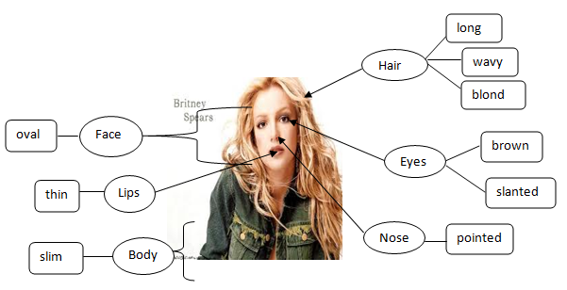

**Figure 2. 1 Example of Clustering Technique**

According to the explanation above, the researcher gave the steps clustering technique to the students.

* + 1. **Descriptive Text**

1. Definition and Purpose of Descriptive Text

Descriptive text is a text which says what a person or thing is like. According to Mashun in Nufidah (2019), descriptive texts are texts with a social purpose that describe object or things individually based on their physical characteristics. The purpose of Descriptive text is to describe and reveal a particular, place, or thing.

Arwida et al. (2023) added that descriptive text is a sentence that has the function of explaining an object, person, animal, etc. There are several grammatical patterns when writing expository text, such as specific nouns, present tense, and vocabulary

1. Generic Structure of Descriptive Text

There are two generic structure of Descriptive Text

1. Identification

Identification is the part of descriptive text that introduces the object in the text. Usually this section contains various information about an object in general.

1. Description

Description is part of descriptive text which contains further information and details about an object, such as shape, color, size and various other characteristics.

1. Language Features of Descriptive Text
2. Explaining or describing objects in detail
3. Using the simple present tense because it tells about the facts of the object being described
4. Using connecting verbs (relating verbs) is, am, are and the verb has or have
5. Using action verbs (verbs that show an action) for example run, sleep, walk, jump, and others
6. Use adjectives to describe objects
7. Example of the text

My Classmate

I have a classmate at school. Her name is Mark Lee. We met often to play and he was always nice to me. Mark's body was tall and well-proportioned. His slender body made his friends envious. Mark also has an actor-like face which many female students like.

He has straight hair with black color. His hobbies are running, swimming and writing a poem. Mark is not only handsome, but also very friendly to his friends and polite to his teachers. Mark always smiled for those who greeted him. Every morning, Mark and I used to go to school together.

Based on the explanation above, the researcher gave the material of descriptive text to the students.

## **Theoretical Framework**

As stated by the theory that have been explained above, the researcher draws the framework of thinking as follows as:

1. Writing is skills that students must practice and master. Giawa (2022) argues that writing is one of the most difficult skills to learn, apart from other skills. Factors that influence good writing include: grammar, vocabulary punctuation, and spelling knowledge.
2. Clustering Technique also known as diagramming, web conception, or mapping are technique that can use to help students organize. Langan (2005) stated that clustering technique is helpful to think in the visual way. There are some lines, boxes, arrows and circle to show relationships among the ideas and detail in clustering technique.

## **Hypothesis**

For the researcher to address the study subject in a different way, the investigator develops the following hypothesis:

Alternative hypothesis (H1): Using Clustering Technique significantly improves the writing abilities of students.

Null hypothesis (H0): Using Clustering Technique does not significantly improve students’ writing abilities.

# CHAPTER III RESEARCH METHODOLOGY

This chapter consists of approach, type, and design of the research, population, sample, and technique of sampling, research variables, data collecting technique, research instrument and technique of analyzing data.

## **Approach, Type, and Design of the Research**

* + 1. **Approach of the Research**

The researcher used a quantitative approach. This technique is defined as scientific. Because it follows principles such as: concrete or empirical, objective, measurable, rational and systematic (Sugiyono, 2014). In this research, only experiment at group received the treatment to check the improvement of students’ writing ability after the clustering technique was applied.

* + 1. **Type of the Research**

This research used quasi-experimental research. It is applied in the experimental group. The experimental group is taught by using clustering technique on treatment. The one gathering pre-test and post-test configuration takes pretest, treatment, and posttest (Airasian, 2000). The researcher used one class of seven grade students at MTs Al-Ikhlas Kluwut as a sample. In the first meeting, students are given the pretest to know their writing ability on descriptive text before using clustering technique. For second until fifth, meetings students received the treatment. At the end of this research they are given a posttest to measure the improvement of students’ writing ability after using clustering technique on learning writing descriptive text.

* + 1. **Design of the Research**

This research used the quantitative approach with one group involved. This research implemented a quasi-experimental design; which is a one-group design for pretest-posttest (Thyer 2012). Researchers gave a pretest and treatment by using Clustering Technique to the treated group then finally gave a posttest. In conducting this research, the researcher used pre-test and posttest design for experimental group. There are seven meetings in this research, including the pre-test was conducted in the first meeting, the treatment in five meetings, and the post-test was conducted in the last meeting.

**Table 3. 1 Design of the research**

|  |  |  |  |
| --- | --- | --- | --- |
| Group | Pre-Test | Treatment | Post-test |
| A | O1 | X | O2 |

A: Experimental Class

X: Treatment of experimental group

O1: Giving Pre-test before treatment

O2: Giving Post-test after treatment

## **Population, Sample and Technique of Sampling**

* + 1. **Population**

The population on this research is the seven grades of MTs Al-Ikhlas Kluwut in academic year of 2023/2024. The students of seven grade is two classes, and the total of the students seven grade are 65 students. The table of total population of the research can be seen below:

**Table 3. 2 Population of the Research in MTs Al-Ikhlas Kluwut**

|  |  |
| --- | --- |
| **Class** | **Quantity** |
| **VII A** | **30** |
| **VII B** | **35** |
| **Total** | **65** |

* + 1. **Sample**

Arikunto (2002) stated that sample of this part of the population that studied. The researcher selected 30 students as sample of this research. The students from MTs Al-Ikhlas Kluwut in academic year 2022/2023. The sample is taken from the population to be participant of the research. Then, the writer chooses one group and only the experimental group.

* + 1. **Technique of Sampling**

Based on Fraenkel (2017), the processes of selecting a sample is known as sampling. Sampling is the process of selecting a subset of individuals (a sample) from a larger population (a population), ideally in a way that reflects the characteristics of the entire group.

One of the suitable sampling techniques is purposive sampling which is used to select the sample. When the target of the sample possesses specific qualities, purposive sampling is employed to ensure that no other sample with the same features is taken. According to Sugiyono (2014), technique sampling is a method for selecting samples based on particular criteria. Purposive sampling is employed when the aim of the sample has specific features. Purposive sampling is used when the sample objective has specific characteristics. purposive techniques are used when researchers want to select research samples randomly by selecting samples according to research needs.

In considering, the researcher used one who group is given the treatment. Group A is chosen because the researcher's experience when taught at MTs Al-Ikhlas Kluwut showed that the student A class has more difficulties during learning writing than B class.

## **Research Variables**

Adapted from Sugiyono (2014), research variable is an attribute, characteristic, or value of an individuals or activity that has specific changes chosen by the researcher to be investigated and conclusions made from those findings. In the same line, Ari (2009) also defined that research variable is something from which conclusions can be delivered by measurement and analysis, an idea or quality that can have several values or scores is called a variable. The researcher got relationships among variables and factors an independent variable (variable X) and a dependent variable (variable Y). The independent variable is the use of clustering technique, which to increase students’ writing ability was dependent variable. Independent variables are called predictor variable because changes in the dependent variable. On the other hand, a dependent variable is a variable that appears as an influence of a dependent variable. Dependent and independent variables are the two categories of variables are use in this research. The variable that is being examined and assessed is known as the dependent variable. The dependent variable is affected by the dependent variable. The research used two variables:

1. Independent variable: Teaching Descriptive Text Using Clustering Technique (X)
2. Dependent variable: Students’ writing ability (Y)

## **Data Collection Technique**

The researcher used test to gather information. Brown (2004) said that the test is a tool for evaluating an individual’s performance, knowledge, or skill in a particular area. Students’ writing proficiency is assessed via an exam both before and after treatment. The test method is the main means of gathering data. The researcher used offline classroom instruction to guide research in order to gather data for this study.

This research conducted a pre-test and post-test. The experimental class was given a pre-test and post-test to assess their ability in writing Descriptive text. For the pre-test the researcher asked the students to compose a simple Descriptive text about their parents. After the pre-test the researcher administered the treatment. Clustering technique to write descriptive text was demonstrated and taught to the students as the treatment. A post-test was distributed to the students which finished by their own. Students are asked to complete the same exam as the pre-test by the researcher. Finding out how the students’ learning outcomes have changed after getting the treatment is the goal of the post-test. There is statistical evaluation of the test outcomes.

## **Research Instrument**

Research instrument is a tool used to collect data in this research. Wilkinson, (2003) stated that research instruments are simply devices for obtaining information relevant to the research project. A standardized writing test was employed by the researcher to assess the progress made by the pupils over the observation period. It is used in the process of collecting data. A written exam was used by the researcher as the research instrument to gather data. Students gave pre and post-tests.

The researcher conducted the data both before and after test, below are the explanation:

1. Pre-test instrument

Before applying the clustering technique in teaching and learning activity, students were taken a pre-test. The researcher is administered a writing exam to the students. Students were given an assignment to write a text about their parents in two paragraphs or less. This is done in an effort to ascertain the pupils’ prior understanding of the subject matter.

1. Treatment

Any educational strategy or technique together with any related academic materials are all considered treatment in this sense. Treatment was given in the classroom. In this instance, clustering technique used in teaching descriptive text.

1. Post-test instrument

The researcher administered a post-test once all course materials were given to the students. The creation of a descriptive text is the main emphasis of this exam. Following three instruction sessions, the post-test was given again. Determining whether or not teaching with the Clustering Technique resulted in a significant improvement in students’ writing skills is the aim of the post-test. Using clustering, the researcher graded the students’ composition of a descriptive about their parents or place. Identification and description are the two components of descriptive text that the text must have.

Assessing a research instrument, two things need to be considered: validity and reliability. Below are the justifications for the validity and reliability of each item. When assessing a research instrument, two factors need to be considered; validity and reliability. Below are the justifications for the validity and reliability of each item:

1. Validity

The ability of an instrument to consistently measure data from a measurable variable establishes it is validity. A test is considered valid if it assesses the intended outcome. A process of expert judgment was used to assess the research instrument’s content. In this sense, consulting experts is the normal procedure for evaluating an instrument’s quality, which comprises utilizing a process known as expert judgment to analyze the instrument.

In order to evaluate expert judgment, a group of people must be asked to choose a tool or express an opinion on a particular component (Portuguez C, 2021). If the instrument makes reference to the chosen criteria, it is considered valid. During the teaching process, the researcher provided the content and administered the test using the instrument. It is referenced of the syllabus and lesson plan that exists and suits for seven grades in the second semester.

1. Reliability

An instrument’s “reliability” is its degree of consistency. This illustrates that even when the exam is administered more than once, the result should remain the same. Effective and good test, according to Arikunto (2002), must be very dependable. Tests that are reliable and consistent can be trusted. Once the test’s validity has been established, it is necessary to reevaluate its reliability and assess student writing assignments uniformly. The crucial aspect is that the rates need to reliability assess the same performance in various circumstances. Therefore, standard operating procedures were used in this research to assess the writing test that students took. The researcher used a writing analytical scoring to measures multiple components, which was derived from Weigle (2002) to evaluate students’ writing abilities.

**Table 3. 3 Scoring Rubric of Descriptive Text**

|  |  |  |
| --- | --- | --- |
| **Components of Writing** | **Score** | **Indicators** |
| **Content** | Very Good  (16-20) | The topic is complete and clear and the details are relating to the topic. |
| Good  (11-15) | The topic is complete and clear but the details are almost relating to the topic. |
| Average  (6-10) | The topic complete and clear but the details are not relating to the topic. |
| Poor  (1-5) | The topic is not clear and the details are not relating to the topic. |
| **Organization** | Very Good  (16-20) | Show the complete parts of identification and description of descriptive text. |
| Good  (11-15) | Show the only parts of the organization of descriptive text. Description is clear and has unity in each sentence. |
| Average  (6-10) | Show the only parts of the organization of descriptive text. Description is clear but has no unity in each sentence. |
| Poor  (1-5) | The writer does not focus on idea based on the topic an activity. The parts of organization of descriptive text are not clear. The text has not unity. |
| **Vocabulary** | Very Good  (16-20) | Effective choice of words and word forms. |
| Good  (11-15) | Few misuses of vocabular, word form, but not change the meaning. |
| Average  (6-10) | Limited range of confusing word and word form. |
| Poor  (1-5) | Very poor knowledge of words, words form, and not understandable. |
| **Grammar** | Very Good  (16-20) | Few or no errors in form of present tense, verb, to be, and objective. |
| Good  (11-15) | Occasional errors in form of present tense, verb, to be, and adjective. |
| Average  (6-10) | Frequent errors in form of present tense, verb, to be, and objective. |
| Poor  (1-5) | Dominated by serious errors in form of present tense, verb, to be, and adjective. |
| **Mechanics** | Very Good  (16-20) | Use correct spelling, punctuation, and capitalization. |
| Good  (11-15) | Occasional errors of spelling, punctuation, and capitalization. |
| Average  (6-10) | Frequent errors of spelling, punctuation, and capitalization. |
| Poor  (1-5) | Dominated by errors of spelling, punctuation, and capitalization. |

Adapted based on the researcher need from Weigle (2002)

The total maximum score can be formulated as follow:

Content : 20

Organization : 20

Vocabulary : 20

Grammar : 20

Mechanics : 20

100

By computing the results of the students in the pre-test and post-test, the researcher compared and measured the effect of this research.

## **Technique of Analyzing Data**

The process of analyzing the information gathered from the study is known as data analysis. Once all written data needed for the study is gathered, the researcher determined whether there is a significant difference in the writing abilities of the students in the descriptive text that was taught using the Clustering Technique. The researcher graded the students’ writing abilities throughout the test. The researcher used Statistical Package for the Social Sciences (SPSS) version 24 to describe the students’ writing abilities in the descriptive text. In this research, the rater who are assign scores to the students’ pre-test and post-test is the researcher’s role as the teacher at MTs Al-Ikhlas Kluwut.

Statistical analysis is another name for quantitative data analysis. It signifies that a numerical presentation of the data server result is present. The test results of the students are compared before and after the Clustering Technique is used in this research to teach Descriptive Text using t-test procedures to examine the data impact of the Clustering Technique on writing instruction.

1. Calculating the Normality

A normality test is used in statistics to check if a data set is representative of a normal distribution. A normal distribution or one that is close to normal, is necessary for many statistical functions. The data were calculated by the researcher used the SPSS program. If the significance value is more than 0.05, then normal distribute data are produced.

1. Calculating the Paired Sample T-test

Using the SPSS program, the researcher computed the paired sample t-test of the students’ writing abilities to observe any variations pertaining to pre- and post-test values following treatment in an experimental group. In this research, the data is examined using the SPSS application, which the researcher used to determine if H1 is accepted and H0 is denied. If t0-value is superior to t-Table, then H1 were approved.