

**THE USE OF DUOLINGO APPLICATION TO ENHANCE STUDENTS’ VOCABULARY MASTERY**

(An Experimental Study on the 9th Grade Students of Pattanakansuksa Foundation School Thailand in the Academic Year of 2024)

**RESEARCH PROJECT**

**Submitted as Partial Fulfillment of the Requirements for the Degree of *Sarjana Pendidikan* in English Education**

**By**

**Warapa Tohdin**

**NPM: 1620600022**

**ENGLISH EDUCATION PROGRAM**

**TEACHING TRAINING AND EDUCATION FACULTY**

**UNIVERSITAS PANCASAKTI TEGAL**

**2024**

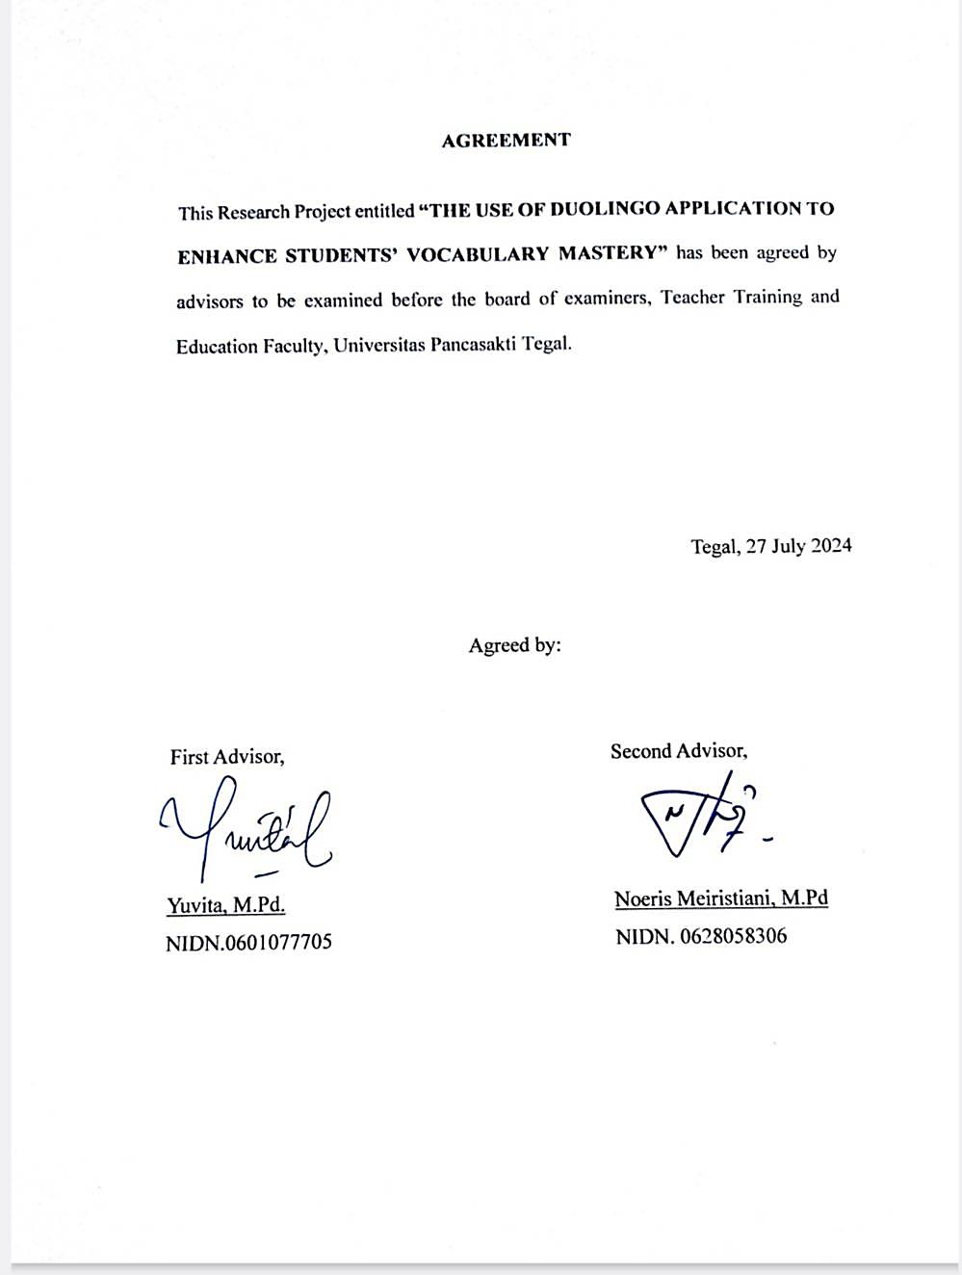

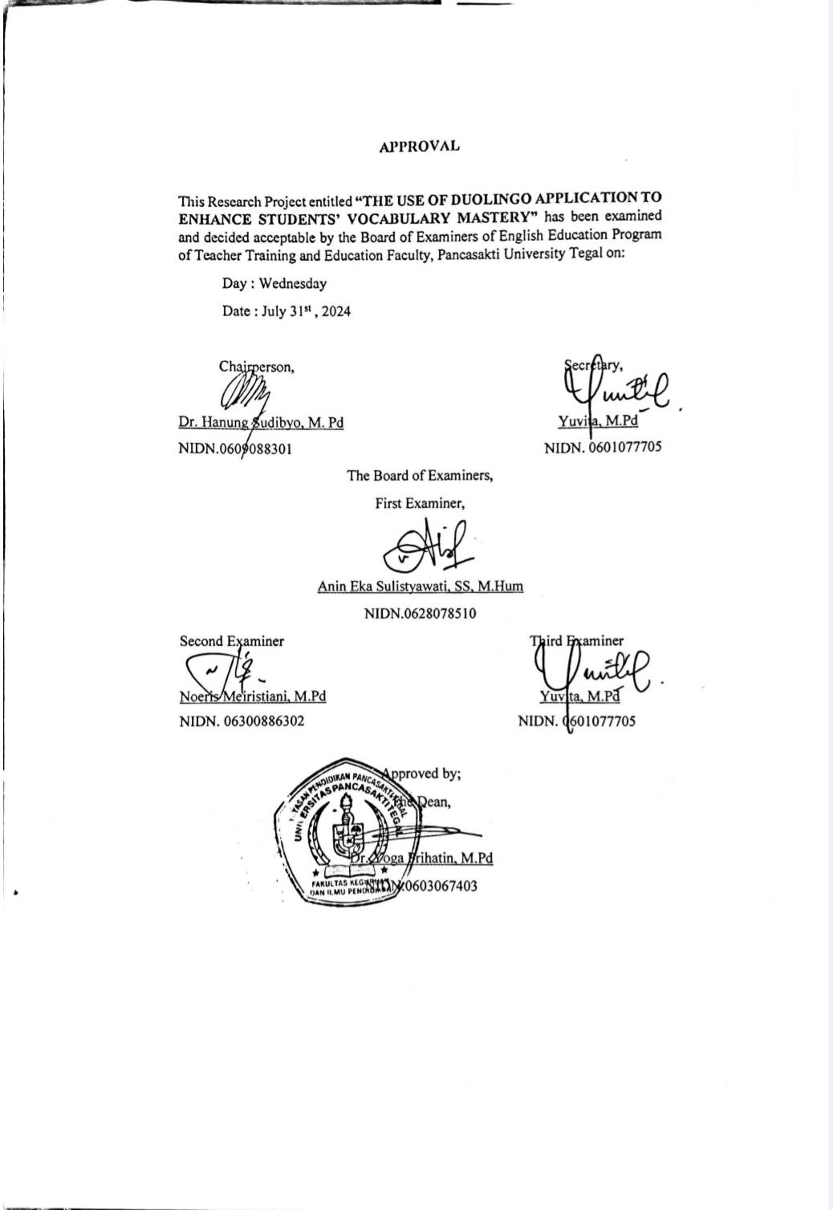

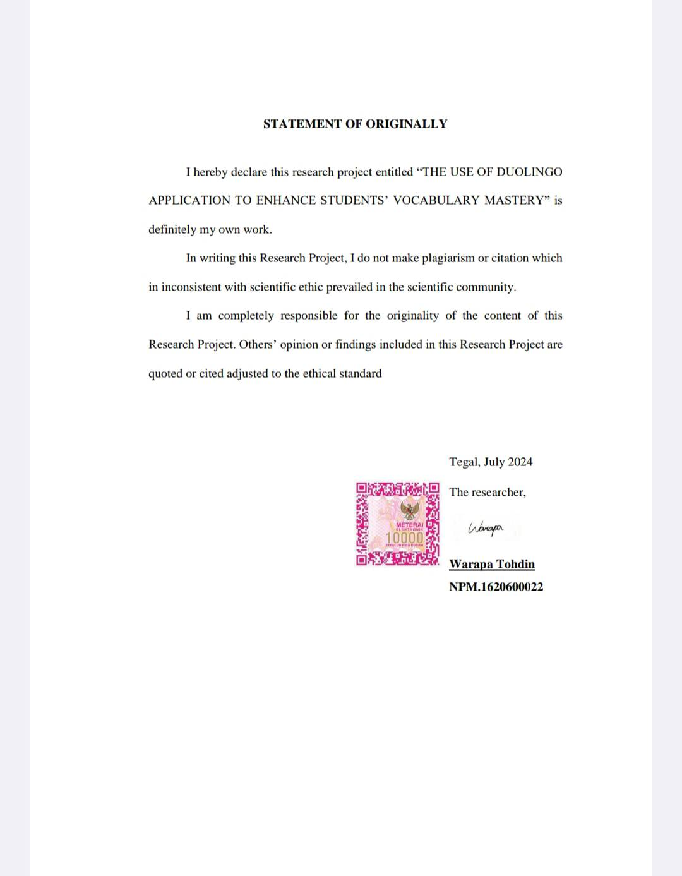

**MOTTO AND DEDICATION**

**Motto:**

* "Truly, after each hardship, there is ease." – Quran 94:5
* “Seek knowledge from the cradle to the grave.” (Prophet Muhammad)

**Dedication:**

I dedicate this research to individuals who have inspired, supported, and guided me every step of this journey. I could not have succeeded in doing this research without them.

* I express my gratitude to Allah, the Most Gracious and Most Merciful, for bestowing knowledge upon me and guiding me throughout my research journey.
* To my beloved family, my parents, and my siblings, who have always given love, care, and support that never ends. Their love, care, and support mean a lot to me. And they are my constant source of strength and inspiration.
* To my dear friends, who have always helped and given me advice when I was feeling down and hopeless. Their friendship is like a beacon of light that guides me forward on my path.
* To my esteemed lecturers, who have imparted knowledge and guidance with unwavering determination.
* And to myself, for having the determination and patience to be able to complete this research.

**PREFACE**

Thanks to Allah, for His blessings and guidance that have led me to complete this research. All praise is due to Allah for granting me the strength, knowledge, and perseverance to complete this research entitled "The Use of Duolingo Application to Enhance Students' Vocabulary Mastery."

The researcher would not have been able to conduct the research without the assistance, advice, and guidance of numerous individuals who contributed from the preparation stage through to the completion of the research. Upon its completion, the researcher wishes to extend their gratitude to all those involved:

1. Dr. Taufiqulloh, M. Hum., as the rector of Pancasakti University Tegal.
2. Dr.Yoga Prihatin, M.Pd. as the dean of the Faculty of Teacher Training and Education, Pancasakti University, Tegal.
3. Mrs. Yuvita, M.Pd as the head of English Department, Teacher Training and Education Faculty of Pancasakti University, Tegal.
4. Mrs. Yuvita, M.Pd as the first advisor, who has provided invaluable guidance, patience, and insights throughout the research process. Your expertise and feedback have greatly increased the quality of this research. Your encouragement during hard times and your constructive criticism have pushed me to achieve more than I ever expected.
5. Mrs. Noeris Meiristiani, M.Pd as the second advisor, who has provided constant support and constructive feedback, was critical in shaping this research. Your attention to detail and dedication to my progress of doing this research have been a strong force throughout this journey.
6. 9th grade students of Pattanakansuksa Foundation School, especially 30 students, who were the sample in this research and provided me with valuable data. All students cooperated and did the test diligently. The data obtained from this research will be very useful in the further development of education.
7. Anita Manoondawee as the Principal of Pattanakansuksa Foundation School, thank you for granting me the permission to conduct this research at your institution. Your openness and support have made this research possible, and I am deeply grateful for your assistance.
8. My beloved mom, who was always there for me when I needed encouragement and when I was down. Your unwavering love, support, encouragement, and belief in me have been my greatest source of strength and inspiration.
9. My beloved dad, who has inspired me when I was tired and gave me motivation. Your teachings and support have shaped me into a person who is determined, patient, and unflinching in the face of any obstacle.
10. My dearest sister, who is both my best friend and my greatest advisor. You have given me advice and support in every way. Your love and concern have been a shield for me in the face of challenges.
11. My two wonderful brothers, who have always stood by my side and encouraged me. Thank you for making me smile when I was stressed. Your laughter is like a magic potion that keeps me happy and relieves stress. The bond between us is very strong and deep.
12. My friends, especially fellow PBI branch members. Thank you to my faithful friends who are by my side in good times and bad. Moreover, thank you for always giving me advice and helping me. Your sincerity and help have gotten me through countless difficult times.
13. My favorite artists, are Jeong Jaehyun and Ten Lee. Your existence in this world means so much to me. You have been my inspiration and motivation throughout my studies. Whenever I feel tired and discouraged, seeing your performances and listening to your music always make me happy and determined to accomplish everything in successfully.
14. Finally, I want to acknowledge and thank myself for the determination, perseverance, and dedication, which have brought me this far. This research is a testament to the combined efforts of many individuals. And I am deeply grateful to all of you. Your participation not only made this research possible but also enhanced my academic and personal growth.

Tegal, July 2024

The researcher,



**Warapa Tohdin**

**NPM.1620600022**

**ABSTRACT**

**Tohdin, Warapa. 2024. 1620600022** “THE USE OF DUOLINGO APPLICATION TO ENHANCE STUDENTS’ VOCABULARY MASTERY (An Experimental Study on the 9th Grade Students of Pattanakansuksa Foundation School Thailand in the Academic Year of 2024)”. Research Project. Strata I Program, Faculty of Teacher Training and Education, Universitas Pancasakti Tegal, The First Advisor is Yuvita, M.Pd, and The Second Advisor is Noeris Meiristiani, M.Pd.

**Keywords:** *Duolingo, Vocabulary Mastery*

The purpose of this study was to investigate the effectiveness of using the Duolingo application on students' vocabulary mastery and to determine if there is a significant difference in vocabulary development between students taught using Duolingo and students taught without using Duolingo among Ninth grade students of Pattanakansuksa Foundation School in the academic year 2024.

The study employed a quantitative approach with a true-experimental research design, utilizing a pre-test and post-test for two groups. The population was 9th grade students of Pattanakansuksa Foundation School, which has a total of 107 students. There were 30 students as a sample consisting of 15 students as the experimental class and 15 students as the control class. The data were analyzed using the IBM SPSS26 Program.

The results of descriptive analysis revealed a significant difference in vocabulary test scores between the experimental and control groups. The experimental group using Duolingo had a higher mean post-test score (86.67) compared to the control group (65.07). Data normality and homogeneity tests confirmed the normal distribution and homogeneity of the data (p > 0.05). Paired samples t-tests indicated a significant difference between the two groups, with a p-value of 0.000 less than 0.05 for post-test comparisons. Therefore, the null hypothesis (Ho) is rejected, and the alternative hypothesis (H1) is accepted. The results suggest that the use of the Duolingo application can be an effective tool for enhancing students' vocabulary mastery. The findings provide evidence for the integration of Duolingo into language learning curricula to enhance students' vocabulary development. This suggests that students should utilize Duolingo for vocabulary enhancement and skill development, and teachers are recommended to integrate Duolingo into their curriculum for effective vocabulary instruction.

**ABSTRAK**

**Tohdin, Warapa. 2024. 1620600022** “THE USE OF DUOLINGO APPLICATION TO ENHANCE STUDENTS’ VOCABULARY MASTERY (An Experimental Study on the 9th Grade Students of Pattanakansuksa Foundation School Thailand in the Academic Year of 2024)”. Skripsi. Program Strata 1. Fakultas Keguruan dan Ilmu Pendidikan, Universitas Pancasakti Tegal, Pembimbing I Yuvita, M.Pd, dan Pembimbing II Noeris Meiristiani, M.Pd.

**Kata Kunci:** *Duolingo, Vocabulary Mastery*

Tujuan dari penelitian ini adalah untuk menyelidiki efektivitas penggunaan aplikasi Duolingo dalam penguasaan kosakata siswa dan untuk menentukan apakah ada perbedaan signifikan dalam perkembangan kosakata antara siswa yang diajarkan menggunakan Duolingo dan siswa yang diajarkan tanpa menggunakan Duolingo di kalangan siswa kelas sembilan di Sekolah Pattanakansuksa Foundation pada tahun ajaran 2024.

Penelitian ini menggunakan pendekatan kuantitatif dengan desain penelitian eksperimen murni, yang memanfaatkan pre-test dan post-test untuk dua kelompok. Populasinya adalah siswa kelas sembilan di Sekolah Pattanakansuksa Foundation, yang berjumlah total 107 siswa. Sampel terdiri dari 30 siswa, dengan 15 siswa sebagai kelompok eksperimen dan 15 siswa sebagai kelompok kontrol. Data dianalisis menggunakan Program IBM SPSS26.

Hasil analisis deskriptif mengungkapkan perbedaan signifikan dalam skor tes kosakata antara kelompok eksperimen dan kelompok kontrol. Kelompok eksperimen yang menggunakan Duolingo memiliki skor rata-rata post-test yang lebih tinggi (86,67) dibandingkan dengan kelompok kontrol (65,07). Uji normalitas dan homogenitas data mengonfirmasi distribusi normal dan homogenitas data (p > 0,05). Uji t untuk sampel berpasangan menunjukkan perbedaan signifikan antara kedua kelompok, dengan nilai p 0,000 kurang dari 0,05 untuk perbandingan post-test. Oleh karena itu, hipotesis nol (Ho) ditolak, dan hipotesis alternatif (H1) diterima.Hasil penelitian ini menunjukkan bahwa penggunaan aplikasi Duolingo dapat menjadi alat yang efektif untuk meningkatkan penguasaan kosakata siswa. Temuan ini memberikan bukti untuk integrasi Duolingo ke dalam kurikulum pembelajaran bahasa untuk meningkatkan perkembangan kosakata siswa. Ini menunjukkan bahwa siswa sebaiknya memanfaatkan Duolingo untuk peningkatan kosakata dan pengembangan keterampilan, dan disarankan agar guru mengintegrasikan Duolingo ke dalam kurikulum mereka untuk pengajaran kosakata yang efektif.

**TABLE OF CONTENTS**

AGREEMENT I

APPROVAL II

STATEMENT OF ORIGINALITY III

MOTTO AND DEDICATION IV

PREFACE V

ABSTRACT VIII

ABSTRAK IX

TABLE OF CONTENTS X

LIST OF TABLES XII

LIST OF FIGURES XIII

LIST OF APPENDICES XIV

CHAPTER I INTRODUCTION 1

1.1 Background of the Problems 1

1.2 Identification of the Problems 5

1.3 Limitation of Problems 5

1.4 Statement of Problems 5

1.5 Objectives of Research 6

1.6 Significances of the Research 6

1.6.1 Theoretical Significances 6

1.6.2 Practical Significances 6

CHAPTER II REVIEW OF RELATED THEORIES, THEORETICAL FRAMEWORK, AND HYPOTHESIS 8

2.1 Previous Studies 8

2.2 Review of Related Theories 11

2.2.1 Duolingo 11

A). Definition of Duolingo 11

B). Advantages of Duolingo 12

C). Disadvantages of Duolingo 14

D). Steps of learning vocabulary using Duolingo 15

2.2.2 Vocabulary 20

A). Definition of vocabulary 20

B). Importance of vocabulary 21

C). Aspects of vocabulary 22

D). Kinds of vocabulary 24

E). Teaching vocabulary 26

F). Teaching vocabulary for 9th grade students 32

2.3 Theoretical Framework 33

2.4 Hypothesis 34

CHAPTER III RESEARCH METHODOLOGY 36

3.1 Approach, Type, and Design of the Research 36

3.2 Population, Sample, and Technique of Sampling 39

3.3 Research Variables 40

3.4 Data Collecting Technique 41

3.5 Research Instrument 42

3.6 Technique of Analyzing Data 44

CHAPTER IV RESEARCH RESULTS AND DISCUSSION 47

4.1 Research Results 47

4.2 Discussion 58

CHAPTER V CONCLUSION AND SUGGESTION 62

5.1 Conclusion 62

5.2 Suggestion 63

REFERENCES 66

APPENDICES 70

**LIST OF TABLES**

Table 2. 1 The steps of learning vocabulary using Duolingo 15

Table 3. 1 Research Design 38

Table 3. 2 Total Number of Sample 40

Table 3. 3 Reliability Statistics 44

Table 4. 1 Descriptive Data Analysis 55

Table 4. 2 Distribution of Pre-Test and Post-test Scores 56

Table 4. 3 Test of Homogeneity 57

Table 4. 4 Paired Samples Test Result 58

**LIST OF FIGURES**

Figure 2. 1 The Theoretical Framework 33

**LIST OF APPENDICES**

Appendix 1 Validity for Instrument Research 70

Appendix 2 Student’s Pre-test and Post-test Scores 72

Appendix 3 Research Instrument 74

Appendix 4 SPSS DATA 79

Appendix 5 Letter of Research Permission 81

Appendix 6 Research Completion Letter 82

Appendix 7 Lesson Plan 83

Appendix 8 Documentation of Research 137

**CHAPTER I**

**INTRODUCTION**

In the first chapter, the researcher explains and outlines the background of the problems, problem identification, limitation of the problems, statement of the problems, objectives of the research, and significance of the research.

* 1. **Background of the Problem**

In today's globalized world, proficiency in a second language has become increasingly important. Humans use language not only as a tool for receiving meaning to express understanding toward each other. Language is also a tool for controlling society and expressing the cultural identity of that nation as well (Pokaisawan et al., 2018). English is one of the most significant languages ​​globally, including Thailand, which uses English as a common language for communicating with foreign countries. Nowadays, English is taught across elementary, middle school, high school, and university levels. English is not only necessary to learn, but it is also a tool for self-improvement for everyone. Learning English is therefore very necessary for education from the basic level to the tertiary level so that Thai students can develop 4 English skills: listening, speaking, reading, and writing skills.

As the globalized world demands more people who speak English fluently, Thai students must obligate English from a young age and must pass multiple English proficiency exams throughout their educational lives. Pattanakansuksa Foundation School is a secondary school located in Khlong Khut Subdistrict, Mueang District, Satun Province. The researcher used this school to conduct this research. Students at Pattanakansuksa Foundation School still have difficulty in learning English. One of the problems that students at Pattanakansuksa Foundation School encounter when learning English is that they have a bad attitude towards English. Students at Pattanakansuksa Foundation School often think that studying English is difficult, which makes them not want to study and not be interested in learning English. Moreover, most students face problems when learning vocabulary. They argue that the vocabulary is so wide that it is difficult to memorize words. This may be because many words in English have similar meanings or because the students do not use English in their daily lives. This makes it impossible to practice memorizing vocabulary with correct understanding.

The Thai Ministry of Education has recognized the significance of English and therefore has set the goal of teaching English, which is that when learners study English from early elementary school to high school, they will have a good attitude towards the English language. When learners exhibit a positive attitude towards English, learners will be able to utilize English effectively for communication in various situations, seek knowledge, pursue a career, and pursue higher education (Ministry of Education Thailand, 2008). The Thai Ministry of Education has designated the 2008 Basic Education Curriculum as the country's core curriculum, specifying that English is classified as a learning subject with the aim of making students have a good attitude towards English. If learners have a good attitude towards English, they will be able to use English to communicate in various situations, seek knowledge, pursue a career, and study at a higher level. Including being able to have knowledge and understanding of the diverse stories and cultures of the world community and being able to creatively transfer Thai ideas and culture to the world society. It consists of the following important contents, such as language for communication, language and culture, language and its relationship with other learning subjects, and language and its relationship with the community and the world.

Currently, English language teaching focuses on developing students' four skills: speaking, listening, reading, and writing. One of the skills that is extremely important is vocabulary mastery. According to Guaqueta and Castro-Garces (2018), among the language skills that all learners need to be able to develop linguistic competence, vocabulary is foremost a key component. Vocabulary knowledge is related to the four skills of listening, speaking, writing, and reading. Before humans can communicate in English, the most important thing they need to know is vocabulary. Lozarito and Segumpan (2022:8) stated that vocabulary is a crucial knowledge area in language that has always played a significant role in acquiring a language. They argue that it is the essential component for language proficiency which links the four skills of listening, speaking, writing, and reading. Therefore, it can be said that learning vocabulary plays an important role in language learning and ability. The ability to communicate and understand language effectively requires a strong vocabulary foundation. Traditional vocabulary learning methods such as memorization and repetition may not always engage students and produce the desired results. In recent years, educational technology has become increasingly popular with the development of various language learning applications to improve language skills. One such application is Duolingo, which offers an interactive and gamified approach to language learning.

Duolingo is one of the most popular applications that most people use to learn English. It is a language training app that focuses on listening, speaking, reading, and writing. Duolingo can also help enhance vocabulary mastery as well. Furthermore, Duolingo is also a mobile application that offers an interactive and gamified language learning experience. It claims to make language learning fun and effective. It offers a personalized learning path and provides immediate feedback. Ajisoko (2020) demonstrated through his research that Duolingo may have a positive effect on vocabulary learning. This application can grab the attention of the learners where they gave a positive response to the application. The learners in his study were more motivated to learn and more skillful because their interest in learning increased. The materials provided were easy to understand and students had the opportunity to practice as well. Furthermore, Duolingo can also eliminate learning boredom, stimulate new ideas, and facilitate students in remembering and practicing the material in daily life. These findings indicate that Duolingo can be a valuable tool for enhancing students' vocabulary mastery.

As English is widely used for communication and academic purposes, developing language skills, particularly vocabulary, is crucial for learners. The emergence of language learning applications such as Duolingo offers a promising alternative. By providing an interactive and gamified learning experience, Duolingo has the potential to enhance students' vocabulary acquisition and improve their overall language proficiency. Understanding the strengths and weaknesses of Duolingo in terms of vocabulary improvement is essential for educators and researchers seeking to optimize language learning strategies. To examine what influence Duolingo would have if the researcher used Duolingo in classroom teaching vocabulary for students at Pattanakansuksa  Foundation School, the researcher therefore conducted a research entitled "The use of Duolingo application to enhance students' vocabulary mastery." This study aims to examine the effectiveness of the Duolingo application in improving students' vocabulary proficiency among Ninth grade students at Pattanakansuksa Foundation School.

* 1. **Problem Identification**

As outlined in the background of the problems, the problems are defined in this research as follows**:**

1. Students lack of proficiency in a second language.
2. Students have a bad attitude towards English.
3. Students face problems with learning vocabulary because the vocabulary is so wide that it is difficult to memorize words.
   1. **Limitation of the Problems**

This study focuses on using the Duolingo app as a tool for enhancing vocabulary mastery of Ninth grade students at Pattanakansuksa Foundation School only. Other language learning applications are not considered in this study.

* 1. **Statement of the Problems**

Based on the background of the problem provided, statement of the problems in this research can be articulated as follows:

1. How is the effectiveness of using the Duolingo application on students' vocabulary mastery?
2. Is there a significant difference in vocabulary mastery between students taught using Duolingo and students taught without using Duolingo?
   1. **Objectives of the Research**

Based on the statements of the problems above, this study aims to investigate the effectiveness of using the Duolingo application on students' vocabulary mastery and to determine if there is a significant difference in vocabulary development between students taught using Duolingo and students taught without using Duolingo among Ninth grade students at Pattanakansuksa Foundation School.

* 1. **Significance of the Research**
     1. **Theoretical Significance**

This study will contribute to the existing body of knowledge on the use of educational technology in language learning. By exploring the impact of the Duolingo application. It provides insights into the theoretical aspects of vocabulary acquisition and the role of technology in language education.

* + 1. **Practical Significance**
       1. For Learners

The findings of this study will benefit students by providing evidence of the effectiveness of using the Duolingo app in enhancing vocabulary mastery. It helps students make informed decisions about including it in their language learning routines. Students can also gain insights into the use of educational technology and its impact on language learning.

* + - 1. For the teachers and educators

This study will be valuable for educators and language teachers. Because it provides insight into the use of educational technology, especially the Duolingo app, to improve vocabulary ability. It will also suggest ways to integrate gamified and interactive methods into the classroom, making language learning more appealing and effective.

* + - 1. For other researchers

Other researchers can build upon this study by exploring different language learning applications or methods and comparing their effectiveness. It will also inspire further research on the integration of technology in language education and its impact on students' language skills.

**CHAPTER II**

**REVIEW OF RELATED LITERATURE**

In this chapter, an overview of previous studies, related theories, theoretical framework, and research hypothesis are presented.

**2.1 Previous Studies**

The researcher has cited previous research relevant to this study. The previous studies from other researchers can help interpret the results of the current study. It provides context and a reference point for comparison. This allows the researcher in this study to assess the importance and significance of the findings. Some researchers are as follows:

Khairani and Zulfitri (2023) conducted research entitled “The effect of Duolingo online application on students’ English vocabulary mastery of VII Grade class at SMP Al Razi Sinar Harapan”. Their research investigated the impact of the Duolingo app on the vocabulary mastery of seventh-grade students at SMP Al Razi Sinar Harapan. The study employed a quantitative approach and randomly assigned 28 seventh-grade students to an experimental group (implementing Duolingo) and a control group (without implementing Duolingo). The research instrument was a multiple-choice test consisting of 15 questions to determine student's achievements in vocabulary. The findings revealed a significant improvement in students' vocabulary skills after using Duolingo, indicating that the application effectively enhanced their vocabulary acquisition.

Borang et al. (2023) conducted research entitled “The use of Duolingo application to increase students’ vocabulary mastery”. This study explored the use of the Duolingo application to enhance students' vocabulary mastery. Their research aimed to investigate the effectiveness of the Duolingo app in improving vocabulary skills. The subjects of their study were 31 students from SMP Negeri 1 Manganitu class 8 B. This study used pre-experimental research with one group pre-test and post-test. The researchers found that incorporating Duolingo into language learning activities led to a significant improvement in students' vocabulary skills. The study also highlighted the positive impact of gamified learning on students' motivation and engagement.

Hernadijaya (2020) conducted research entitled “The use of Duolingo application to enhance junior high school student’s English vocabulary.” This investigated the efficacy of using the Duolingo mobile app to enhance vocabulary acquisition and engagement in EFL learners. Through a quasi-experimental design was tested on seventh-graders with two groups sample experimental and control groups that each group consist of 17 students, the study found that the experimental group utilizing Duolingo exhibited a significant improvement in vocabulary knowledge compared to the control group. The results also showed that Duolingo's gamified approach, which incorporates interactive exercises and rewards, can effectively supplement classroom instruction and foster a more engaging and effective learning experience for EFL learners.

Oktarini (2023) conducted research entitled “The Effect of Using Duolingo to Improve Students’ Vocabulary Mastery at The Eleventh Grade Students of SMAN 5 Pinggir.” The study investigated the impact of using the Duolingo app on vocabulary mastery among eleventh-grade students. This study was a quantitative approach with a quasi-experimental design. The findings demonstrated a significant improvement in students' vocabulary skills after utilizing the Duolingo application. The study also highlighted the importance of incorporating technology-based learning tools in language classrooms.

Febriani et al. (2023) conducted research entitled “Improving student’s English vocabulary using Duolingo application.” This study explored how the Duolingo app can be used to improve students' English vocabulary. This study was classroom action research focused on improving students' English vocabulary using the Duolingo application. The participants in this research were 15 students from the 12th grade Social 3 class at SMA Negeri 1 Selakau during the 2021/2022 academic year. The researchers found that consistent use of Duolingo resulted in significant vocabulary improvement among students. The study also highlighted the user-friendly interface and interactive features of the application, which contributed to students' engagement and motivation.

Previous studies have consistently shown the positive impact of the Duolingo application on students' vocabulary mastery, but they have not specifically examined its effectiveness for ninth-grade student. There is a lack of research investigating the use of Duolingo to enhance vocabulary mastery among ninth-grade junior high school students specifically. Additionally, while previous studies have employed various research designs, there is a need for further research using a quantitative approach with an experimental design (true experimental) to establish a causal relationship between the use of Duolingo and vocabulary enhancement. This study will highlight the need for a study that examines the effectiveness of Duolingo in improving vocabulary mastery among ninth-grade junior high school students using a quantitative approach with an experimental design (true experimental), thereby advancing a more comprehensive understanding of the application's impact on vocabulary acquisition in this specific educational context.

**2.2 Review of Related Theories**

The topic of "The use of Duolingo application to enhance students' vocabulary mastery," is supported by several theories. Thus, the researcher gathered various relevant theories from multiple sources.

**2.2.1 Duolingo**

1. **Definition of Duolingo**

Duolingo is a modern app designed to facilitate second language acquisition (Habibie, 2020). This application is an innovative language learning application that has garnered significant popularity in recent years. It is a popular language learning application that provides interactive lessons and exercises to help improve language skills.

Ambara (2020) stated that Duolingo is a language learning tool employed in language acquisition, specifically designed to foster active learner engagement within the educational context. This tool is effective for vocabulary instruction and offers all students a fair opportunity to practice the material.

According to Fariska and Gusti (2022), Duolingo is designed to assist children to make language learning, particularly English vocabulary, more accessible and enjoyable for children.

In conclusion, Duolingo can be an effective mobile application for teaching and learning languages. This application can help learners improve vocabulary proficiency. Duolingo provides interactive lessons and exercises to help users increase their language skills. Additionally, Duolingo also helps keep users engaged and interested in learning language through enjoyable way.

1. **Advantages of Duolingo**

Duolingo application offers several advantages as for learning language, including the following:

1. Duolingo is an accessible and convenient application that can be accessed anytime and anywhere. This makes it convenient for users to practice vocabulary, they can practice vocabulary wherever and whenever they want.
2. Duolingo incorporates gamification elements, such as levels, achievements, and leaderboards, which make the learning process engaging and fun, motivating learners to continue practicing and improving their vocabulary.
3. Duolingo offers short and interactive lessons, which are designed to optimize learning and retention. This approach allows users to focus on specific vocabulary areas and gradually build their knowledge over time.
4. Duolingo adapts to each user's proficiency level and learning pace, providing personalized advice and exercises based on their strengths and weaknesses. This helps users to focus on areas that need improvement and enhances their vocabulary learning experience.
5. Duolingo covers a wide range of topics, from everyday conversations to specialized vocabulary in various domains. This variety helps users to expand their vocabulary in different areas of interest and practical use.
6. Duolingo provides instant feedback on user answers, pointing out errors and offering explanations where necessary, it can help users to understand and correct their mistakes, reinforcing their vocabulary learning.
7. Duolingo allows users to connect with friends, join language clubs, and participate in discussion boards. This social aspect creates a sense of community, provides opportunities for practicing with others, and fosters motivation and responsibility.
8. Duolingo continuously tracks users' progress, showing their streaks, completed lessons, and overall performance. This feature enables users to monitor their growth, set goals, and stay motivated to consistently improve their vocabulary.
9. Duolingo has both a basic and a paid versions. The app offers a free version with access to most of its features, making it accessible to many users. Additionally, there is a premium subscription available for those who want to unlock additional content and features.
10. **Disadvantages of Duolingo**

Despite its advantages, Duolingo also has certain limitations. Pramesti and Susanti (2020) showed in their research that there are some disadvantages of Duolingo as follows:

1. Duolingo requires an internet connection to work. It will not be useful when users live in a remote area without internet access.
2. The voice in the listening exercise part comes out with an unnatural sound.
3. Sometimes the sentences are odd and unusual.
4. In the Duolingo application, there are no grammar explanations, users have to comprehend the grammar rules by themselves.

Besides, other researchers like Muddin (2018) has also identified disadvantages of using Duolingo as a tool for learning vocabulary, such as the teacher must use a projector if implementing Duolingo in the classroom, which can make students more active and they will participate in the learning and teaching process. The teacher also has to be prepared to allocate time and tools if used in regular classroom, such as time to prepare projector, loudspeaker, and notebook.

From the information above, it can be concluded that Duolingo has some drawbacks. Dispite its advantages, this application still requires further improvement to address these shortcomings and enhance its overall effectiveness.

1. **Steps of learning vocabulary using Duolingo**

**Table 2.1** **The steps of learning vocabulary using Duolingo**

|  |  |  |
| --- | --- | --- |
| Steps | Pictures | Explanation |
| 1.Download Duolingo application |  | Install the Duolingo app on a compatible device. |
| 2.Create Duolingo account |  | Create a Duolingo account to make it easier for the next learning session without having to spend time signing up for an account. |
| 3.Select a Target Language |  | Choose the language you want to learn on the Duolingo platform. |
| 4.Set Learning Goals |  | Define your learning objectives and the specific vocabulary areas you want to focus on. |
| 5.Start Duolingo with basic exercises |  | Begin with the foundational lessons provided by Duolingo to familiarize yourself with the language. |
| 6.Complete Duolingo lessons |  | Progress through the Duolingo lessons, which gradually introduce new vocabulary and reinforce previously learned words. |
| 7.Practice vocabulary through Duolingo regularly |  | Dedicate consistent time to practice on Duolingo to reinforce vocabulary retention. |
| 8.Utilize Additional Resources |  | Supplement your learning by using external resources, such as dictionaries or language exchange platforms. |
| 9.Review and Track Progress |  | Use Duolingo's progress tracking features to monitor your vocabulary mastery and identify areas for improvement. |

In learning vocabulary, Duolingo is an ideal application for the new generation who want to learn vocabulary by learning through mobile applications. This app is easily accessible as it can be downloaded and installed on compatible devices. Creating an account on Duolingo allows for a seamless learning experience without the need to spend time on signing up. Additionally, Duolingo offers a wide range of target languages to choose from, allowing users to learn the language they desire. It also provides the flexibility to set learning goals and focus on specific vocabulary areas. Starting with the foundational lessons, Duolingo helps users familiarize themselves with the language and gradually introduces new vocabulary while reinforcing previously learned words.

Consistent practice is key to retaining vocabulary, and Duolingo encourages users to dedicate regular time to practice on the app. To enhance the learning experience, Duolingo recommends utilizing external resources like dictionaries or language exchange platforms. Duolingo's progress tracking features enable users to review their progress and identify areas for improvement in vocabulary mastery. Overall, Duolingo is a comprehensive and user-friendly application that offers a structured approach to learning vocabulary.

**2.2.2 Vocabulary**

1. **Definition of Vocabulary**

Several definitions of vocabulary exist. Vocabulary refers to words or groups of words used in communication, have a specific meaning, and are used in various contexts to communicate or express meaning to be understood together. It includes words, phrases, idioms, and expressions that are commonly used in a particular language or profession. Vocabulary is connected with components such as listening, speaking, reading, and writing (Rahmah et al. 2023). A strong vocabulary is important for effective communication, comprehension, reading, and writing skills. Alqahtani (2015:25) explained that vocabulary encompasses all the words required to convey ideas and express the speaker's meaning.

Based on Saroyan (2016), “vocabulary is a crucial component of language that enables us to express our thoughts, ideas, feelings, and experiences, serving as a fundamental tool for conveying information.”

According to the definitions provided, vocabulary is described as a collection of words, phrases, idioms, and expressions that a person possesses and utilizes to effectively communicate in a language. It encompasses the words needed to convey ideas, express meaning, and share thoughts, feelings, and experiences. Vocabulary plays a crucial role in various language skills such as listening, speaking, reading, and writing, and is essential for comprehension and effective communication. It functions as a medium for conveying information and is considered an indispensable part of language.

1. **Importance of Vocabulary**

Vocabulary is a crucial element for understanding the English language. Knowing more vocabulary will help people read and understand the content correctly and quickly. Learning new words increases people's confidence in communicating with native English speakers. Using the right and appropriate vocabulary helps to communicate clearly and in an organized way.

Alqahtani (2015) highlights that vocabulary knowledge is essential for communicative competence and the successful acquisition of a second language. Additionally, Rashid et al. (2022) argue that if students do not have a broad vocabulary, they will not be able to understand other people's ideas or communicate their own.

Vocabulary is crucial for learning the English language. Expanding one's vocabulary not only improves reading comprehension but also increases confidence when communicating with native speakers. The ability to use the right words in a clear and organized manner facilitates effective communication. As highlighted by expert vocabulary knowledge is crucial for enhancing communicative competence and successfully acquiring a second language. Furthermore, a limited vocabulary prevents individuals from understanding others' ideas and expressing their ideas effectively. Therefore, language learners must prioritize vocabulary acquisition in order to grow English language proficiency.

1. **Aspects of Vocabulary**

Based on Lado (1972:1) as cited in Mardianawati (2012), five aspects that learners can be learned English vocabulary. They are meaning, spelling, pronunciation, word classes, and word use.

1. Meaning

The significant aspect of vocabulary teaching is fostering learners' independence, guiding them to handle new words, and expanding their vocabulary beyond the lesson. Learners should be encouraged to discover the meaning of new words through guided discovery, contextual guesswork, and using dictionaries. Guided discovery involves asking questions or providing examples to help learners guess meaning correctly, which this way engaging them in semantic processing that aids learning.

Contextual guesswork refers to making use of the context to derive meaning or guess from word formation. Understanding word formation, such as prefixes and suffixes, can also assist learners in discovering meanings. Teachers can assist learners by teaching specific techniques and practice in contextual guesswork, such as recognizing or comprehending discourse markers and identifying the function of words in a sentence. This is also useful when using a dictionary.

1. Spelling

Spelling is essential for reading and writing. Learning high-frequency sight words improves reading and writing. Learners should be able to approach spelling without stress to avoid inhibiting writing. English spelling can be a problem because of irregularities, such as the different pronunciation of the letter "I" which is sometimes not pronounced /I/. Therefore, English teachers should ensure the correct pronunciation and spelling of words.

1. Pronunciation

Pronunciation is how words are spoken. Although most words have only one pronunciation, but there are still some words that can have multiple pronunciations. English pronunciation can be difficult because it's not always related to the spelling. Accurate pronunciation helps learners remember words and communicate effectively. Learners should practice pronouncing words accurately to improve their comprehension and recall.

1. Word classes

Word classes mean categories of words, which is an important feature in semantic feature analysis. Different types of words, such as nouns, verbs, adverbs, adjectives, and prepositions are examples of word classes. The classification is dependent on the function of words in communication.

1. Word use

Word use pertains to how words are employed in different contexts. It can also involve grammar and thus be the subject of profound analysis.

In the context of enhancing students' vocabulary mastery, Duolingo application can be a valuable tool. By incorporating the key aspects of vocabulary learning outlined, such as meaning, spelling, pronunciation, word classes, and word use, Duolingo provides a comprehensive and engaging platform for students to improve their vocabulary skills. Through interactive exercises, gamification, and personalized learning paths, Duolingo effectively addresses the challenges associated with vocabulary acquisition. It encourages guided discovery and contextual guesswork, promoting active engagement and a deeper understanding of word meanings. Additionally, the emphasis on pronunciation and spelling enhances students' confidence and accuracy in both reading and writing. Furthermore, Duolingo focuses on word classes and word use. The application provides ample opportunities for students to practice using words in different contexts, fostering their ability to apply vocabulary knowledge in real world scenarios.

1. **Kinds of Vocabulary**

Based on Thornbury (2002:22), English vocabulary includes two kinds: productive and receptive vocabulary. Understanding words when humans hear or read them is called receptive vocabulary knowledge. On the other hand, the skill of using words when humans write or speak is productive vocabulary knowledge. It is commonly believed that humans first learn to understand words before they can use them productively, either through intentional learning or by chance (Zhou, 2010:15).

Talabklang (2019:25-26) provides an overview of the ideas of Saengthanu and Phongthat which divided vocabulary into two kinds: content words and function words.

1. Content Words

Content words are words that may have meanings independent of the structure of the sentence. It is a word that has a meaning according to the dictionary, such as daughter, box, pen, etc. However, their meanings can change depending on their position within a sentence. Content words include nouns, verbs (excluding auxiliary verbs), adjectives, and adverbs, and their meanings can vary based on their grammatical role in a sentence.

1. Function Words

Function words are terms that lack inherent meaning and primarily change based on sentence structure. They are used more frequently than content words, with approximately 95 out of 100 useful words being function words. Teaching these words can be challenging as simply knowing their meanings or translations is often insufficient. Instead, students need to observe examples of their usage and practice applying them in different structures. These include articles, prepositions, personal pronouns, possessive adjectives, demonstratives, relative pronouns, conjunctions, and auxiliary verbs.

Content words and function words are two essential components of vocabulary. Content words provide the core meaning of a sentence, while function words help to connect and organize those words. Both types of word are important for effective communication. Duolingo application can assist students in expanding their vocabulary of both types of words through interactive exercises and real-world examples. By addressing both content words and function words, Duolingo can provide a comprehensive approach to enhancing students' vocabulary mastery.

1. **Teaching Vocabulary**

According to Alqahtani (2015), teaching vocabulary is a widely discussed in the field of teaching English as a foreign language. During the teaching and learning process takes place, teachers encounter challenges as a result. They have difficulty teaching students to achieve satisfactory results.

At present, there are several methods and techniques for teaching vocabulary. Teachers should be able to find methods and techniques for teaching vocabulary that are appropriate to the student's situation. It is extremely important to keep students happy and enthusiastic about learning vocabulary. There are several methods and techniques for teaching vocabulary according to experts.

Susanto (2017:186-188) discussed techniques for teaching vocabulary according to experts. Various recommendations are as follows:

1. Teaching vocabulary using objects

This technique utilizes visual aids and demonstrations to help learners remember vocabulary. It is particularly effective for beginners and young learners when presenting concrete vocabulary. Based on Takač and Singleton (2008), the use of this technique includes: using visual aids and demonstrations. Furthermore, Gairns & Redman (1986) stated that real objects in the classroom or brought to the classroom can be used to show the meanings of words.

1. Teaching vocabulary by drilling, spelling, and active involvement

This technique is used to accustom learners with word patterns, especially with sounds. To make students more familiar with the words, drilling should be clear and natural (Thornbury, 2002). The Drilling technique is very necessary because the learners need to say the word to themselves while learning to recall the word from memory (Ellis & Beaton, 1993, in Read, 2000; 2004). Spelling is also important for English words, as the pronunciation doesn't always indicate the spelling. The technique involves eliciting the word's meaning from the students and personalizing it by using it in a context related to their lives.

1. Teaching vocabulary using drawing and picture

Drawing objects on the blackboard or using flashcards with pictures can help young learners understand and remember vocabulary. Teaching vocabulary using pictures can also connect the students' prior knowledge to new words and make the meanings clear. Various visual aids such as posters, wall charts, and photographs can be used to enhance vocabulary teaching.

1. Teaching vocabulary using mime, expressions, and gestures

Using mime, facial expressions, and gestures can to teach vocabulary is effective because it emphasizes their importance in communication (Alqahtani, 2015). This approach can be used to convey the meanings of words in both reading and speaking activities, focusing primarily on communication. For example, adjectives such as "sad" and "happy" can be illustrated through facial expressions, while the word "hat" can be demonstrated by miming the action of removing a hat from one's head. Numerous studies have emphasized the importance of gestures in acquiring second language learning (Alqahtani, 2015). Teachers frequently use gestures, especially with young learners or beginners, to capture attention and make lessons more engaging. Research identifies three primary functions for teaching gestures: managing the class, assessing students, and introducing new material. Gestures can include hand movements, facial expressions, pantomime, and body movements, which either represent or symbolize concepts, helping learners infer the meaning of spoken words or expressions, provided they are clear and comprehensible (Tellier, 2007). However, the effectiveness of this method can depend on the type of gestures used. It is crucial to be aware that unfamiliar foreign gestures might lead to misunderstandings (Hauge, 1999; Sime, 2001). Besides aiding comprehension, teaching gestures can also enhance memorization. Many second language teachers find that gestures help students memorize new vocabulary, with some students, especially young ones, even spontaneously mimicking the gesture while using the word. Although the influence of gestures on memorization is widely acknowledged, it has not been extensively studied systematically and empirically (Tellier, 2007).

1. Teaching vocabulary using enumeration and contrast

Enumeration is a method where a collection of items is listed to present the meaning of a word. This technique is useful when a word is difficult to explain visually. For example, when teaching the word "clothes," the teacher can list various items like a dress, a skirt, and trousers to help learners in comprehending the word’s meaning. The same technique can be used for words like "vegetable" or "furniture" (Gruneberg & Sykes, 1991). Contrasting words can also be helpful in teaching vocabulary. By contrasting a word with its opposite, such as "good" and "bad," learners can better understand the meaning. However, it may be challenging to contrast words with gradable opposites, like "white" and "red" having "pink" in between. Furthermore, the verb "contrast" refers to express a difference, such as a photo showing how much weight has been lost by comparing "before" and "after" photos. Learning about synonyms is important also because this is how dictionaries are organized.

1. Teaching vocabulary through guessing from context

Guessing from context involves using the context of a text to understand unfamiliar vocabulary. This includes two types of context: the context within the text (morphological, semantic, and syntactic information) and the general context (background knowledge about the subject being read). The specific context, including the words and sentences surrounding an unknown word, can provide clues to its meaning. Learning from context can occur through extensive reading, participating in conversations, or listening to stories, films, and other media (Nation, 2001).

Sayfievna (2023) also proposed a method for teaching vocabulary, which offered to teach vocabulary using word cards, word association, visual techniques, brainstorming, and matching columns.

1. Teaching vocabulary by word cards

This method involves using flashcards or word cards to teach vocabulary. One side of the card contains the English word, while the other side includes a sentence with the word, its definition, synonyms, and pronunciation. Word cards are helpful for memory retention and allow students to carry their new vocabulary around with them to look at whenever they have the opportunity.

1. Teaching vocabulary by word association

This technique involves teaching vocabulary through word associations. Instead of learning words individually, students learn them in phrases and sentences commonly used together. This approach helps students relate connected words and aids in easier absorption and retention of vocabulary.

1. Teaching vocabulary by visual techniques

Visual aids such as pictures, diagrams, and color coding can make vocabulary teaching more effective. Associating words with visuals helps students remember them based on their color, position on a page, or their connection with other words, pictures, or phrases. This method also encourages the development of semantic maps, where related words are listed together, and enabling one word to trigger the memory of another.

1. Teaching vocabulary by using brainstorming

Brainstorming effectively engages students and enhances the introduction of new vocabulary more interesting. By building on their existing knowledge and connecting it to new words, students are more likely to remember the new vocabulary. Writing the keyword in the middle of the board and adding related words around it can help visually reinforce the connections between them. Employing colorful pens when writing on a whiteboard to highlight different words.

1. Teaching vocabulary by matching columns

Matching columns is another effective technique for assessing students' understanding of new vocabulary. This method involves having students match new words in one column with their definitions in another column. The new vocabulary items are numbered in column one and the definitions are mixed up and lettered in column two. Additionally, students can create sentences using this technique by matching the beginning of the sentence or phrase from column one with the ending of column two.

1. **Teaching Vocabulary for 9th Grade Students**

The Thai curriculum emphasizes a holistic approach to language learning, integrating real-life contexts and cultural elements into vocabulary instruction. For 9th-grade students, learning on vocabulary related about food and animal, including countable and uncountable nouns, idioms and sayings about food, and the food chain alongside pronouns, provides an engaging and practical framework for developing language skills.

1. Teaching Vocabulary through Food Categories, Countable and Uncountable Nouns

Teaching vocabulary through food categories helps students understand and categorize different types of food items, enhancing their descriptive abilities. Differentiating between countable and uncountable nouns is crucial for grammatical accuracy in English. Countable nouns refer to items that can be counted (e.g., apples, lobsters), while uncountable nouns describe materials or ideas that cannot be easily counted (e.g., milk, rice). This distinction aids in proper article and quantifier usage.

2. Teaching Vocabulary through Idioms and Sayings about Food

Idioms and sayings related to food are integral to understanding cultural nuances and informal language use. These expressions often convey meanings that are not literal and provide insight into the values and humor of a language. For example, the idiom "spill the beans" means to reveal a secret, and "a piece of cake" means something very easy. Introducing these idioms helps students grasp figurative language and adds color to their language use.

3. Teaching Vocabulary through Food Chain and Pronouns

The food chain is a key concept in biology and environmental science, illustrating the relationships between organisms. Teaching vocabulary related to the food chain helps students understand terms like "producer," "consumer," and "decomposer," and roles such as "herbivore," "carnivore," and "omnivore." Integrating pronouns in this context teaches students how to avoid repetition and maintain clarity in their descriptions. For instance, instead of repeating nouns, students learn to use pronouns like "it" or "they" appropriately.

Overall, there are many methods and techniques for teaching vocabulary. From the above methods, it can be concluded that those methods are very interesting and practical in teaching vocabulary.

* 1. **Theoretical Framework**

This research focused on improving vocabulary mastery using Duolingo. The theoretical framework of this research is:

**Figure 2.1 Theoretical Framework**

Input

* Duolingo Application
* Implementing Duolingo Application
* Observation
* Tests

Process s

1. To see the outcomes of the effectiveness of the Duolingo app in enhancing students' vocabulary mastery.

2. To see the findings of the significant difference of students' vocabulary mastery between students' taught by using Duolingo and taught without using it.

Output

Based on the theoretical framework, the researcher will use true-experimental research to achieve the thesis. For the input, the researcher will create vocabulary practice materials to examine the students’ vocabulary proficiency. The researcher will give a test as a pre-test for both experimental and control groups. In the process, the researcher will implement Duolingo as a medium in teaching and learning process for experimental group. And Duolingo will not be implemented in control groups. After that, a post-test will be given for both groups. For the output, after conducting the pre-test, treatment, process using Duolingo, and post-test, the researcher will find whether or not there is any improvement of students’ vocabulary mastery and find the significant difference of students' vocabulary mastery using Duolingo and without using Duolingo.

* 1. **Hypothesis**

As an alternative answer of the research questions, the researcher formulated the following hypothesis such as:

1. Ho (Null hypothesis): There is no a significant difference of students’ vocabulary mastery between students taught by using Duolingo and students taught without using Duolingo.
2. H1 (Alternative hypothesis): There is a significant difference of students’ vocabulary mastery between students taught by using Duolingo and students taught without using Duolingo.

**CHAPTER III**

**RESEARCH METHODOLOGY**

In this chapter, the researcher discusses the methods in this research, such as the research approach and design, the population, sample, and technique of sampling of the research, research variables, data collecting technique, research instrument, and technique of analyzing data.

**3.1 Approach, Type, and Design of the Research**

**3.1.1 Research Approach**

In this study, the researcher used a quantitative approach to conduct the research. Creswell (2014) defines quantitative research as the investigation of social or human problems based on testing theories that include variables, measured numerically, and analyzed using statistical procedures, in order to determine whether the general characteristics of the theory's predictions are true or not.Additionally, quantitative research focuses on collecting measurable data and presenting results in an objective and standardized manner, allowing for clear comparison and conclusion.The researcher employed quantitative research methods to investigate the effect of Duolingo application on students’ vocabulary mastery. This involves analyzing the quantitative results from the test administered to the students before and after implementing the Duolingo application.

**3.1.2 Research Type**

The researcher employed an experimental design to find out whether or not the use of Duolingo application affects students' vocabulary mastery on 9th grade students of Pattanakansuksa Foundation School. According to Asenahabi (2019), “experimental research is the investigation where one or more dependent variables is manipulated to measure the effect on one or more variables.” Furthermore, experimental research aims to provide evidence for or against a causal relationship between two variables. The results of experimental studies can be used to support or refute hypotheses and to inform future research and practice.

The researcher used a true-experimental research design to conduct this research. The design of this research is a true-experimental design, with two groups experimental and control groups of pretest-posttest design. The researcher used two classes of the 9th grade students at Pattanakansuksa Foundation School as a sample. Initially, a pretest was administered to assess students' vocabulary proficiency before using Duolingo and without using Duolingo. Subsequently, the treatment was given to students. A post-test was administered at the end of the research period to measure students’ vocabulary mastery after implementing and without implementing Duolingo in teaching vocabulary.

According to the above assumption, this research involves two variables: an independent variable (X) and a dependent variable (Y). The independent variable is the use of Duolingo as a medium to enhance students’ vocabulary mastery. And the students’ vocabulary mastery is the dependent variable. The Independent variable refers to the factors that the researcher can control or change and is expected to cause or affect the dependent variable. Meanwhile, the dependent variable is measured or observed and is expected to change with changes in the independent variable.

**3.1.3 Research Design**

When carrying out a study, the design of research refers to the specific structure of the study. Based on Sharma et al. (2023), the research design is the plan or framework for conducting an investigatory study and covers the methods for collecting and analyzing data. Research design is therefore a step in preparing a plan before conducting research as a guideline for work by analyzing various things that will be used in the research to answer the questions the researcher chooses.

This study was conducted by employing a true-experimental design with two groups pre-test and post-test. In conducting this research, the researcher employed experimental and control groups using a pre-test and post-test design for experimental and control classes. There were eight meetings, two meetings were pre-test and post-test and six meetings were treatment. In treatment, the researcher taught them the same material.

**Table 3.1 Design of the Research**

|  |  |  |  |
| --- | --- | --- | --- |
| Class | Pre-test | Treatment | Post-test |
| Experimental class  N1 | T1 | Implementing Duolingo  X1 | T2 |
| Control class  N2 | T1 | Without implementing Duolingo  Xo | T2 |

**Notes:**

N1 = Experimental class

N2 = Control class

T1 = Pre-test

X1 = Treatment of experimental class (Implementing Duolingo)

Xo = Treatment of control class (Without Implementing Duolingo)

T2 = Post-test

* 1. **Population, Sample, and Technique of Sampling**

**3.2.1 Population**

The population encompasses the entire group units that characterize the variable under investigation and from which research results can be generalized (Shukla, 2020). The population in this study consisted of 9th-grade students at Pattanakansuksa Foundation School during the first semester of the 2024 academic year, totaling 107 students.

**3.2.2 Sample**

Jacob et al. (2022:55) describe a sample as a representative portion of a larger population. Additionally, a sample is a group selected from the population by some techniques to be representative of the study and to collect data. The sample group in this research was students in Grade 9, there were 30 students of 9th grade of Pattanakansuksa Foundation School in the 2024 academic year as a sample of this research. The sample was divided into two groups: an experimental group of 15 students and a control group of 15 students.

**3.2.3 Technique of Sampling**

Sampling is the process of selecting a sample from either an individual or a large group population for a certain kind of research purpose (Bhardwaj, 2019). In this study, the researcher employed a simple random sampling technique using the draw lots method to select the sample. Simple random sampling is best suited for highly homogeneous populations (Bhardwaj, 2019).

This type of sampling gives all sample units an equal chance of being selected and uses a simple method. The method might be to draw lots by making a list of the entire population. Or use a random number table with numbers to list all the units of the population.

**Table 3.2 Total Number of Sample**

|  |  |  |
| --- | --- | --- |
| No | Class | Students |
| 1 | N1 (Experimental class) | 15 |
| 2 | N2 (Control class) | 15 |
|  | Total | 30 |

* 1. **Research Variables**

Research variables are attributes of things that the researcher is interested in studying or finding answers to. It can be quantitative and qualitative**.** Shukla (2018) stated, “A variable pertains to the variation in the occurrence of an element within a person, object, animal, place or situation or any natural phenomena”. In other words, variables are things that the researcher is interested in measuring to get data in a certain form.

In this research, two types of variables were examined: the independent variable and the dependent variable. The independent variable is the factor being studied and is predetermined by the researcher. The dependent variable reflects the outcome or effec resulting from the independent variable. The two variables that the researcher used in this study were:

1. Independent variable (X): Duolingo application
2. Dependent Variable (Y): Students’ vocabulary mastery
   1. **Data Collecting Technique**

Data were collected through the use of pre-test and post-test. The experimental group and control groups were given a pre-test to assess their vocabulary mastery before implementing and without implementing the Duolingo application. Before giving treatment, the researcher gave students a pre-test of questions related to vocabulary about animal, food, and clothes to measure the vocabulary knowledge level of the students for both the experimental group and the control group. After taking a pre-test, the researcher administered the treatment. The researcher taught vocabulary to students by using Duolingo for the experimental class as a treatment. For the control class, there was a treatment without using Duolingo, but the researcher used traditional methods such as a dictionary and English textbook (Action Student’s book 3) as a medium. Students were given a post-test after receiving treatment. The questions in the post-test were the same as the pre-test. The purpose of the post-test was to determine differences in the learning outcomes of experimental group students after using Duolingo and to see the significant difference in students' vocabulary mastery between experimental class students' taught by using Duolingo and control class students’ taught without using Duolingo.

* 1. **Research Instrument**

According to Awu Isaac Oben (2021), a research instrument is a scientifically and systematically designed tool that is used to gather, measure, and analyze data related to specific research interests and objectives. In other words, it is a technique or essential thing that researchers use to collect data or measure the variables they want to study. The research instrument in this study was a vocabulary test consisting of a pre-test and a post-test.

1. Pre-test

Students in experimental and control classes were given a pre-test before the teaching process using Duolingo and without using Duolingo. Students were given a vocabulary test by the researcher. The researcher has students take a vocabulary test with multiple choice questions. This aims to determine students’ initial knowledge of vocabulary.

1. Treatment

The second instrument in this study was treatment. The researcher provided the treatment in an experimental classroom by teaching vocabulary using the Duolingo application. For the control classroom, there was treatment without using the Duolingo application, but the researcher used traditional method such as a dictionary and English textbook (Action Student’s book 3) as a medium in the teaching and learning process.

1. Post-test

The researcher administered a post-test after students received treatment. The goal of the post-test was to determine whether students' vocabulary mastery has improved significantly as a result of teaching using Duolingo. The questions in the post-test were the same as the pre-test.

To collect information to get accurate information, it is necessary to choose measuring instruments that are of reliable quality. In this study, the researcher selected the characteristics of a good measuring instrument, namely Validity and Reliability.

1. Validity

Validity refers to the extent of accuracy in a measurement or observation. This indicates that the results of the research truly reflect what it was intended to measure or observe. The aim of a validity test is to assess how effectively a measurement tool measures what it is supposed to measure.

In this study, the validity of the research instrument was assessed using Pearson bivariate correlation, which compares each item's score to the total score. Items that have a strong correlation with the overall score are considered relevant and valid. If the calculated value of 'r' is higher than the 'r' table value, the instrument is deemed valid.

The results of validity test results are displayed in the appendix. There were 30 students participated as a respondents in the validity test. The r table value for 30 respondents at the 5 % significant level is 0.361. Thus, the instrument is valid if the calculated value of (r) is higher than 0.361. Out of 50 questions tested for validity, 25 question items were found to be valid and 25 were invalid. The researcher selected all 25 questions that are valid to use for the pre-test and post-test questions.

1. Reliability

The purpose of a reliability test is to determine how consistent a measurement tool is. The test should be reliable over time, which means that the student's scores on the test should be consistent when they take the test multiple times.

In this study, the reliability of the research instrument was assessed using Cronbach's alpha formula. It is used to determine the reliability of the pre-test and post-test. A Cronbach's alpha value of 0.7 or higher is generally considered acceptable. The results of the reliability test using IBM SPSS 26 are shown in the following table.

**Table 3.3 Reliability Statistics**

|  |  |
| --- | --- |
| Cronbach's Alpha | N of Items |
| .818 | 50 |

From the results of the test above, Cronbach's Alpha value is reported as 0.818. Since a Cronbach's alpha value of 0.7 or higher is generally considered acceptable, a value of 0.818 is well above this threshold. This suggests that the instrument is reliable.

* 1. **Technique of Analyzing Data**

Data analysis is the process of analyzing various data to draw conclusions from that data. It is the process of bringing the obtained data into the process of displaying values, finding meaning, and summarizing the results from the data. The researcher used Normality, Homogeneity, and the t-test formula to determine the effectiveness of Duolingo in teaching vocabulary. In this study, the researcher used the IBM SPSS26 program to calculate the data.

1. Normality test

The normality test is used to determine if the data follows a normal distribution. Before performing the t-test, the researcher needs to test the normality of the data. The researcher used the IBM SPSS26 tool to calculate the data. If the significance value or p-value is less than 0.05, this means the data is not normally distributed. On the other hand, if the significance value is greater than 0.05, this means the data is normally distributed and the researcher will then be able to use the t-test for accurate and reliable data analysis.

2. Homogeneity test

The homogeneity test is used to determine if the variances of the two groups (Experimental group vs Control group) are equal. The researcher used a statistical test, such as Levene's test in the IBM SPSS 26 to compare the variances. If the p-value is less than 0.05, the variances are not equal. On the other hand, the variances are equal if the p-value is greater than 0.05.

3. T-test

The t-test is used to determine if there is a significant difference in vocabulary mastery between the experimental and control groups. If the p-value is less than 0.05, the null hypothesis is rejected and the alternative hypothesis is accepted, indicating a significant difference between the groups. If the p-value is greater than 0.05, the null hypothesis is accepted and the alternative hypothesis is rejected, indicating no significant difference between the groups.