REFERENCES
Alqahtani, M. (2015). The importance of vocabulary in language learning and how to be taught. International Journal of Teaching and Education, III(3), 21–34. https://doi.org/10.20472/te.2015.3.3.002
Alvons, H. (2020). Duolingo as an educational language tool to enhance EFL students’ motivation in learning English. Jurnal Bahasa Dan Satra Inggris, 9(1), 13–26. http://doi.org/10.31314/british.9.1.13-26.2020
Ajisoko, P. (2020). The use of Duolingo apps to improve English vocabulary learning. International Journal of Emerging Technologies in Learning, 15(7), 149–155. https://doi.org/10.3991/IJET.V15I07.13229
Awu, I. O. (2021). Research instruments: a questionnaire and an interview guide used to investigate the implementation of higher education objectives and the attainment of Cameroon’s vision 2035. European Journal of Education Studies, 8(7). https://doi.org/10.46827/ejes.v8i7.3808
Bhardwaj, P. (2019). Types of sampling in research. Journal of the Practice of Cardiovascular Sciences, 5(3), 157. https://doi.org/10.4103/jpcs.jpcs_62_19
Borang, K. A., Maru, G., & Rorimpandey, R. (2023). The use of Duolingo application to increase students’ vocabulary mastery. SoCul:International Journal of Research in Social Cultural Issue, 3(1), 750–757. https://ejurnal.unima.ac.id/index.php/socul/article/download/7431/3982
Bostley, M. A. (2019). Qualitative research, Mixed method research. In International Journal of Contemporary Applied Researches (Vol. 6, Issue 5). https://www.researchgate.net/publication/342354309
Creswell, J. W. (2014). Research design: qualitative, quantitative, and mixed methods approaches. Thousand Oaks, CA: SAGE Publications, Inc; 4th edition (January 1, 2014)
Friska Sri Devi, G. A. K. (2022). Children’s Language Learning Vocabulary Through Mobile Applications: Duolingo. Jurnal Pendidikan Tambusai, 6(1), 4481–4486. https://doi.org/10.31004/jptam.v6i1.3575
Guaqueta, C. A., & Castro-Garces, A. Y. (2018). The use of Language Learning Apps as a Didactic Tool for EFL Vocabulary Building. English Language Teaching, 11(2), 61. https://doi.org/10.5539/elt.v11n2p61
Hernadijaya, N. (2020). The use of Duolingo application to enhance junior high school student’s English vocabulary. RETAIN: Journal of Research in English Language Teaching, 8(2), 17–24. Retrieved from https://ejournal.unesa.ac.id/index.php/retain/article/view/33055
Ilham, W. A. (2020). The effect of using Duolingo application in learning vocabulary at SMAN 2 Karangan. Journal of English language teaching learning and literature, 3(1), 48–55. https://support.duolingo.com/hc/en-us/articles/204829090-What-is-Duolingo-accessed
Jacob, O. S., Timothy P. D., Newton, I. G., & Paul, O. (2022). Types of sampling methods in human research: Why, When and How? European Researcher, 13(2), 55–63. https://doi.org/10.13187/er.2022.2.55
Khairani. M., & Zulfitri. (2023). The effect of Duolingo online application on students’ English vocabulary mastery of VII grade class at SMP Al Razi Sinar Harapan. Journal Pusat Studi Pendidikan Rakyat, 3(2), 62–70. https://pusdikra-publishing.com/index.php/jies
Kyle Sagubay-Lozarito, K., & Vivienne Segumpan, M. J. (2022). Effectiveness of digital games in students’ vocabulary. International Journal of English Language Teaching, 10(3), 8–14. https://www.eajournals.org/
Mardianawati, Lies. (2012). Vocabulary teaching strategies used by teachers of junior high school ( A Descriptive Study on Private Junior High Schools in Cilacap in Academic Year 2012/2013 ) A THESIS.
Ministry of Education Thailand. (2008). Basic Educational Core Curriculum B.E. 2551 (A.D. 2008). Ministry of Education Thailand. (2008). 2551.
Muddin, A. (2018). The use of Duolingo to improve students’ vocabulary. Skripsi thesis, UIN Ar-Raniry Banda Aceh.
Pokaisawan, C., Inghamarathon, S., & Sutthiphong, R. (2018). Various factors causing language variations across different societies. 6th National Academic Conference, Agricultural Advancement Sustainable Thai society (p. 1388), Chom Bueng Witthaya Rajabhat Village. http://rms.mcru.ac.th/uploads/264215.pdf
Pramesti, & Ani Susanti. (2020). Students’ Perception Of The Use Of Mobile Application Duolingo For Learning English. International Journal of Scientific & Technology Research, 9(1), 1800–1804. www.ijstr.org
Rahmah, N., Tahir, M., & Talib, A. (2023). The effect of vocabulary mastery on students’ reading comprehension. International Journal of Business, English, and Communication (IJoBEC), 1(1), 36–44. https://journal.unm.ac.id/index.php/ijobec/article/download/32/389/1952
Rashid, M. H., Lan, Y., & Hui, W. (2022). The importance of vocabulary in teaching and learning in applied linguistics. Linguistics and Culture Review, 6(2), 541–550. https://doi.org/10.21744/lingcure.v6ns2.2177
Riva, F., Eusabinus, B., Yohanes Gatot Sutapa, Y., & Urai Universitas Tanjungpura Kalimantan Barat, S. (2023). Improving student’s English vocabulary using Duolingo application. In JSRET (Journal of Scientific), 2(4), 1789–1799. https://doi.org/10.58526/jsret.v2i4.297.
Saroyan, S. (2016). How to teach vocabulary effectively. Foreign Language in Higher Education, 20(1-2 (20)), 230–235. https://doi.org/10.46991/FLHE/2016.20.1-2.230
Sayfievna, A. S. (2023). The techniques of teaching vocabulary in the classroom. American Journal Of Philological Sciences, 03(06), 73–80. https://doi.org/10.37547/ajps/Volume03Issue06-11
Sharma, L. R., Jha, S., Koirala, R., Aryal, U., & Bhattarai, T. (2023). Navigating the research landscape: A Guide to the selection of the right research design. International Research Journal of MMC, 4(1), 64–78. https://doi.org/10.3126/irjmmc.v4i1.51863
Shukla, S. (2018). Variables, hypotheses and stages of research 1. Capacity Building Programme for Social Science Faculty, 1–14. https://www.researchgate.net/publication/325127119
Shukla, S. (2020). Concept of population and sample. How to Write a Research Paper? https://www.researchgate.net/publication/346426707
Suci Oktarini, D. (2023). The effect of using Duolingo to improve students’ vocabulary mastery at the eleventh grade students of SMAN 5 Pinggir. Jolly Journal of English Education, 1(2), 64–78. http://ejournal.staihwduri.ac.id/index.php/jjee
Susanto, A. (2017). The teaching of vocabulary: A perspective. Jurnal KATA, 1(2), 182–191. https://doi.org/10.22216/jk.v1i2.2136
Talabklang, P. (2019). The development of vocabulary learning achievement using activity-based learning for Prathom Suksa 2 students of Wat Khiankhet School. Master’s thesis, Silpakorn University, 2019. Graduate School, Silpakorn University.
Thornbury, S. (2002). How to teach vocabulary. Essex: Pearson Education Limited.
Zhou, S. (2010). Comparing receptive and productive academic vocabulary knowledge of Chinese EFL learners. Asian Social Science, 6(10), 14–19. www.ccsenet.org/ass

APPENDICES

Appendix 1
Validity for Instrument Research

Validity
Question Item | The calculated value of 'r'  (r count) | The 'r' table value  ( r table) | Significant Value | Information
1 | 0.078 | 0.361 | 0.684 | Invalid
2 | 0.361 | 0.361 | 0.050 | Invalid
3 | 0.282 | 0.361 | 0.131 | Invalid
4 | 0.529 | 0.361 | 0.003 | Valid
5 | -0.001 | 0.361 | 0.994 | Invalid
6 | 0.207 | 0.361 | 0.273 | Invalid
7 | 0.324 | 0.361 | 0.080 | Invalid
8 | 0.424 | 0.361 | 0.019 | Valid
9 | 0.685 | 0.361 | 0.000 | Valid
10 | 0.213 | 0.361 | 0.058 | Invalid
11 | 0.338 | 0.361 | 0.068 | Invalid
12 | 0.376 | 0.361 | 0.041 | Valid
13 | 0.372 | 0.361 | 0.043 | Valid
14 | 0.125 | 0.361 | 0.510 | Invalid
15 | 0.463 | 0.361 | 0.010 | Valid
16 | 0.444 | 0.361 | 0.014 | Valid
17 | 0.572 | 0.361 | 0.001 | Valid
18 | 0.392 | 0.361 | 0.032 | Valid
19 | 0.446 | 0.361 | 0.013 | Valid
20 | 0.683 | 0.361 | 0.000 | Valid
21 | 0.531 | 0.361 | 0.003 | Valid
22 | 0.433 | 0.361 | 0.017 | Valid
23 | 0.190 | 0.361 | 0.315 | Invalid
24 | 0.538 | 0.361 | 0.002 | Valid
25 | 0.418 | 0.361 | 0.021 | Valid
26 | 0.204 | 0.361 | 0.280 | Invalid
27 | 0.045 | 0.361 | 0.814 | Invalid
28 | 0.481 | 0.361 | 0.007 | Valid
29 | 0.339 | 0.361 | 0.067 | Invalid
30 | 0.539 | 0.361 | 0.002 | Valid
31 | 0.432 | 0.361 | 0.017 | Valid
32 | 0.138 | 0.361 | 0.467 | Invalid
33 | 0.041 | 0.361 | 0.831 | Invalid
34 | 0.103 | 0.361 | 0.586 | Invalid
35 | 0.054 | 0.361 | 0.775 | Invalid
36 | 0.307 | 0.361 | 0.099 | Invalid
37 | 0.063 | 0.361 | 0.742 | Invalid
38 | 0.162 | 0.361 | 0.393 | Invalid
39 | 0.372 | 0.361 | 0.043 | Valid
40 | 0.406 | 0.361 | 0.026 | Valid
41 | 0.589 | 0.361 | 0.001 | Valid
42 | 0.418 | 0.361 | 0.021 | Valid
43 | 0.375 | 0.361 | 0.041 | Valid
44 | 0.305 | 0.361 | 0.101 | Invalid
45 | 0.384 | 0.361 | 0.036 | Valid
46 | 0.514 | 0.361 | 0.004 | Valid
47 | 0.065 | 0.361 | 0.733 | Invalid
48 | 0.058 | 0.361 | 0.762 | Invalid
49 | 0.123 | 0.361 | 0.517 | Invalid
50 | 0.009 | 0.361 | 0.964 | Invalid

Appendix 2
Student’s Pre-test and Post-test Scores

Experimental group
Students name  (Experimental group) | Vocabulary test score
 | Pre-test | Post-test
Ameeria Aleekaji | 80 | 96
Bilkis Limad | 36 | 72
Farhana Suwameen | 84 | 92
Hassanee Jaidee | 72 | 96
Manita Puhad | 44 | 88
Pimlada Madta | 40 | 64
Rosdeeyana Samoh | 92 | 96
Rungthiwa Onnuan | 96 | 100
Saleema Sengwart | 68 | 76
Saruta Muangkeaw | 36 | 84
Sasiwan Tehsahob | 76 | 88
Siyada Kullam | 48 | 68
Sonier Phumkaew | 84 | 92
Supansa Longsoh | 72 | 88
Tasneem Masaman | 92 | 100

Control group
Students name  (Control group) | Vocabulary test score
 | Pre-test | Post-test
Areeya Mongman | 68 | 72
Chasia Phutphong | 44 | 64
Fateena Leewang | 60 | 64
Nadda Peesai | 36 | 56
Najjamee Lamsa | 76 | 84
Nanthikarn Peesai | 44 | 48
Nichanan Langji | 56 | 72
Nicharee Phannarai | 80 | 84
Noorcheela Labsudta | 84 | 92
Nurani Patan | 40 | 56
Nurifa Bilanglod | 60 | 68
Parita Slam | 28 | 44
Paweenut Seenmuang | 72 | 80
Suwaiyah Bilanglod | 36 | 40
Wanwisa Suwanrit | 40 | 52

Appendix 3
Research Instrument

Pre-test and Post-test
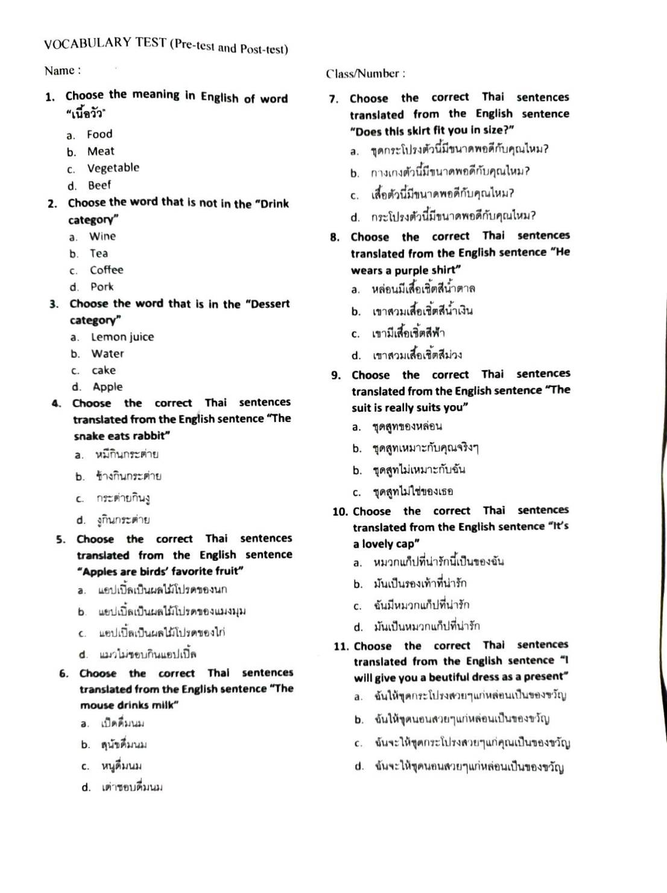

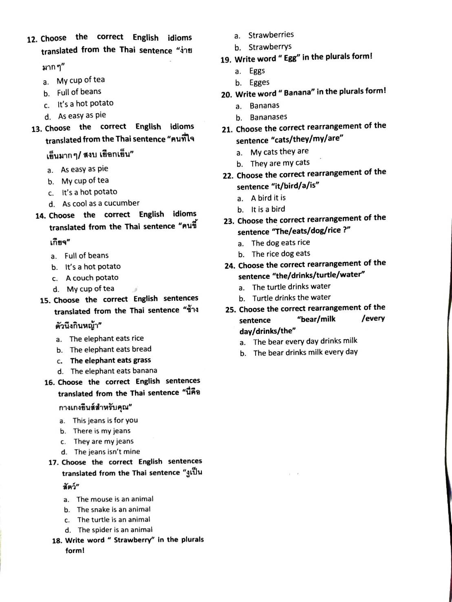

Test Answer Key:
VOCABULARY TEST (Pre-test and Post-test)
Name: Class/Number:

- Choose the meaning in English of word “เนื้อวัว”
a. Food
b. Meat
c. Vegetable
d. Beef
- Choose the word that is not in the “Drink category”
a. Wine
b. Tea
c. Coffee
d. Pork
- Choose the word that is in the “Dessert category”
a. Lemon juice
b. Water
c. cake
d. Apple
- Choose the correct Thai sentences translated from the English sentence “The snake eats rabbit”
a. หมีกินกระต่าย
b. ช้างกินกระต่าย
c. กระต่ายกินงู
d. งูกินกระต่าย
- Choose the correct Thai sentences translated from the English sentence “Apples are birds’ favorite fruit”
a. แอปเปิ้ลเป็นผลไม้โปรดของนก
b. แอปเปิ้ลเป็นผลไม้โปรดของแมงมุม
c. แอปเปิ้ลเป็นผลไม้โปรดของไก่
d. แมวไม่ชอบกินแอปเปิ้ล
- Choose the correct Thai sentences translated from the English sentence “The mouse drinks milk”
a. เป็ดดื่มนม
b. สุนัขดื่มนม
c. หนูดื่มนม
d. เต่าชอบดื่มนม
- Choose the correct Thai sentences translated from the English sentence “Does this skirt fit you in size?”
a. ชุดกระโปรงตัวนี้มีขนาดพอดีกับคุณไหม?
b. กางเกงตัวนี้มีขนาดพอดีกับคุณไหม?
c. เสื้อตัวนี้มีขนาดพอดีกับคุณไหม?
d. กระโปรงตัวนี้มีขนาดพอดีกับคุณไหม?
- Choose the correct Thai sentences translated from the English sentence “He wears a purple shirt”
a. หล่อนมีเสื้อเชิ้ตสีน้ำตาล
b. เขาสวมเสื้อเชิ้ตสีน้ำเงิน
c. เขามีเสื้อเชิ้ตสีฟ้า
d. เขาสวมเสื้อเชิ้ตสีม่วง
- Choose the correct Thai sentences translated from the English sentence “The suit is really suits you”
- ชุดสูทของหล่อน
- ชุดสูทเหมาะกับคุณจริงๆ
b. ชุดสูทไม่เหมาะกับฉัน
c. ชุดสูทไม่ใช่ของเธอ
- Choose the correct Thai sentences translated from the English sentence “It’s a lovely cap”
a. หมวกแก็ปที่น่ารักนี้เป็นของฉัน
b. มันเป็นรองเท้าที่น่ารัก
c. ฉันมีหมวกแก็ปที่น่ารัก
d. มันเป็นหมวกแก็ปที่น่ารัก

- Choose the correct Thai sentences translated from the English sentence “I will give you a beutiful dress as a present”
a. ฉันให้ชุดกระโปรงสวยๆแก่หล่อนเป็นของขวัญ
b. ฉันให้ชุดนอนสวยๆแก่หล่อนเป็นของขวัญ
c. ฉันจะให้ชุดกระโปรงสวยๆแก่คุณเป็นของขวัญ
d. ฉันจะให้ชุดนอนสวยๆแก่หล่อนเป็นของขวัญ
- Choose the correct English idioms translated from the Thai sentence “ง่ายมากๆ”
a. My cup of tea
b. Full of beans
c. It’s a hot potato
d. As easy as pie
- Choose the correct English idioms translated from the Thai sentence “คนที่ใจเย็นมากๆ/ สงบ เยือกเย็น”
a. As easy as pie
b. My cup of tea
c. It’s a hot potato
d. As cool as a cucumber
- Choose the correct English idioms translated from the Thai sentence “คนขี้เกียจ”
a. Full of beans
b. It’s a hot potato
c. A couch potato
d. My cup of tea
- Choose the correct English sentences translated from the Thai sentence “ช้างตัวนึงกินหญ้า”
a. The elephant eats rice
b. The elephant eats bread
c. The elephant eats grass
d. The elephant eats banana

- Choose the correct English sentences translated from the Thai sentence “นี่คือกางเกงยีนส์สำหรับคุณ”
a. This jeans is for you
b. There is my jeans
c. They are my jeans
d. The jeans isn’t mine
- Choose the correct English sentences translated from the Thai sentence “งูเป็นสัตว์”
a. The mouse is an animal
b. The snake is an animal
c. The turtle is an animal
d. The spider is an animal
- Write word “ Strawberry” in the plurals form!
a. Strawberries
b. Strawberrys
- Write word “ Egg” in the plurals form!
a. Eggs
b. Egges
- Write word “ Banana” in the plurals form!
a. Bananas
b. Bananases
- Choose the correct rearrangement of the sentence “cats/they/my/are”
a. My cats they are
b. They are my cats
- Choose the correct rearrangement of the sentence “it/bird/a/is”
a. A bird it is
b. It is a bird
- Choose the correct rearrangement of the sentence “The/eats/dog/rice ?”
a. The dog eats rice
b. The rice dog eats

- Choose the correct rearrangement of the sentence “the/drinks/turtle/water”
a. The turtle drinks water
b. Turtle drinks the water

- Choose the correct rearrangement of the sentence “bear/milk /every day/drinks/the”
a. The bear every day drinks milk
b. The bear drinks milk every day
Appendix 4
SPSS DATA

T-Test

Notes
Output Created |  | 13-JUN-2024 13:33:33
Comments
Input | Data | C:\Users\Asus\OneDrive\เดสก์ท็อป\Untitled1 data descriptive.sav
 | Active Dataset | DataSet1
 | Filter | <none>
 | Weight | <none>
 | Split File | <none>
 | N of Rows in Working Data File | 15
Missing Value Handling | Definition of Missing | User defined missing values are treated as missing.
 | Cases Used | Statistics for each analysis are based on the cases with no missing or out-of-range data for any variable in the analysis.
Syntax |  | T-TEST PAIRS=PreEx PreCon WITH PostEx PostCon (PAIRED)  /CRITERIA=CI(.9500)  /MISSING=ANALYSIS.
Resources | Processor Time | 00:00:00.00
 | Elapsed Time | 00:00:00.01
Paired Samples Statistics

Paired Samples Statistics
 |  | Mean | N | Std. Deviation | Std. Error Mean
Pair 1 | Pre-test Experiment | 68.00 | 15 | 21.541 | 5.562
 | Post-test Experiment | 86.67 | 15 | 11.580 | 2.990
Pair 2 | Pre-test Control | 54.93 | 15 | 18.045 | 4.659
 | Post-test Control | 65.07 | 15 | 15.746 | 4.065

Paired Samples Correlations

Paired Samples Correlations
 |  | N | Correlation | Sig.
Pair 1 | Pre-test Experiment & Post-test Experiment | 15 | .797 | .000
Pair 2 | Pre-test Control & Post-test Control | 15 | .945 | .000

Paired Samples Test

Paired Samples Test
 |  | Paired Differences |  |  |  |  | t | df | Sig. (2-tailed)
 |  | Mean | Std. Deviation | Std. Error Mean | 95% Confidence Interval of the Difference
 |  |  |  |  | Lower | Upper
Pair 1 | Pre-test Experiment - Post-test Experiment | -18.667 | 14.156 | 3.655 | -26.506 | -10.828 | -5.107 | 14 | .000
Pair 2 | Pre-test Control - Post-test Control | -10.133 | 6.022 | 1.555 | -13.468 | -6.798 | -6.517 | 14 | .000

Appendix 5
Letter of Research Permission

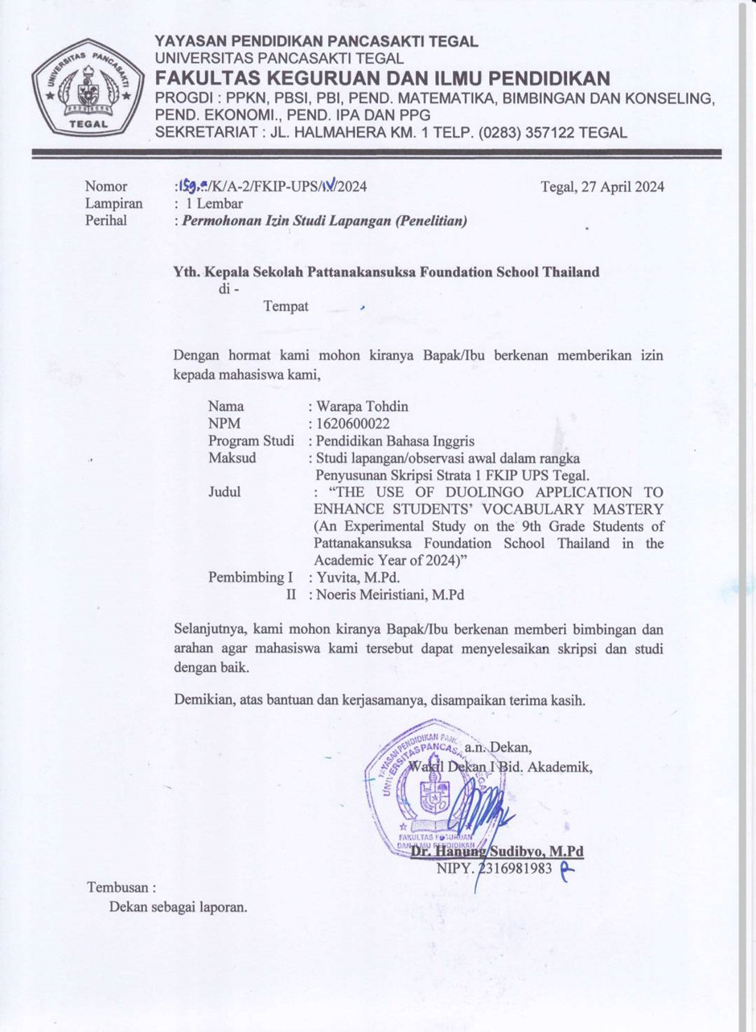
Appendix 6
Research Completion Letter

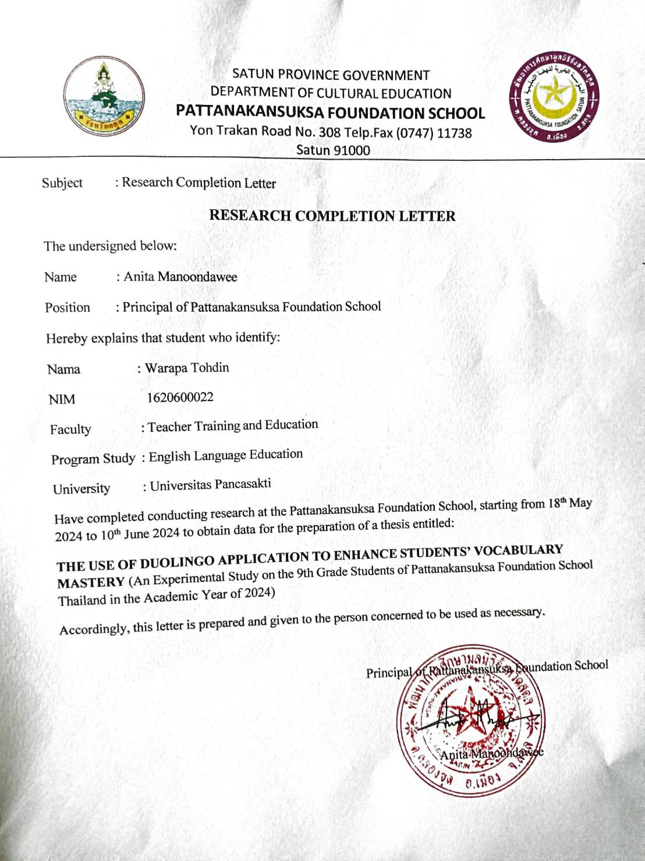
Appendix 7
Lesson Plan

Lesson Plan 6 Meetings (Experimental Group)
Treatment
Meeting 1
School identity : Pattanakansuksa Foundation School
Subject of Lesson : English
Grade/Class : 9th Class Experimental 1
Main material : Food for thought
Time allocation : 1 meeting (1x90 minutes)

Indicator
FL 1.1 M. 3/2 Read aloud messages, news, advertisements, and short poetry according to reading principles.
FL 1.1 M. 3/3 Identify and write non-text media, various formats to relate to the sentences and texts that have been heard or read.
FL 1.1 M. 3/4 Select/specify the topic, main idea, supporting details, and express opinions about stories that have been listened and read from various types of media, including reasons and examples.
FL 1.2 M. 3/1 Converse and write to exchange information about themselves, various matters around them, situations, news and matters of interest to society, and communicate the information continuously and appropriately.
FL 1.2 M. 3/5 Speak to express their own feelings about various matters around them and various activities by following the models heard.
FL 1.3 M. 3/1 Speak and write to describe themselves, experiences/ matters/various issues of interest to society.
FL 2.1 M. 3/1 Choose the language, tone of voice, gestures and manners appropriate to various persons and occasions in accordance with the social manners and culture of the native speakers.
FL 4.1 M. 3/1 Use language for communication in real situations/ simulated situations in the classroom, school, community and society.
Essential competencies of students
1) Competency 1:
Communication ability
Indicator 1: Indicative behavior
1. Able to speak convey knowledge and understanding from what has been read, listened to, or viewed in their own words.
3. Able to write convey knowledge and understanding from what has been read, listened to, or viewed in their own words.
4. Able to convey thoughts, feelings, and opinions in writing from what has been read, listened to, or viewed in their own words.
2) Competency 2:
Thinking ability
Indicator 1: Indicative behavior
1. Able to analyze, synthesize, evaluate, determine importance, and compare information within the context of everyday life.
3) Competency 4:
Ability to use life skills
Indicator 3: Indicative behavior
6. Able to use language, manners, and gestures appropriately according to personal and social contexts and opportunities.
Learning Objectives
1. Read aloud words, texts, and passages correctly according to reading principles (K, S, A) (FL 1.1 M. 3/2)
2. Select/specify the topic, main idea of the reading passage or non-text media and details about grammar principles and writing sentences correctly (K, S, A) (FL 1.1 M 3/3, FL 1.1 M. 3/4)
3. Discuss and exchange information about what to eat and drink every day (K, S) (FFL 1.2 M. 3/1, FL 1.2 M. 3/1, FL 2.1 M. 3/1, FL 4.1 M. 3/1)
4. Write a description of information about daily eating habits and things that should be changed for good health (K, S) (FL 1.3 M. 3/1, FL 1.2 M. 3/5, FL 2.1 M. 3/1)
Assessment
1. Willing to learn, take part
2. Complete the assigned task
3. Responsible
Media and Sources
- Duolingo
- TV
- Laptop
- Board

Activities | Teaching and Learning Activities | Time Allocation
Warm up / Opening activities | - The teacher greets the class.  - The teacher checks the student's attendance.  - The teacher asks students to pray together before starting the lesson.  - The teacher asks about the test they take in the previous meeting. | 10 Minutes
Main Activity | - The teacher asks the students what food they like to eat, what that food is made from, what food they ate today, and whether they think they received all the nutrients in the past meal. | 5 Minutes
 | - The teacher introduces the Duolingo application and its features for vocabulary acquisition to the students in the experimental class.  - The teacher opens the Duolingo application and has the students do exercises related to food together. | 20 Minutes
 | - The teacher asks the students to look at vocabulary words related to categories of food and drink, such as fruit, meat, vegetables, desserts, drinks, dairy products, seafood, poultry, and others in Duolingo app.  - The students write the meanings of those vocabulary words in Thai.  - The teacher asks the students to separate the words according to their categories.  - After the students finish separating the words and writing their meanings, the teacher draws a table on the board.  - Each student comes to the board to write the vocabulary of each category.  - The teacher asks the students to find additional vocabulary in each category from the Duolingo application.  - The teacher explains countable nouns and uncountable nouns to the students.  - The teacher assigns students to look at the vocabulary they find and identify which words are countable nouns, uncountable nouns, and which can be both.  - The students write a short sentence about their daily eating habits and what they should change to stay healthy. | 50 Minutes
Closing | - The teacher concludes the lesson, and gives feedback to the students  - Closing and GREETING | 5 Minutes

Meeting 2
School identity : Pattanakansuksa Foundation School
Subject of Lesson : English
Grade/Class : 9th Class Experimental 1
Main material : Idioms and Sayings about food
Time allocation : 1 meeting (1x90 minutes)
Indicator
FL 1.1 M. 3/2 Read aloud messages, news, advertisements, and short poetry according to reading principles.
FL1.1 M. 3/3 Identify and write non-text media, various formats to relate to the sentences and texts that have been heard or read.
FL 1.1 M. 3/4 Select/specify the topic, main idea, supporting details, and express opinions about stories that have been listened and read from various types of media, including reasons and examples.
FL 1.2 M. 3/4 Speak and write appropriately to ask for and give information, explain, compare and express opinions about what has been heard or read.
FL 1.3 M. 3/1 Speak and write to describe themselves, experiences/ matters/various issues of interest to society.
FL 2.1 M. 3/1 Choose the language, tone of voice, gestures and manners appropriate to various persons and occasions in accordance with the social manners and culture of the native speakers.
FL 2.2 M. 3/2 Compare and explain the similarities and the differences between the lifestyles and the culture of the native speakers and those of Thais, and apply them appropriately.
FL 3.1 M. 3/1 Search for, collect and summarise the information/ facts related to other learning areas from learning sources, and present them through speaking/writing.
FL 4.1 M. 3/1 Use language for communication in real situations/ simulated situations in the classroom, school, community and society.
FL 4.2 M. 3/1 Use foreign languages in conducting the research, collecting and summarising knowledge and various information from the media and different learning sources for further education and livelihood.
Essential competencies of students
1) Competency 1:
Communication ability
Indicator 1: Indicative behavior
1. Able to speak convey knowledge and understanding from what has been read, listened to, or viewed in their own words.
3. Able to write convey knowledge and understanding from what has been read, listened to, or viewed in their own words.
2) Competency 2:
Thinking ability
Indicator 1: Indicative behavior
2. Able to find relationships between various components of information seen in the context of daily life.
3) Competency 4:
Ability to use life skills
Indicator 2: Indicative behavior
1. Have skills in seeking knowledge and Information
2. Able to connect knowledge
Indicator 3: Indicative behavior
6. Able to use language, manners, and gestures appropriate to the person and occasion according to social etiquette.
3) Competency 5: Ability to use technology
Indicator 1: Indicative behavior
1. Able to choose and use technology to learn creatively and with morals.
Learning Objectives
1. Read aloud words, texts, and passages correctly according to reading principles (K, S, A) (FL 1.1 M. 3/2)
2. Select /specify the topic, main idea of the reading passage or non-text media and details about grammar and composing sentences correctly (K, S, A) (FL 1.1 M. 3/3, FL 1.1 M. 3/4)
3. Tell the difference between idiom and saying correctly (K, S, A) (FL 1.2 M. 3/4, FL 1.3 M. 3/1, FL 2.1 M. 3/1, FL 2.2 M. 3/2)
4. Write a quiz or test on the topic of idioms and sayings related to food correctly and appropriately (K, S, A) (FL 1.2 M.3/4, FL 1.3 M.3/1, FL 2.1 M.3/1)
5. Research idioms and sayings in English related to food from various learning sources (K, S) (FL 3.1 M.3/1, FL 4.1 M.3/1, FL 4.2 M.3/1)
Assessment
1. Willing to learn, take part
2. Complete the assigned task
3. Responsible
Media and Sources
- Duolingo
- TV
- Laptop
- Board

Activities | Teaching and Learning Activities | Time Allocation
Warm up / Opening activities | - The teacher greets the class.  - The teacher checks the student's attendance.  - The teacher asks students to pray together before starting the lesson.  - The teacher asks about the material they learn in the previous meeting. | 10 Minutes
Main Activity | - The teacher asks the students if they know any idioms or sayings about food. And asks them to give examples. | 5 Minutes
 | - The teacher opens the Duolingo app and has students work together on exercises related to food.  - The researcher explains the definitions of idiom and saying to the students. | 20 Minutes
 | - The teacher asks the students to help answer what the difference between an idiom and a saying is.  - The teacher writes examples of idioms and sayings on the board along with their meanings.  - The students identify which sentences are idioms and which are sayings.  - The teacher divides the students into groups of 5 students (3 groups).  - The students open the Duolingo app again.  - The researcher assigns each group to find two words about food from the Duolingo app.  - Each group creates idioms and sayings from those words.  - The students present the idioms and sayings they create to the class. | 50 Minutes
Closing | - The teacher concludes the lesson, and gives feedback to the students  - Closing and GREETING | 5 Minutes

Meeting 3
School identity : Pattanakansuksa Foundation School
Subject of Lesson : English
Grade/Class : 9th Class Experimental 1
Main material : Idioms and Sayings about food
Time allocation : 1 meeting (1x90 minutes)
Indicator
FL 1.1 M. 3/2 Read aloud messages, news, advertisements, and short poetry according to reading principles.
FL 1.1 M. 3/3 Identify and write non-text media, various formats to relate to the sentences and texts that have been heard or read.
FL 1.1 M. 3/4 Select/specify the topic, main idea, supporting details, and express opinions about stories that have been listened and read from various types of media, including reasons and examples.
FL 1.2 M. 3/4 Speak and write appropriately to ask for and give information, explain, compare and express opinions about what has been heard or read.
FL 1.3 M. 3/1 Speak and write to describe themselves, experiences/ matters/various issues of interest to society.
FL 2.1 M. 3/1 Choose the language, tone of voice, gestures and manners appropriate to various persons and occasions in accordance with the social manners and culture of the native speakers.
FL 2.2 M. 3/2 Compare and explain the similarities and the differences between the lifestyles and the culture of the native speakers and those of Thais, and apply them appropriately.
FL 3.1 M. 3/1 Search for, collect and summarise the information/ facts related to other learning areas from learning sources, and present them through speaking/writing.
FL 4.1 M. 3/1 Use language for communication in real situations/ simulated situations in the classroom, school, community and society.
FL 4.2 M. 3/1 Use foreign languages in conducting the research, collecting and summarising knowledge and various information from the media and different learning sources for further education and livelihood.
Essential competencies of students
1) Competency 1:
Communication ability
Indicator 1: Indicative behavior
1. Able to speak convey knowledge and understanding from what has been read, listened to, or viewed in their own words.
3. Able to write convey knowledge and understanding from what has been read, listened to, or viewed in their own words.
2) Competency 2:
Thinking ability
Indicator 1: Indicative behavior
2. Able to find relationships between various components of information seen in the context of daily life.
3) Competency 4:
Ability to use life skills
Indicator 2: Indicative behavior
1. Have skills in seeking knowledge and Information
2. Able to connect knowledge
Indicator 3: Indicative behavior
6. Able to use language, manners, and gestures appropriate to the person and occasion according to social etiquette.
3) Competency 5: Ability to use technology
Indicator 1: Indicative behavior
1. Able to choose and use technology to learn creatively and with morals.
Learning Objectives
1. Read aloud words, texts, and passages correctly according to reading principles (K, S, A) (FL 1.1 M. 3/2)
2. Select /specify the topic, main idea of the reading passage or non-text media and details about grammar and composing sentences correctly (K, S, A) (FL 1.1 M. 3/3, FL 1.1 M. 3/4)
3. Tell the difference between idiom and saying correctly (K, S, A) (FL 1.2 M. 3/4, FL 1.3 M. 3/1, FL 2.1 M. 3/1, FL 2.2 M. 3/2)
4. Write a quiz or test on the topic of idioms and sayings related to food correctly and appropriately (K, S, A) (FL 1.2 M.3/4, FL 1.3 M.3/1, FL 2.1 M.3/1)
5. Research idioms and sayings in English related to food from various learning sources (K, S) (FL 3.1 M.3/1, FL 4.1 M.3/1, FL 4.2 M.3/1)
Assessment
1. Willing to learn, take part
2. Complete the assigned task
3. Responsible

Media and Sources
- Duolingo
- TV
- Laptop
- Board

Activities | Teaching and Learning Activities | Time Allocation
Warm up / Opening activities | - The teacher greets the class.  - The teacher checks the student's attendance.  - The teacher asks students to pray together before starting the lesson.  - The teacher asks about the material they learn in the previous meeting. | 10 Minutes
Main Activity | - The teacher asks the students to review the idioms and sayings from the previous meeting | 5 Minutes
 | - The teacher prepares additional Duolingo exercises about food for the students.  - The teacher divides the students into 3 groups, each consisting of 5 students.  - The teacher has the students play a game by doing exercises related to food in the Duolingo app, where the first group to answer correctly gets 1 point.  - While playing the game, the students observe new words related to food and write them down on a piece of paper. | 20 Minutes
 | - The teacher assigns the students to choose two new words related to food that they write down to create their own idioms and sayings, similar to the previous meeting.  - The teacher writes the idioms and sayings created by the three groups on the board and on paper to use as labels for a hint game.  - The students send a representative from each group to pick up labels of idioms or sayings and give hints by showing gestures to their group members to guess the idioms and sayings. If students pick up an idiom or saying that their group creates, they have to pick a new label. | 50 Minutes
Closing | - The teacher concludes the lesson, and gives feedback to the students  - Closing and GREETING | 5 Minutes

Meeting 4
School identity : Pattanakansuksa Foundation School
Subject of Lesson : English
Grade/Class : 9th Class Experimental 1
Main material : Just for you (Offering presents/Expressing thanks
Time allocation : 1 meeting (1x90 minutes)

Indicator
FL 1.1 M 3/2 Read aloud messages, news, advertisements, and short poetry according to reading principles.
FL 1.1 M. 3/3 Identify and write non-text media, various formats to relate to the sentences and texts that have been heard or read.
FL 1.1 M. 3/4 Select/specify the topic, main idea, supporting details, and express opinions about stories that have been listened and read from various types of media, including reasons and examples.
FL 1.2 M. 3/1 Converse and write to exchange information about themselves, various matters around them, situations, news and matters of interest to society, and communicate the information continuously and appropriately.
FL 1.2 M. 3/4 Speak and write appropriately to ask for and give information, explain, compare and express opinions about what has been heard or read.
FL 1.2 M. 3/5 Speak and write to describe their own feelings and opinions about various matters, activities, experiences and news/incidents, as well as provide justifications appropriately.
FL 1.3 M. 3/1 Speak and write to describe themselves, experiences/ matters/various issues of interest to society.
FL 2.1 M. 3/1 Choose the language, tone of voice, gestures and manners appropriate to various persons and occasions in accordance with the social manners and culture of the native speakers.
FL 4.1 M. 3/1 Use language for communication in real situations/ simulated situations in the classroom, school, community and society.
Essential competencies of students
1) Competency 1:
Communication ability
Indicator 1: Indicative behavior
1. Able to speak convey knowledge and understanding from what has been read, listened to, or viewed in their own words.
3) Competency 4:
Ability to use life skills
Indicator 3: Indicative behavior
1. Able to work creatively with others, able to express their own opinions, accept and listen to the opinions of others.
6. Able to use language, manners, and gestures appropriate to the person and occasion according to social etiquette.
Learning Objectives
1. Read aloud words, texts, and passages correctly according to reading principles (K, S, A) (FL 1.1 M. 3/2)
2. Select /specify the topic, main idea of the reading passage or non-text media, and details about grammar and composing sentences correctly (K, S, A) (FL 1.1 M. 3/3, FL 1.1 M. 3/4, FL 1.2 M. 3/4)
3. Discuss the correct and appropriate way to buy and offer presents. (K, S, A) (FL 1.2 M. 3/1, FL 1.2 M. 3/5, FL 1.3 M. 3/1, FL 2.1 M. 3/1, FL 4.1 M. 3/1)
Assessment
1. Willing to learn, take part
2. Complete the assigned task
3. Responsible
Media and Sources
- Duolingo
- TV
- Laptop

Activities | Teaching and Learning Activities | Time Allocation
Warm up / Opening activities | - The teacher greets the class.  - The teacher checks the student's attendance.  - The teacher asks students to pray together before starting the lesson.  - The teacher asks about the material they learn in the previous meeting. | 10 Minutes
Main Activity | - The teacher asks students to give an example of a birthday present. And ask them what they would like to give as a birthday present to a friend. | 5 Minutes
 | - The teacher opens the Duolingo app and asks the students to do exercises in the lesson about clothing types.  - During the exercises, students learn various vocabulary related to clothing.  - The teacher asks the students if they ever receive presents from others and what those presents are.  - The teacher discusses the importance of expressing thanks and offering presents in social interactions.  - The teacher gives examples of sentences used to express thanks and offer presents and asks the students to help translate those sentences into Thai. | 30 Minutes
 | - The teacher assigns the students to open the Duolingo app again and find vocabulary words related to clothing.  - The students use those words to compose three sentences each about expressing thanks and offering presents.  - At the end of the meeting, students submit their assignments. | 40 Minutes
Closing | - The teacher concludes the lesson, and gives feedback to the students  - Closing and GREETING | 5 Minutes

Meeting 5
School identity : Pattanakansuksa Foundation School
Subject of Lesson : English
Grade/Class : 9th Class Experimental 1
Main material : Just for you (Offering presents/Expressing thanks
Time allocation : 1 meeting (1x90 minutes)
Indicator
FL 1.1 M. 3/2 Read aloud messages, news, advertisements, and short poetry according to reading principles.
FL 1.1 M. 3/3 Identify and write non-text media, various formats to relate to the sentences and texts that have been heard or read.
FL 1.1 M. 3/4 Select/specify the topic, main idea, supporting details, and express opinions about stories that have been listened and read from various types of media, including reasons and examples.
FL 1.2 M. 3/1 Converse and write to exchange information about themselves, various matters around them, situations, news and matters of interest to society, and communicate the information continuously and appropriately.
FL 1.2 M. 3/4 Speak and write appropriately to ask for and give information, explain, compare and express opinions about what has been heard or read.
FL 1.2 M. 3/5 Speak and write to describe their own feelings and opinions about various matters, activities, experiences and news/incidents, as well as provide justifications appropriately.
FL 1.3 M. 3/1 Speak and write to describe themselves, experiences/ matters/various issues of interest to society.
FL 2.1 M. 3/1 Choose the language, tone of voice, gestures and manners appropriate to various persons and occasions in accordance with the social manners and culture of the native speakers.
FL 4.1 M. 3/1 Use language for communication in real situations/ simulated situations in the classroom, school, community and society.
Essential competencies of students
1) Competency 1:
Communication ability
Indicator 1: Indicative behavior
1. Able to speak convey knowledge and understanding from what has been read, listened to, or viewed in their own words.
3) Competency 4:
Ability to use life skills
Indicator 3: Indicative behavior
1. Able to work creatively with others, able to express their own opinions, accept and listen to the opinions of others.
6. Able to use language, manners, and gestures appropriate to the person and occasion according to social etiquette.
Learning Objectives
1. Read aloud words, texts, and passages correctly according to reading principles (K, S, A) (FL 1.1 M. 3/2)
2. Select /specify the topic, main idea of the reading passage or non-text media, and details about grammar and composing sentences correctly (K, S, A) (FL 1.1 มM. 3/3, FL 1.1 M. 3/4, FL 1.2 M. 3/4)
3. Discuss the correct and appropriate way to buy and offer presents. (K, S, A) (FL 1.2 M. 3/1, FL 1.2 M. 3/5, FL 1.3 M. 3/1, FL 2.1 M. 3/1, FL 4.1 M. 3/1)
Assessment
1. Willing to learn, take part
2. Complete the assigned task
3. Responsible
Media and Sources
- Duolingo
- TV
- Laptop

Activities | Teaching and Learning Activities | Time Allocation
Warm up / Opening activities | - The teacher greets the class.  - The teacher checks the student's attendance.  - The teacher asks students to pray together before starting the lesson.  - The teacher asks about the material they learn in the previous meeting. | 10 Minutes
Main Activity | - The teacher reviews and summarizes the vocabulary and phrases that the students learn in previous meetings. | 5 Minutes
 | - The teacher opens the Duolingo app and has students work together on exercises related to clothing.  - As the students do exercises in Duolingo, the teacher asks them to write down words they never heard before in their notebooks.  - The teacher gives the students example sentences for expressing thanks and offering presents.  - The teacher provides two examples of dialogues about expressing thanks and offering presents. | 30 Minutes
 | - The teacher asks the students to pair up. The students work in pairs to change some words in the dialogues that the teacher provides by replacing the type of presents with clothing presents using the clothing vocabulary they obtain from the Duolingo app.  - After changing the words in the dialogues, the students read the dialogues to the teacher in front of the class. For one student without a partner, the teacher acts as their partner for the dialogue. | 40 Minutes
Closing | - The teacher concludes the lesson, and gives feedback to the students  - Closing and GREETING | 5 Minutes

Meeting 6
School identity : Pattanakansuksa Foundation School
Subject of Lesson : English
Grade/Class : 9th Class 1
Main material : Science (The food chain)
Time allocation : 1 meeting (1x90 minutes)
Indicator
FL 1.1 M. 3/2 Read aloud messages, news, advertisements, and short poetry according to reading principles.
FL 1.1 M. 3/3 Identify and write non-essay media, various formats to relate to the sentences and texts that have been heard or read.
FL 1.1 M. 3/4 Select/specify the topic, main idea, supporting details, and express opinions about stories that have been listened and read from various types of media, including reasons and examples.
FL 1.2 M. 3/4 Speak and write appropriately to ask for and give information, explain, compare and express opinions about what has been heard or read.
FL 1.3 M. 3/1 Speak and write to describe themselves, experiences/ matters/various issues of interest to society.
FL 2.1 M. 3/1 Choose the language, tone of voice, gestures and manners appropriate to various persons and occasions in accordance with the social manners and culture of the native speakers.
FL 4.1 M. 3/1 Use language for communication in real situations/ simulated situations in the classroom, school, community and society.
FL 4.2 M. 3/1 Use foreign languages in conducting the research, collecting and summarising knowledge and various information from the media and different learning sources for further education and livelihood.
Essential competencies of students
1) Competency 1:
Communication ability
Indicator 1: Indicative behavior
1. Able to speak convey knowledge and understanding from what has been read, listened to, or viewed in their own words.
2. Able to speak convey own thoughts, feelings, and viewpoints from the materials have been read, listened to, or viewed in their own words.
3. Able to write convey knowledge and understanding from what has been read, listened to, or viewed in their own words.
2) Competency 4:
Ability to use life skills
Indicator 2: Indicative behavior
1. Have skills in seeking knowledge and Information
2. Able to connect knowledge
3) Competency 5: Ability to use technology
Indicator 2: Indicative behavior
1. Able to choose and use technology to learn creatively and with morals.
Learning Objectives
1. Read aloud words, texts, and passages correctly according to reading principles (K, S, A) (FL1.1 M. 3/2)
2. Select /specify the topic, main idea of the reading passage or non-text media, and details about grammar and composing sentences correctly (K, S, A) (FL 1.1 M. 3/3, FL 1.1 M. 3/4, FL 1.2 M. 3/4)
3. Speak and explain about food chains correctly (K, S, A) (FL 1.3 M. 3/1, FL 2.1 M. 3/1)
5. Research information about other forms of food chains from various learning sources. (K, S) (FL 3.1 M. 3/1, FL 4.1 M. 3/1, FL 4.2 M. 3/1)
Assessment
1. Willing to learn, take part
2. Complete the assigned task
3. Responsible
Media and Sources
- Duolingo
- TV
- Laptop

Activities | Teaching and Learning Activities | Time Allocation
Warm up / Opening activities | - The teacher greets the class.  - The teacher checks the student's attendance.  - The teacher asks students to pray together before starting the lesson.  - The teacher asks about the material they learn in the previous meeting. | 10 Minutes
Main Activity | - The teacher asks the students who has pets and what food their pets eat. | 5 Minutes
 | - The teacher opens the Duolingo app and shows pictures of animals in the app to students.  - The teacher asks the students to guess what the material for the meeting is about.  - The teacher asks the students to do exercises in the lesson about animals and pronouns in the Duolingo app.  - The teacher uses Duolingo’s exercises to introduce new vocabulary related to animals and pronouns.  - The teacher explains that the content for the day is the food chain and pronouns. | 20 Minutes
 | - The teacher engages students in a discussion about the importance of pronouns in describing the food chain.  - The teacher emphasizes how pronouns help avoid repetition, indicate relationships between organisms, maintain clarity, emphasize connections, and facilitate comparisons.  - The teacher guides students through a group activity (3 groups) where they create their own food chains using the vocabulary learned from the Duolingo app.  - The activity allows students to apply their understanding of pronouns in a practical context and reinforces the importance of pronouns in accurately describing food chains.  - At the end of the meeting, students present their assignments in front of the class. | 50 Minutes
Closing | - The teacher concludes the lesson, and gives feedback to the students  - Closing and GREETING | 5 Minutes

Lesson Plan 6 Meetings (Control Group)
Treatment

Meeting 1
School identity : Pattanakansuksa Foundation School
Subject of Lesson : English
Grade/Class : 9th Class Control 2
Main material : Food for thought
Time allocation : 1 meeting (1x90 minutes)

Indicator
FL 1.1 M. 3/2 Read aloud messages, news, advertisements, and short poetry according to reading principles.
FL 1.1 M. 3/3 Identify and write non-text media, various formats to relate to the sentences and texts that have been heard or read.
FL 1.1 M. 3/4 Select/specify the topic, main idea, supporting details, and express opinions about stories that have been listened and read from various types of media, including reasons and examples.
FL 1.2 M. 3/1 Converse and write to exchange information about themselves, various matters around them, situations, news and matters of interest to society, and communicate the information continuously and appropriately.
FL 1.2 M. 3/5 Speak to express their own feelings about various matters around them and various activities by following the models heard.
FL 1.3 M. 3/1 Speak and write to describe themselves, experiences/ matters/various issues of interest to society.
FL 2.1 M. 3/1 Choose the language, tone of voice, gestures and manners appropriate to various persons and occasions in accordance with the social manners and culture of the native speakers.
FL 4.1 M. 3/1 Use language for communication in real situations/ simulated situations in the classroom, school, community and society.
Essential competencies of students
1) Competency 1:
Communication ability
Indicator 1: Indicative behavior
1. Able to speak convey knowledge and understanding from what has been read, listened to, or viewed in their own words.
3. Able to write convey knowledge and understanding from what has been read, listened to, or viewed in their own words.
4. Able to convey thoughts, feelings, and opinions in writing from what has been read, listened to, or viewed in their own words.
2) Competency 2:
Thinking ability
Indicator 1: Indicative behavior
1. Able to analyze, synthesize, evaluate, determine importance, and compare information within the context of everyday life.
3) Competency 4:
Ability to use life skills
Indicator 3: Indicative behavior
6. Able to use language, manners, and gestures appropriately according to personal and social contexts and opportunities.
Learning Objectives
1. Read aloud words, texts, and passages correctly according to reading principles (K, S, A) (FL 1.1 M. 3/2)
2. Select/specify the topic, main idea of the reading passage or non-text media and details about grammar principles and writing sentences correctly (K, S, A) (FL 1.1 M 3/3, FL 1.1 M. 3/4)
3. Discuss and exchange information about what to eat and drink every day (K, S) (FFL 1.2 M. 3/1, FL 1.2 M. 3/1, FL 2.1 M. 3/1, FL 4.1 M. 3/1)
4. Write a description of information about daily eating habits and things that should be changed for good health (K, S) (FL 1.3 M. 3/1, FL 1.2 M. 3/5, FL 2.1 M. 3/1)
Assessment
1. Willing to learn, take part
2. Complete the assigned task
3. Responsible
Media and Sources
- English textbook (Action Student’s book3)
- Dictionary
- TV
- Laptop
- Board

Activities | Teaching and Learning Activities | Time Allocation
Warm up / Opening activities | - The teacher greets the class.  - The teacher checks the student's attendance.  - The teacher asks students to pray together before starting the lesson.  - The teacher asks about the test they take in the previous meeting. | 10 Minutes
Main Activity | - The teacher asks the students what food they like to eat, what that food is made from, what food they ate today, and whether they think they received all the nutrients in the past meal. | 5 Minutes
 | - The teacher introduces English textbook (Action Student’s book3) to the students in the control class. | 20 Minutes
 | - The teacher asks the students to look at vocabulary words related to categories of food and drink, such as fruit, meat, vegetables, desserts, drinks, dairy products, seafood, poultry, and others in English textbook (Action Student’s book3)  - The students write the meanings of those vocabulary words in Thai using dictionary.  - The teacher asks the students to separate the words according to their categories.  - After the students finish separating the words and writing their meanings, the teacher draws a table on the board.  - Each student comes to the board to write the vocabulary of each category.  - The teacher asks the students to find additional vocabulary in each category from the dictionary.  - The teacher explains countable nouns and uncountable nouns to the students.  - The teacher assigns students to look at the vocabulary they find and identify which words are countable nouns, uncountable nouns, and which can be both.  - The students write a short sentence about their daily eating habits and what they should change to stay healthy. | 50 Minutes
Closing | - The teacher concludes the lesson, and gives feedback to the students  - Closing and GREETING | 5 Minutes

Meeting 2
School identity : Pattanakansuksa Foundation School
Subject of Lesson : English
Grade/Class : 9th Class Control 2
Main material : Idioms and Sayings about food
Time allocation : 1 meeting (1x90 minutes)

Indicator
FL 1.1 M. 3/2 Read aloud messages, news, advertisements, and short poetry according to reading principles.
FL1.1 M. 3/3 Identify and write non-text media, various formats to relate to the sentences and texts that have been heard or read.
FL 1.1 M. 3/4 Select/specify the topic, main idea, supporting details, and express opinions about stories that have been listened and read from various types of media, including reasons and examples.
FL 1.2 M. 3/4 Speak and write appropriately to ask for and give information, explain, compare and express opinions about what has been heard or read.
FL 1.3 M. 3/1 Speak and write to describe themselves, experiences/ matters/various issues of interest to society.
FL 2.1 M. 3/1 Choose the language, tone of voice, gestures and manners appropriate to various persons and occasions in accordance with the social manners and culture of the native speakers.
FL 2.2 M. 3/2 Compare and explain the similarities and the differences between the lifestyles and the culture of the native speakers and those of Thais, and apply them appropriately.
FL 3.1 M. 3/1 Search for, collect and summarise the information/ facts related to other learning areas from learning sources, and present them through speaking/writing.
FL 4.1 M. 3/1 Use language for communication in real situations/ simulated situations in the classroom, school, community and society.
FL 4.2 M. 3/1 Use foreign languages in conducting the research, collecting and summarising knowledge and various information from the media and different learning sources for further education and livelihood.
Essential competencies of students
1) Competency 1:
Communication ability
Indicator 1: Indicative behavior
1. Able to speak convey knowledge and understanding from what has been read, listened to, or viewed in their own words.
3. Able to write convey knowledge and understanding from what has been read, listened to, or viewed in their own words.
2) Competency 2:
Thinking ability
Indicator 1: Indicative behavior
2. Able to find relationships between various components of information seen in the context of daily life.
3) Competency 4:
Ability to use life skills
Indicator 2: Indicative behavior
1. Have skills in seeking knowledge and Information
2. Able to connect knowledge
Indicator 3: Indicative behavior
6. Able to use language, manners, and gestures appropriate to the person and occasion according to social etiquette.
3) Competency 5: Ability to use technology
Indicator 1: Indicative behavior
1. Able to choose and use technology to learn creatively and with morals.

Learning Objectives
1. Read aloud words, texts, and passages correctly according to reading principles (K, S, A) (FL 1.1 M. 3/2)
2. Select /specify the topic, main idea of the reading passage or non-text media and details about grammar and composing sentences correctly (K, S, A) (FL 1.1 M. 3/3, FL 1.1 M. 3/4)
3. Tell the difference between idiom and saying correctly (K, S, A) (FL 1.2 M. 3/4, FL 1.3 M. 3/1, FL 2.1 M. 3/1, FL 2.2 M. 3/2)
4. Write a quiz or test on the topic of idioms and sayings related to food correctly and appropriately (K, S, A) (FL 1.2 M.3/4, FL 1.3 M.3/1, FL 2.1 M.3/1)
5. Research idioms and sayings in English related to food from various learning sources (K, S) (FL 3.1 M.3/1, FL 4.1 M.3/1, FL 4.2 M.3/1)
Assessment
1. Willing to learn, take part
2. Complete the assigned task
3. Responsible
Media and Sources
- English textbook (Action Student’s book3)
- Dictionary
- TV
- Laptop
- Board

Activities | Teaching and Learning Activities | Time Allocation
Warm up / Opening activities | - The teacher greets the class.  - The teacher checks the student's attendance.  - The teacher asks students to pray together before starting the lesson.  - The teacher asks about the material they learn in the previous meeting. | 10 Minutes
Main Activity | - The teacher asks the students if they know any idioms or sayings about food. And asks them to give examples. | 5 Minutes
 | - The teacher opens the English textbook (Action Student’s book3)  - The researcher explains the definitions of idiom and saying to the students. | 20 Minutes
 | - The teacher asks the students to help answer what the difference between an idiom and a saying is.  - The teacher shows examples of idioms and sayings from the English textbook (Action Student’s book3) and translate their meanings.  - The students identify which sentences are idioms and which are sayings.  - The teacher divides the students into groups of 5 students (3 groups).  - The students open the the English textbook (Action Student’s book3)  - The researcher assigns each group to find two words about food from the dictionary.  - Each group creates idioms and sayings from those words.  - The students present the idioms and sayings they create to the class. | 50 Minutes
Closing | - The teacher concludes the lesson, and gives feedback to the students  - Closing and GREETING | 5 Minutes

Meeting 3
School identity : Pattanakansuksa Foundation School
Subject of Lesson : English
Grade/Class : 9th Class Control 2
Main material : Idioms and Sayings about food
Time allocation : 1 meeting (1x90 minutes)

Indicator
FL 1.1 M. 3/2 Read aloud messages, news, advertisements, and short poetry according to reading principles.
FL 1.1 M. 3/3 Identify and write non-text media, various formats to relate to the sentences and texts that have been heard or read.
FL 1.1 M. 3/4 Select/specify the topic, main idea, supporting details, and express opinions about stories that have been listened and read from various types of media, including reasons and examples.
FL 1.2 M. 3/4 Speak and write appropriately to ask for and give information, explain, compare and express opinions about what has been heard or read.
FL 1.3 M. 3/1 Speak and write to describe themselves, experiences/ matters/various issues of interest to society.
FL 2.1 M. 3/1 Choose the language, tone of voice, gestures and manners appropriate to various persons and occasions in accordance with the social manners and culture of the native speakers.
FL 2.2 M. 3/2 Compare and explain the similarities and the differences between the lifestyles and the culture of the native speakers and those of Thais, and apply them appropriately.
FL 3.1 M. 3/1 Search for, collect and summarise the information/ facts related to other learning areas from learning sources, and present them through speaking/writing.
FL 4.1 M. 3/1 Use language for communication in real situations/ simulated situations in the classroom, school, community and society.
FL 4.2 M. 3/1 Use foreign languages in conducting the research, collecting and summarising knowledge and various information from the media and different learning sources for further education and livelihood.
Essential competencies of students
1) Competency 1:
Communication ability
Indicator 1: Indicative behavior
1. Able to speak convey knowledge and understanding from what has been read, listened to, or viewed in their own words.
3. Able to write convey knowledge and understanding from what has been read, listened to, or viewed in their own words.
2) Competency 2:
Thinking ability
Indicator 1: Indicative behavior
2. Able to find relationships between various components of information seen in the context of daily life.
3) Competency 4:
Ability to use life skills
Indicator 2: Indicative behavior
1. Have skills in seeking knowledge and Information
2. Able to connect knowledge
Indicator 3: Indicative behavior
6. Able to use language, manners, and gestures appropriate to the person and occasion according to social etiquette.
3) Competency 5: Ability to use technology
Indicator 1: Indicative behavior
1. Able to choose and use technology to learn creatively and with morals.
Learning Objectives
1. Read aloud words, texts, and passages correctly according to reading principles (K, S, A) (FL 1.1 M. 3/2)
2. Select /specify the topic, main idea of the reading passage or non-text media and details about grammar and composing sentences correctly (K, S, A) (FL 1.1 M. 3/3, FL 1.1 M. 3/4)
3. Tell the difference between idiom and saying correctly (K, S, A) (FL 1.2 M. 3/4, FL 1.3 M. 3/1, FL 2.1 M. 3/1, FL 2.2 M. 3/2)
4. Write a quiz or test on the topic of idioms and sayings related to food correctly and appropriately (K, S, A) (FL 1.2 M.3/4, FL 1.3 M.3/1, FL 2.1 M.3/1)
5. Research idioms and sayings in English related to food from various learning sources (K, S) (FL 3.1 M.3/1, FL 4.1 M.3/1, FL 4.2 M.3/1)
Assessment
1. Willing to learn, take part
2. Complete the assigned task
3. Responsible
Media and Sources
- English textbook (Action Student’s book3)
- Dictionary
- TV
- Laptop
- Board

Activities | Teaching and Learning Activities | Time Allocation
Warm up / Opening activities | - The teacher greets the class.  - The teacher checks the student's attendance.  - The teacher asks students to pray together before starting the lesson.  - The teacher asks about the material they learn in the previous meeting. | 10 Minutes
Main Activity | - The teacher asks the students to review the idioms and sayings from the previous meeting | 5 Minutes
 | - The teacher asks students to find new words related to food in dictionary and write them down on a piece of paper. | 20 Minutes
 | - The teacher assigns the students to choose two new words related to food that they write down to create their own idioms and sayings, similar to the previous meeting.  - The teacher writes the idioms and sayings created by the three groups on the board and on paper to use as labels for a hint game.  - The students send a representative from each group to pick up labels of idioms or sayings and give hints by showing gestures to their group members to guess the idioms and sayings. If students pick up an idiom or saying that their group creates, they have to pick a new label. | 50 Minutes
Closing | - The teacher concludes the lesson, and gives feedback to the students  - Closing and GREETING | 5 Minutes

Meeting 4
School identity : Pattanakansuksa Foundation School
Subject of Lesson : English
Grade/Class : 9th Class Control 2
Main material : Just for you (Offering presents/Expressing thanks
Time allocation : 1 meeting (1x90 minutes)

Indicator
FL 1.1 M 3/2 Read aloud messages, news, advertisements, and short poetry according to reading principles.
FL 1.1 M. 3/3 Identify and write non-text media, various formats to relate to the sentences and texts that have been heard or read.
FL 1.1 M. 3/4 Select/specify the topic, main idea, supporting details, and express opinions about stories that have been listened and read from various types of media, including reasons and examples.
FL 1.2 M. 3/1 Converse and write to exchange information about themselves, various matters around them, situations, news and matters of interest to society, and communicate the information continuously and appropriately.
FL 1.2 M. 3/4 Speak and write appropriately to ask for and give information, explain, compare and express opinions about what has been heard or read.
FL 1.2 M. 3/5 Speak and write to describe their own feelings and opinions about various matters, activities, experiences and news/incidents, as well as provide justifications appropriately.
FL 1.3 M. 3/1 Speak and write to describe themselves, experiences/ matters/various issues of interest to society.
FL 2.1 M. 3/1 Choose the language, tone of voice, gestures and manners appropriate to various persons and occasions in accordance with the social manners and culture of the native speakers.
FL 4.1 M. 3/1 Use language for communication in real situations/ simulated situations in the classroom, school, community and society.
Essential competencies of students
1) Competency 1:
Communication ability
Indicator 1: Indicative behavior
1. Able to speak convey knowledge and understanding from what has been read, listened to, or viewed in their own words.
3) Competency 4:
Ability to use life skills
Indicator 3: Indicative behavior
1. Able to work creatively with others, able to express their own opinions, accept and listen to the opinions of others.
6. Able to use language, manners, and gestures appropriate to the person and occasion according to social etiquette.
Learning Objectives
1. Read aloud words, texts, and passages correctly according to reading principles (K, S, A) (FL 1.1 M. 3/2)
2. Select /specify the topic, main idea of the reading passage or non-text media, and details about grammar and composing sentences correctly (K, S, A) (FL 1.1 M. 3/3, FL 1.1 M. 3/4, FL 1.2 M. 3/4)
3. Discuss the correct and appropriate way to buy and offer presents. (K, S, A) (FL 1.2 M. 3/1, FL 1.2 M. 3/5, FL 1.3 M. 3/1, FL 2.1 M. 3/1, FL 4.1 M. 3/1)
Assessment
1. Willing to learn, take part
2. Complete the assigned task
3. Responsible
Media and Sources
- English textbook (Action Student’s book3)
- Dictionary
- TV
- Laptop

Activities | Teaching and Learning Activities | Time Allocation
Warm up / Opening activities | - The teacher greets the class.  - The teacher checks the student's attendance.  - The teacher asks students to pray together before starting the lesson.  - The teacher asks about the material they learn in the previous meeting. | 10 Minutes
Main Activity | - The teacher asks students to give an example of a birthday present. And ask them what they would like to give as a birthday present to a friend. | 5 Minutes
 | - The teacher asks the students if they ever receive presents from others and what those presents are.  - The teacher discusses the importance of expressing thanks and offering presents in social interactions.  - The teacher shows examples of sentences used to express thanks and offer presents from English textbook (Action Student’s book3) and asks the students to help translate those sentences into Thai using dictionary. | 30 Minutes
 | - The teacher assigns the students to open the dictionary again and find vocabulary words related to clothing.  - The students use those words to compose three sentences each about expressing thanks and offering presents.  - At the end of the meeting, students submit their assignments. | 40 Minutes
Closing | - The teacher concludes the lesson, and gives feedback to the students  - Closing and GREETING | 5 Minutes

Meeting 5
School identity : Pattanakansuksa Foundation School
Subject of Lesson : English
Grade/Class : 9th Class Control 2
Main material : Just for you (Offering presents/Expressing thanks
Time allocation : 1 meeting (1x90 minutes)

Indicator
FL 1.1 M. 3/2 Read aloud messages, news, advertisements, and short poetry according to reading principles.
FL 1.1 M. 3/3 Identify and write non-text media, various formats to relate to the sentences and texts that have been heard or read.
FL 1.1 M. 3/4 Select/specify the topic, main idea, supporting details, and express opinions about stories that have been listened and read from various types of media, including reasons and examples.
FL 1.2 M. 3/1 Converse and write to exchange information about themselves, various matters around them, situations, news and matters of interest to society, and communicate the information continuously and appropriately.
FL 1.2 M. 3/4 Speak and write appropriately to ask for and give information, explain, compare and express opinions about what has been heard or read.
FL 1.2 M. 3/5 Speak and write to describe their own feelings and opinions about various matters, activities, experiences and news/incidents, as well as provide justifications appropriately.
FL 1.3 M. 3/1 Speak and write to describe themselves, experiences/ matters/various issues of interest to society.
FL 2.1 M. 3/1 Choose the language, tone of voice, gestures and manners appropriate to various persons and occasions in accordance with the social manners and culture of the native speakers.
FL 4.1 M. 3/1 Use language for communication in real situations/ simulated situations in the classroom, school, community and society.
Essential competencies of students
1) Competency 1:
Communication ability
Indicator 1: Indicative behavior
1. Able to speak convey knowledge and understanding from what has been read, listened to, or viewed in their own words.

3) Competency 4:
Ability to use life skills
Indicator 3: Indicative behavior
1. Able to work creatively with others, able to express their own opinions, accept and listen to the opinions of others.
6. Able to use language, manners, and gestures appropriate to the person and occasion according to social etiquette.
Learning Objectives
1. Read aloud words, texts, and passages correctly according to reading principles (K, S, A) (FL 1.1 M. 3/2)
2. Select /specify the topic, main idea of the reading passage or non-text media, and details about grammar and composing sentences correctly (K, S, A) (FL 1.1 มM. 3/3, FL 1.1 M. 3/4, FL 1.2 M. 3/4)
3. Discuss the correct and appropriate way to buy and offer presents. (K, S, A) (FL 1.2 M. 3/1, FL 1.2 M. 3/5, FL 1.3 M. 3/1, FL 2.1 M. 3/1, FL 4.1 M. 3/1)
Assessment
1. Willing to learn, take part
2. Complete the assigned task
3. Responsible
Media and Sources
- English textbook (Action Student’s book3)
- Dictionary
- TV
- Laptop

Activities | Teaching and Learning Activities | Time Allocation
Warm up / Opening activities | - The teacher greets the class.  - The teacher checks the student's attendance.  - The teacher asks students to pray together before starting the lesson.  - The teacher asks about the material they learn in the previous meeting. | 10 Minutes
Main Activity | - The teacher reviews and summarizes the vocabulary and phrases that the students learn in previous meetings. | 5 Minutes
 | - The teacher shows the students example sentences for expressing thanks and offering presents from English textbook (Action Student’s book3)  - The teacher shows two examples of dialogues about expressing thanks and offering presents from English textbook (Action Student’s book3) | 30 Minutes
 | - The teacher asks the students to pair up. The students work in pairs to change some words in the dialogues that the teacher shows by replacing the presents using the new clothing vocabulary they obtain from the dictionary.  - After changing the words in the dialogues, the students read the dialogues to the teacher in front of the class. For one student without a partner, the teacher acts as their partner for the dialogue. | 40 Minutes
Closing | - The teacher concludes the lesson, and gives feedback to the students  - Closing and GREETING | 5 Minutes

Meeting 6
School identity : Pattanakansuksa Foundation School
Subject of Lesson : English
Grade/Class : 9th Class Control 2
Main material : Science (The food chain)
Time allocation : 1 meeting (1x90 minutes)

Indicator
FL 1.1 M. 3/2 Read aloud messages, news, advertisements, and short poetry according to reading principles.
FL 1.1 M. 3/3 Identify and write non-essay media, various formats to relate to the sentences and texts that have been heard or read.
FL 1.1 M. 3/4 Select/specify the topic, main idea, supporting details, and express opinions about stories that have been listened and read from various types of media, including reasons and examples.
FL 1.2 M. 3/4 Speak and write appropriately to ask for and give information, explain, compare and express opinions about what has been heard or read.
FL 1.3 M. 3/1 Speak and write to describe themselves, experiences/ matters/various issues of interest to society.
FL 2.1 M. 3/1 Choose the language, tone of voice, gestures and manners appropriate to various persons and occasions in accordance with the social manners and culture of the native speakers.
FL 4.1 M. 3/1 Use language for communication in real situations/ simulated situations in the classroom, school, community and society.
FL 4.2 M. 3/1 Use foreign languages in conducting the research, collecting and summarising knowledge and various information from the media and different learning sources for further education and livelihood.
Essential competencies of students
1) Competency 1:
Communication ability
Indicator 1: Indicative behavior
1. Able to speak convey knowledge and understanding from what has been read, listened to, or viewed in their own words.
2. Able to speak convey own thoughts, feelings, and viewpoints from the materials have been read, listened to, or viewed in their own words.
3. Able to write convey knowledge and understanding from what has been read, listened to, or viewed in their own words.
2) Competency 4:
Ability to use life skills
Indicator 2: Indicative behavior
1. Have skills in seeking knowledge and Information
2. Able to connect knowledge
3) Competency 5: Ability to use technology
Indicator 2: Indicative behavior
1. Able to choose and use technology to learn creatively and with morals.
Learning Objectives
1. Read aloud words, texts, and passages correctly according to reading principles (K, S, A) (FL1.1 M. 3/2)
2. Select /specify the topic, main idea of the reading passage or non-text media, and details about grammar and composing sentences correctly (K, S, A) (FL 1.1 M. 3/3, FL 1.1 M. 3/4, FL 1.2 M. 3/4)
3. Speak and explain about food chains correctly (K, S, A) (FL 1.3 M. 3/1, FL 2.1 M. 3/1)
5. Research information about other forms of food chains from various learning sources. (K, S) (FL 3.1 M. 3/1, FL 4.1 M. 3/1, FL 4.2 M. 3/1)
Assessment
1. Willing to learn, take part
2. Complete the assigned task
3. Responsible
Media and Sources
- English textbook (Action Student’s book3)
- Dictionary
- TV
- Laptop

Activities | Teaching and Learning Activities | Time Allocation
Warm up / Opening activities | - The teacher greets the class.  - The teacher checks the student's attendance.  - The teacher asks students to pray together before starting the lesson.  - The teacher asks about the material they learn in the previous meeting. | 10 Minutes
Main Activity | - The teacher asks the students who has pets and what food their pets eat. | 5 Minutes
 | - The teacher opens English textbook (Action Student’s book3) and shows pictures of animals in the book to students.  - The teacher asks the students to guess what the material for the meeting is about.  - The teacher uses dictionary to introduce new vocabulary related to animals and pronouns.  - The teacher explains that the content for the day is the food chain and pronouns. | 20 Minutes
 | - The teacher engages students in a discussion about the importance of pronouns in describing the food chain.  - The teacher emphasizes how pronouns help avoid repetition, indicate relationships between organisms, maintain clarity, emphasize connections, and facilitate comparisons.  - The teacher guides students through a group activity (3 groups) where they create their own food chains using the vocabulary learned from the dictionary.  - The activity allows students to apply their understanding of pronouns in a practical context and reinforces the importance of pronouns in accurately describing food chains.  - At the end of the meeting, students present their assignments in front of the class. | 50 Minutes
Closing | - The teacher concludes the lesson, and gives feedback to the students  - Closing and GREETING | 5 Minutes

Appendix 8
Documentation of Research

Experimental Group:

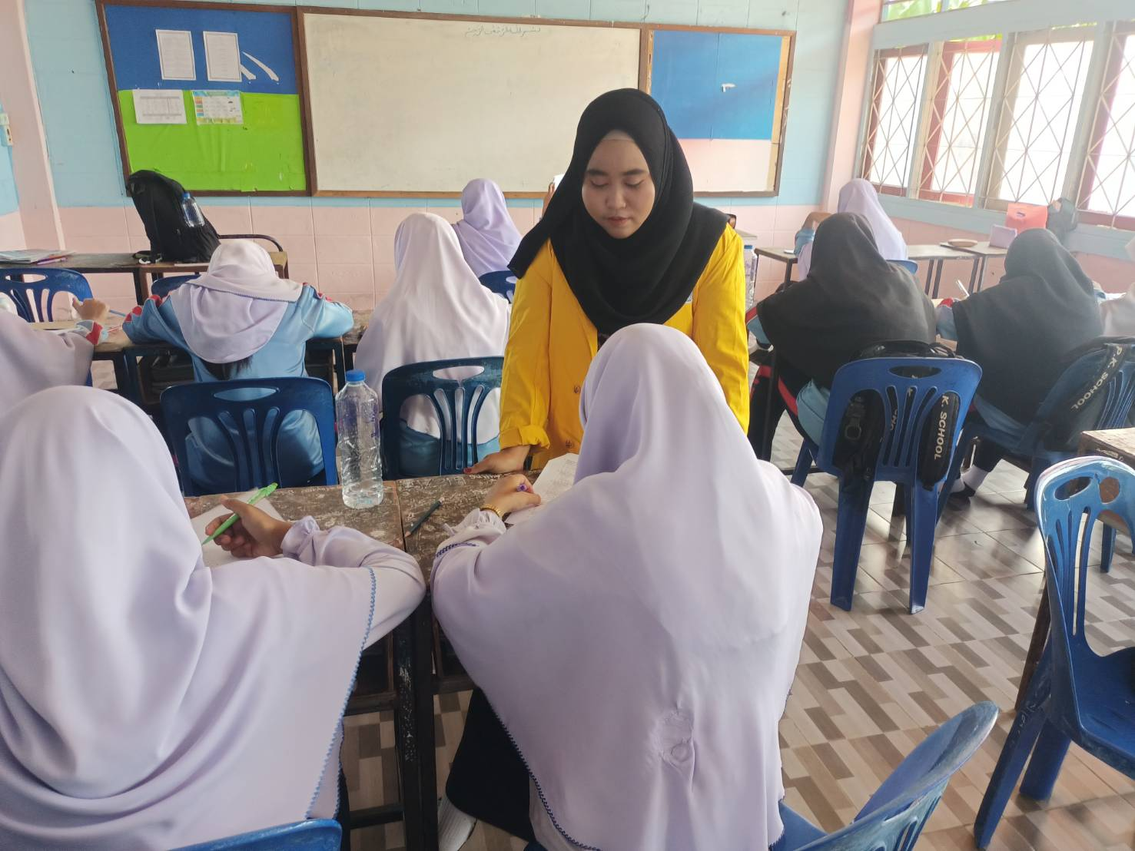
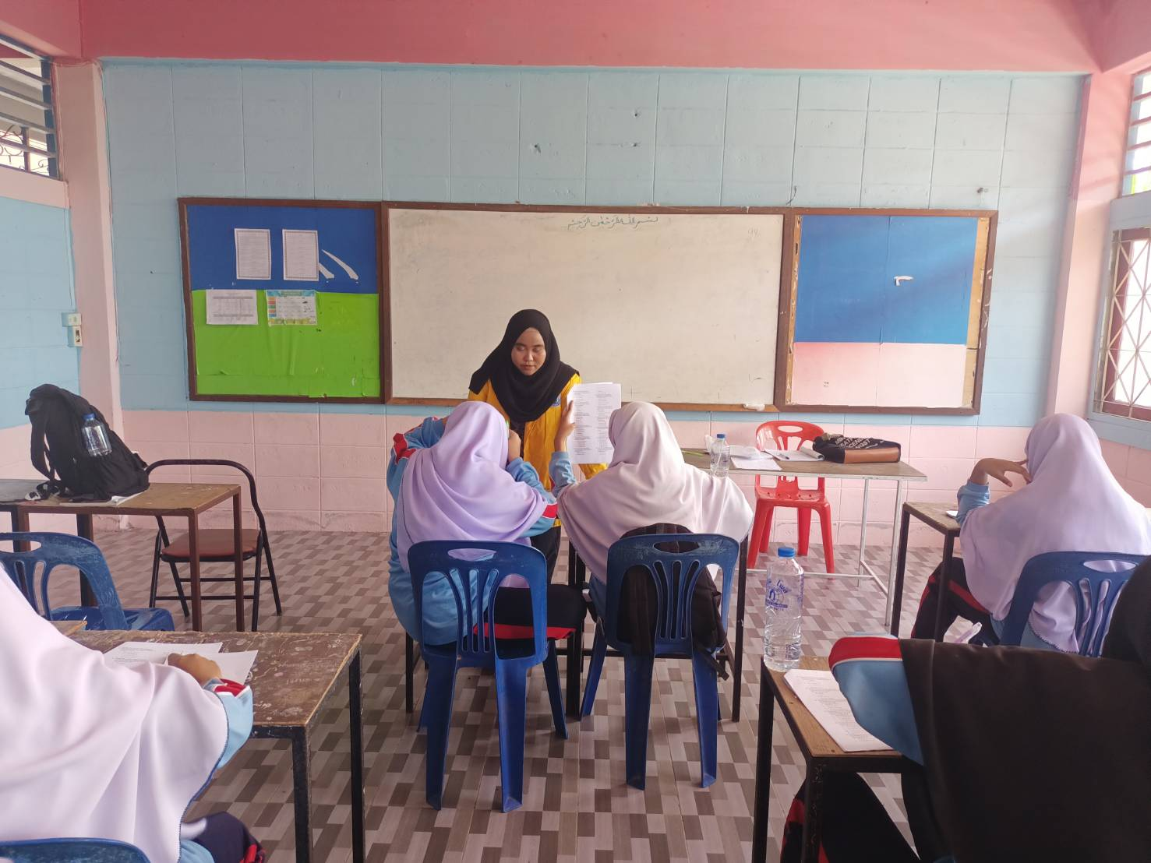

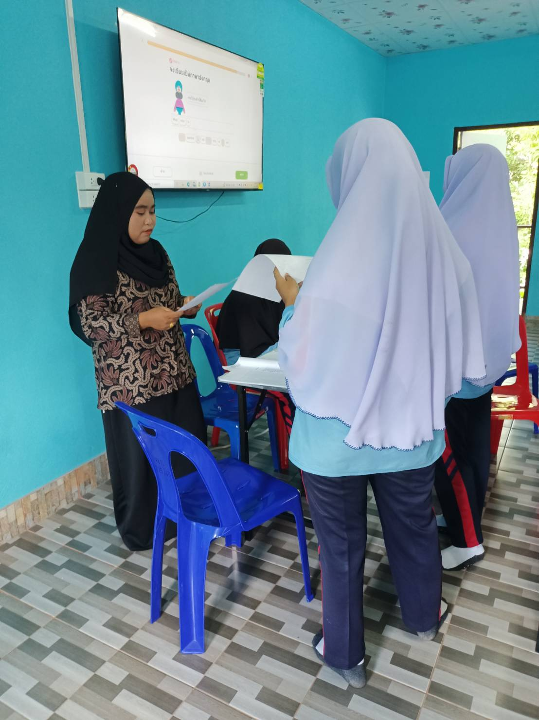
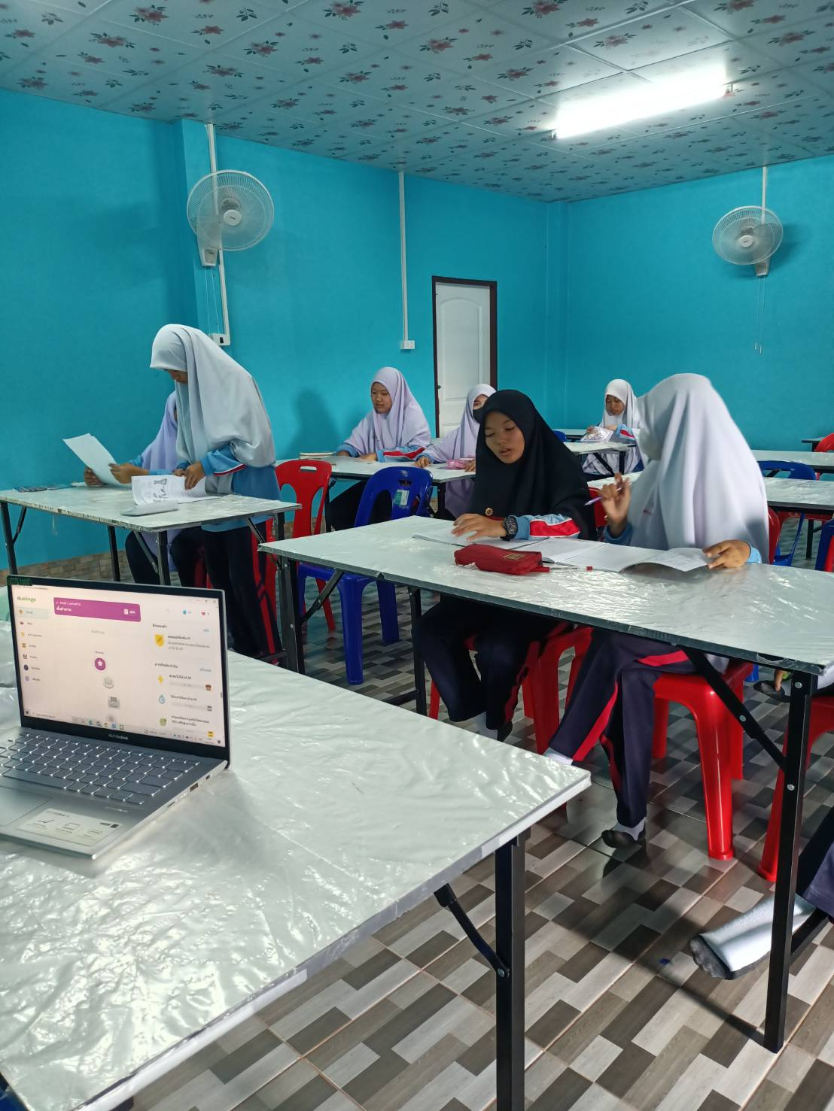

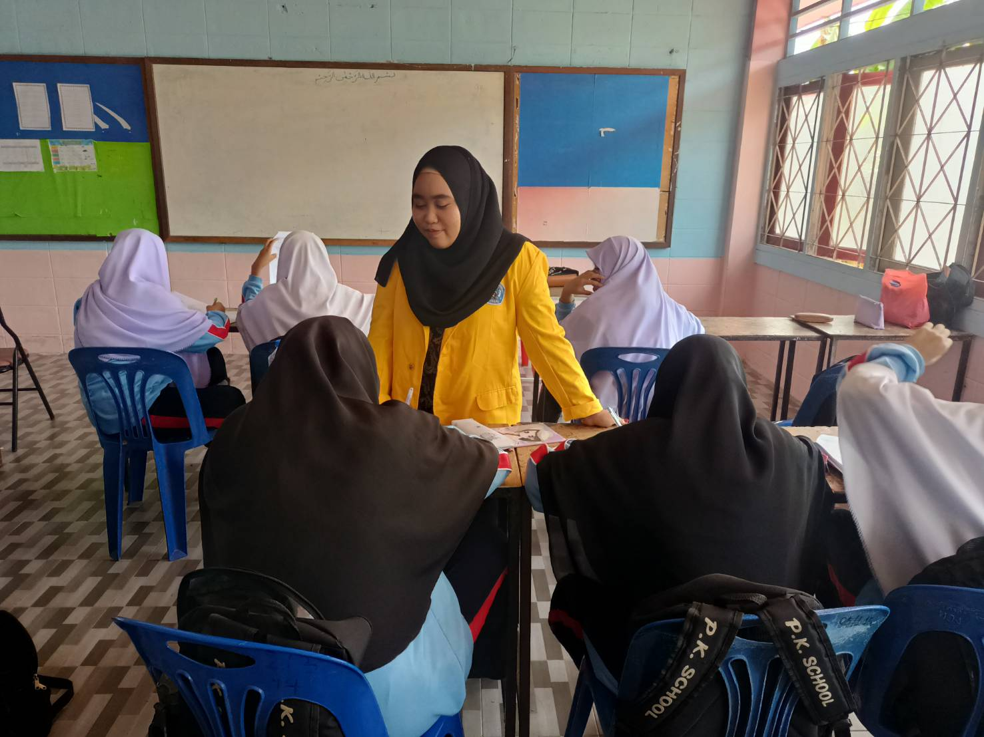

Control Group:

